Legal Applicant Name:

NORTH CAROLINA DEPARTMENT OF TRANSPORTATION

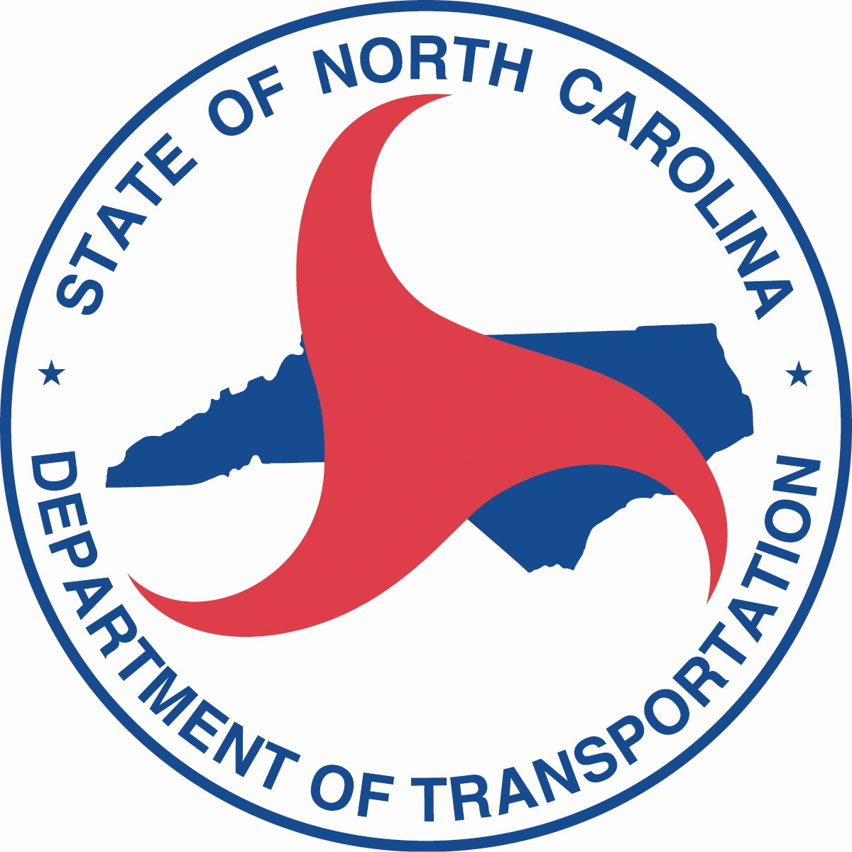

American Rescue Plan (ARP)
Operating Funds
Program Overview and Application
(Revised 02-08-2022)

North Carolina Department of Transportation
Integrated Mobility Division
November 1, 2021

Introduction

On March 11, 2021, President Biden signed the American Rescue Plan (ARP) into law. This bill provides additional relief to address the continued impact of COVID-19 (i.e., coronavirus disease 2020) on the economy, public health, state and local governments, individuals, and businesses.
ARP grants are available to rural and small urban public transportation systems who receive Section 5311 funding to assist with expenses for the operating portion of scheduling software and other operating expenses.

Eligible Applicants and Reimbursement
All systems receiving Section 5311 are eligible to apply for ARP funding. Section 5311 eligible applicants are designated in each county by the County Commissioners as stated in their “5311 Designee Certification” form, signed by the Chairman of the County Commissioners of each county. This designation is a 5-year designation and is currently in place for the period of 2018 through 2022.

The ARP grant will reimburse systems for 100% of the net operating expenses. Net operating expenses are those expenses remaining after the provider subtracts operating revenues from eligible operating expenses. Operating revenues must include farebox revenues.

Farebox revenues include fares paid by riders who are later reimbursed by a human service agency or other user-side subsidy arrangement. Purchase of transit passes or other fare media for clients would be considered farebox revenue. Farebox revenues do not include payments made directly to the transit system by human service agencies to purchase service. A voluntary or mandatory fee that a college, university, or similar institution imposes on all its students for free or discounted transit service is also not farebox revenue. Farebox revenue must be used to reduce total operating expenses (treated as revenue). The ARP Claim Summary Sheet submitted with claims provides further details of expenses and Farebox Revenue.

Net Operating Expenses = Total Eligible Operating Expenses – Fare Revenues

Note: Income from contracts to provide human service transportation may be used either to reduce the net project cost (treated as revenue) or to provide local match for operating assistance. In either case, the cost of providing the contract service must be included in the total project cost.

Revision of Expense Codes
Reimbursement will be made in one of two, G-codes on the reimbursement Operating budget form:
G-315 - Emergency Relief Operating
G-316 – Non-Fixed Rate ADA Paratransit
Fare Revenues to be included on:
F-511 General Public Fares

Eligible Activities

Baseline technology:
- Scheduling software (new statewide RFP for purchasing)
- Automatic Vehicle Location
- Customer-facing apps

Operating expenses (after subtracting fare revenues) including but not limited to the following:
- Provision of transit service:
  - Driver and other operations worker salaries (including part-time)
  - Fuel
  - Supplies (including personal protective equipment and cleaning supplies, first aid)
  - Administrative leave for operations employees (including COVID-19 leave pay)
  - Existing operations and maintenance service contracts

Program Monitoring and Oversight
The Regional Grant Specialists from the N.C. Department of Transportation will provide technical assistance, approve reimbursement claims, monitor the implementation of the project to monitor compliance with federal regulations and evaluate project performance. The list of Regional Grant Specialist assignments is included in the application package.

Applying for Funds

Application Introduction

An application for the ARP operating funds will be open in EBS to apply for the amount an applicant is approved for in this application.

American Rescue Plan application P2022_ARP_OPER

NOTE:

Applicants who have submitted a complete FY 2022 application package for 5311 Administrative/ Operating are only required to submit the following supporting documents below. The checkboxes to the left of the documents are the “application checklist”, please check off each document completed for submission.

American Rescue Plan Application (this document)
Proof of currently active DUNS
Signed FY22 Certifications and Assurances (from FY2022 5311 Admin application)
Signed FY22 Authorizing Resolution (from either 5311 or 5307 application)
Application in EBS

The ARP application must be submitted through EBS no later than February 1, 2022. The documents identified above must be attached to the application in EBS.

Timetable
Application Timeline for FY 2022

DATES | TASK/EVENT
November 1, 2021 | - Grant Application Package Distributed
Nov 2021 – Jan 31, 2022 | - RGS' Available to Assist Grantees with Questions
February 1, 2022 | - Grant Application Due to NCDOT
Feb 1 – 15, 2022 | - Grant Application Review Process
March 3, 2022 | - IMD makes funding recommendation to NCDOT BOT
March 3, 2022 | - Effective date of agreement through June 2023

Submitting Claims

Claims for ARP funds must be accompanied by documentation supporting expenses being reported.
General:
If you want a waiver for things like procurement requirements or charter rules, please make sure to put something in the Emergency Relief Docket, the docket item will need to be referenced for those expenses
- The Emergency Relief Docket (FTA-2020-0001 at www.regulations.gov) is open and available for requests for relief from FTA statutory and administrative requirements of Section 5307 and 5311 funding. The Emergency Relief Docket allows grantees to request a waiver from FTA requirements during or after an emergency. Grant recipients should discuss the need for a waiver with the FTA regional office prior to submitting a request to the docket. Any requests or approvals from FTA requirements should be referenced in the grant application.

- Documentation of Operating software purchase

- All operating expenses (after subtracting fare revenues) are eligible under Section 5311 for all recipients in rural areas that are incurred on or after January 20, 2020, including the following:

  - Existing operations and maintenance service contracts, whether previously funded by federal or non-federal funds. Contracts that were funded with non-federal funds and that did not follow federal procurement requirements would need to submit a request for a waiver to the Emergency Relief docket and the waiver would need to be approved by FTA.

Please provide a summary using the American Rescue Plan Operating Claim Summary Sheet or something similar. A Claim Summary Sheet for your use is provided in this application.

