Technical Notes on version 9 of the R&R Project Design Template
Author: Jason P. Streich

Basic Information
Built with three general page styles in mind.
- Landing page – a page designed to help visitors quickly drill down to the information they seek.
- Content page – for pages with a lot of text/images in a variety of formats.
- Site Home page – main page for entire site. A modified version of the Landing page with custom widgets and presentation (not complete at this time).

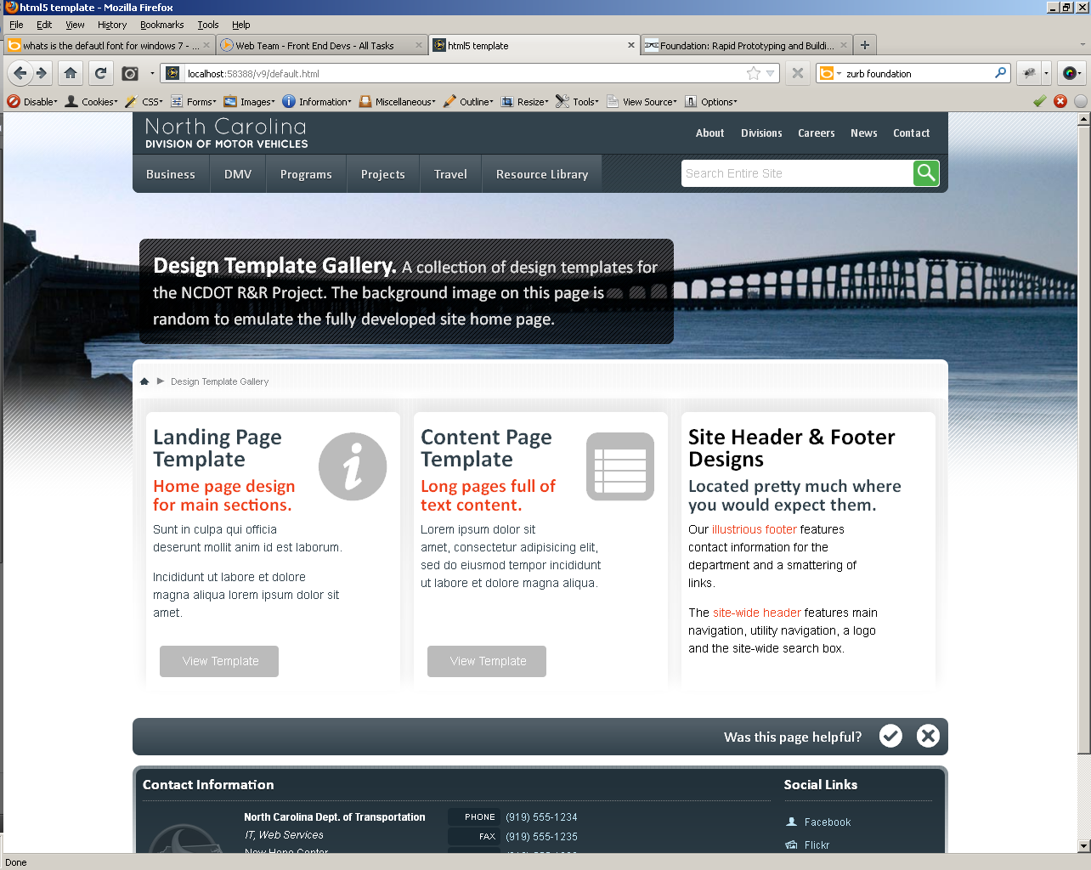  Figure 1: Site Home page template | 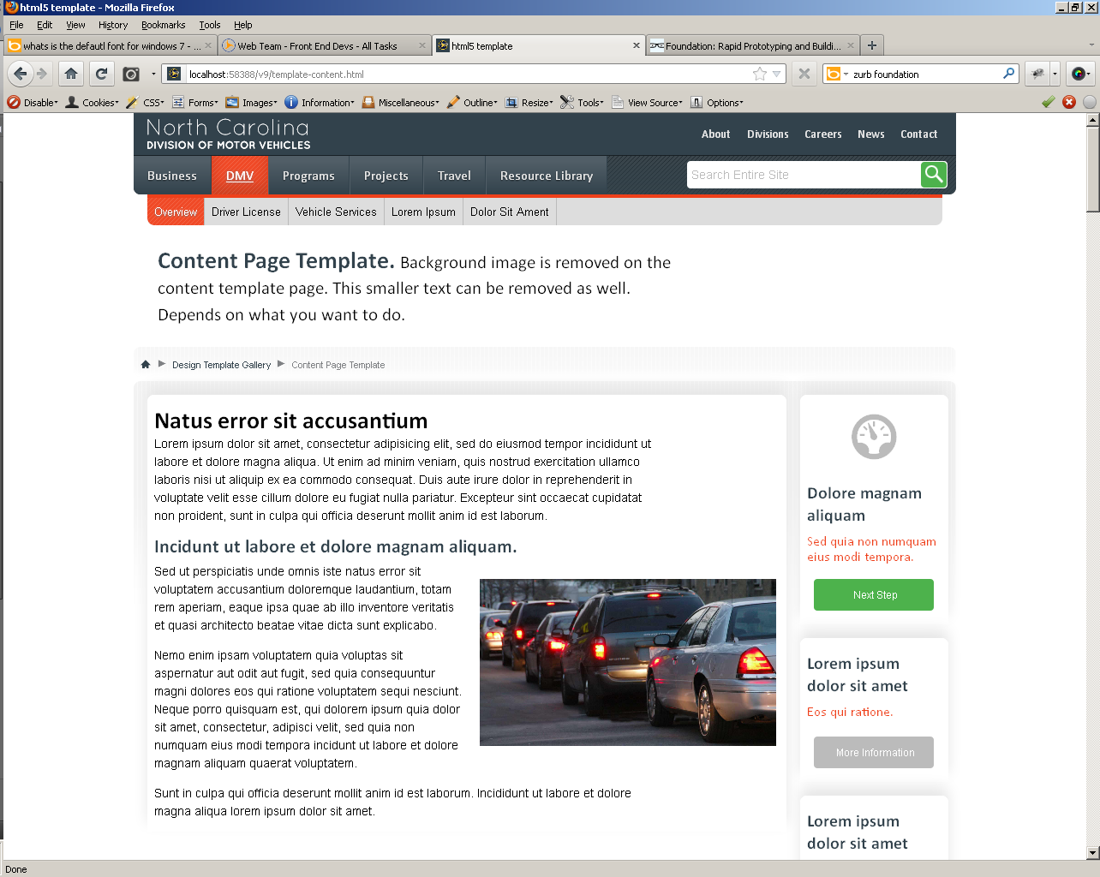  Figure 2: Content page template
The Code
This next section is written from a technical standpoint with the assumption that you have html/css/javascript coding experience. It would be helpful to have a copy of the template code available to view as you read through this document.

The templates are built for modern browsers and degrade in legacy browsers. Under no circumstances should content be hidden from legacy browsers. If content is displayed in a component and that component is not supported by a legacy browser, an alternate method of display must be created. This alternate method can be browser specific.

Modern Browsers  - Apple Safari 5+  - Apple Mobile Safari 4+  - Android Browser 3+  - Google Chrome 13+  - Microsoft Internet Explorer 9+  - Mozilla Firefox 5+  - Opera 10+ | Legacy Browsers  - Microsoft Internet Explorer 8  - Microsoft Internet Explorer 7  (internal usage only)

Code Guidelines
- Write code as valid html5.
- The use of css3 is encouraged for some visual styling. Make sure to include all vendor prefixes and a fallback solution for legacy browsers.
Figure 3: Example of vendor prefixes in css3
- Typically, all elements, attributes, and values are written lowercase.
- All attribute values are enclosed by double quotes.
- Self-closing elements are written as html (verses written as xhtml).
Figure 4: Self closing elements as html | Figure 5: Self closing elements as xhtml. Nothing technically wrong with this. Discouraged for the sake of simplicity.
- Avoid all css hacks for legacy browsers. Use browser specific css classes instead (see css section).
- New html5 elements are not used. They are avoided because legacy browsers would have to be enhanced/bootstrapped via JavaScript to display them properly.

The Template Code
It might be helpful to open one of the template files at this point. This next section is a “top-down” description of what you will find and where things are located in the file.

Section 1: Doctype, open html & head element
Section 1.1: Doctype
- Valid html5
Section 1.2: Situational CSS
Figure 6: Doctype and Situation css
- The “Situational CSS” is used to target specific browsers and templates. We use IE Conditional Comments to replace the opening html element, adjusting the class names for our current situation. The following table describes the css class names, their purpose, and possible situations. Additionally, we can use JavaScript to change values.

Class name | Situation/Description
no-js | Default class value. Targets browser/visitors that do not have JavaScript enabled.
static | Designates pages with static, manually updated content. Holdover from previous template.
app | Designates pages with external data sources and web based applications. Holdover from previous template.
content | Target template: Content page
landing | Target template: Landing page
lt-ie9 | Target browsers: less than Internet Explorer 9
lt-ie8 | Target browsers: less than Internet Explorer 8
lt-ie7 | Target browsers: less than Internet Explorer 7

Section 1.3: Title element, meta data, & load main style sheet
Figure 7: Main style sheet is named, "master.css" and is located in the sub folder, "css"
Section 1.4: Respond.js
- Internet Explorer conditional comments loading minified respond.js for legacy browsers. respond.js makes older versions of Internet Explorer play nice with css3 media queries. Their purpose is to allow for responsive site design.
Section 1.5: Shortcut icons, iOS information and Windows 7 “pinning”

Section 2: #billboard, #page-header, and the main <h1> element
- Depending on the page template, the first piece of content in the body is either a div with the id of #billboard or a div with the id of #page-header.
- #billboard (and its children) is responsible for the large, hero image on the Landing page template and the Site Home page template. On these pages it also contains the main <h1> element. #page-header contains the breadcrumb navigation.
- On the Content template page, #page-header contains the main <h1> element and breadcrumb navigation. The #billboard div is completely removed from the Content template page.

Figure 8: Main <h1> on a landing page | Figure 9: Main <h1> on a content page
Section 3: Page Content
Section 3.1: Sections & the Grid
- The templates are design around rows of content. These rows are designated by the class name, “section”
- The blocks of content inside of each section are labeled by the class, “panel”
- The width of each panel is determined by a class that starts with the letters, “col” (for column) and ends with a two or three digit number. The number represents how wide you want that panel, in percent. Make sure the total percent of your panels is 100 (or in rare cases, 99) to fill an entire row. Do not exceed a total of 100 percent, as this will break the grid.
- There are 14 base “col” classes that determine the width of a panel.
- This is referred to as the “grid system” or “grid” for short.

Figure 10: Basic example of grid system. Evenly split, three column layout for content.
- The grid system includes built in margins and padding for each panel.
- Important Note: The final panel in a section requires the additional class value of “last”
Basic Grid Structure Classes
Class Name | Description
section | Content row. Includes css float clearfix.
panel | General content block inside a section. Can be either a div or anchor element.
last | Additional class value for final panel in a section. This is required.

Width Classes (applied at the element level)
Class Name | Description | Class Name | Description
col10 | Width of 10%
col20 | Width of 20% | col25 | Width of 25%
col30 | Width of 30% | col33 | Width of 33%
col40 | Width of 40%
col50 | Width of 50%
col60 | Width of 60% | col66 | Width of 66%
col70 | Width of 70% | col75 | Width of 75%
col80 | Width of 80%
col90 | Width of 90%
col100 | Width of 100%

Style Classes (classes added at the section level, after “section”)
Class Name | Description
 | Default style has margins and a white background. Each panel has a drop shadow.
no-margins | Removes margins from panels.
pinstripe | Adds gray background to section. Gray fades down to white. Panels have white background with gray or black text.
pinstripe-dark | Adds dark gray background to section. Dark gray fades to white. Panels have dark blue background with white text. The site footer uses an altered version of this style.

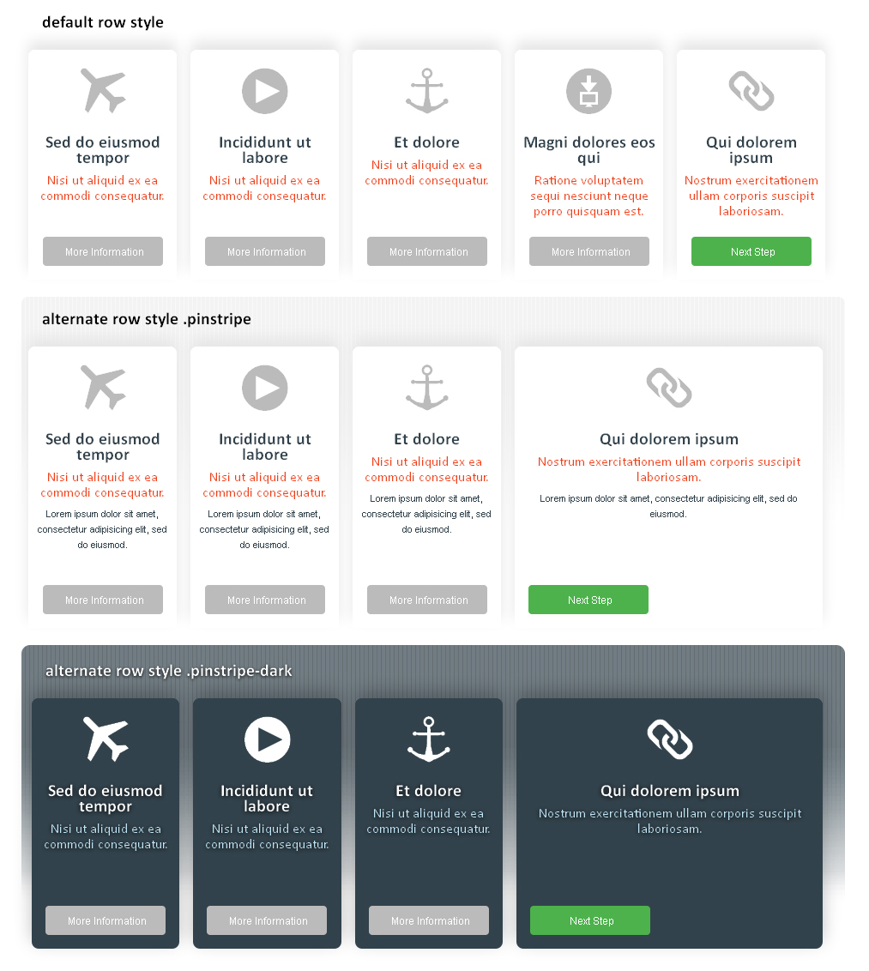
Figure 11: Visual representation of section styles

