Create a Calendar
A calendar displays information about events, dates and schedules. If you are familiar with Outlook, you will notice many similarities with SharePoint calendars.
There are many ways to modify calendars for your specific needs. Because some methods need fairly extensive explanation, these methods are documented in separate help files:
- Versioning – enable/disable the ability to track changes
- Content Approval – enable/disable the requirement to approve an event before it is available
- Validation – add rules to test that properties contain reasonable values
- Rating – enable/disable the feature that lets users like or rate items
- Columns – add additional columns, modify existing columns or delete unneeded columns
- Views – create, modify or delete customized displays
Note: Calendars are displayed on a web page in the List View web part. See the help file for the List View web part for more information.

Contents
Create a Calendar
Views
Columns

Create a Calendar
- Navigate to the site.
- Click the Settings gear, and click Add an app.

- On the Your apps page, click the Calendar icon.
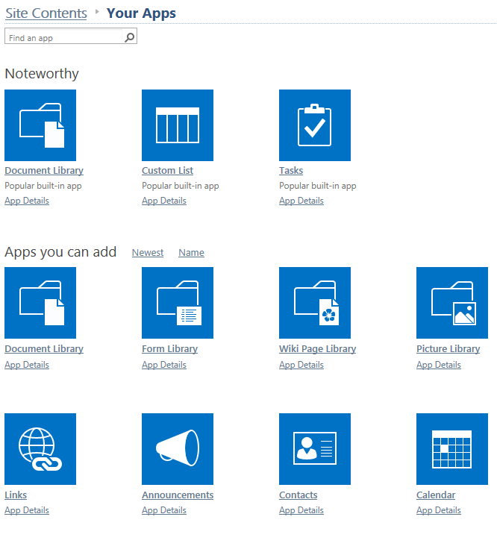
- In the Site Contents dialog, enter a name for the Calendar.
OR

In the Site Contents dialog, click Advanced Options and enter a name and description for the Calendar.
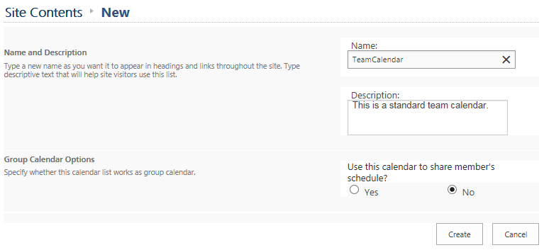
- Click Create. The Site Contents page now includes the Calendar with a green icon for new! To change the calendar name, click its icon.
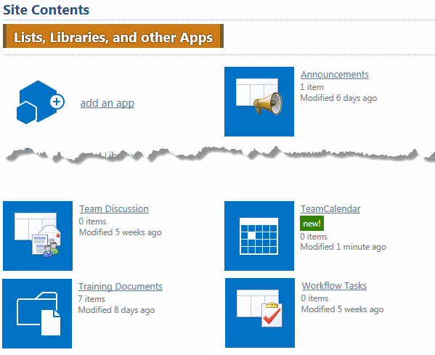
- Click the CALENDAR tab and click List Settings.
- Under General Settings, click List name, description and navigation. Add a space to the name and click Save to store the modified name.
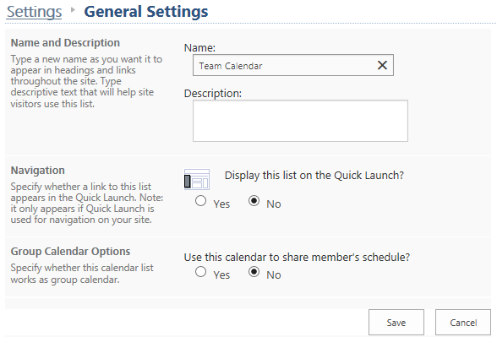

Views
The default view for a Calendar is Calendar, as shown here.
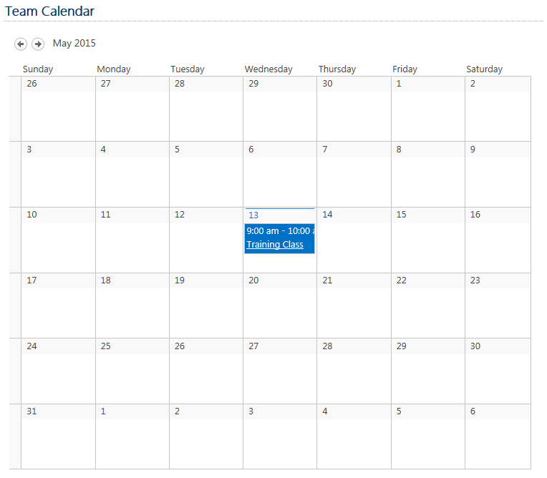
Two additional views – All Events and Current Events – are also created whenever a calendar is created.

The All Events view is a standard list view.
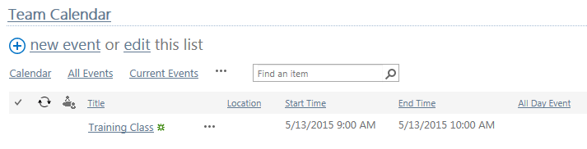
The Current Events view has fewer options to customize.
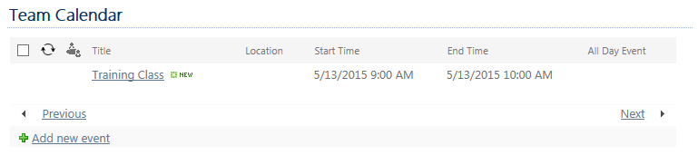
Because views are not listed at the top of the default Calendar view, changing to another view works a bit differently.
- Navigate to the calendar.
- On the ribbon, click the CALENDAR tab. In the Manage Views section, click the drop-down arrow below Current View. Click the view you want to use.
If a calendar is displayed in a List View web part on a page, the Calendar view may take up too much space. Change to the Current Events view for a more compact display.
- Navigate to the page that contains the calendar.
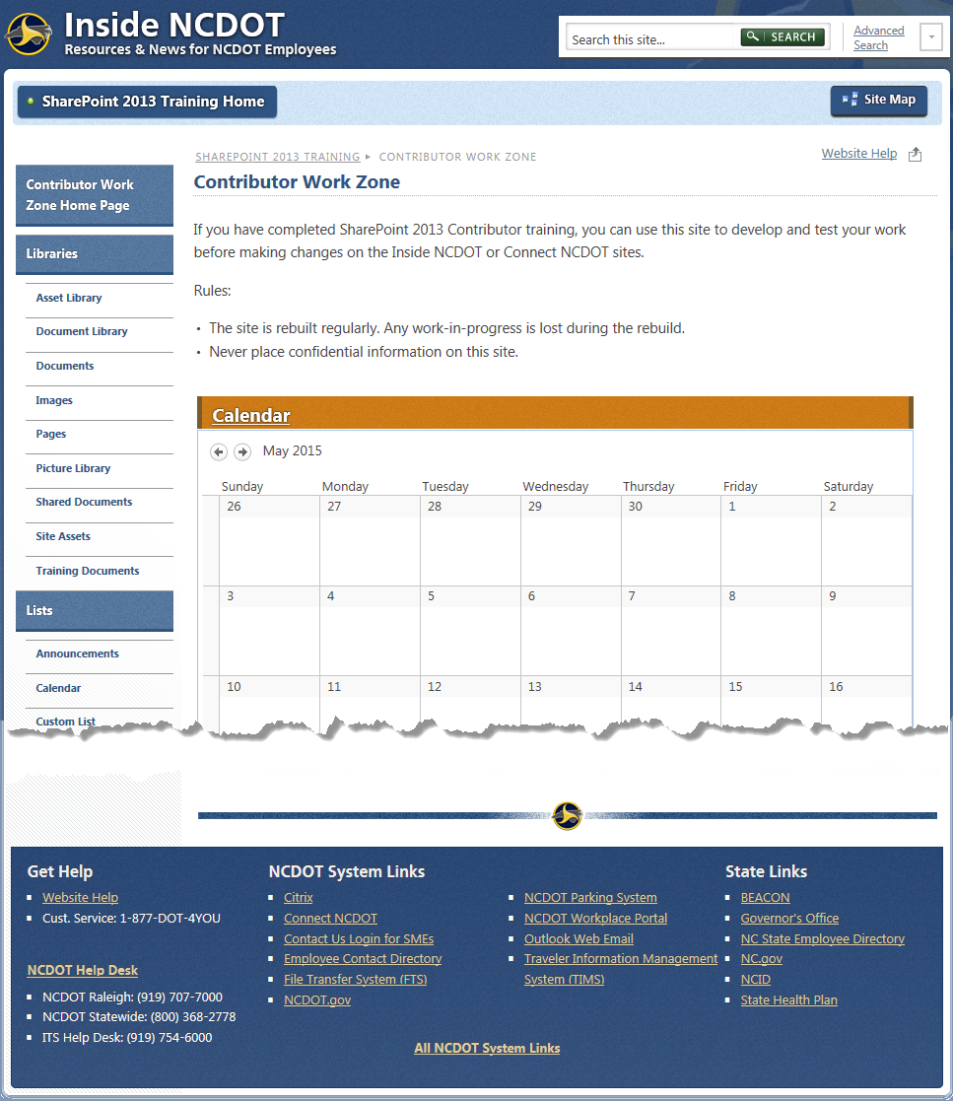
- On the ribbon, click the PAGE tab. In the Edit group, click Edit.
- Hover over or click the web part that contains the calendar. Click the down arrow in the upper right corner of the web part to display the web part menu. Click Edit Web Part.
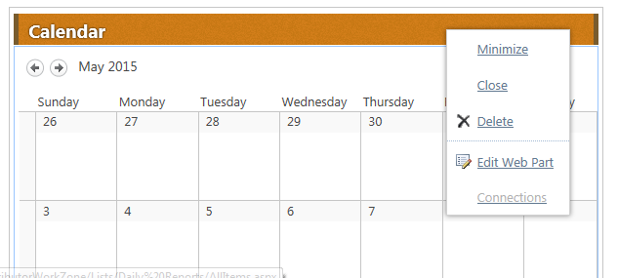
- Change the Selected View to Current Events and click OK to save the change.
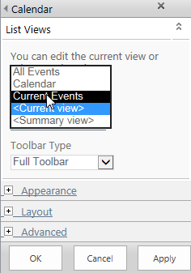
- Save the page. The Current Events view now appears.
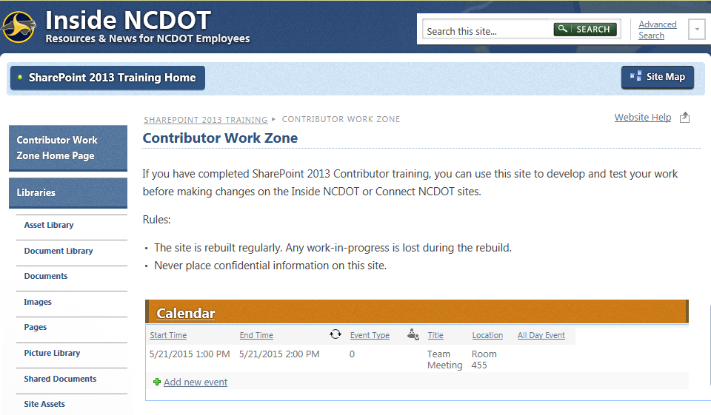

Columns
These columns are automatically included in a new Calendar. The Title column can be renamed, but cannot be deleted.
