Create a Discussion Board
A discussion board is a forum for users to communicate with their team, raise issues and ask questions.
There are many ways to modify discussion boards for your specific needs. Because some methods need fairly extensive explanation, they are documented in separate help files:
- Versioning – enable/disable the ability to track changes
- Content Approval – enable/disable the requirement to approve content before it is available
- Validation – add rules to test that properties contain reasonable values
- Rating – enable/disable the feature that lets users like or rate discussion topics and replies
- Columns – add additional columns, modify existing columns or delete unneeded columns
- Views – create, modify or delete customized displays
Note: Discussion boards are displayed on a web page in the List View web part. See the help file for the List View web part for more information.

Contents
Create a Discussion Board
Begin a Discussion
Reply to a Discussion Topic
Edit a Post
Delete Discussion Topic or Reply
Best Reply
Featured Discussion
Set Alert
Views Available in the Top-Level List Ribbon
Subject
Featured Discussions
Management
Recent
My discussions
Unanswered Questions
Answered Questions
Featured

Views Available in the Discussion-Level List Ribbon
Flat
Threaded
Management
Columns

Create a Discussion Board
- Navigate to the site.
- Click the Settings gear, and click Add an app.
- On the Your apps page, click the Discussion Board icon.
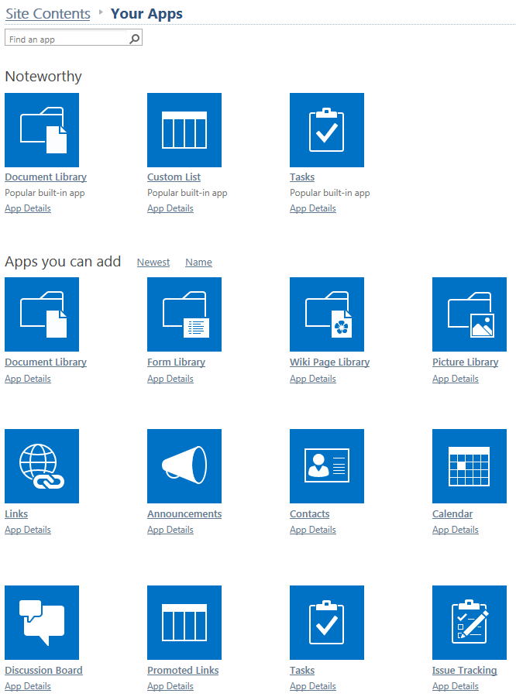
- In the Site Contents dialog, enter a name for the discussion board.
OR
In the Site Contents dialog, click Advanced Options and enter a name and description for the discussion board.
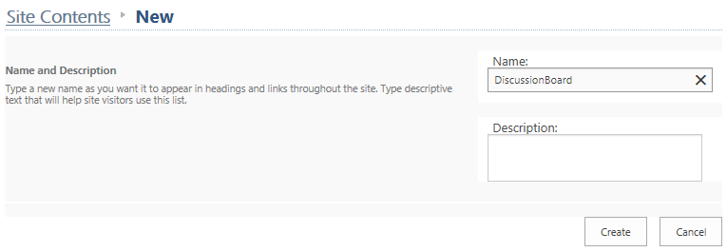
- Click Create. The Site Contents page now includes the discussion board with a green icon for new! To change the discussion board name, click its icon.
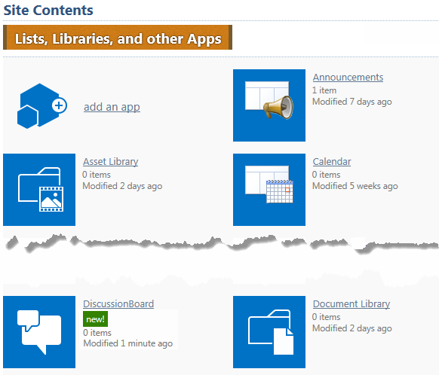
- On the ribbon, click the LIST tab. In the Settings group, click List Settings.
- Under General Settings, click List name, description and navigation.
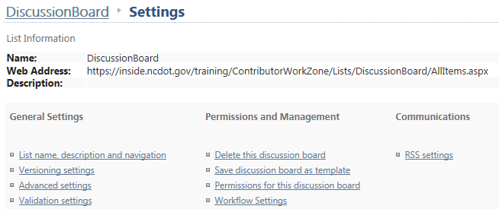
- Add a space to the name and click Save to store the modified name.
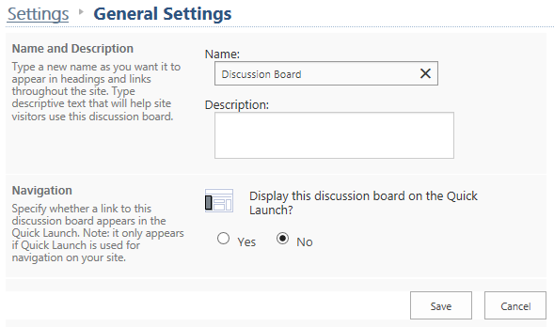

Begin a Discussion
- Navigate to the discussion board. A refresh button is on the right.
- Click New Discussion.
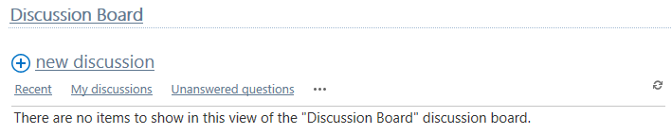

- Enter the subject and body text. Define the entry as a question if you wish; this allows the discussion topic to appear in the Answered Questions or Unanswered Questions view. Click Save.
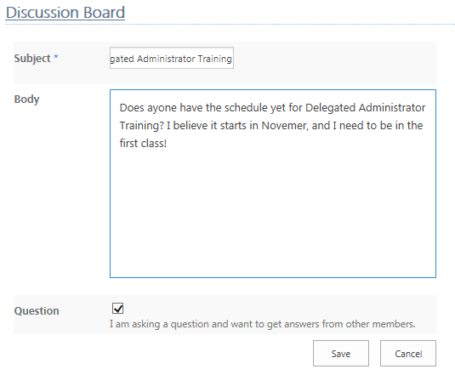
The discussion topic appears in the discussion board.
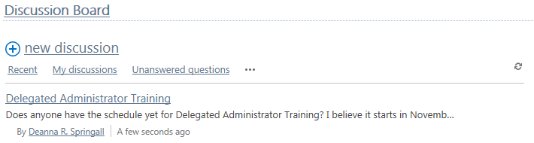

Reply to a Discussion Topic
- Navigate to the discussion board. A refresh button is on the right.
- Click the discussion topic.
- Click Reply. As you enter your reply, the Reply button is enabled. Click it to post your reply.
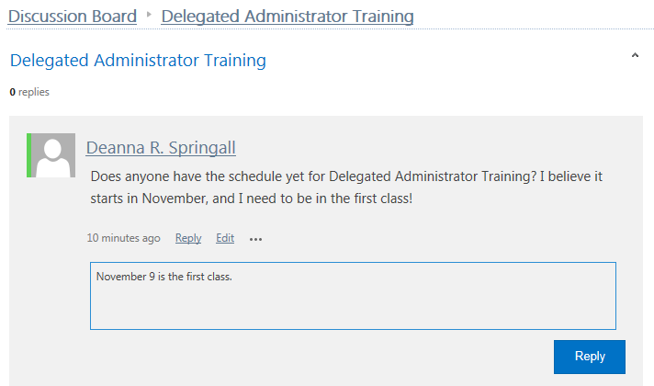
OR
Enter a reply in the text box. As you type, the Reply button is enabled. Click it to post your reply.
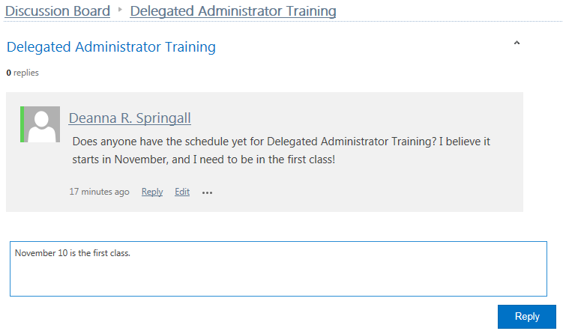

Edit a Post
- Navigate to the discussion board and click the discussion topic. A refresh button is on the right.
- Click Edit to modify the original post.

Delete Discussion Topic or Reply
You can delete discussion topics.
- Navigate to the discussion board and click the discussion topic. A refresh button is on the right.
- Click the ellipsis below the discussion topic, and click Delete.
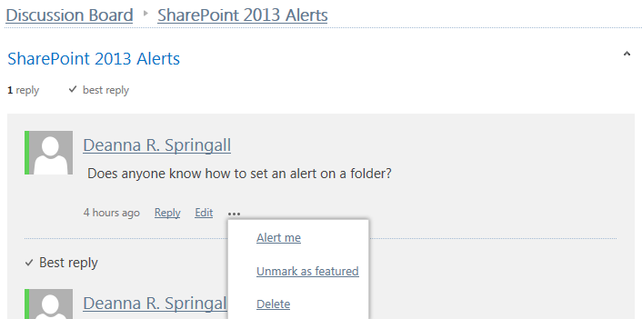

You can also delete individual replies.
- Navigate to the discussion board. A refresh button is on the right. Click the discussion topic.
- Click the ellipsis below the reply, and click Delete.
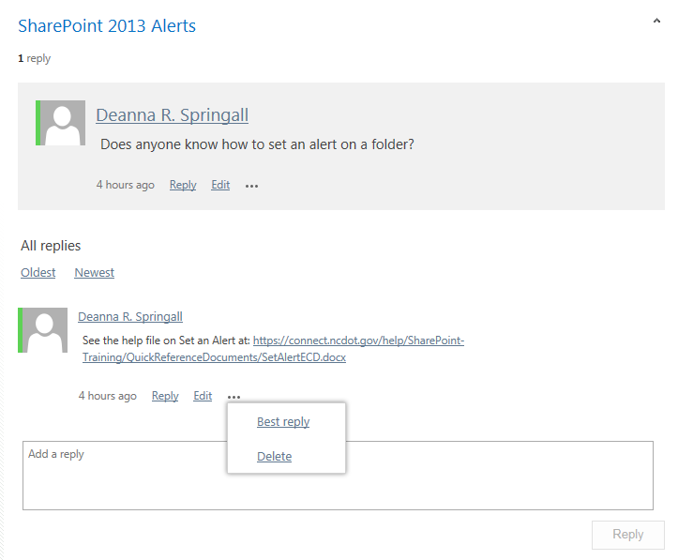

Best Reply
You can highlight one reply as the best.
- Click the ellipsis by the preferred reply, and click Best reply.
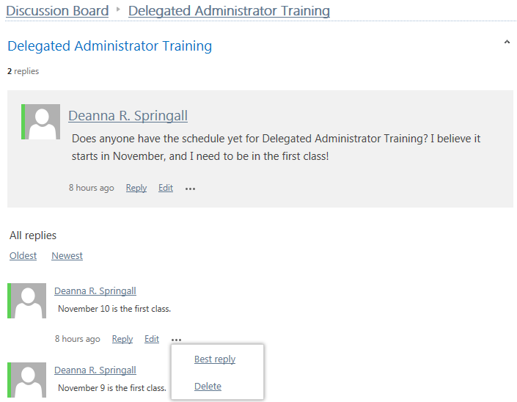
The best reply is then noted at the top of the list.
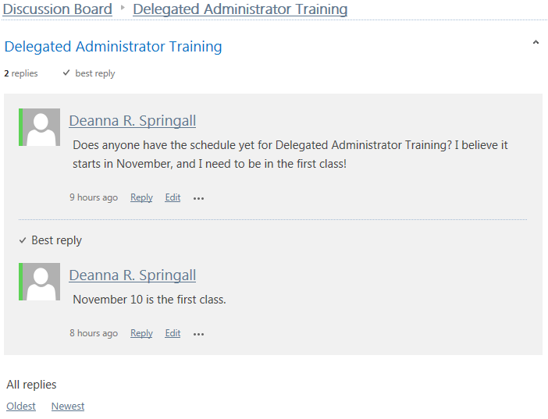

Featured Discussion
To highlight or emphasize a discussion topic, you can tag it as a featured discussion. You can have more than one featured discussion.
- Navigate to the discussion board.
- On the ribbon, click the LIST tab. In the Manage Views group, click the drop-down arrow under Current View, and click the Management view.
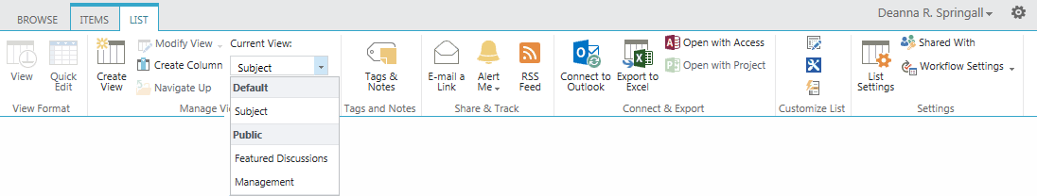
- Select the discussion topic to feature by clicking next to its title.
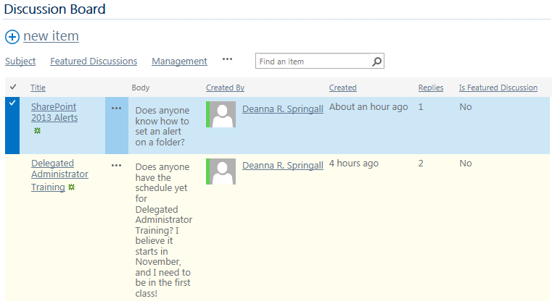
- On the ribbon, click the MODERATION tab. In the Featured Discussions group, click Mark as Featured.
The value of Is Featured Discussion changes to Yes.
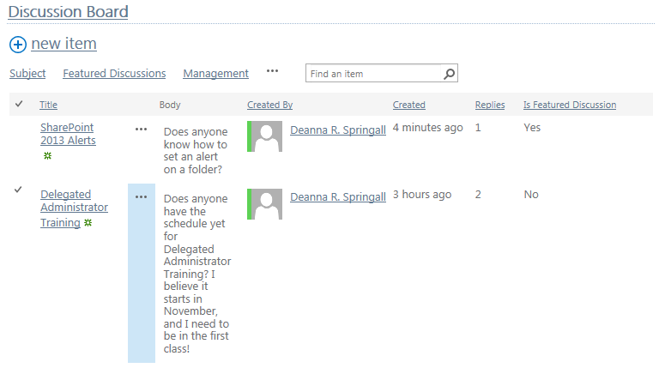
- On the ribbon, click the LIST tab. In the Manage Views group, click the drop-down arrow under Current View, and click Featured Discussions. This is the Featured Discussions view.
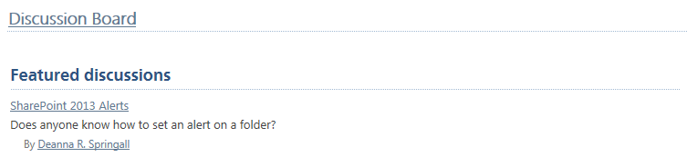

Set Alert
You can set an alert on a discussion topic.
- Navigate to the discussion board and click the discussion topic. A refresh button is on the right.
- Click the ellipsis below the discussion topic, and click Alert me.

Views Available in the Top-Level List Ribbon
When you are at the home page of the discussion board, you have one set of views available under the LIST tab and a second set of views available at the top of the discussion board.
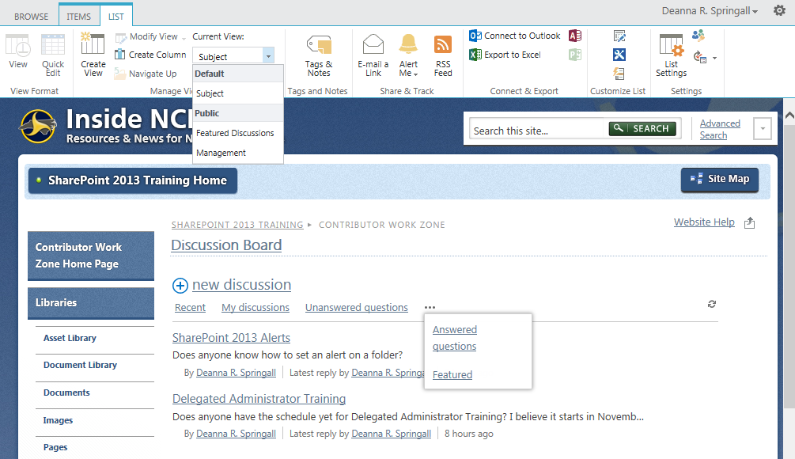

Subject
The Subject view is the default and simply lists the various discussion topics.
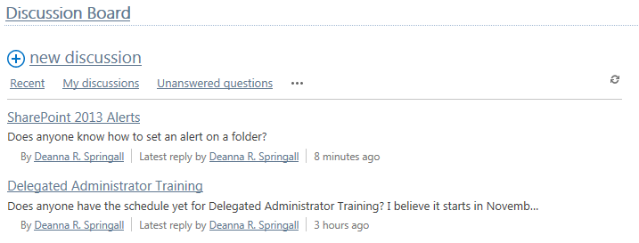

Featured Discussions
The Featured Discussions view includes those discussion topics that have been designated as being of special importance. There can be one or more.
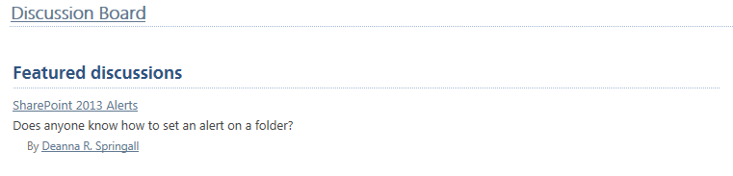

Management
The Management view is a standard list view that includes the number of Replies by discussion topic. You can also enter terms into the text box and click Search.
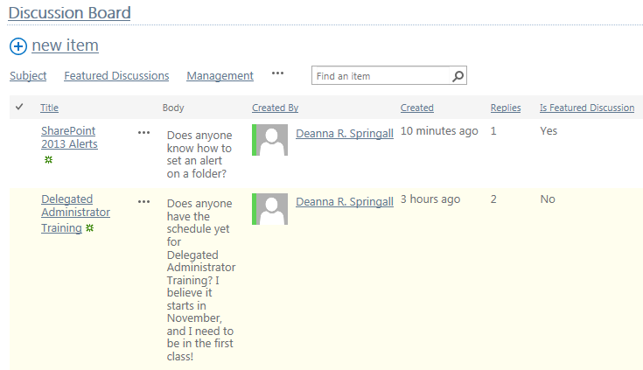

Recent
The Recent view shows the newest discussion topics.
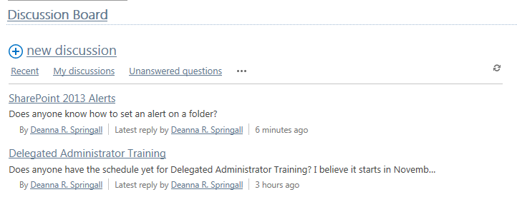

My discussions
The My discussions view shows the discussion topics and replies for the current user.

Unanswered Questions
The Unanswered questions view shows which discussion topics have no reply marked as Best reply.
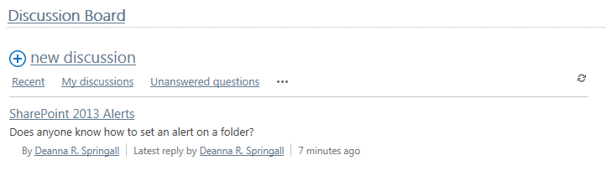

Answered Questions
The Answered questions view shows which discussion topics have a reply marked as Best Reply.
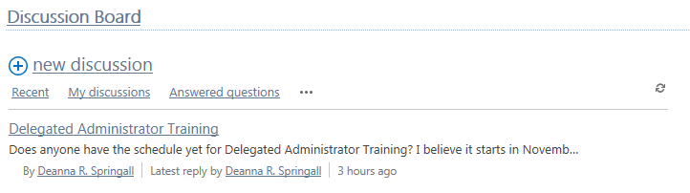

Featured
This is the same as the Featured Discussions view, above.

Views Available in the Discussion-Level List Ribbon
When you are at the level of an individual discussion topic, you have another set of views available. Within a discussion topic, the replies can be flat or threaded.
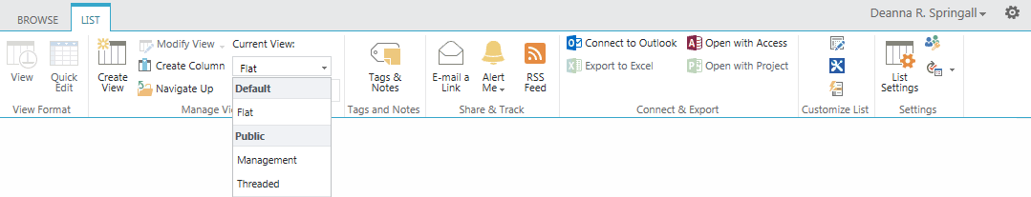

Flat
The Flat view is the default.
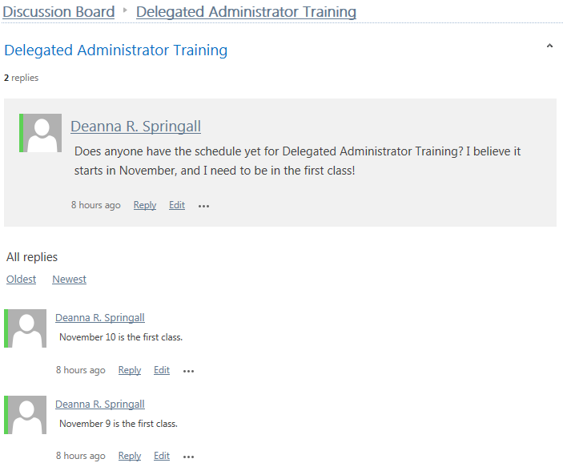

Threaded
The threaded view is more compact.
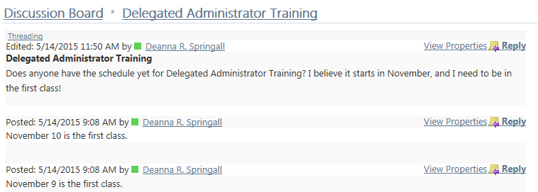

Management
The Management view is the same as before, except that here it shows only the current discussion topic.

Columns
These columns are automatically included in a new Discussion Board.
