Create a Library
A library is a special type of list that contains files and their associated data. A library is often called a document library, although it can contain pictures, videos, PDFs, spreadsheets, and other types of files in addition to Word documents. On occasion, a library will also be called a list.
The first section of this help file describes how to quickly build a predefined library with default settings. The remaining sections of this help file give additional details on Document, Asset and Picture libraries. While other types of libraries are available, these three are the most commonly used at NCDOT.
In addition, there are many ways to modify libraries for your specific needs. Because some methods need fairly extensive explanation, these methods are documented in separate help files:
- Versioning – enable/disable the ability to track changes to files
- Content Approval – enable/disable the requirement that a file be reviewed and approved before becoming available
- Check Out/Check In – enable/disable the requirement that a file be checked out (and, thus, locked to other users) for editing
- Folders – enable/disable the ability to add folders to a library
- Validation – add rules to test that file properties contain reasonable values
- Column default values – set a default if most files have the same value for that column
- Rating – enable/disable the ability of users to like or rate individual files
- Columns – add additional columns, modify existing columns or delete unneeded columns
- Views – create, modify or delete customized displays of the library
Note: Libraries are displayed on a web page in the List View web part. See the help file for the List View web part for more information.

Contents
Create a Default Library
More about Document Libraries
More about Asset Libraries
More about Picture Libraries

Create a Default Library
- Navigate to the site.
- Click the Settings gear, and click Add an app.
- The Your Apps page appears. The Noteworthy section lists the most popular apps. Look for the type of library to add; you may need to go to the next page of apps.
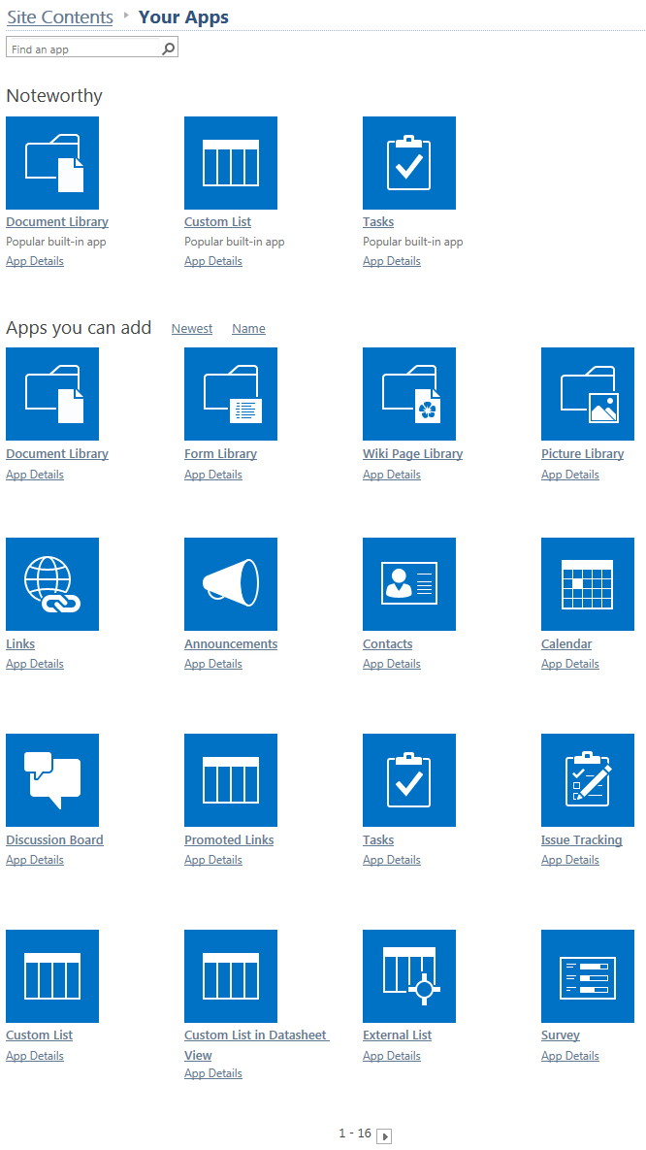
OR
Search for the type of library by name.
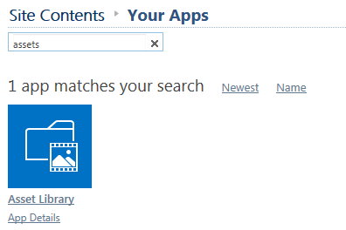
- Click the icon for the library. If prompted, trust the connection. This example creates a Document Library.
- Enter a name for the library, and click Create. (Advanced Options are explained later.)
Note: When you name the library, that name is also used in the library’s address (URL). Keep the name short but descriptive and do NOT use spaces or special characters. Once you create a library, change its name later to make it easier for users to read.
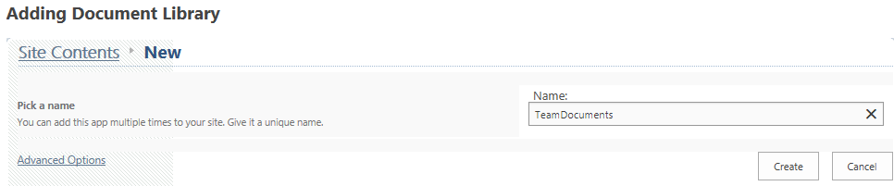The Site Contents page now includes the new library with a green icon for new!
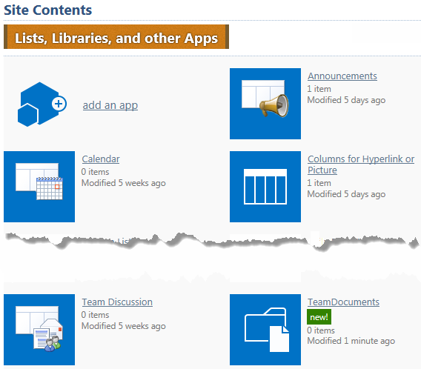

- To change the library name, click the new library, click the LIBRARY tab, click Library Settings, click List name, description and navigation settings, and modify the name. The URL is not changed. Click Save to store the modified name.
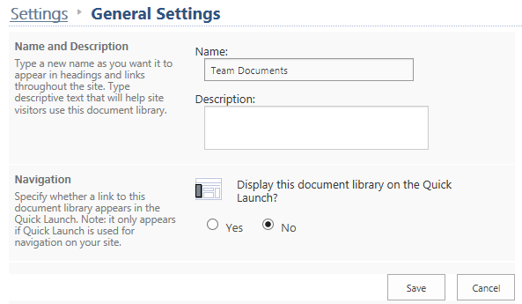

More about Document Libraries
When a Document Library is created and you are prompted to enter a name, click Advanced Options to enter additional information.

The Advanced Options let you add a description and enable or disable the ability to track changes to files. Although you can modify the template associated with the New Document command, it is generally best to leave the template as a blank Word document.
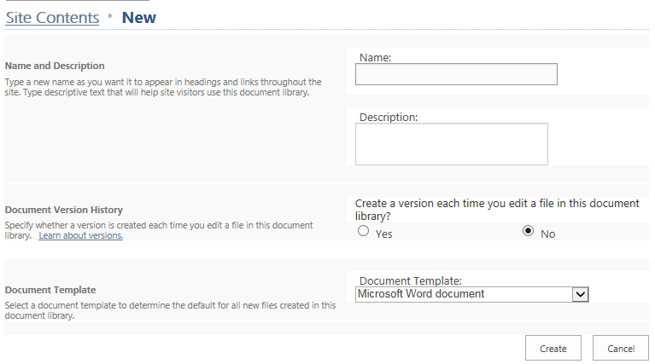
The default view for a Document Library is All Documents.
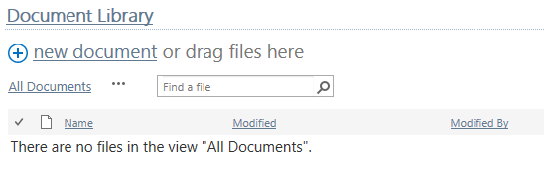
These columns are automatically included in a new Document Library. The Title column can be renamed, but cannot be deleted.
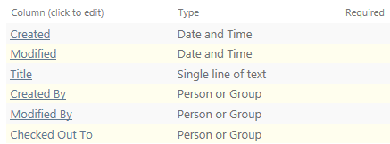

More about Asset Libraries
When an Asset Library is created and you are prompted to enter a name, click Advanced Options to enter additional information.
The Advanced Options let you add a description and enable or disable the ability to track changes to files.
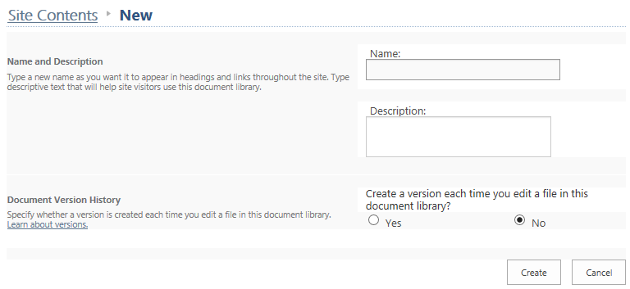
The default view for an Asset Library is Thumbnails. An additional view of All Assets is created.
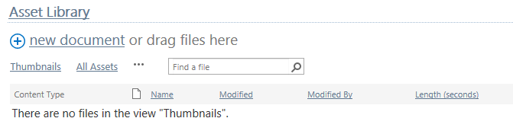

These columns are automatically included in a new Asset Library. The Title column can be renamed, but cannot be deleted.
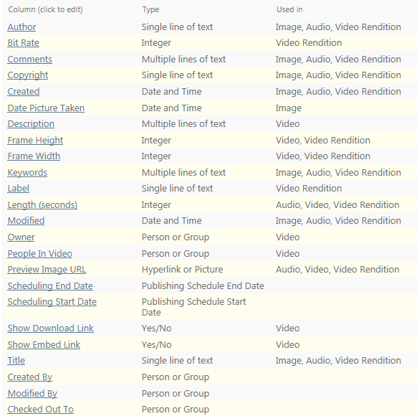

More about Picture Libraries
When a Picture Library is created and you are prompted to enter a name, click Advanced Options to enter additional information.

The Advanced Options let you add a description and enable or disable the ability to track changes to files.
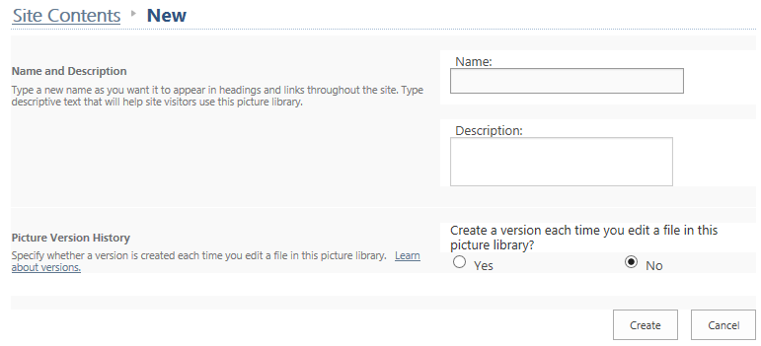
The default view for a Picture Library is Thumbnails. Additional views for All Pictures and for Slides are also created.
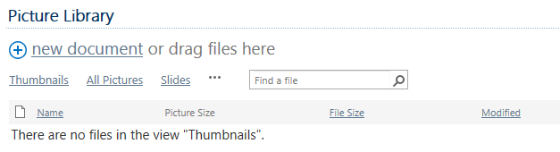
These columns are automatically included in a new Picture Library. The Title column can be renamed, but cannot be deleted.
