Create a List
A list is a collection of data, such as a contacts list or a list of tasks. Each entry in a list is called an item.
The first section of this document describes how to quickly build a predefined list with default settings. The remaining sections of this help file give additional details for list types that are commonly used at NCDOT.
Note: Calendars, discussion boards and surveys are described in separate help files because they are significantly different from the lists described here.
In addition, there are many ways to modify lists for your specific needs. Because some methods need fairly extensive explanation, these methods are documented in separate help files:
- Versioning – enable/disable the ability to track changes
- Content Approval – enable/disable the requirement to approve an item before it is available
- Validation – add rules to test that properties contain reasonable values
- Rating – enable/disable the feature that lets users like or rate individual items
- Columns – add additional columns, modify existing columns or delete unneeded columns
- Views – create, modify or delete customized displays
Note: Lists are displayed on a web page in the List View web part. See the help file for the List View web part for more information.

Contents
Create a Default List
More about Announcements
More about Contacts
More about Custom Lists
More about Custom Lists in Datasheet View
More about Links
More about Tasks

Create a Default List
- Navigate to the site.
- Click the Settings gear, and click Add an app.
- The Your apps page appears. The Noteworthy section lists the most popular apps. Look for the type of list (announcements, calendar, links, etc.) to add; you may need to go to the next page of apps.
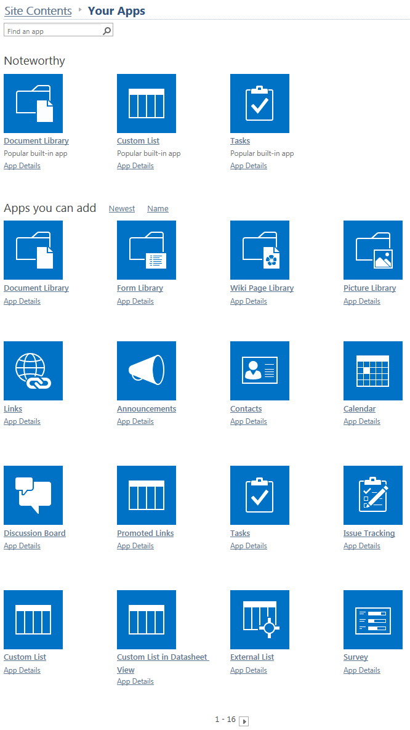
OR
Search for the type of list by name.
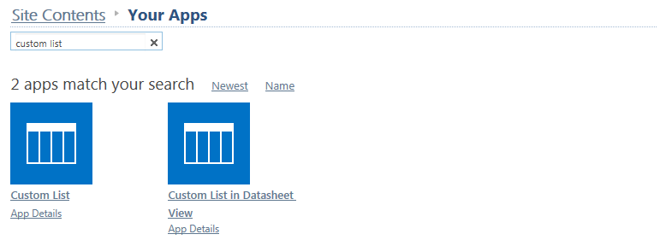
- Click the icon for the list. This example creates a Custom list.
- Enter a name for the list or click Advanced Options to enter a name and description for the list. Click Create.
Note: When you name a list, that name is also used in the list’s address (URL). Keep the name short but descriptive and do NOT use spaces or special characters. Once you create a list, you can change its name later to make it easier for users to read.
- The Site Contents page now includes the new list with a green icon for new!
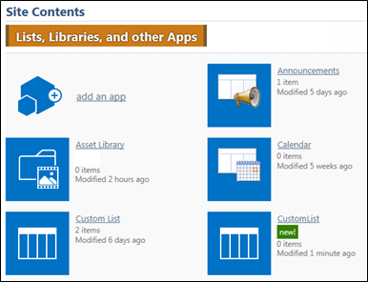

- To change the list name, click the icon for the new list, click the LIST tab, click List Settings, and click List name, description and navigation settings. Modify the name and click Save to store it. The URL does not change.
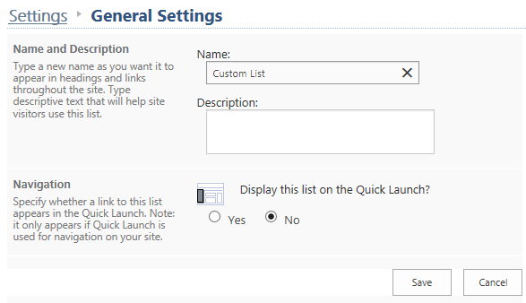

More about Announcements
The default view for Announcements is All items.
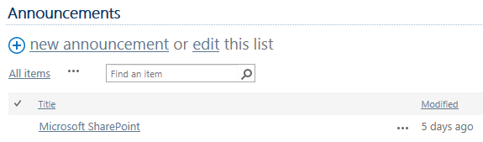
These columns are automatically included in a new Announcements list. The Title column can be renamed, but cannot be deleted.
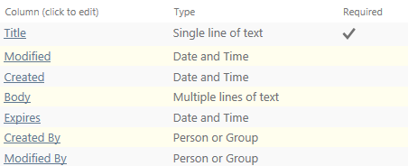

More about Contacts
The default view for a Contacts list is All contacts.
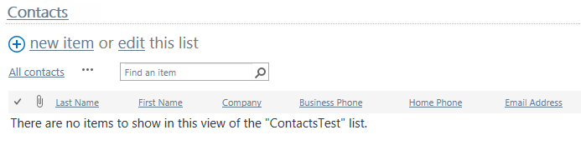
These columns are automatically included in a new Contacts list.
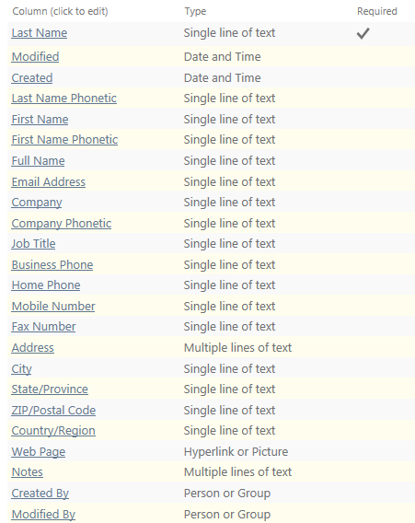

More about Custom Lists
The default view for a Custom list is All items.
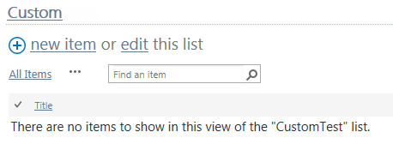
These columns are automatically included in a new Custom list. The Title column can be renamed, but cannot be deleted.
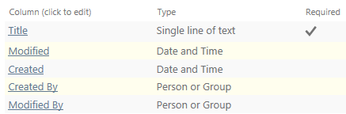

More about Custom Lists in Datasheet View
The datasheet view is actually the Quick Edit feature, which lets you efficiently edit item properties.
The default view for a Custom list in a datasheet view is All Items.
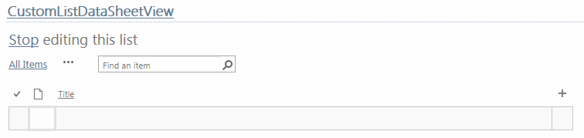
These columns are automatically included in a new Custom list in datasheet view. The Title column can be renamed, but cannot be deleted.
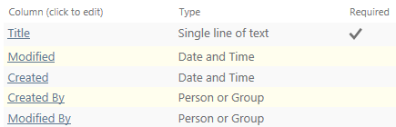

More about Links
The default view for a Links list is All Links.
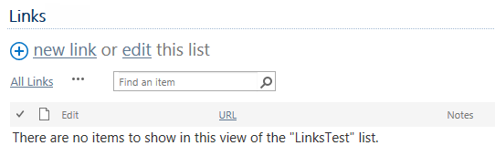
These columns are automatically included in a new Links list.
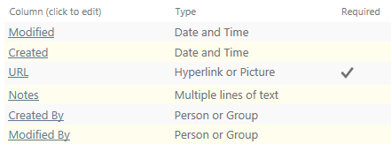

More about Tasks
The default view for a Tasks list is All Tasks. Additional views for Calendar, Completed, Gantt Chart, Late Tasks, My Tasks and Upcoming are also created.
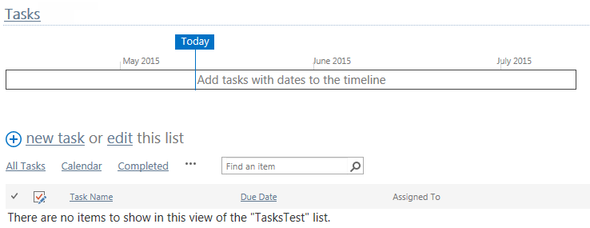

These columns are automatically included in a new Tasks list.
