Create a Survey
In surveys you define questions and set up branching logic depending upon the answers. Adding questions to a survey is similar to creating columns; see the help file for Create a Column.
Note: Survey takers need edit or contribute permissions to take the survey.
You can set validation at the survey level, where you compare one question to another in the same survey. This differs from column validation (described below) where you compare an answer’s value with a static value. Because it needs fairly extensive explanation, see the help file on Validation for additional information.
Note: Surveys are displayed on a web page in the List View web part. See the help file for the List View web part for more information.

Contents
Create a Survey – Method 1
Create a Survey – Method 2
Add Questions
Single Line of Text
Multiple Lines of Text
Choice
Rating Scale
Number
Currency
Date and Time
Lookup
Yes/No
Person or Group
Page Separator
External Data
Managed Metadata
Column Validation
Branching Logic
Flow of Work
Example of Branching Logic
Respond to the Survey
Evaluate Survey Results
Survey Actions
Default View
Default Columns

Create a Survey – Method 1
You can quickly create a survey, then rename it and define the options for anonymity and multiple responses.
- Navigate to the site.
- Click the Settings gear, and click Add an app.
- On the Your apps page, scroll down to the bottom of the first page to find the Survey icon, or type survey into the search box and click the magnifying glass to search for the app.
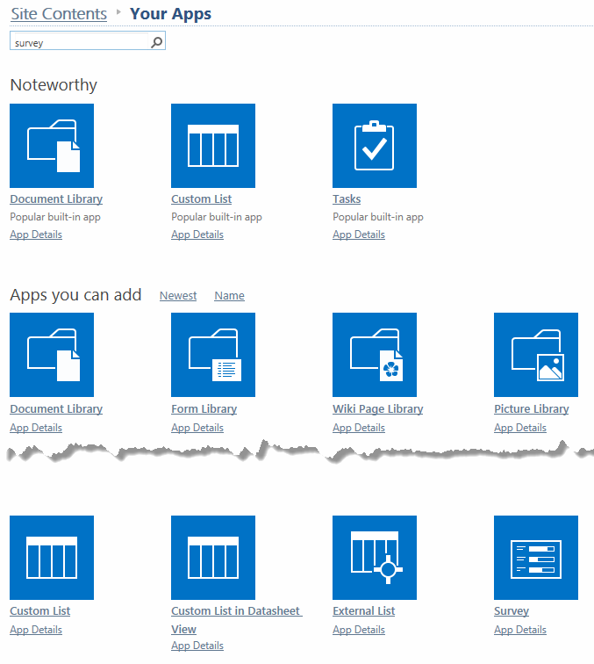
- Click the Survey icon.
- Enter a name for the survey and click Create.
Note: When you give a survey a name, that name is also used in the address (URL). Keep the name short but descriptive and do NOT use spaces or special characters. Once you create a
survey, you can change its name later to make it easier for survey takers to read.
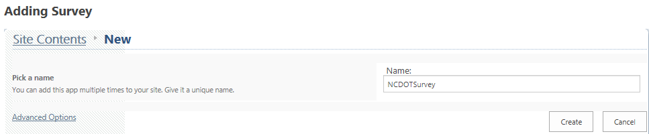
- The Site Contents page now includes the new survey with a green icon for new! To change its name, click the new survey.
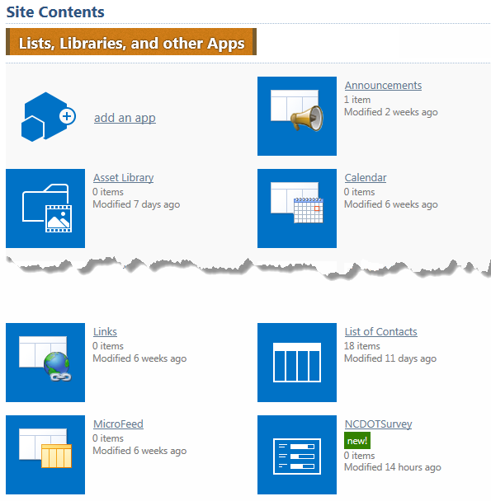
- On the main survey page, click Settings and click Survey Settings. 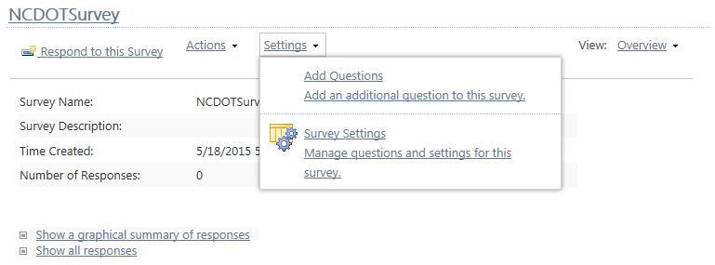
- On the Settings page in the General Settings section, click List name, description and navigation settings.
- On the General Settings page, modify the name by adding a space to it for readability. The URL is not changed.

- Indicate whether you want the survey to be anonymous and whether you want to let a survey taker submit multiple surveys. You may want to allow multiple responses temporarily, so you can test all the logic paths; once testing is complete, you can then disallow multiple responses. Click Save to store the modified name and survey options.

Create a Survey – Method 2
You can also create a survey, define the options for anonymity and multiple surveys, and go directly into question development.
- Navigate to the site.
- Click the Settings gear, and click Add an app.
- On the Your apps page, scroll down to the bottom of the first page to find the Survey icon, or type survey into the search box and click the magnifying glass to search for the app.
- Click the Survey icon.
- Click Advanced Options.

- Enter a name and description for the survey.
Note: When you give a survey a name, that name is also used in the address (URL). Keep the name short but descriptive and do NOT use spaces or special characters. Once you create a survey, you can change its name later to make it easier for survey takers to read.
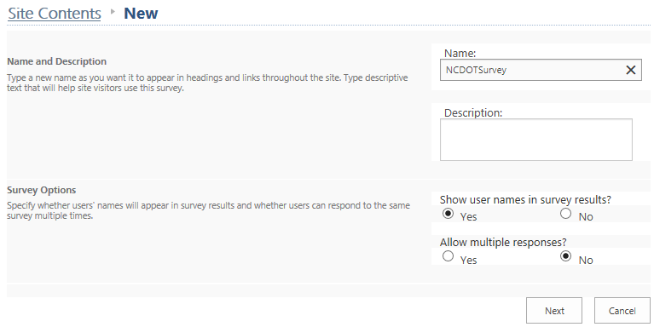
- Indicate whether you want the survey to be anonymous and whether you want to let a survey taker submit multiple surveys. You may want to allow multiple responses temporarily, so you can test all the logic paths; once testing is complete, you can then disallow multiple responses. Then, click Next to add a question. How to add a question is explained in the next section.
- Don’t forget to change the name of the survey if you need to add spaces to make it easier to read.

Add Questions
If you use the Advanced Options to create a survey, you immediately go into the New Question interface (Step 3). Otherwise, begin to add questions starting with Step 1.
- Navigate to the survey.
- Click Settings, and click Add questions.
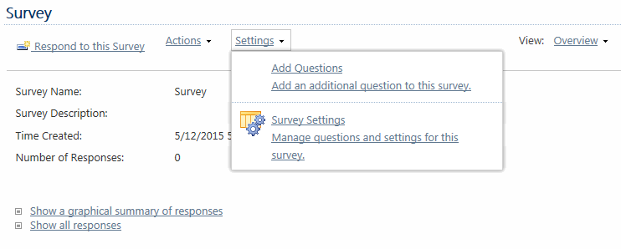

- In the New Question page, enter your question and define the type of answer. Except for Rating Scale and Page Separator, question types are identical to column types. Depending upon the type of answer, you may have additional question settings. Click Next Question to create another question, then click Finish when you have finished the questions.
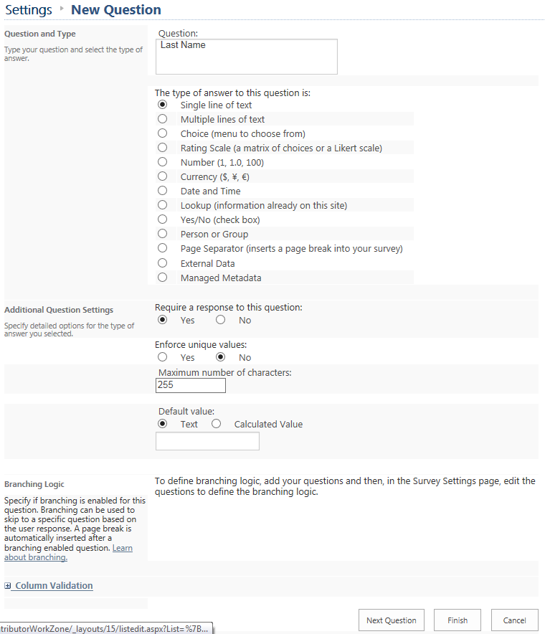See the next subsections for details on the additional settings for each type of answer.
- Navigate to the survey’s home page and click Respond to this Survey to see the final survey.
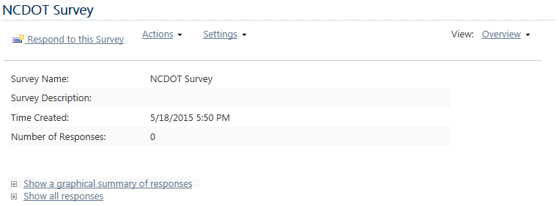
- Review the survey, then click Cancel to close it.

Single Line of Text
The survey taker can enter a simple line of unformatted text. A common example is a last name. Validation is available. Additional settings are:
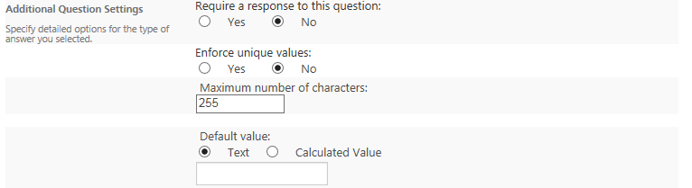
- Require a response to this question – If the question is skipped, an error message appears. An asterisk (*) indicates that a response is required.
- Enforce unique values – A unique value appears only once in a response to a question; that is, no two questions can have the same response.
- Maximum number of characters – This is the most number of characters allowed in the field.
- Default value – This value is automatically used if the survey takers do not enter a value. Many survey takers accept the default value without thinking, so it may be a good idea to leave the answer blank and make it required.

Multiple Lines of Text
The survey taker can enter many lines of text that can be formatted. This is often used for descriptions, notes or comments. Additional settings are:
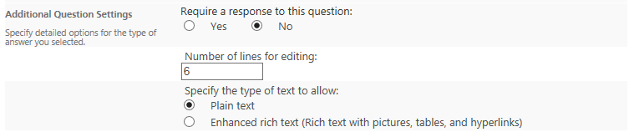
- Require a response to this question – If the question is skipped, an error message appears. An asterisk (*) indicates that a response is required.
- Number of lines for editing – This is the number of lines in the text box. It affects the size of the text box, but not the amount of text you can enter.
- Specify the type of text to allow – You can enter unformatted (plain) or formatted (font, size, color, etc.) text, or you can use advanced formatting such as hyperlinks, images, and tables.

Choice
The survey taker chooses from standardized options listed in a drop-down menu, radio buttons, or checkboxes. This approach helps ensure data consistency. Validation is available. Additional settings are:
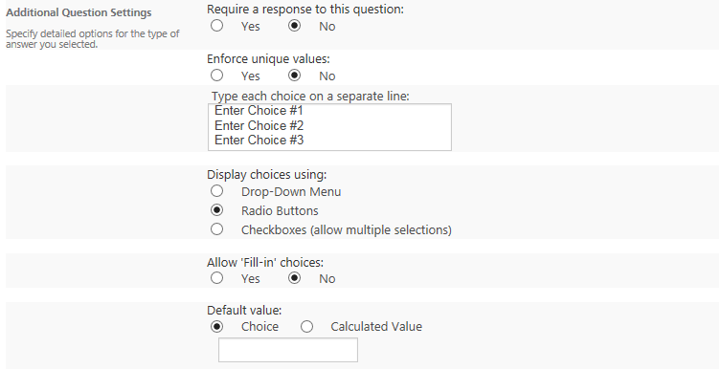
- Require a response to this question – If the question is skipped, an error message appears. An asterisk (*) indicates that a response is required.
- Enforce unique values – A unique value appears only once in a response to a question; that is, no two questions can have the same response.
- Type each choice on a separate line – These are the values (such as a list of districts or divisions) that you want the survey taker to choose from.
- Display choices using – A drop-down menu or set of radio buttons allow the survey taker to make only one choice; radio buttons are generally recommended for three or fewer choices, and drop-down menus for four or more choices. Checkboxes allow the survey taker to make more than one choice.
- Allow ‘Fill-in’ choices – The survey taker can enter a value that does not appear in the choices, but the value is not added to the choices.
- Default value – This value is automatically used if the survey taker does not enter a value. Many survey takers accept the default value without thinking, so it may be a good idea to leave the answer blank and make it required.

Rating Scale
A Rating Scale question contains sub-questions that are ranked from one extreme to the other. For example, if the main question is about opinions on a transportation plan, sub-questions might address the degree of the plan’s comprehensiveness, affordability, and community impact. Additional settings are:
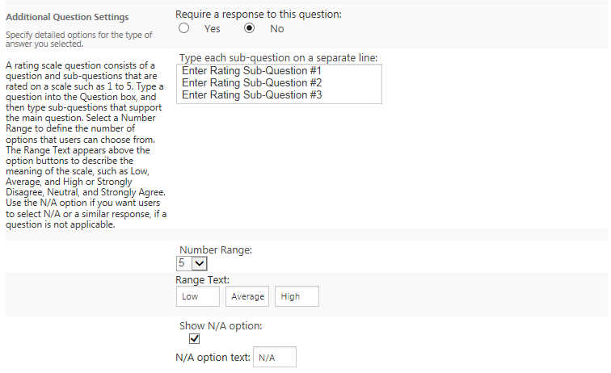
- Require a response to this question – If the question is skipped, an error message appears. An asterisk (*) indicates that a response is required.
- Type each sub-question on a separate line – Enter the sub-questions to be rated.
- Number Range – Enter the number of choices for the scale. A common value is 5.
- Range Text – Enter the text to describe the low, average and high ratings. Common values are Poor, Average and Excellent.
- Show N/A option – This is the option to ignore a sub-question by marking it not applicable.
- N/A option text – If you want to allow a N/A rating, this is the text describing it. Common values are Not Applicable or Does Not Apply.

For example, this is a Rating Scale question.
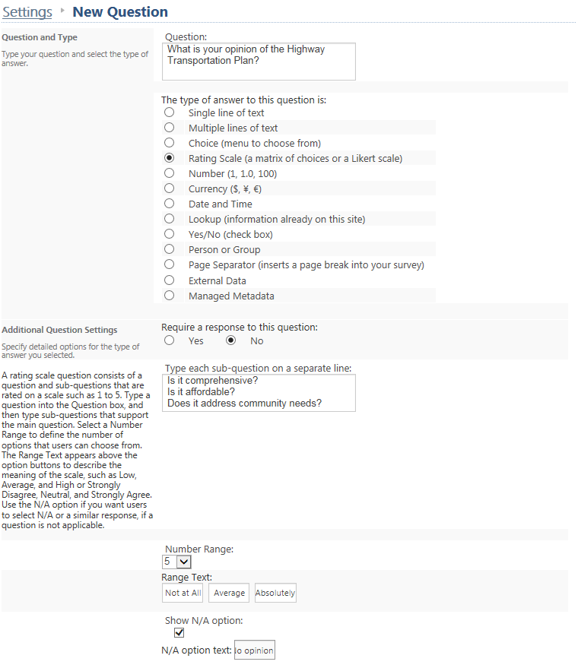

This is how the question appears on the survey.
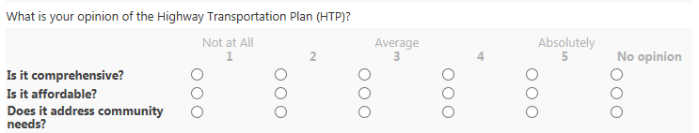

Number
The survey taker can enter non-monetary, numeric values. Validation is available. Additional settings are:
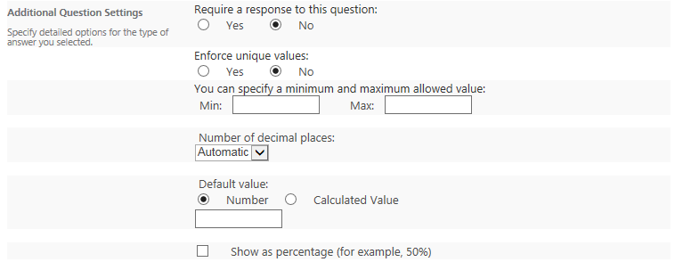
- Require a response to this question – If the question is skipped, an error message appears. An asterisk (*) indicates that a response is required.
- Enforce unique values – A unique value appears only once in a response to a question; that is, no two questions can have the same response.
- You can specify a minimum and maximum allowed value – These are the smallest and largest values that can be entered.
- Number of decimal places – This is how many decimal places the entry can have. The value of automatic uses the number of decimal places that the survey taker entered.
- Default value – This value is automatically used if the survey taker does not enter a value. Many survey takers accept the default value without thinking, so it may be a good idea to leave the answer blank and make it required.
- Show as percentage – The value is shown as a percentage.

Currency
The survey taker can enter monetary values. Validation is available. Additional settings are:
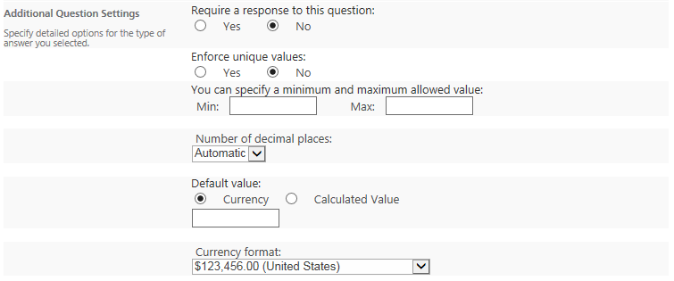
- Require a response to this question – If the question is skipped, an error message appears. An asterisk (*) indicates that a response is required.
- Enforce unique values – A unique value appears only once in a response to a question; that is, no two questions can have the same response.
- You can specify a minimum and maximum allowed value – These are the smallest and largest values that can be entered.
- Number of decimal places – This is how many decimal places the entry can have. The value of automatic uses the number of decimal places that the survey taker entered.
- Default value – This value is automatically used if the survey taker does not enter a value. Many survey takers accept the default value without thinking, so it may be a good idea to leave the answer blank and make it required.
- Currency format – This defines the currency symbol.

Date and Time
The survey taker can enter a calendar date or date/time combination. Validation is available. Additional settings are:
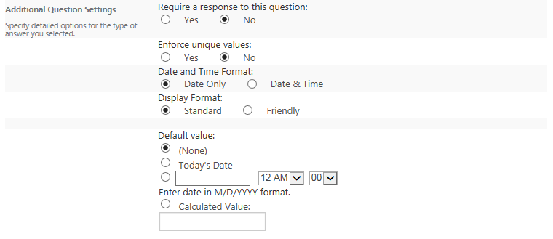
- Require a response to this question – If the question is skipped, an error message appears. An asterisk (*) indicates that a response is required.
- Enforce unique values – A unique value appears only once in a response to a question; that is, no two questions can have the same response.
- Date and Time Format – This determines whether the survey taker can enter a date only or a date and time.
- Display Format – The column value is shown in standard format or friendly format. Friendly format, for example, is “April 15” instead of 4/15/2015 or “3 hours ago” instead of 12:13 PM.
- Default value – This value is automatically used if the survey taker does not enter a value. Many survey takers accept the default value without thinking, so it may be a good idea to leave the answer blank and make it required.

Lookup
The survey taker can choose values for a column as if they were using a Choice column. However, those values actually reside in a column in a second list and the current column looks them up in the second list.
For example, assume there are a survey and a Contacts list with managers’ names. The survey can connect to the Contacts list (the “remote” list) and retrieve the managers’ names to display in the survey. This way, the names are maintained in one place even if they are used in many places. Additionally, changes in the Contacts list are automatically propagated to the lookup columns that use the Contacts list.
You can easily show additional columns such as addresses in the survey because that information is associated with the names in the Contacts list.
Additional settings for this column are:
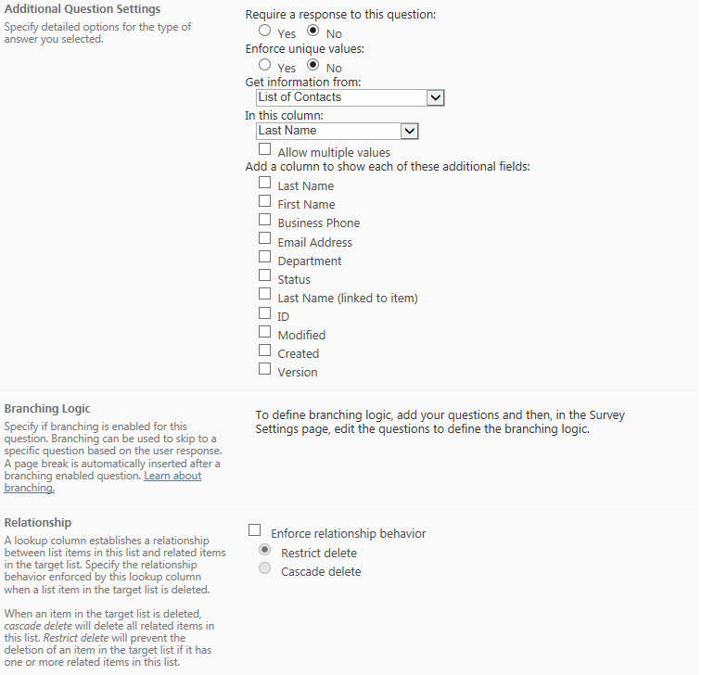
- Require a response to this question – If the question is skipped, an error message appears. An asterisk (*) indicates that a response is required.
- Enforce unique values – A unique value appears only once in a response to a question; that is, no two questions can have the same response.
- Get information from – This is the “remote” list that contains the column with the values you want to use. The list must reside on the same site.
- In this column – This is the column in the “remote” list that contains the values you want to use. Select Allow multiple values if you want the survey taker to choose more than one value; if you do this, the Enforce unique values and Enforce relationship behavior settings are disabled.
- Add a column to show each of these additional fields – You can display additional columns from the “remote” list. These columns can be viewed but cannot be edited because they come from a different list. There are some restrictions on what type of columns from the “remote” list can be displayed.
- Enforce relationship behavior – If an item in the “remote” list is deleted, choose Cascade delete to delete related items in the survey; use Cascade delete carefully because it deletes the items in all lists. Otherwise, choose Restrict delete to prevent deleting an item in the “remote” list if the survey has a related item; it issues a warning that says the item is in use.

Yes/No
The survey taker selects a checkbox for Yes or deselects the checkbox for No. The value can also be treated as true/false or 1/0.
You may prefer to use a Choice answer with radio buttons for Yes and No rather than the Yes/No answer. The Yes/No answer only offers an unlabeled box to check or uncheck; this may be unclear to some survey takers.

Person or Group
Note: If you wish to use SharePoint Groups, call or email the Help Desk to request assistance from Web Services. This section only addresses people.
The survey taker chooses one or more people from a list of all users. An example is choosing a person whom you wish to nominate for an honor. Because SharePoint recognizes this column as containing names (not just text strings), it can draw additional information associated with that name from the Active Directory. Additional settings are:
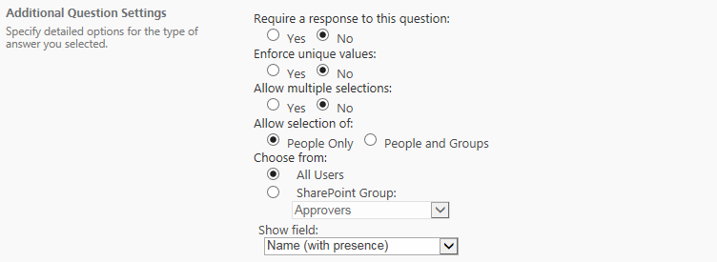
- Require a response to this question – If the question is skipped, an error message appears. An asterisk (*) indicates that a response is required.
- Enforce unique values – A unique value appears only once in a response to a question; that is, no two questions can have the same response.
- Allow multiple selections – This allows selection of more than one person.
- Allow selection of – Select People Only, not People and Groups.
- Choose from – Select All Users, not SharePoint Group.
- Show field – This selects the information you wish to show about the person or people.

Page Separator
This option inserts a page break into the survey.
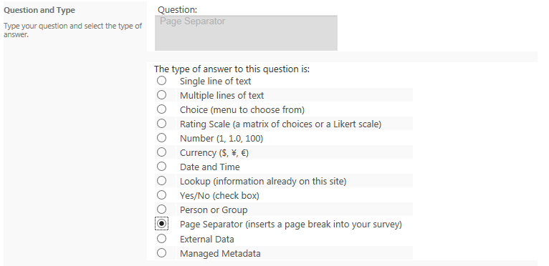

External Data
This column displays data that comes from a data source outside of SharePoint through Business Connectivity Services (BCS).
Note: This requires advanced configuration. Call or email the Help Desk to request assistance from Web Services.

Managed Metadata
This column uses data stored in the Term Store.
Note: This requires advanced configuration. Call or email the Help Desk to request assistance from Web Services.

Column Validation
When you create a question, you can set validation rules (in addition to the question settings described previously). These rules check the appropriateness of the response, using formulas similar to Excel.
An example is a formula that compares a response for task completion date to the project end date.
=[TaskCompletionDate]<DATE(2014,10,15)
If the completion date occurs after the end of the project, you can set a message such as Task must be completed before the project ends.
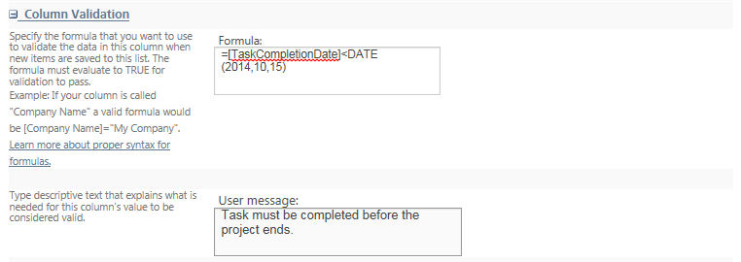
Validation is available for these types of questions.
- Single line of text
- Choice
- Number
- Currency
- Date and Time
With column validation, you are working at the individual column level. So, you can only compare the value in that column with a static value. If you need to compare two columns, you need to work at the survey level; see the help file for Validation Settings.

Branching Logic
Branching logic offers different paths of questions based upon the response to a question. For example, if you are creating a survey about a class, you might ask if survey takers have had a class before with a particular instructor. If so, the next question might be whether they want the instructor again. If not, they’d exit the survey.

Flow of Work
This is an overview of how to create a survey with branching logic.
- Sketch out the flow of questions. In this example, Questions 1, 2, 3 and 4 are Choice questions. Question 5 allows multiples lines of text. Questions 1-5 require an answer.

- Enter all questions into the survey. In this example, all questions have been entered. Navigate to Settings, then Survey Settings to see the list of questions and their Required status.
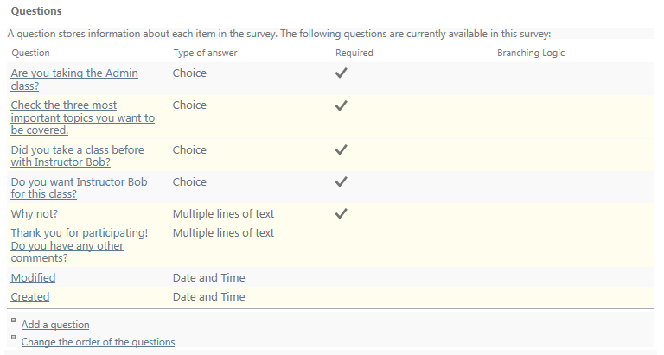
- Edit each question that needs to branch, and add the branching logic. In this example, all logic has been entered. Each branching question is automatically followed by a page separator. Navigate to the Survey Settings again and you’ll see the questions now have branching logic.
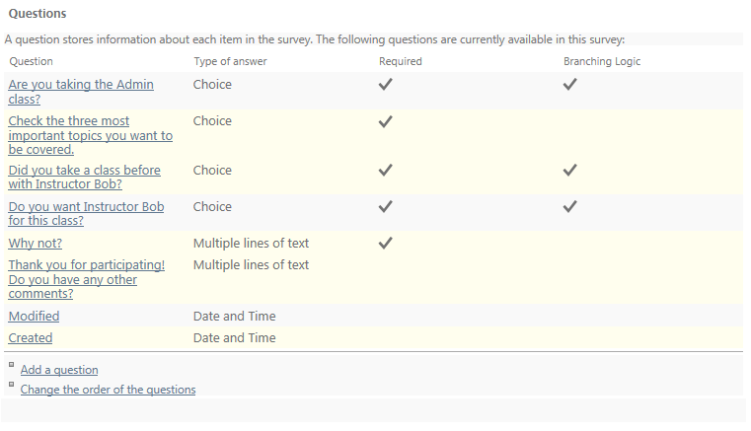

- Add additional page separators as needed for clarity. Unless the entire survey is very short, has little branching logic, or has only very short questions, it is often best to break after each question.
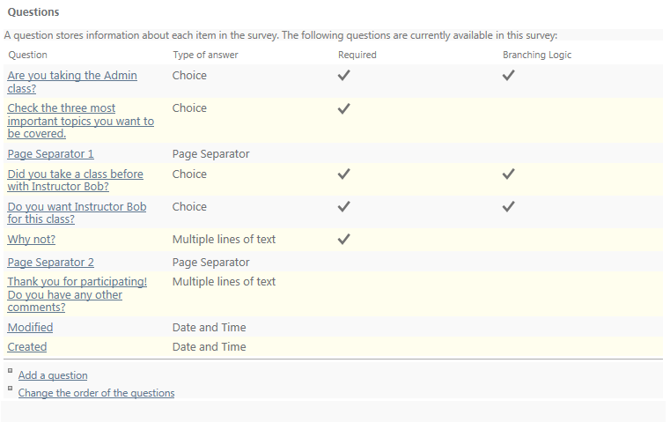
- Test the survey.
- Delete the test responses.
- Distribute the survey.

Example of Branching Logic
Let’s add the branching logic for the first question.
- Navigate to the survey.
- Click Settings and click Survey Settings.
- Click the question to edit.
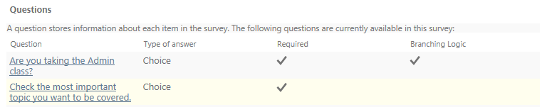Scroll down to the Branching logic section.
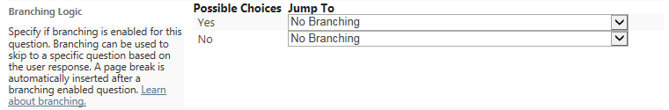
- For the Yes response, choose to go to the next question.
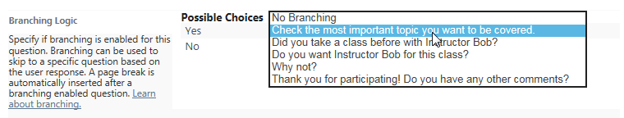
- For the No response, choose to go to the exit page. Click OK when complete to return to the Settings page.
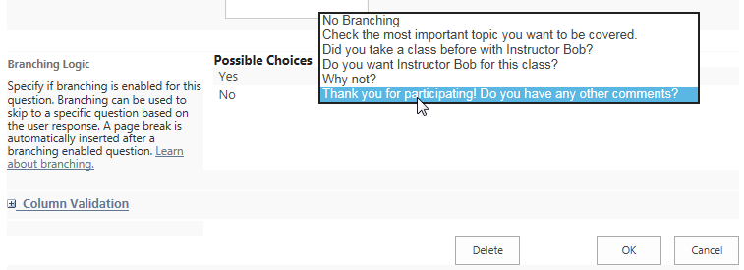

- A good way to see the survey order and logic is to look at the settings for column order. On the Settings page, click Change the order of the questions at the bottom of the page.
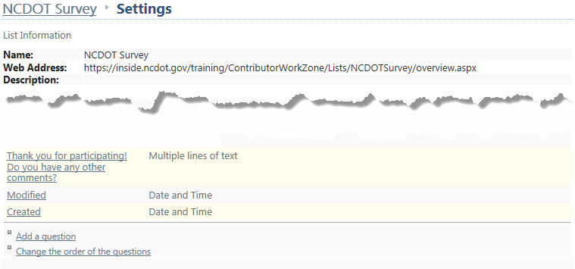Here’s the summary. When you are finished with your review, click Cancel.
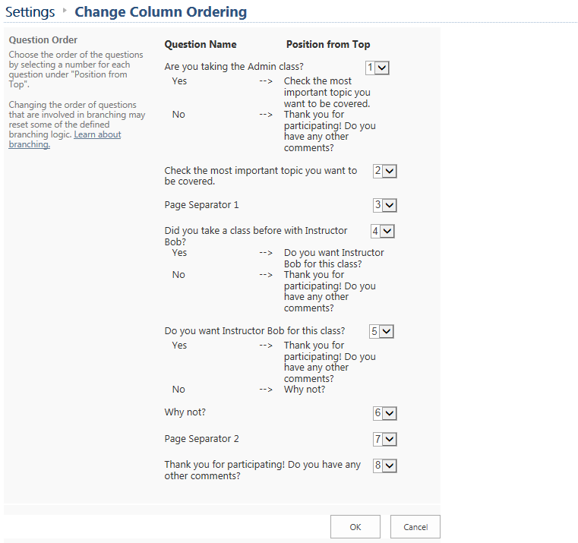

Respond to the Survey
To solicit responses to a survey, distribute a link to survey takers.
- Send a link to the home page of the survey, where the survey taker can begin the survey by clicking Respond to this Survey.
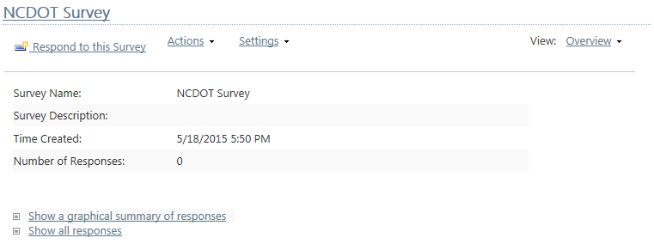
- Send a link to the actual form, where the survey taker can immediately start the survey.
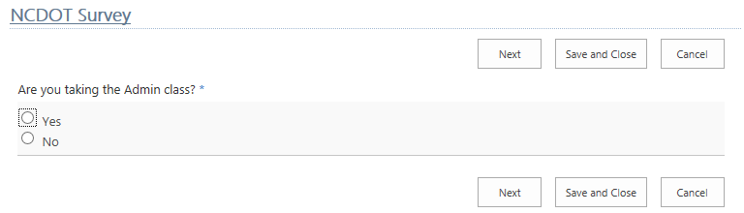
- Create an introductory page in SharePoint page and add information about the survey, its purpose and the estimated completion time. Be sure to include a prominent link to the actual form.

Evaluate Survey Results
You can view all responses as a graph or a list.
This is an example of a list. If you click a response, you will see the details of that response.
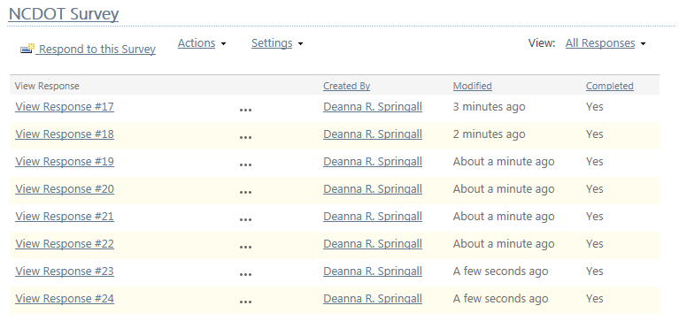
These are the details of that response.
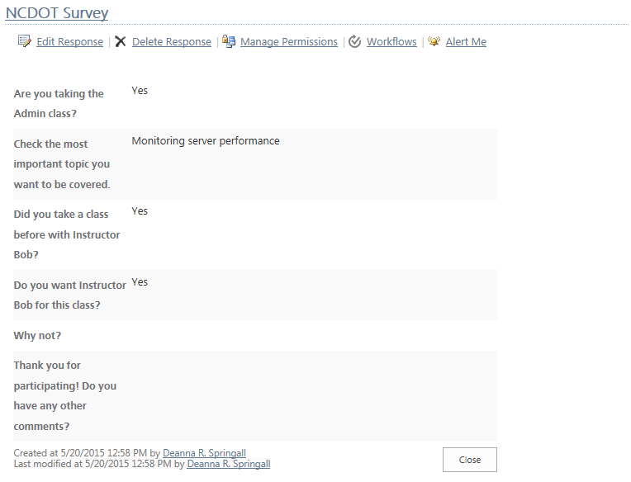
This is an example of a graph.
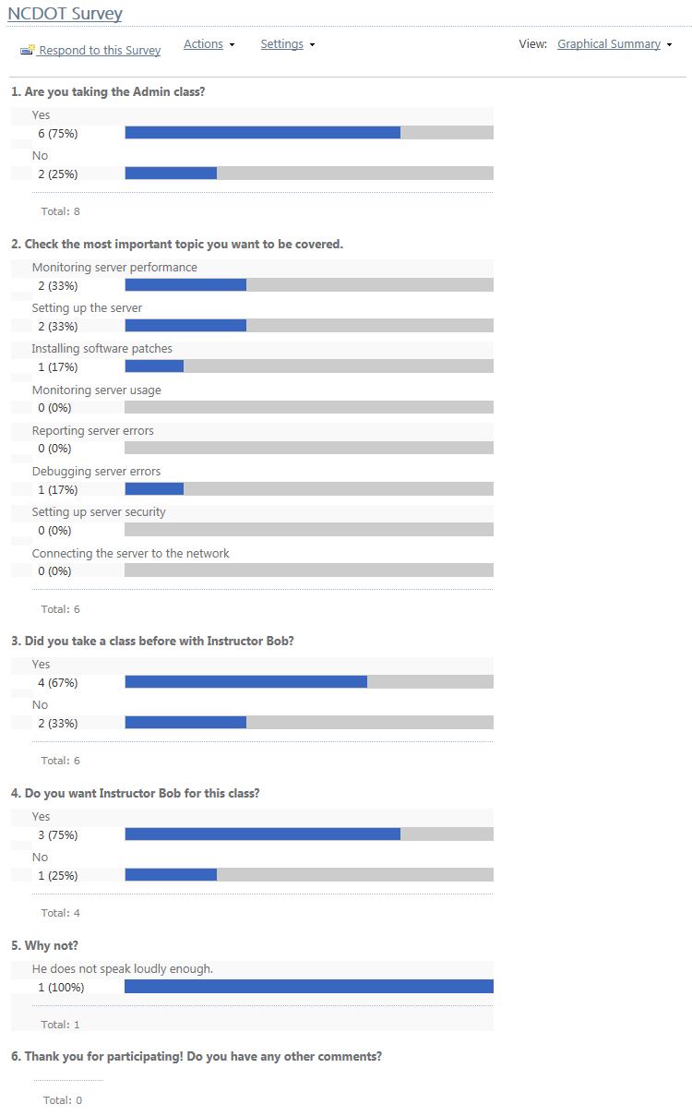

Survey Actions
As you can with other SharePoint lists, you can export a survey to spreadsheet, view an RSS feed, and set an alert. See the help files for Export to Excel, RSS Feed, and Set Alert for more information.
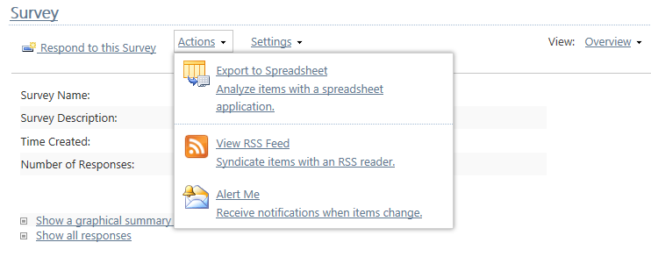

Default View
The default view for a survey is Overview. Additional views for All Responses and Graphical Summary are also created. These additional views are the same as the links in the lower left and are a way to view results as described earlier.
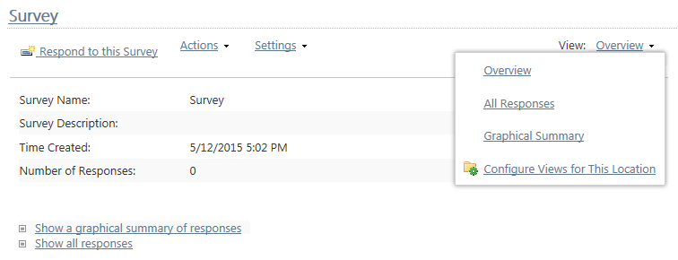

Default Columns
These columns are automatically included in a new survey. Question types are the same as column types so, for each question you add to a survey, a column is created.
