Create a Blue Button – Inside NCDOT
If you want to create a prominent link on Inside NCDOT, add an NCDOT “blue button.”
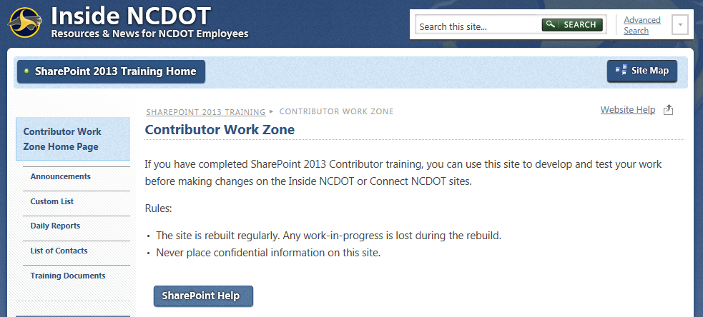
- Navigate to the page.
- Click the Settings gear, and click Edit page. If prompted, check out the page.
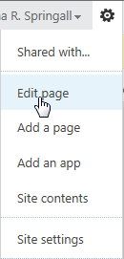

- In the zone where you want to place the blue button, click Add a Web Part. The web part gallery opens below the ribbon. In the Categories section, click Media and Content. In the Parts section, click Content Editor. Click Add.
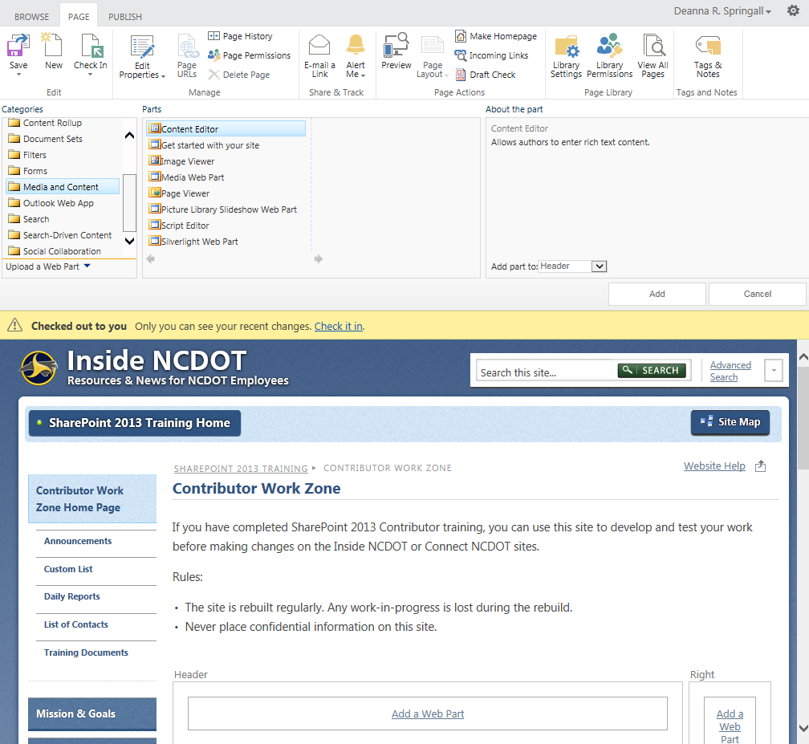The web part is added to the web part zone on the page.
- Hover over the title of the web part, click the down arrow, and click Edit Web Part to open the tool pane.
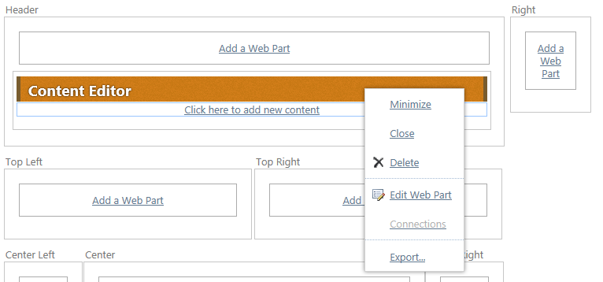
- In the tool pane, expand the Appearance section, enter Blue Button as the Title of the web part, and change the Chrome Type to None. Click OK to save the changes.
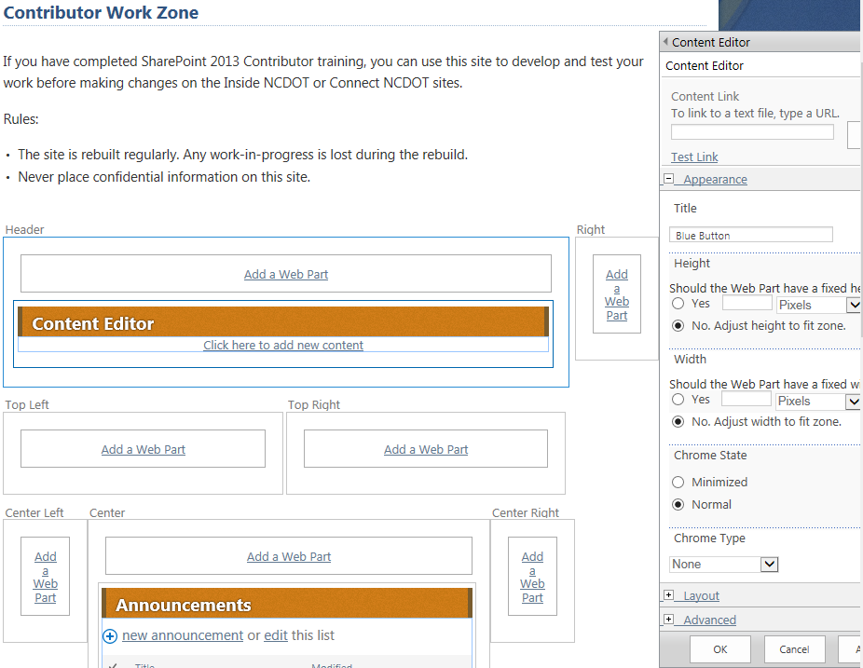
- In the Content Editor web part, click Click here to add new content.
- Enter the text that the user will see, then highlight that text.
- In the ribbon, click the INSERT tab. In the Links group, click Link. Click From Address.
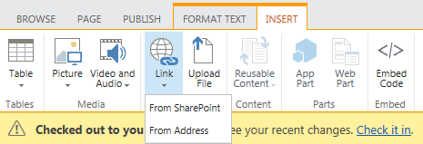
- Enter the address (URL). Click Try link to ensure the URL is correct. Click OK.
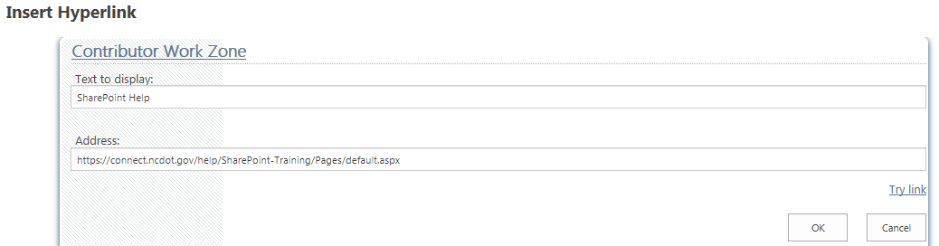The Text to display field must contain the text you entered in Step 7. If it doesn’t, click Cancel, highlight the text and repeat Step 8.

The Content Editor web part now contains a standard link.
- Keep your cursor in the text area of the Content Editor web part and, in the ribbon, click the FORMAT TEXT tab. In the Markup group, click Edit Source.
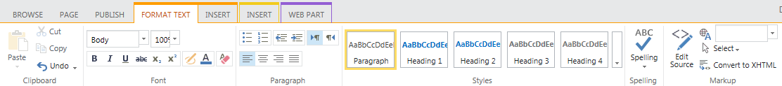The code (HTML) for the link appears.
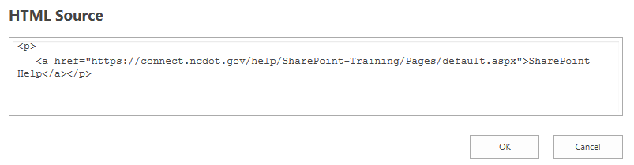
- Add class="ncdot_calltoaction" after <a and before href. Click OK to save the HTML.
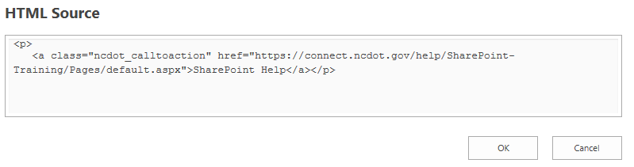
This code change turns the link into a blue button.
- In the ribbon, click the PAGE tab. In the Edit group, click Save to save the page.
- Remember to check in and publish it so users can see your changes.

