Add or Edit a Web Part
This help file focuses on how to add and edit web parts, as well as common options (appearance and layout) for all web parts. See the help files for commonly used web parts to learn how to use and customize specific web parts.

Contents
Add and Edit a Web Part
Tool Pane – Appearance Options
Title
Height and Width
Chrome State
Chrome Type
Tool Pane – Layout Options

Add and Edit a Web Part
- Navigate to the page.
- Click the Settings gear, and click Edit page. If prompted, check out the page.
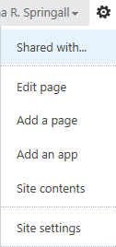
- In the zone where you want to place the web part, click Add a Web Part.
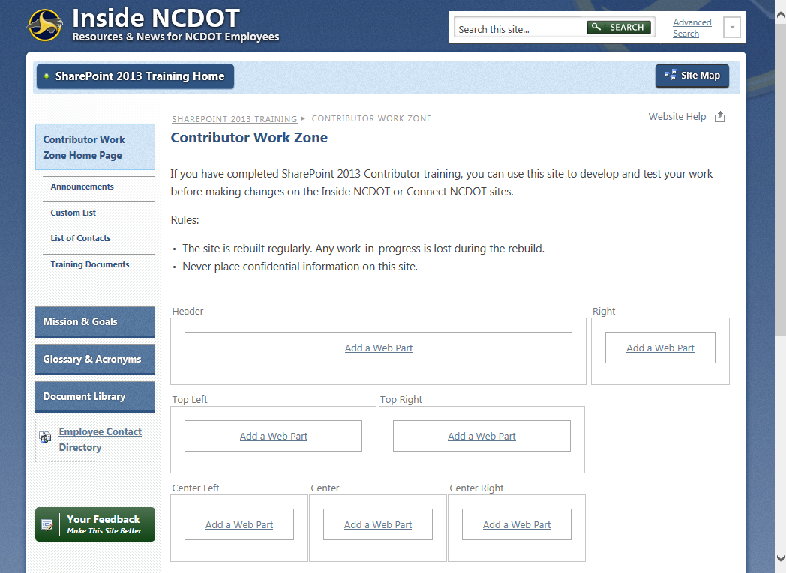
OR
Click the INSERT tab and click Web Part.
- The web part gallery opens below the ribbon. In the Categories section, click the category of the web part. In the Parts section, choose the web part. This example uses the Media and Content category and an Image Viewer web part. If you selected a zone in Step 4, the Add part to drop-down lists that zone; otherwise, choose where to place the web part from the Add part to drop-down. Click Add. The web part is added to the web part zone on the page.
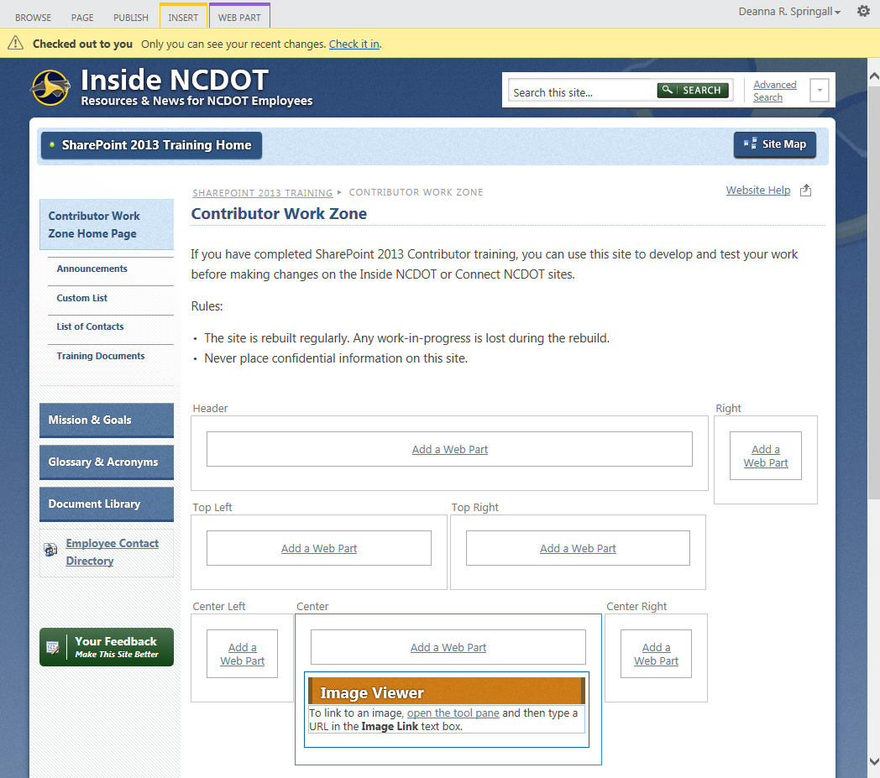
- Hover over the title of the web part, click the down arrow, and click Edit Web Part to open the tool pane.
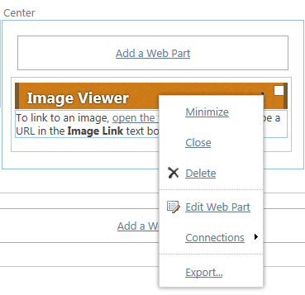
Some web parts offer an option to click open the tool pane.
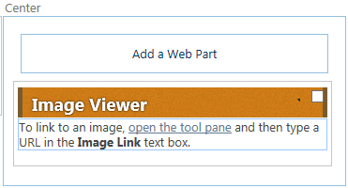
The tool pane appears in the right part of the screen and offers customization options.
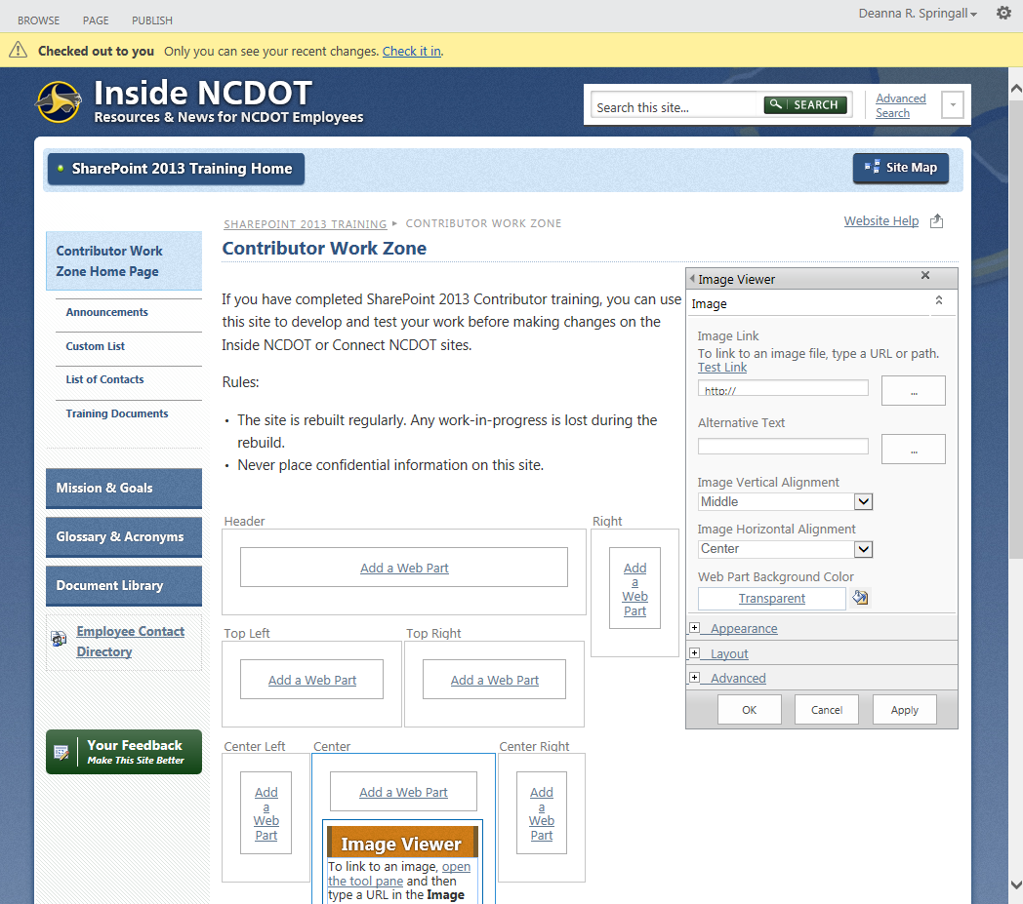 Options vary according to the web part, but common options include Appearance, Layout and Advanced. These editing options are explained in the later section on Editing Options.
- In this example, enter the link (URL) to the image. Click Test Link to ensure the address is correct.
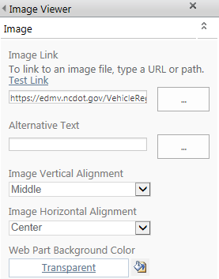
- Expand the Appearance section, enter a new Title, and change the Chrome Type to Title and Border. Click OK to save the changes.
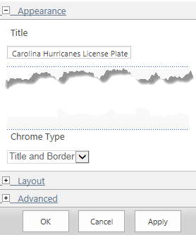
The web part now displays the image, title and border.
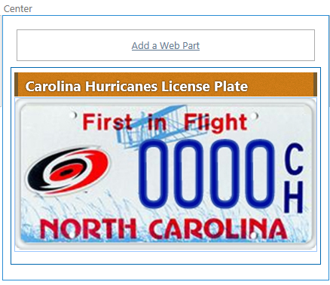
- In the ribbon, click the PAGE tab. In the Edit group, click Save to save the page.
- Remember to check the page in and publish it so users can see your changes.
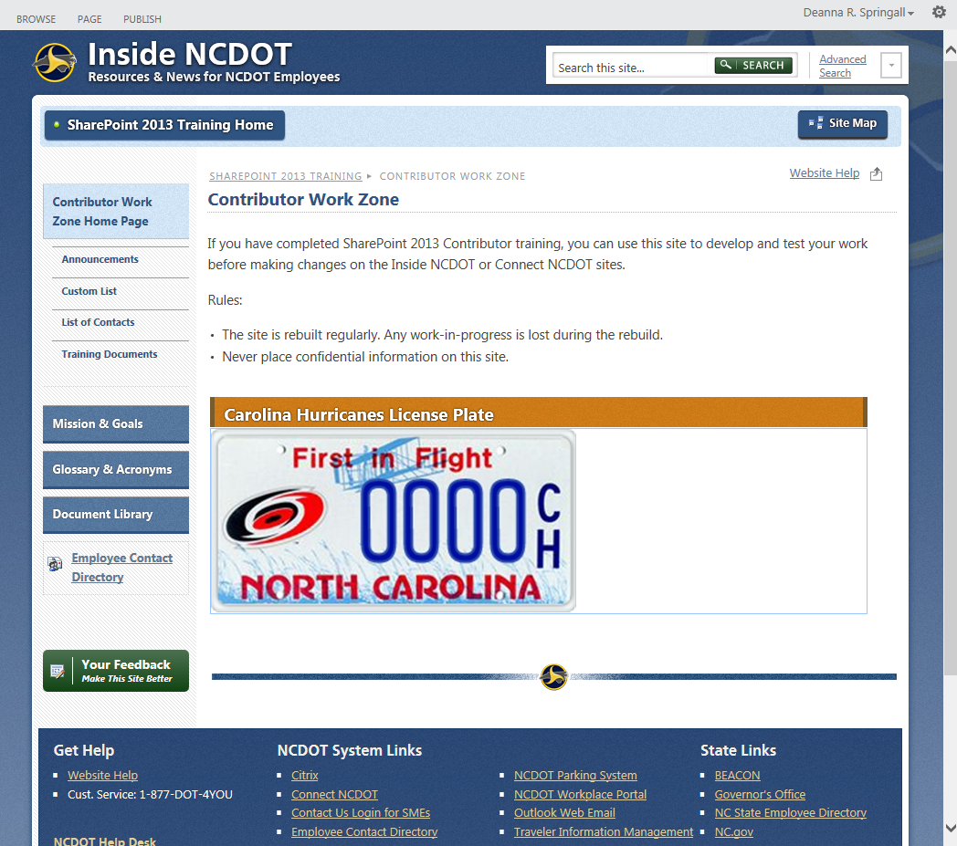

Tool Pane – Appearance Options
These are the appearance options. Once you make any changes, click Apply or OK.
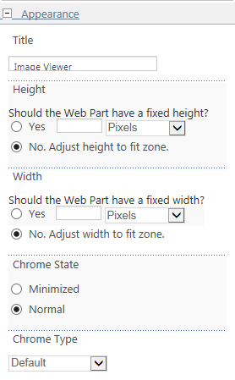

Title
The title appears in the title area of the chrome.
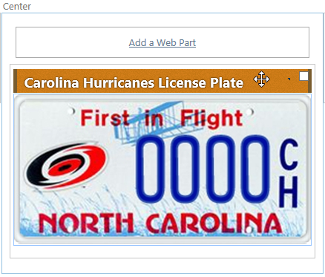

Height and Width
If needed, you can define a specific height and width for the web part in centimeters, inches, millimeters, points, picas or pixels. Generally, it’s a good idea to let the web part adjust itself to fit the web part zone.

Chrome State
Chrome state can be either normal or minimized. The normal chrome state displays the content of the web part.
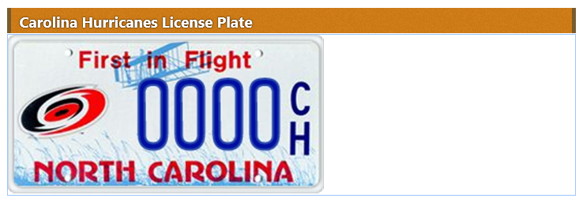
The minimized chrome state hides the content of the web part. If the chrome type is set to display the title, the minimized state shows only the title as shown here. If the chrome type is set to not show the title, the web part is completely hidden.

Chrome Type
Chrome type controls whether the title and border of the web part are displayed.
Title and Border
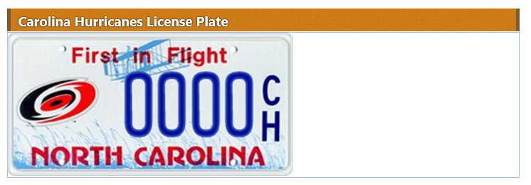

Title Only
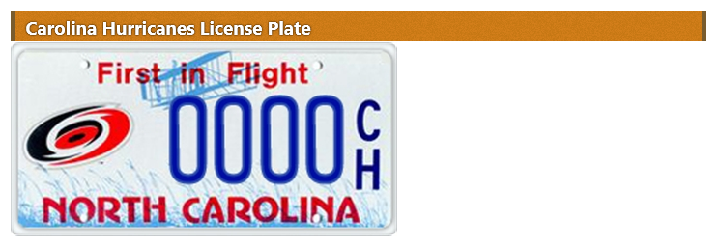
Border Only
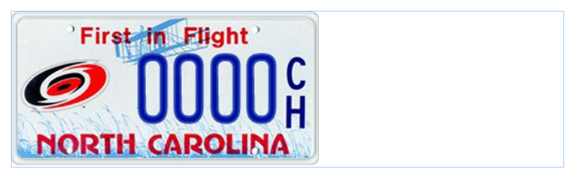
None
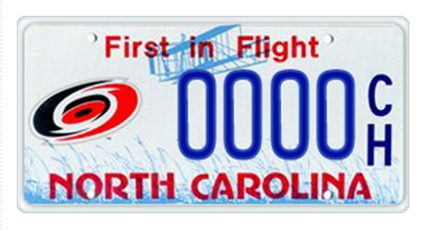
Default
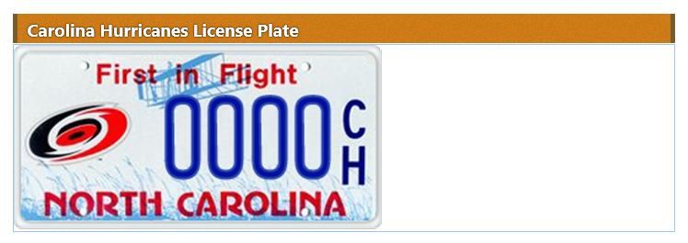

Tool Pane – Layout Options
These are the layout options. Once you make any changes, click Apply or OK.
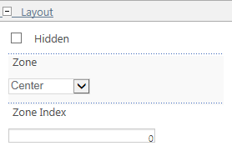
- Hidden – Check this box so the web part is not displayed on the page. The web part is visible and editable when the page is being edited and its title contains the word (Hidden).
Note: A hidden web part is loaded whenever the page is opened, so it may affect page speed.
- Zone – Use this option to move a web part to another zone. Select its destination zone from the drop-down.
- Zone Index – Use this option to move web parts within the same zone. Web parts with lower index numbers appear above web parts with higher index numbers.

In this example, both a List View web part (Announcements) and an Image Viewer web part (License Plate) are in the Center web part zone. If you select Edit Web Part for each, Announcements has a Zone Index number of 0, while License Plate has a Zone Index number of 1. So, Announcements appears above License Plate.
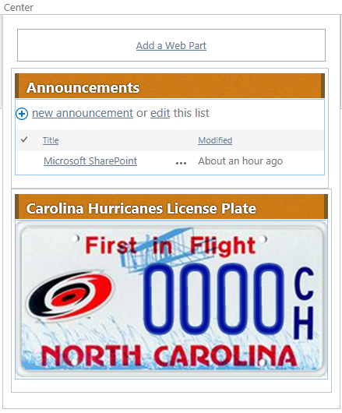
If you edit Announcements and give it a Zone Index number of 2, it will appear below License Plate.
