Create a Page
All new pages are based upon a Welcome Page template and are stored in the Pages library.

Contents
Create a Page – Method 1
Create Page – Method 2
What Page Layout Should I Use?
Inside
Connect Home Page Layout
Connect Letting Home Page Layout
Connect Content 3 Column Top/Wide Bottom
Connect Content 66%-33% Top/Wide Bottom
Connect Content Details
Connect Content Even Split
Connect Content Left Navigation
Connect Content Wide Top/Wide Bottom
Connect Help Home Page Layout
Connect Landing Page Layout
Connect Landing Page Letting

Create a Page – Method 1
- Click the Settings gear and click Add a Page.
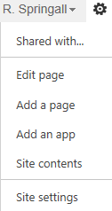
OR
On the ribbon, click the PAGE tab. In the Edit group, click New.
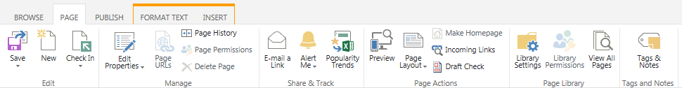
- In the ADD A PAGE dialog, enter the name of the new page and click Create.
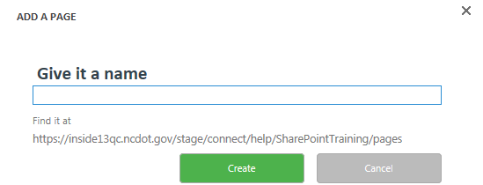
The new page is created. When it opens, it is checked out to you and ready for editing.
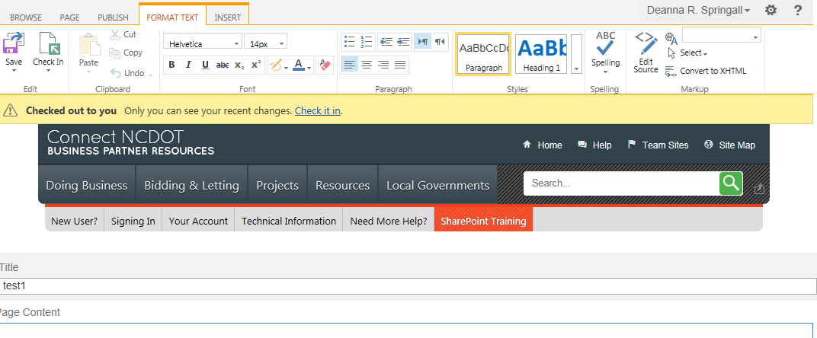

- Apply a page template. On the ribbon, click the PAGE tab. In the Page Actions group, click Page Layout, and click the layout to be used. Examples of each page layout are later in this help file.
For Connect NCDOT, select one of the Welcome Page templates.
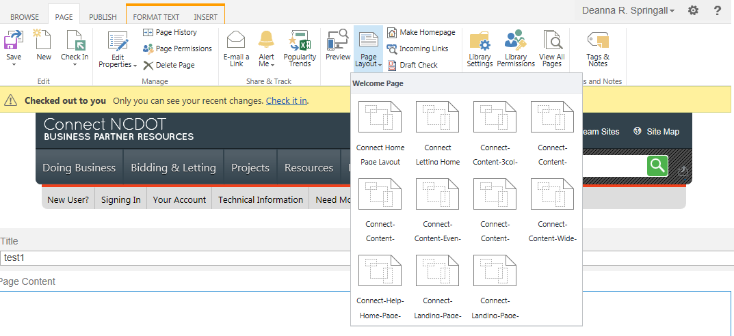 For Inside NCDOT, use the Blank Web Part page template.
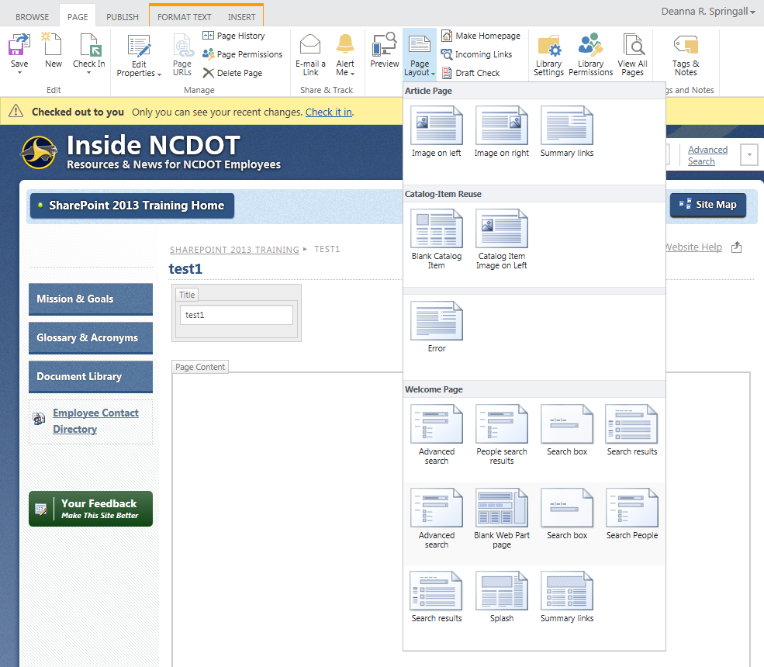
- Add apps (lists and libraries) and add and configure web parts as needed. There are so many options to add content to a page that they are documented separately. See the help file for Add, Edit or Delete a Web Part and the help file for Add an App.
- Save the changes. On the ribbon, click the PAGE tab. In the Edit group, click Save.
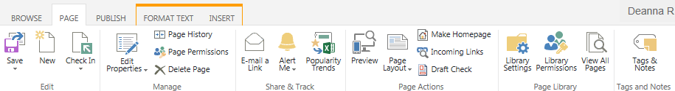
- Because the page was checked out to you when it was created, click Check it in. Add comments to describe your changes and click Continue.
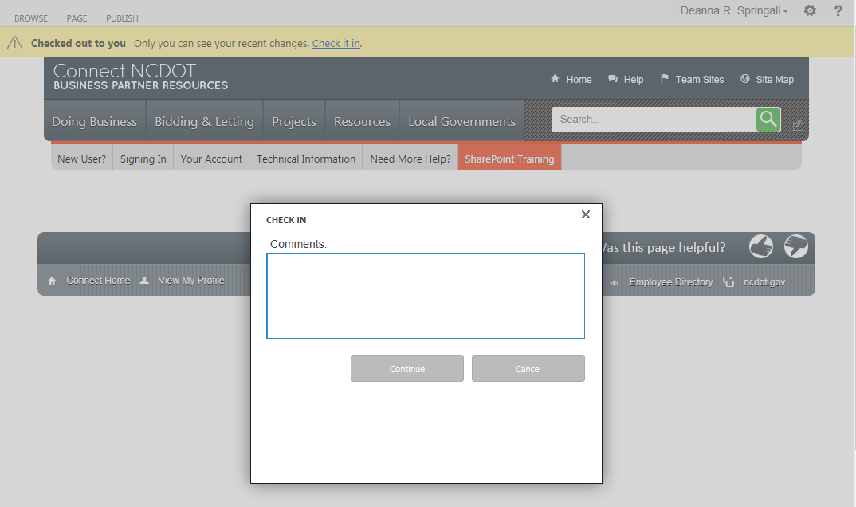
- The page must also be published so your changes can be viewed by all. Click Publish it.
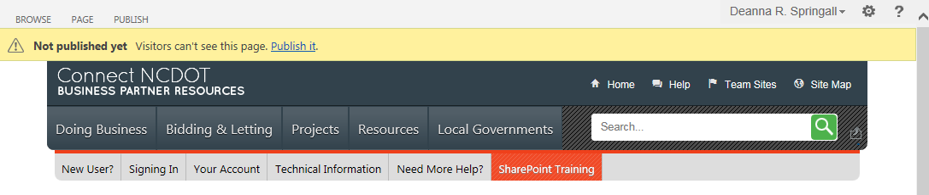

Create Page – Method 2
- Click the Settings gear, and click Site contents.
- Click the icon for the Pages library.
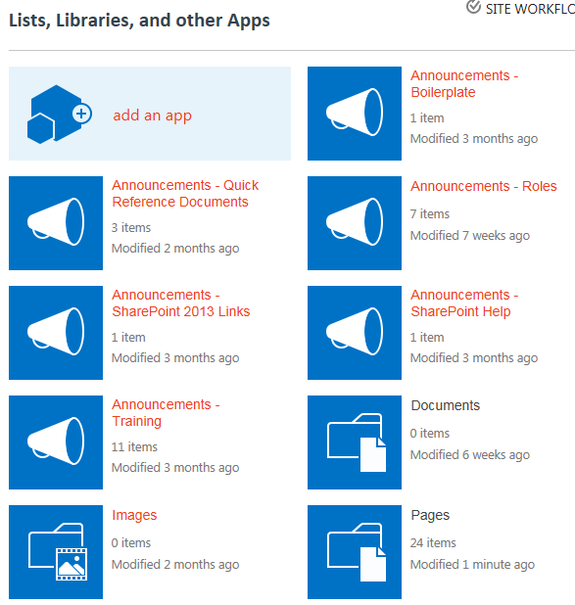
- On the ribbon, click the FILES tab, click down arrow by New Document, and click Welcome Page.
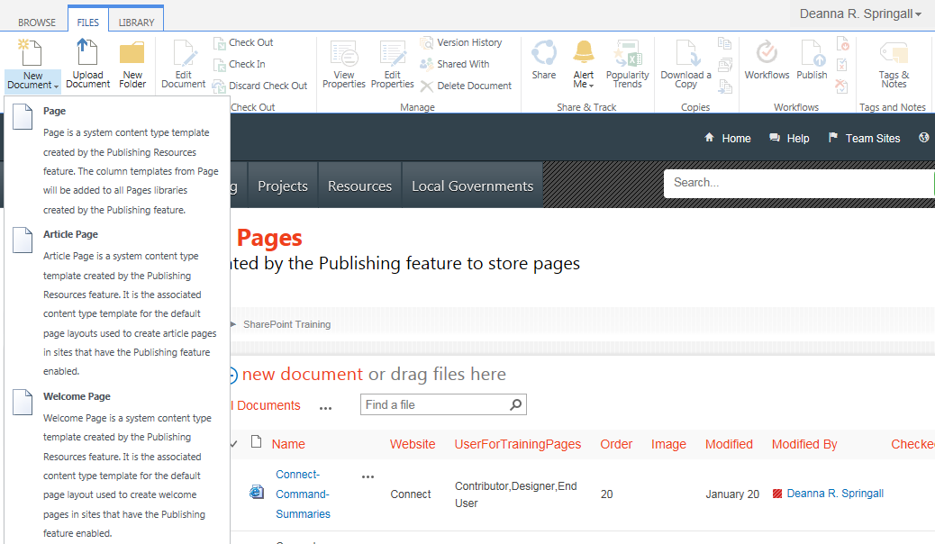
- On the Create Page page, enter a Title for the page and, if desired, a Description. The URL Name is automatically created from the title but you can enter another name if you want. Click the Page Layout that you want for the new page, and click Create. Examples of each page layout are later in this help file.
This is the Create Page on Connect NCDOT, showing the various Welcome Page templates.
This is the Create Page on Inside NCDOT; use the Blank Web Part page template.
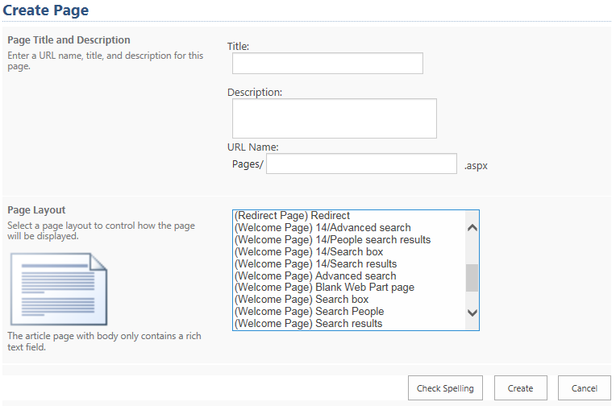
- Navigate to the page you just created. Click the Settings icon, click Site contents, and click the icon for the Pages library. Note the green star that indicates the page is new and the green down arrow that indicates the page is checked out.
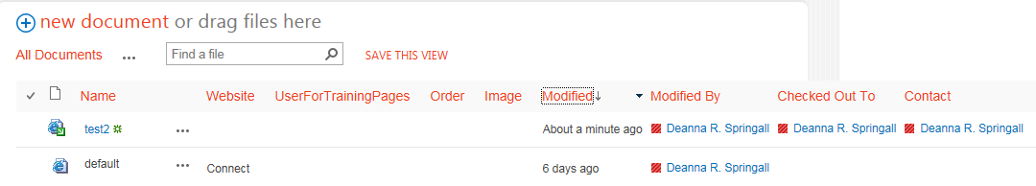
- Click the page name to navigate to the page.
- To open the page for editing, click the Settings gear and click Edit page.
OR
On the ribbon, click the PAGE tab and, in the Edit section, click Edit.
Steps 8-11 are the same as Steps 4-8 in the previous section.
- Add apps (lists and libraries) and add and configure web parts as needed. There are many, many options to add content to a page, so they are documented separately. See the help file for Add, Edit or Delete a Web Part and the help file for Add an App.
- Save the changes. On the ribbon, click the PAGE tab. In the Edit group, click Save.
- Because the page was checked out to you when it was created, click Check it in. Add an explanation of your changes and click Continue.
- The page must also be published so your changes can be viewed by all. Click Publish it.

What Page Layout Should I Use?
For Inside NCDOT, use the Welcome Page: Blank Web Part page as the page template. For Connect NCDOT, you can choose among several Welcome Page templates.
Examples of each are given in the next sections.

Inside: Blank Web Part Page
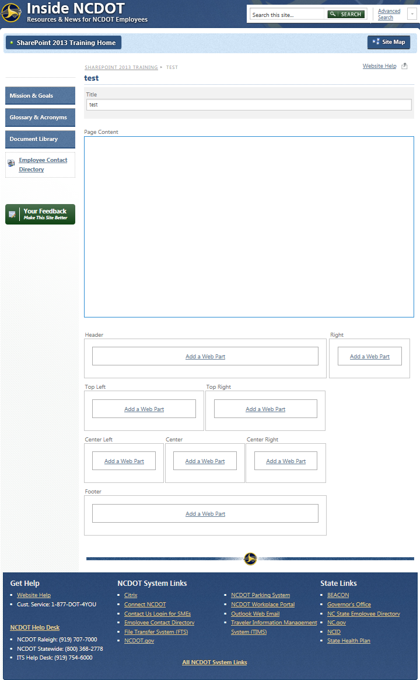

Connect: Home Page Layout
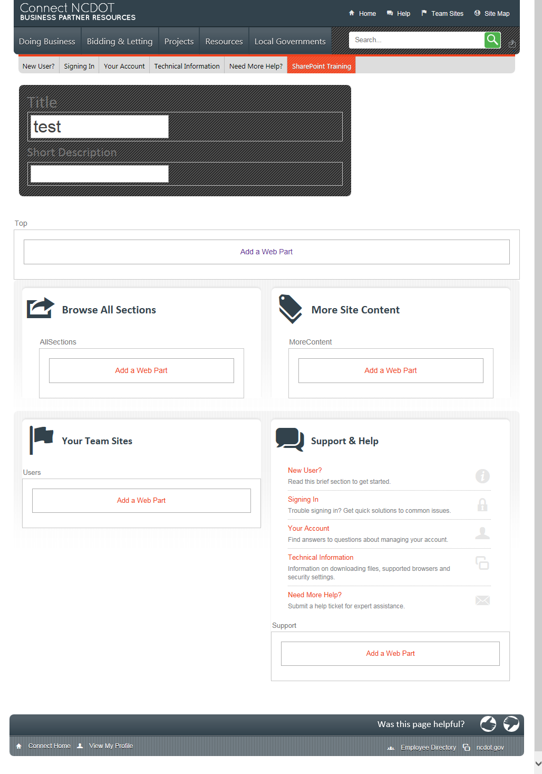

Connect: Letting Home Page Layout
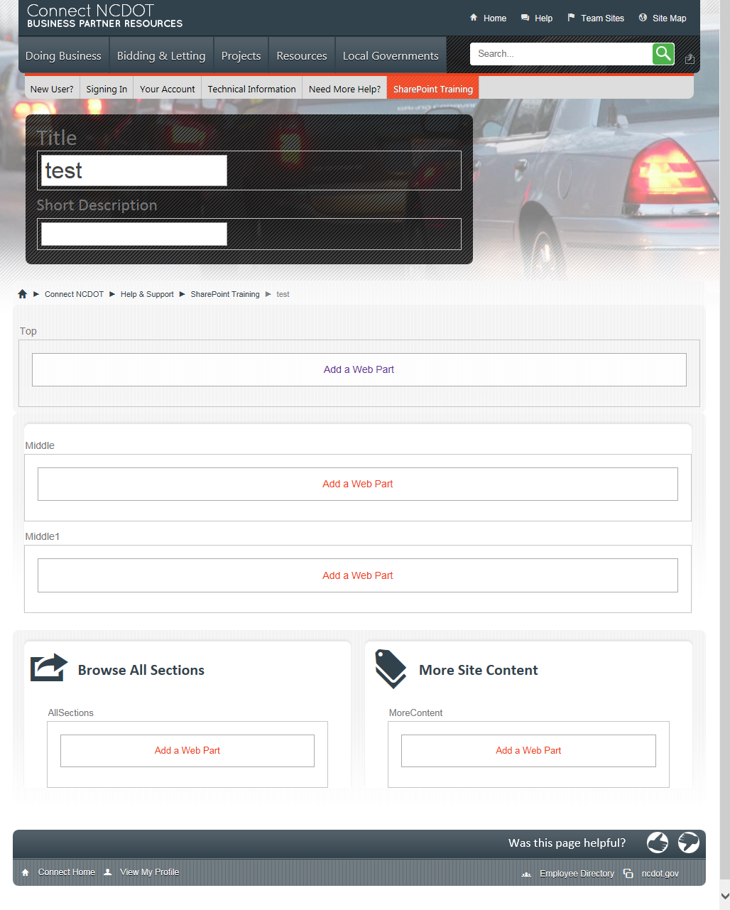

Connect: Content 3 Column Top/Wide Bottom
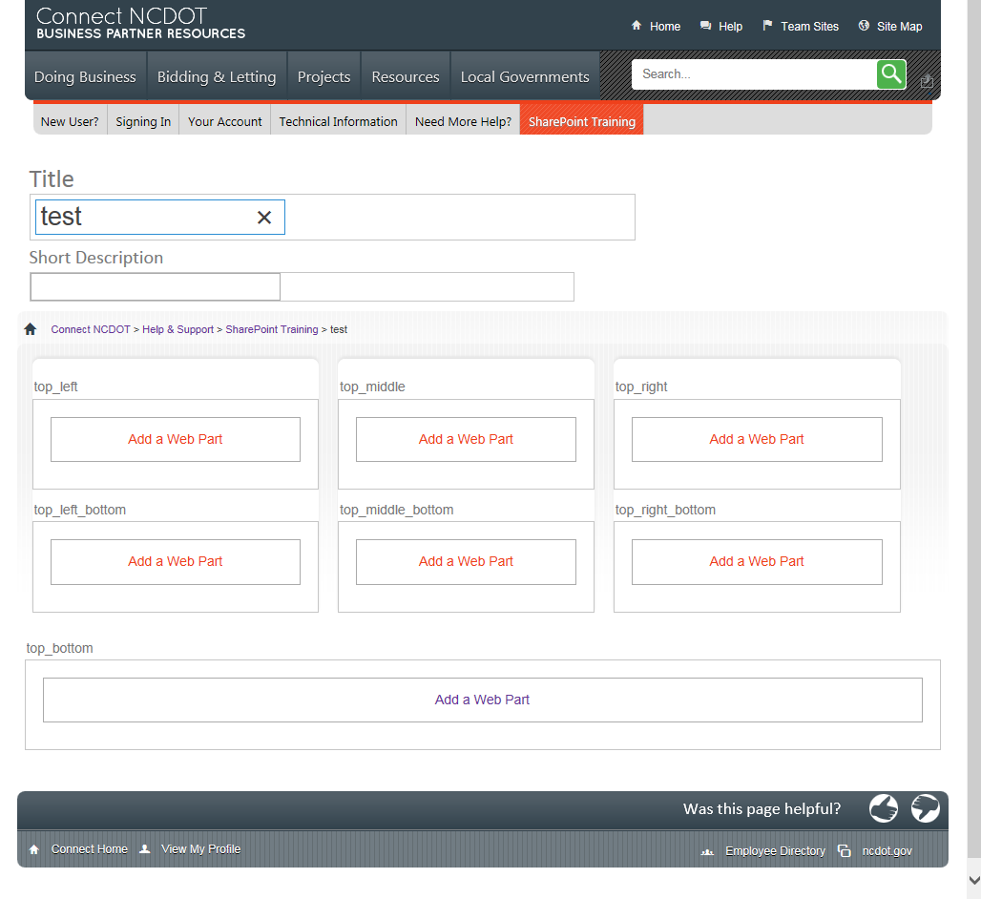

Connect: Content 66%-33% Top/Wide Bottom
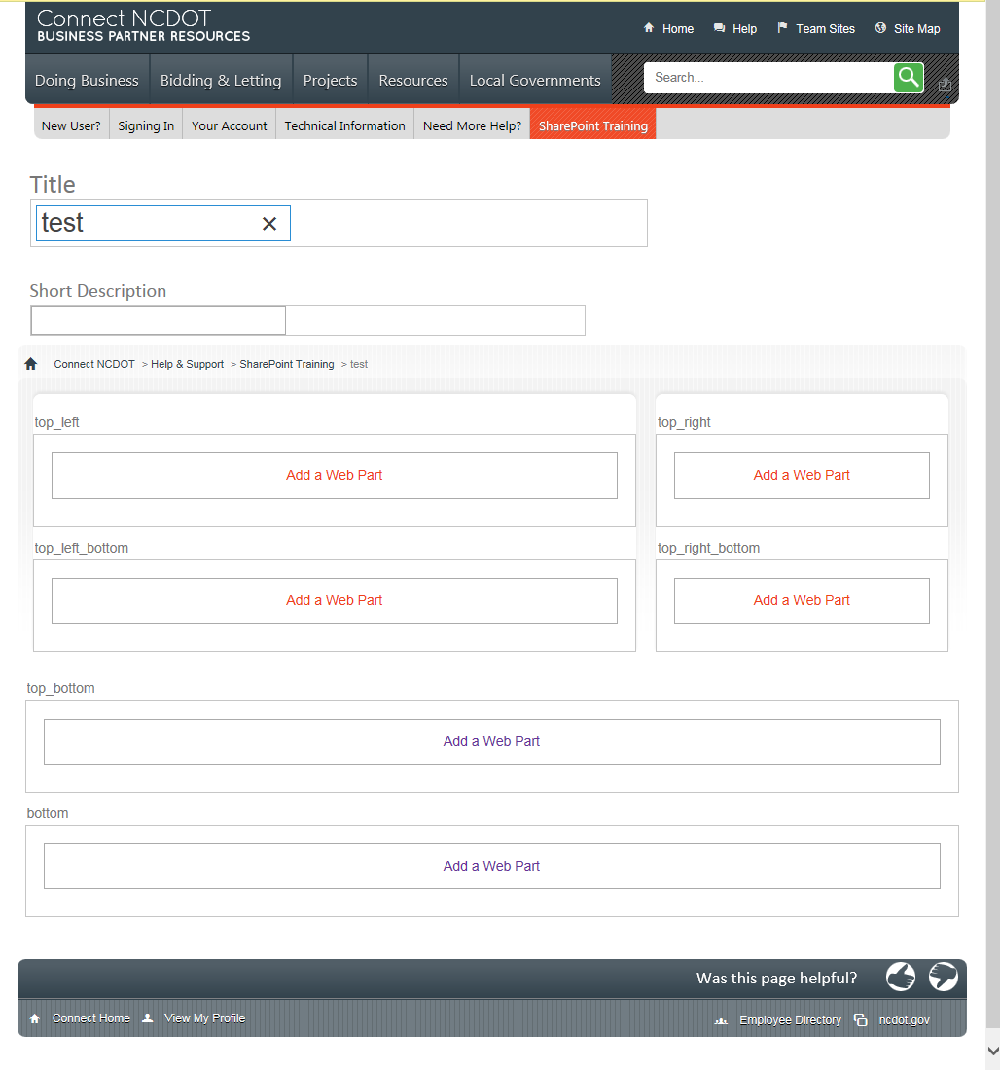

Connect: Content Details
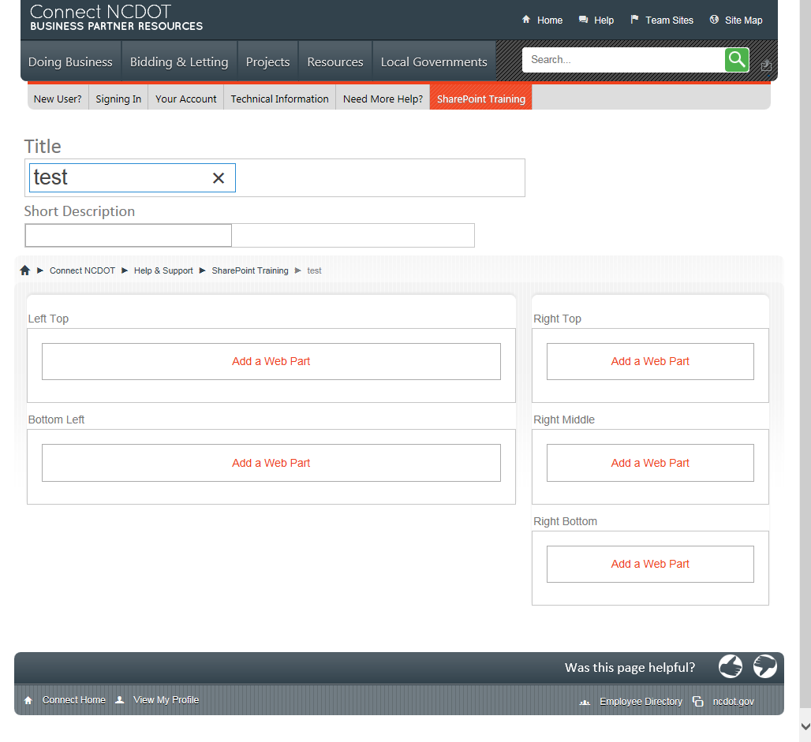

Connect: Content Even Split
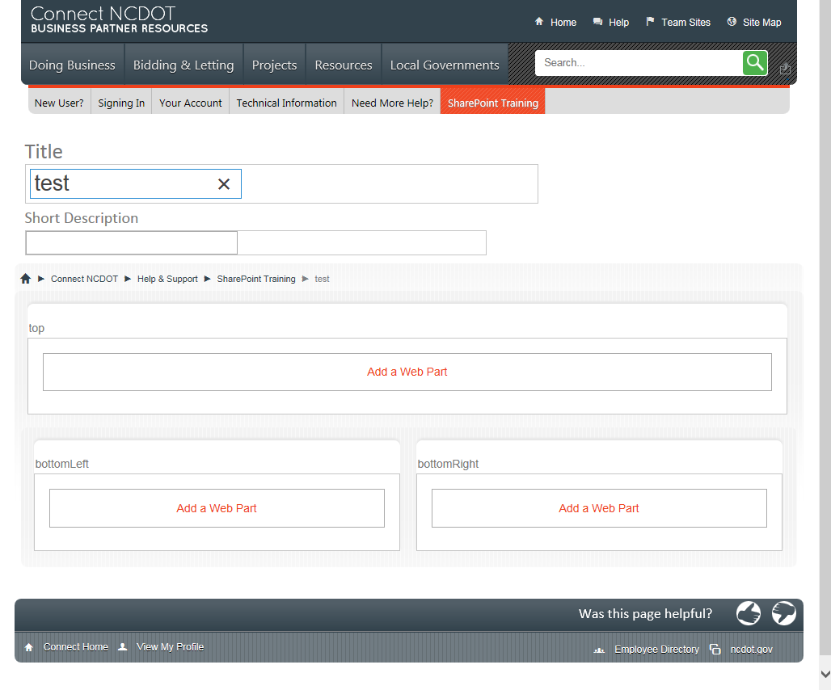

Connect: Content Left Navigation
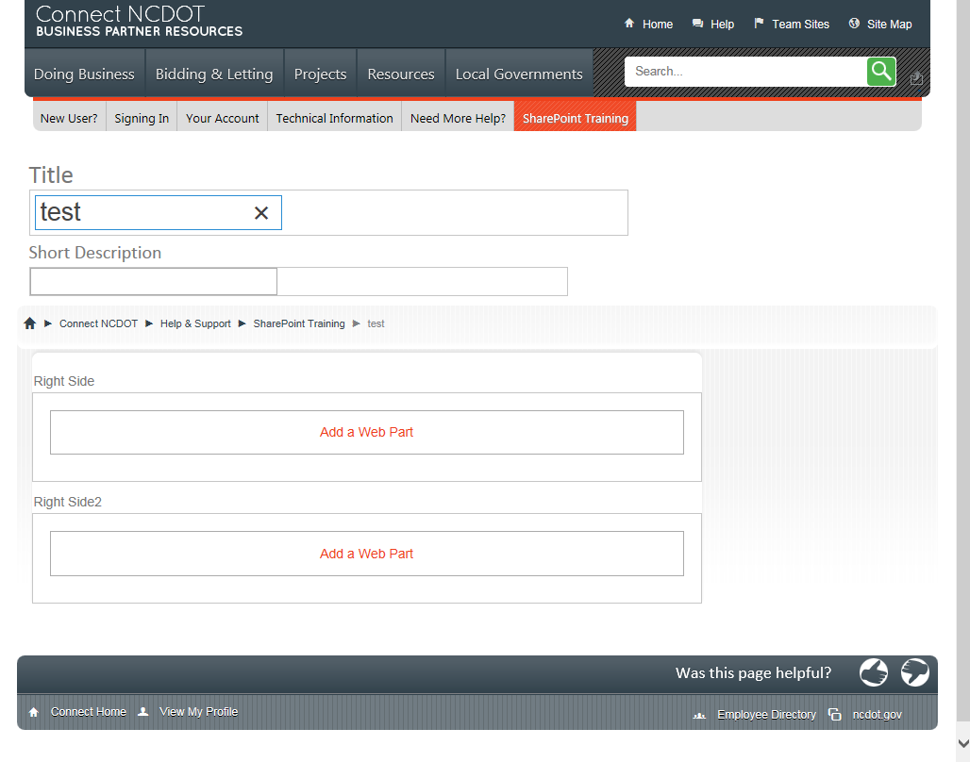

Connect: Content Wide Top/Wide Bottom
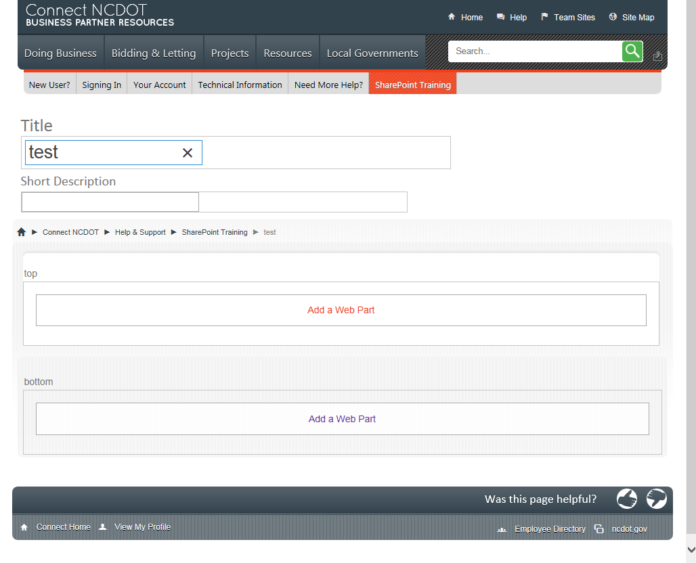

Connect: Help Home Page Layout
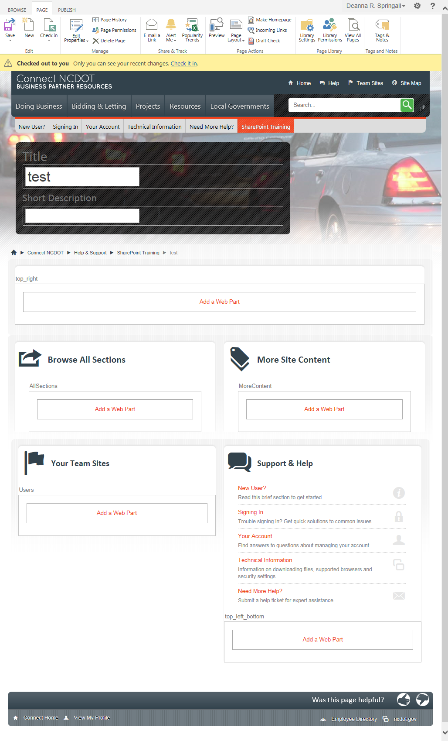

Connect: Landing Page Layout
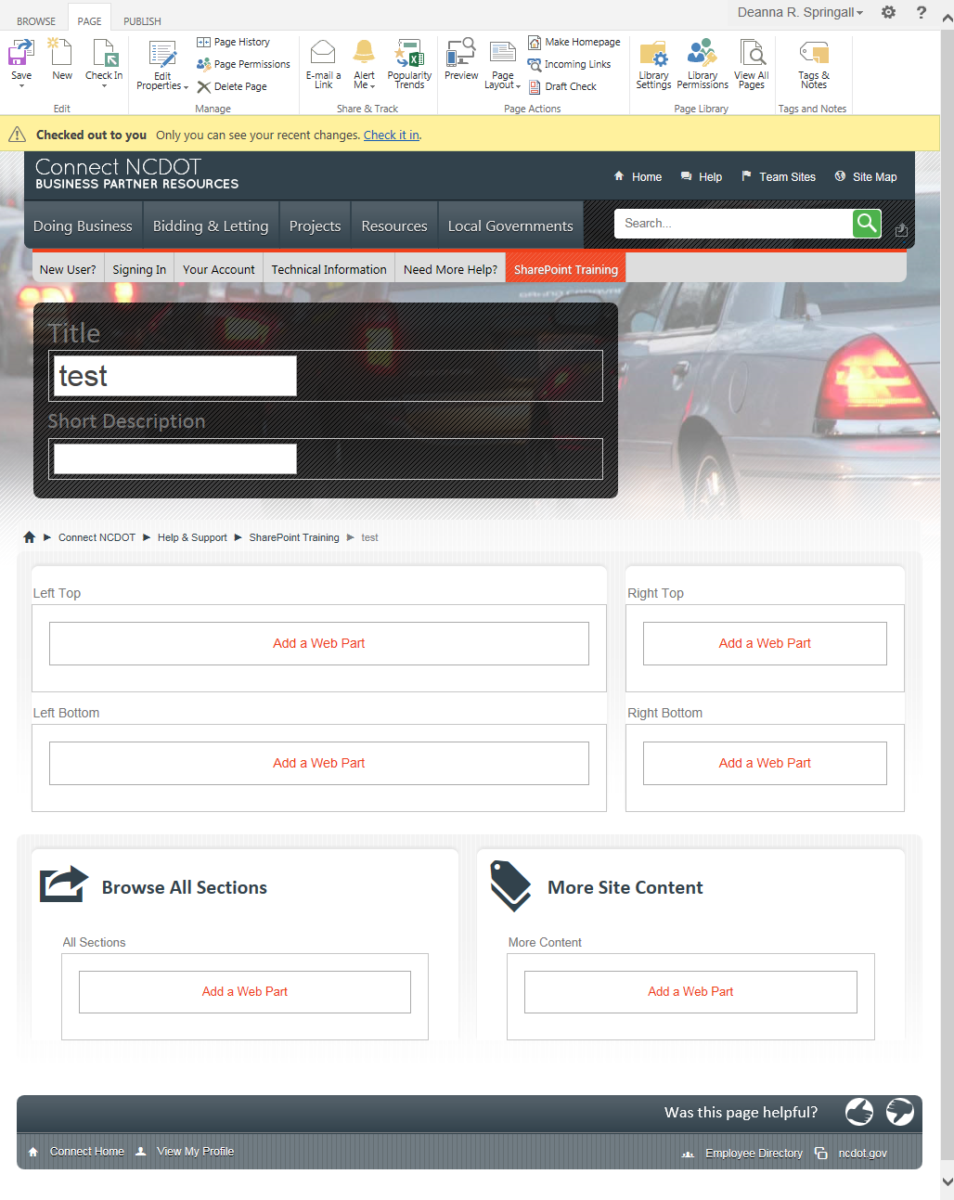

Connect: Landing Page Letting

