Add or Remove a List or Library from Quick Launch – Connect NCDOT
Because Connect NCDOT is a public-facing site, options to customize Quick Launch are restricted.
In the unauthenticated (public) area of Connect NCDOT, Quick Launch appears below the top navigation and cannot be customized.
In the authenticated area of Connect NCDOT, where a log in is required for team and project sites, Quick Launch can sometimes be customized. Here is an example.
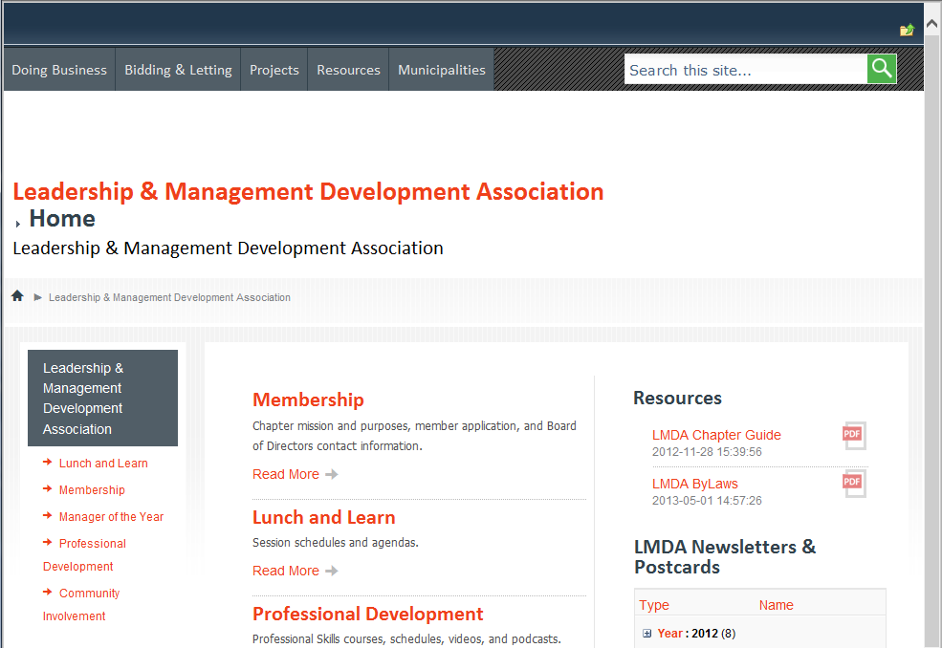
However, some types of team and project sites in Connect NCDOT are more controlled and you may not be able to customize Quick Launch.
- Quick Launch for PMO sites has a standardized Quick Launch.
- Quick Launch for Construction sites has varying standards.
If you are on a project or team site that allows customization of Quick Launch, take these steps.
- Navigate to the list or library.
- From the ribbon, click the LIST or LIBRARY tab. In the Settings group, click List Settings or Library Settings. This example uses a list.
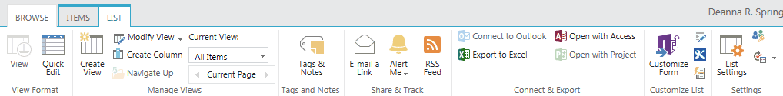
- On the Settings page under General Settings, click List name, description and navigation.
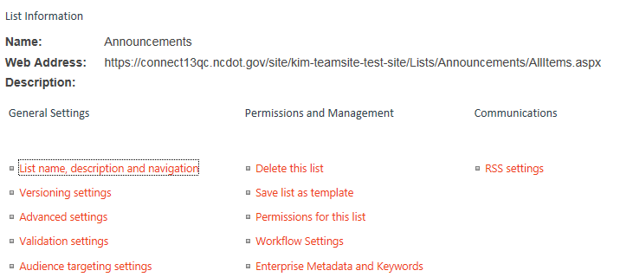
- In the Navigation area, click Yes to display the list in Quick Launch or No to remove the list from Quick Launch. Click Save.
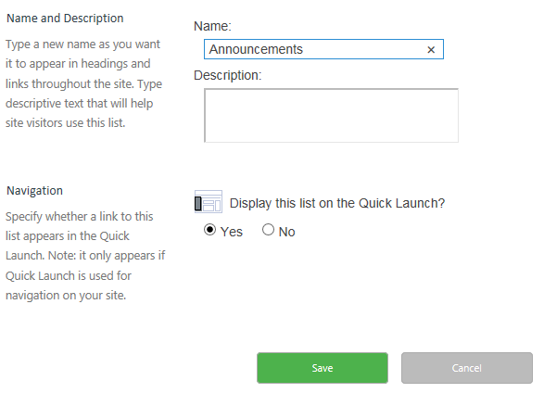
The change is immediate.

