Add or Remove a List or Library from Quick Launch – Inside NCDOT
On Inside NCDOT, you can add or remove a list or a library to Quick Launch above these five standard elements:
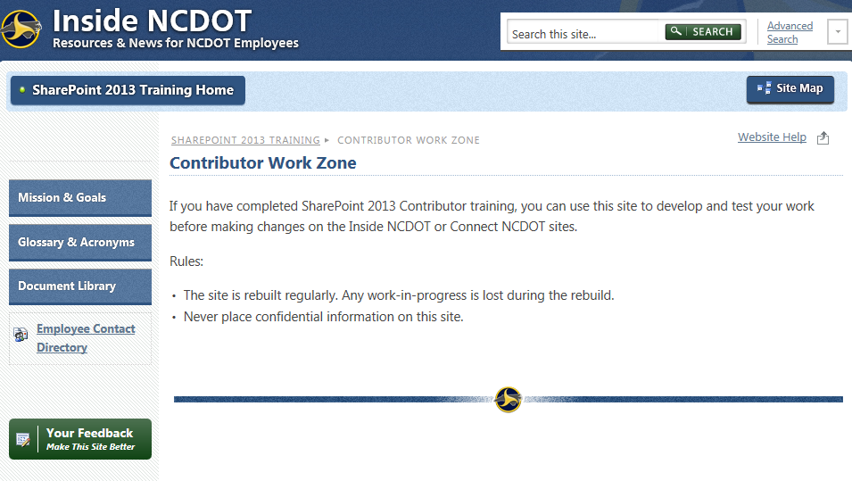
- Navigate to the list or library.
- From the ribbon, click the LIST or LIBRARY tab. In the Settings group, click List Settings or Library Settings. This example uses a list.
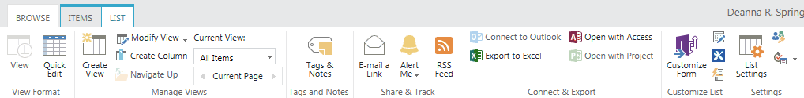
- On the Settings page under General Settings, click List name, description and navigation.
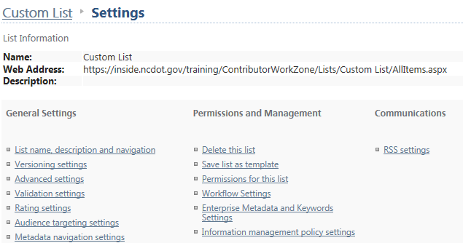
- In the Navigation area, click Yes to display the list as a heading in Quick Launch or No to remove the list from Quick Launch. Click Save.
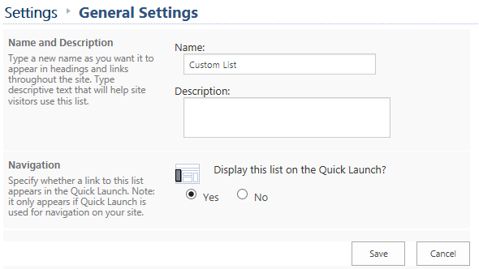

The change is immediate. When you are viewing the list, the Quick Launch heading is light blue to indicate it is the current list. If you are elsewhere in the site, the Quick Launch heading is dark blue.
