Add a Site Column
You can add site columns to any list or library in the same site. Site columns let you reuse the same information and standardize its collection.
- SharePoint offers a number of pre-defined, standard site columns such as address, author, company and status. These site columns are organized into groups such as Core Contact and Calendar Columns and Core Document Columns.
- The NCDOT Web Services team has also created site columns for NCDOT use, such as county, division, let contract type, and let status. These site columns are usually available in the Custom Columns group.
For example, you can reuse a site column of North Carolina counties in several libraries in a site and not have to recreate the column and its county values every time.
Adding a site column to a list or library simply makes it available for use. When you add the site column, you have the option to insert it into the default view of the list or library. Or, you can insert site columns into views later. See the help file on Views for more information.
- Navigate to the list or library where you want to add a site column.
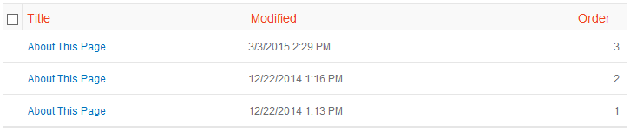
- On the ribbon, click the LIST or LIBRARY tab. In the Settings group, click List Settings or Library Settings. In this example, we are using a list.
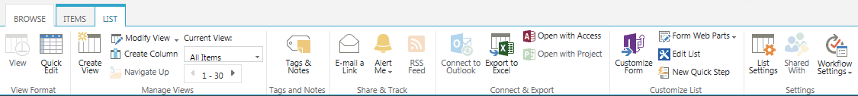
- In the Columns section of List Settings, click Add from existing site columns.
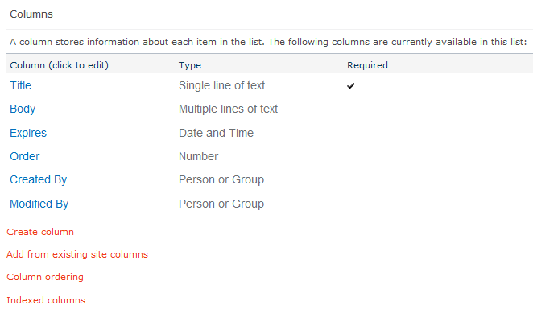
- Click the group containing the site column to add, then click the site column to select it; if you don’t know the group, you can also scroll through the complete list of site columns to find the column you need. Click Add to move the site column into the list of Columns to add.
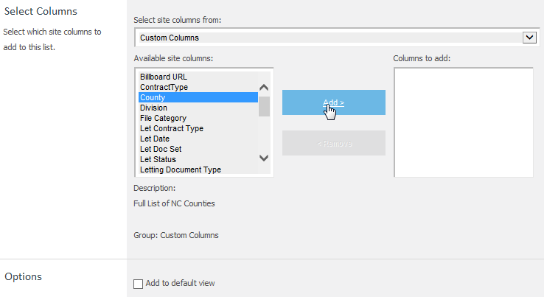
- Under Options, click Add to default view. Click OK to add the selected site columns to the view.
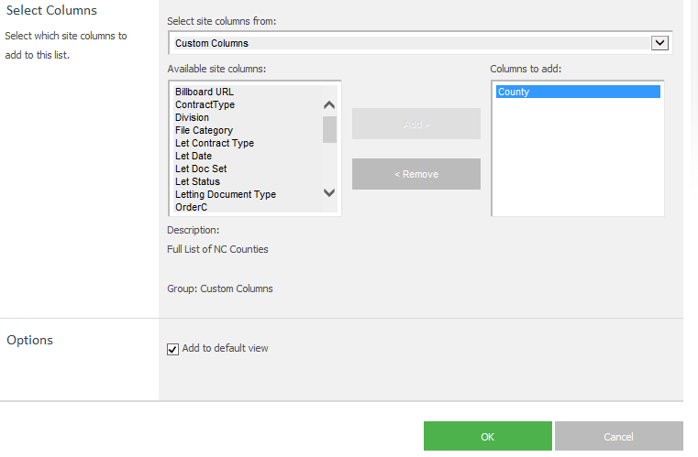The default view of the list now includes the site column.
