Approve or Reject Pending Items
When an item is created, it is assigned a status of Pending until an approver reviews and approves or rejects it. While pending, the item is generally not viewable except to its author and to those who can see drafts. Once approved, the item is visible to whoever can view the list.
An approver is not automatically notified when a new item is created. So, the approver should:
- Set an alert for the list to know when new content is added.
- Check the list periodically to see if there is content awaiting approval.
- Ask the Web Services team to create a formal approval workflow.
Note: The content approval setting must be enabled if you want to use this approval process.

Content
Approve or Reject an Item – Method 1
Approve or Reject an Item – Method 2

Approve or Reject an Item – Method 1
- Navigate to the list.
- Click either the Approve/reject Items or All Items view. The unapproved item has a status of Pending in the Approval Status column.
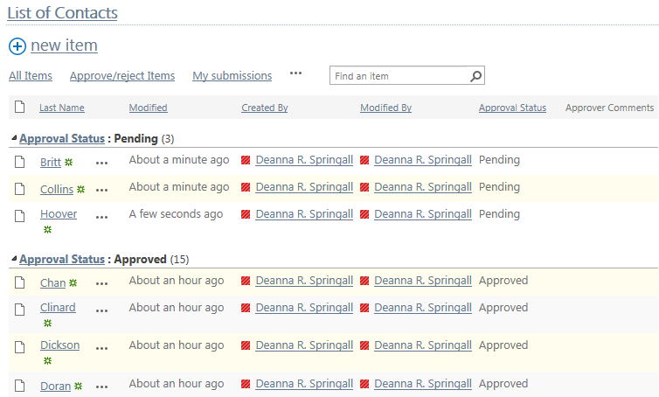
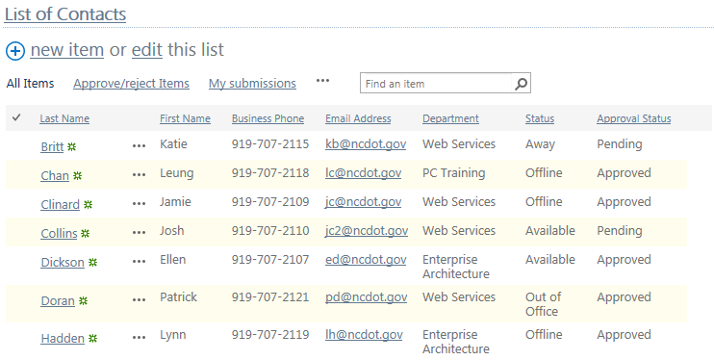
- In either view, click the ellipsis next to the title of the item, and click Approve/Reject.
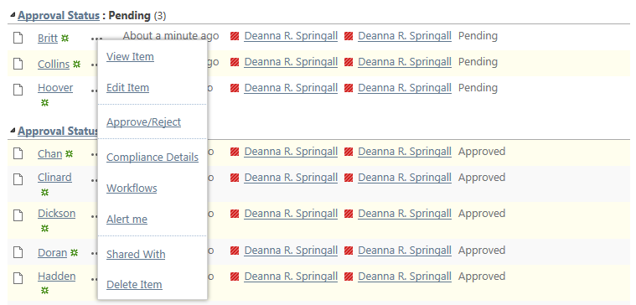
- Click Approved, add comments as needed and click OK.
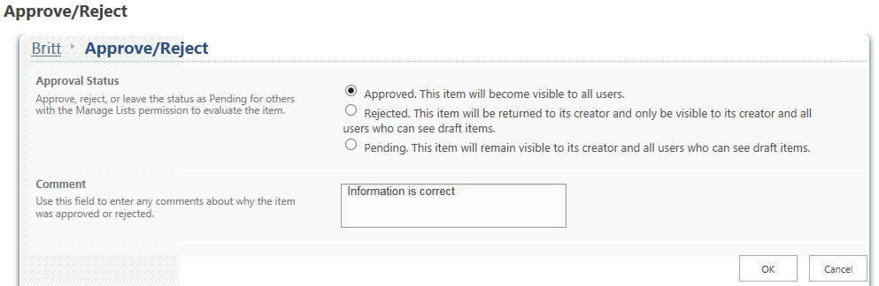
The Approval Status changes to Approved and the comments are posted.
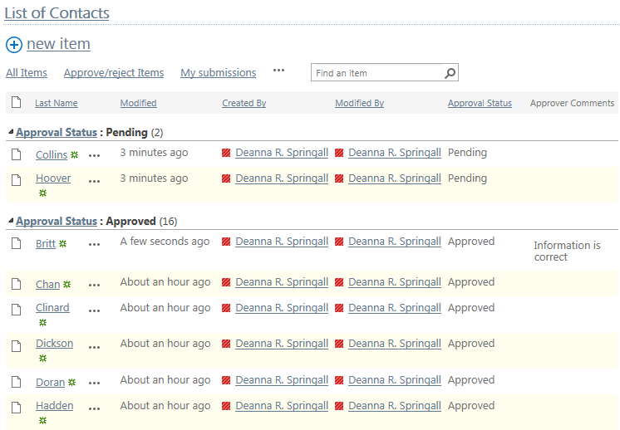

Approve or Reject an Item – Method 2
- In the All Items view, select the item by clicking the checkbox next to the title of the item.
- On the ribbon, click the FILES tab. In the Workflows section, click Approve/Reject.
- Click Approved, add comments as needed and click OK. The Approval Status changes to Approved. If the column is on in the All Documents view, the comments also appear.

