Attach a File to an Item
By default, a list allows attachments to list items. Designers can disable this feature if desired.
- Navigate to the list.
- Select the item for the attachment by clicking the checkbox next to the title of the item.
- On the ribbon, click the ITEMS tab. In the Manage group, click Edit Item.
- On the ribbon, click the EDIT tab. In the Actions group, click Attach File.
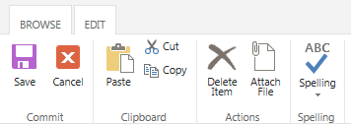
- Browse to the file to attach, click the name of the file, and click OK.
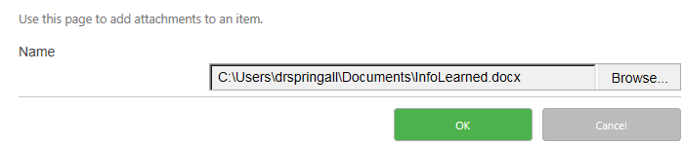
- Click Save.
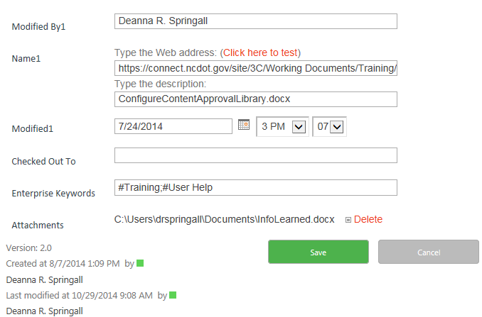
- Confirm that the file is attached. Click the ellipsis by the title of the item and click View Item.
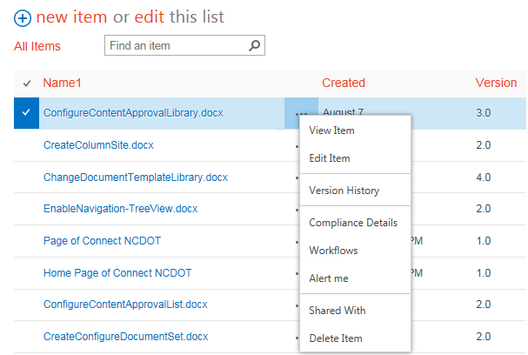The file is now part of the item’s properties.
