Overlay Multiple Calendars
You can overlay multiple SharePoint calendars so your users can view the events from several different calendars in one, coordinated color-coded calendar. This way, team and project members do not have to visit multiple calendars.
- Navigate to the calendar. This example shows how to overlay a project calendar on a team calendar.
- In the team calendar, click the CALENDAR tab, and click Calendars Overlay.
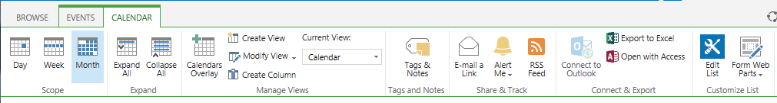
- In Calendar Overlay Settings, click New Calendar.
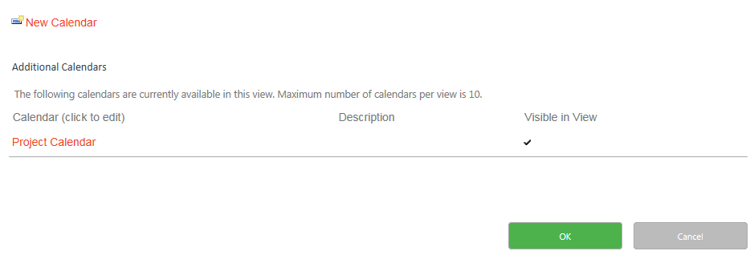
- Enter a name for the project calendar.
- Click SharePoint.
- If needed, include a short description of the project calendar.

- Change the Color theme for the project calendar if needed.
Note: Use different colors for different calendars, so it is easier to distinguish types of events.
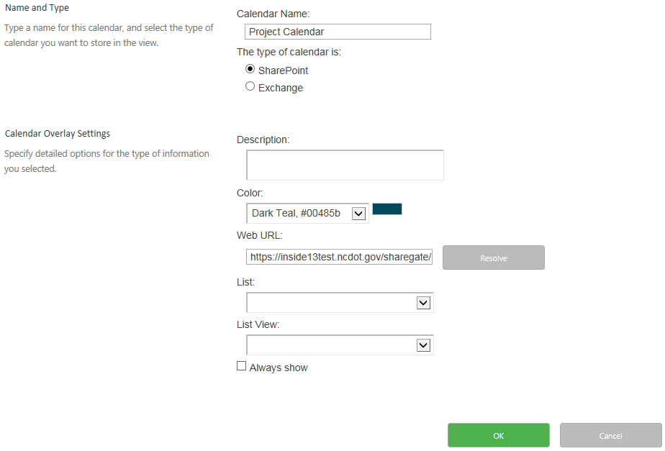

- Enter the Web URL (address) of the SharePoint site that contains the project calendar. In this example, the project calendar is in the same site as the group calendar, so Web URL is already completed. Click Resolve.
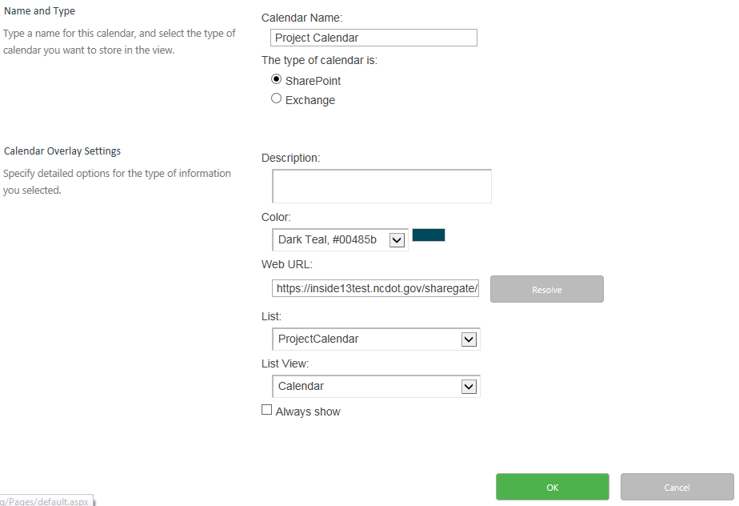
- Click the List drop-down arrow, and click the calendar to be overlaid.
- Click the List View drop-down, and click the view of the calendar to be overlaid.
- Repeat these steps to add up to ten overlays.
- If you want the calendars to always be overlaid, check Always show.
- Click OK to accept the overlay, and click OK to finish. In this example, the team calendar and the project calendar are listed in Calendars in View. 