Change Default Column Values – Library
Assigning a default value to a library column can speed data entry and improve accuracy. For example, if the Data Security Classification value for most files in a library is Unrestricted, set it as the default value for that column. That way, the user only has to change the value to Restricted when necessary. If needed, you can also set default values at the folder level within a library.
If a value for the property already exists in the file before it’s uploaded, the value is not overridden by the default value. Here’s an example where a file already had a Document Type of libraries before it was uploaded to a folder that had Lists set as the default Document Type.
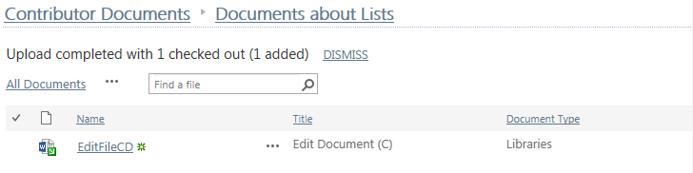
Once a default value is assigned to a file, you can edit the file properties to change the value if needed.

Contents
Library with No Folders
Library with Folders

Library with No Folders
- Navigate to the library.
- On the ribbon, click the LIBRARY tab. In the Settings group, click the Library Settings icon.
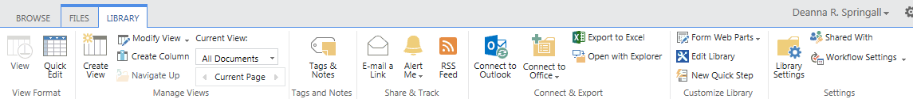
- On the Settings page in the General Settings column, click Column default value settings.
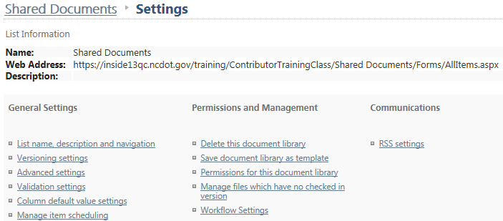
- Columns and default values are listed. To change the default, click the column name.
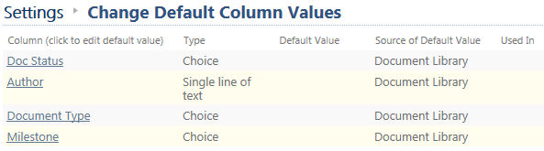
- In the Edit Default Value dialog, click Use this default value, enter a default value of Plan, and click OK. Although the values are defined as a choice, you must know what to enter here.
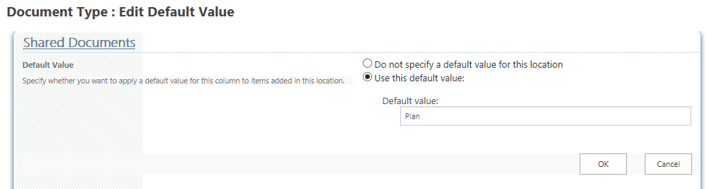

The column now has a default value listed on the settings page.
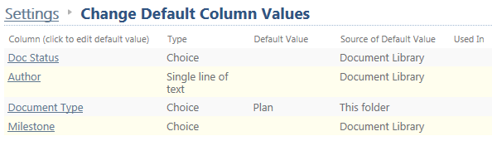
- Navigate back to the library. On the ribbon, click the FILES tab. In the New group, click Upload Document and select a file. Once uploaded, the file properties are displayed and the Document Type is already assigned a value of Plan.
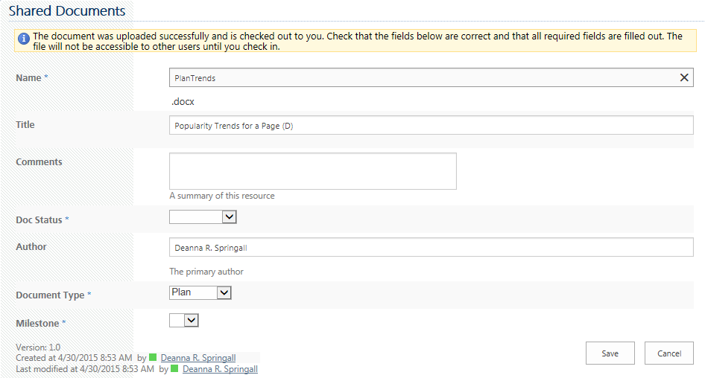

Library with Folders
- Navigate to the library. Notice there are two (empty) folders in the library.
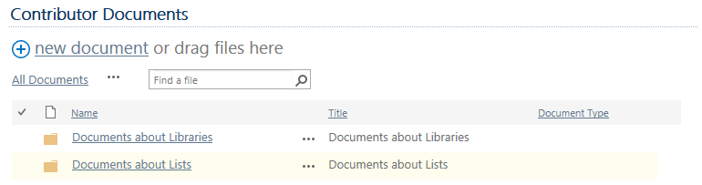
- On the ribbon, click the LIBRARY tab. In the Settings group, click the Library Settings icon.
- On the Settings page in the General Settings column, click Column default value settings.
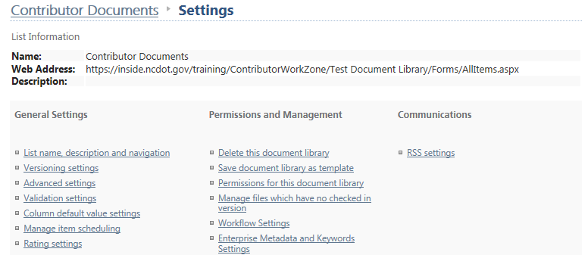
- Columns and default values are listed for the top level of the library. Click the column name to change its default value.
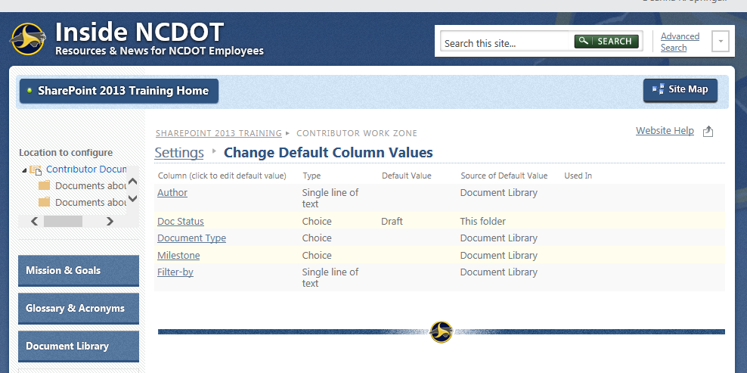

- In the Edit Default Value dialog, click Use this default value, enter a default value of Help, and click OK. Although the values are defined as a choice, you must know what to enter here.
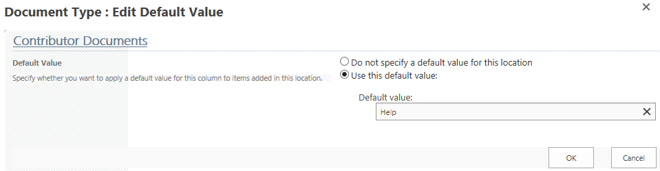 The column now has a default value listed on the Settings page.
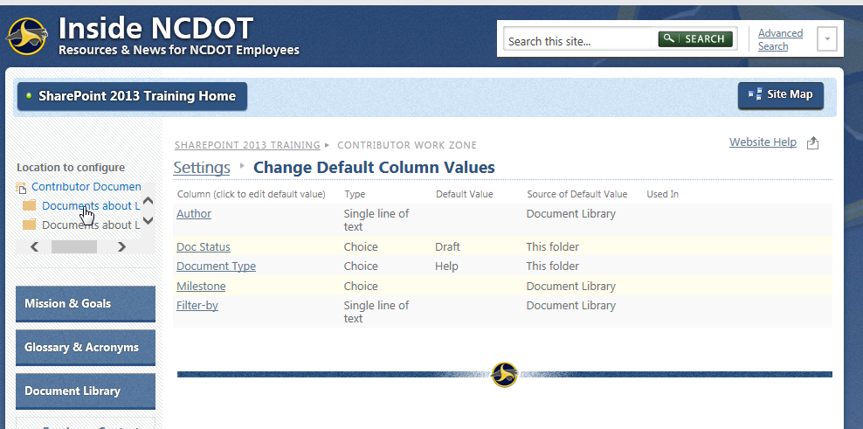
- To change the default value for a folder, click the folder.
- Columns and default values are listed for the folder. The folder inherits the default value from the top level of the library. Click the column name to change its default value.
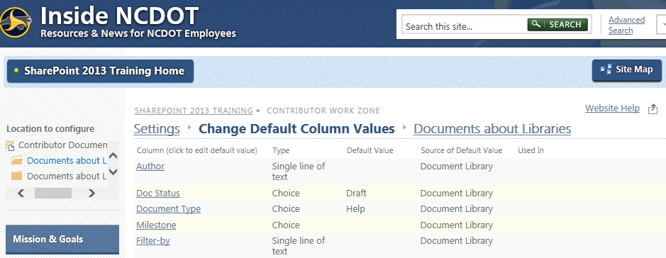
- In the Edit Default Value dialog, click Use this default value, enter a default value of Libraries and click OK. Although the values are defined as a choice, you must know what to enter here.
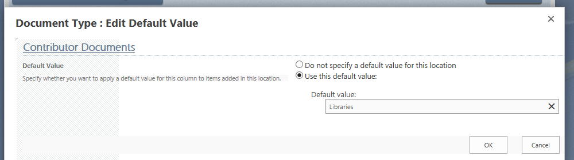
The column has a new default value listed on the Settings page and the folder has a small icon to indicate that a default is set.
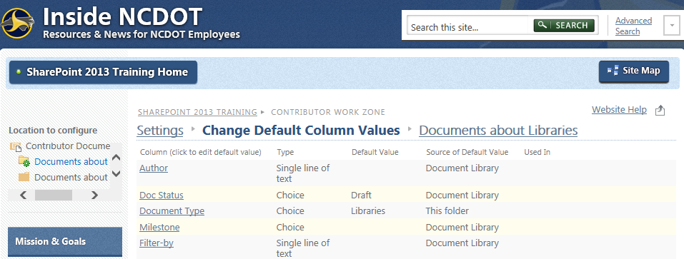

- Click the other folder. Columns and default values are listed for the folder. The folder inherits the default value from the top level of the library. Click the column name to change its default value.
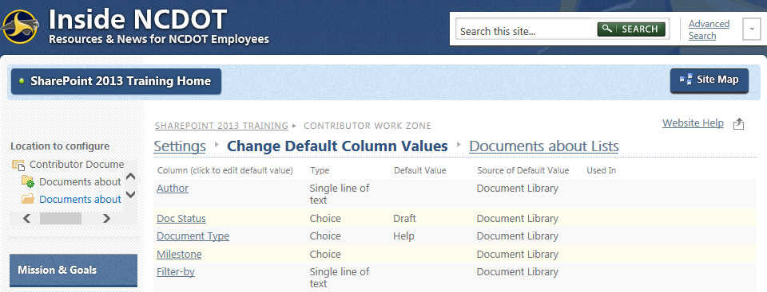
- In the Edit Default Value dialog, click Use this default value, enter a default value of List, and click OK. Although the values are defined as a choice, you must know what to enter here.
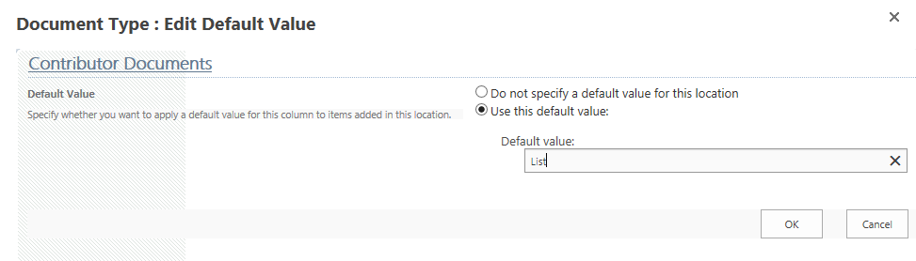
The column now has a new default value listed on the Settings page and the folder has a small icon to indicate that a default is set.
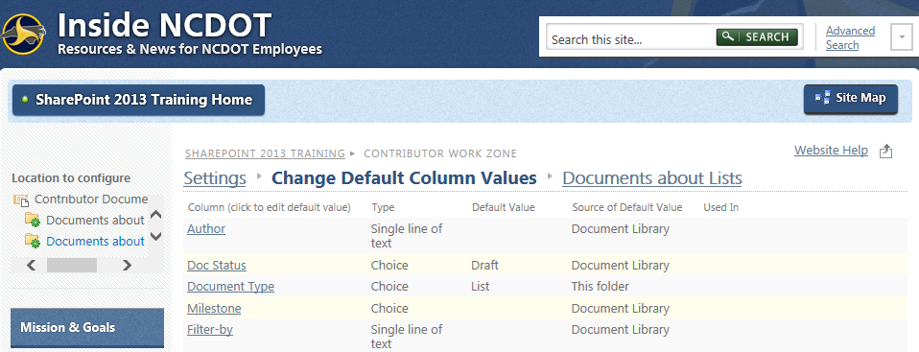

To test the default values, upload documents to each folder. Here’s an example for one folder.
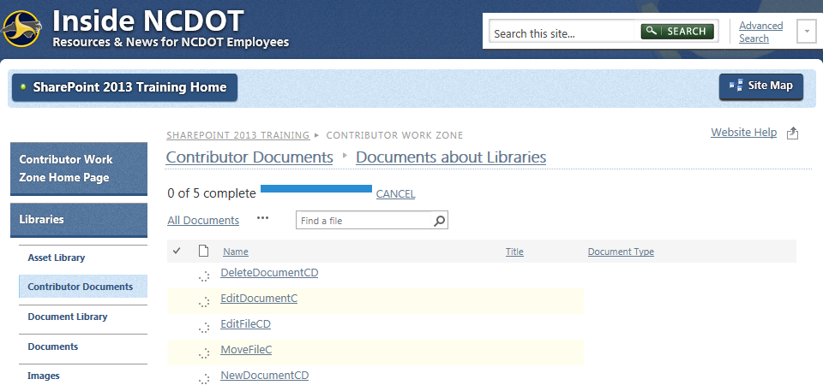
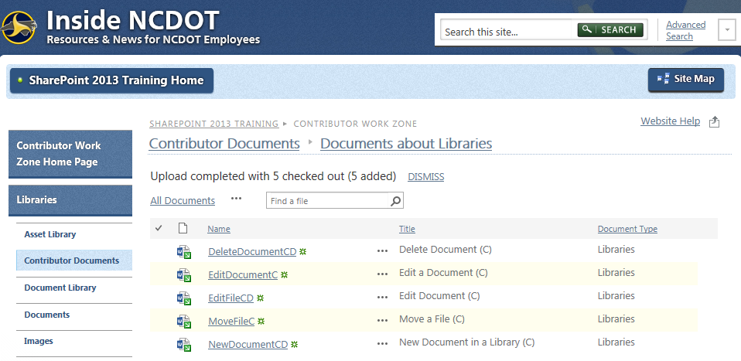

And here’s an example for the top level of the library.
