Compare Versions of a Page
You can compare different versions of a page if you need to track changes or find information that was deleted earlier. The number of versions kept is determined when versioning is configured.
Many pages on Inside NCDOT and Connect NCDOT contain only web parts. Because page history does not track changes within web parts, you may not see as many changes as you’d expect when you compare page versions.

Contents
Compare Current Version to Earlier Version
Compare Two Earlier Versions

Compare Current Version to Earlier Version
- Navigate to the page.
- On the ribbon, click Page. In the Manage group, click Page History.
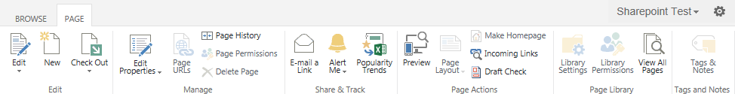
- In the Page History, the left column lists the current version (5.1) and earlier versions.

- In the Compare with version drop-down, click an earlier version to compare with the current version. Here we are comparing Version 5.1 to version 0.1.
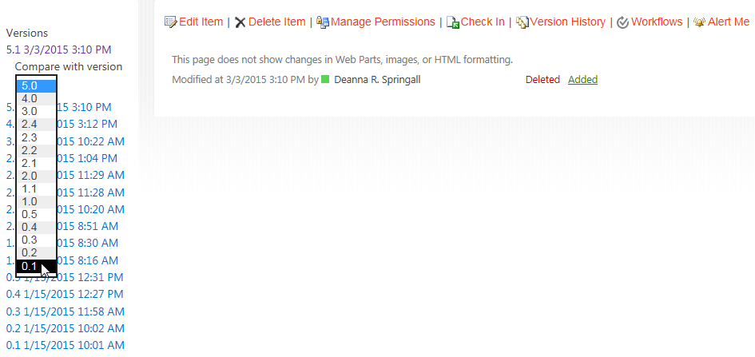The comparison indicates that a change was made to the title.
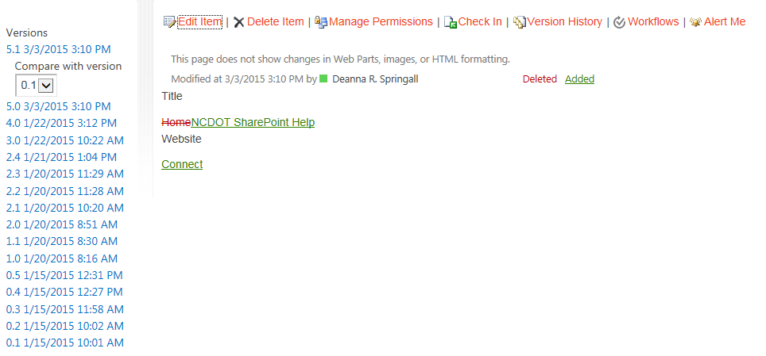

Compare Two Earlier Versions
- Click the first version to compare; in this example, click 1.0. The Compare with version drop-down moves below the selection.
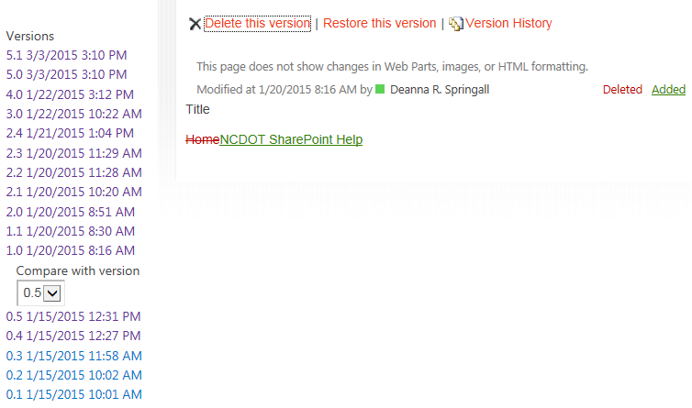
- In the Compare with version drop-down, select an earlier version (0.1). Here we are comparing Version 1.0 to Version 0.1.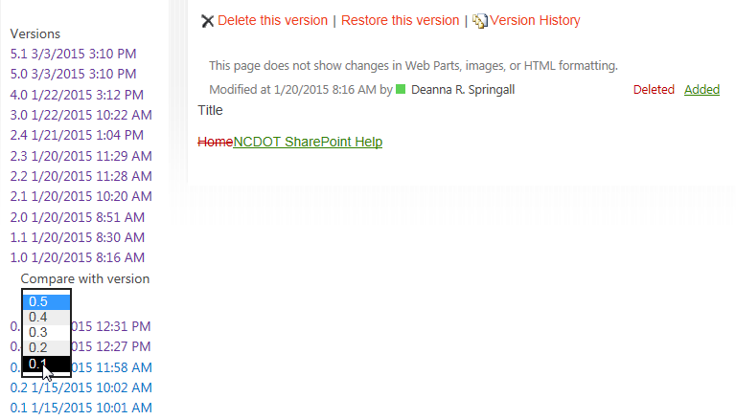

The comparison shows the same change as before. So, this narrows down when the change was made. Instead of being made between versions 5.1 and 0.1, it was made between versions 1.0 and 0.1.
