Connect to Office
This feature adds a shortcut to a SharePoint library in your Office applications so you can easily access files in the library from within Office.
- Navigate to the library.
- On the ribbon, click the LIBRARY tab. In the Connect & Export group, click the down arrow next to Connect to Office, and click Add to SharePoint Sites.
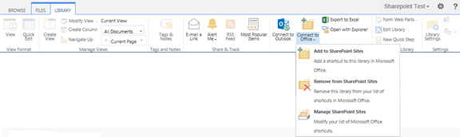A shortcut is placed in the SharePoint Sites folder in the Favorites list in Windows Explorer.
