Connect a Contacts List to Outlook
You can connect a SharePoint contacts list into Outlook.
- Navigate to the SharePoint contacts list.
- On the ribbon, click the LIST tab. In the Connect & Export group, click the Connect to Outlook icon.
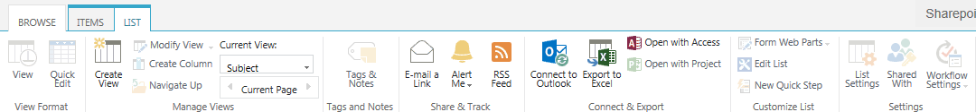
- Click Allow to open the program.
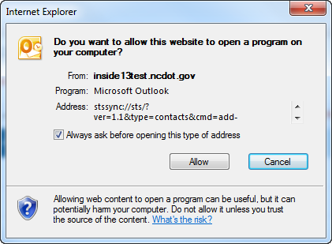
- If prompted, click Yes to connect the contacts list to Outlook.
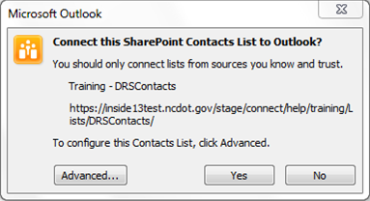
- If prompted, log in.
- Open Outlook. The SharePoint contacts list appears in the Contacts section of the navigation pane, under Other Contacts.
