Connect a Library to Outlook
Document libraries can be displayed within Outlook so you can access the files without opening SharePoint. You can easily switch between multiple libraries using the Outlook navigation options.
Note: If the Connect to Outlook option is grayed out, call or email the Help Desk to request assistance from Web Services.

Contents
Connect the Library to Outlook
Find a File
Edit a File
Print a File

Connect the Library to Outlook
- Navigate to the SharePoint document library.
- On the ribbon, click the LIBRARY tab. In the Connect & Export group, click Connect to Outlook.
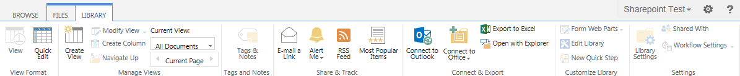
- Click Allow to open the program.
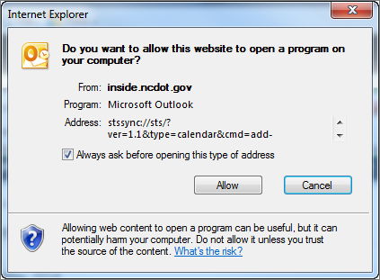
- If prompted, click Yes to connect the library to Outlook.
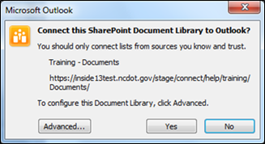
- If prompted, log in.
- Open Outlook. All files in the library are downloaded to Outlook.
- Expand SharePoint Lists to see the name of the library. The total number of files in the library is in parentheses. Click the library name to see all downloaded files.
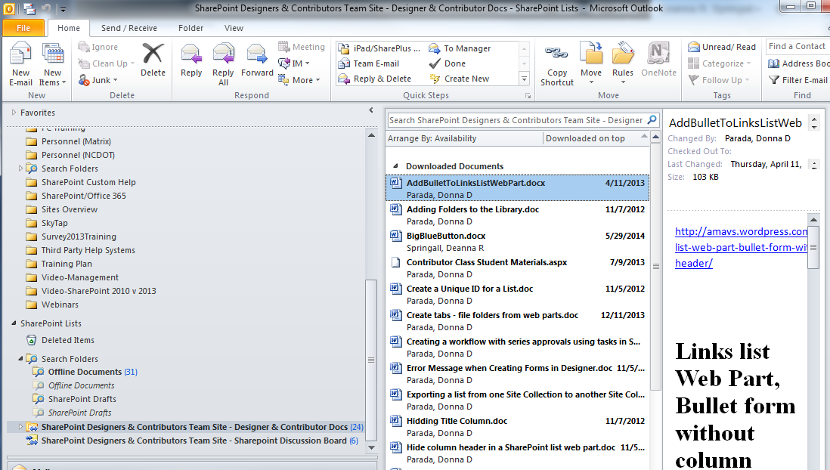

Find a File
- Open Outlook.
- Expand SharePoint Lists in the navigation pane. Click the name of the library to display a list of its files.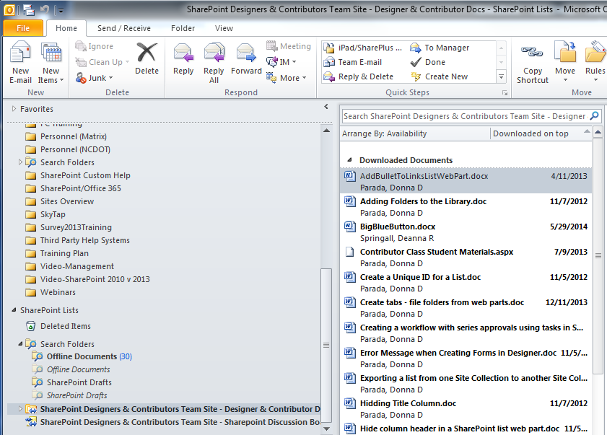
- Enter the search query in the search box and press Enter. Files with that text in their title or body are listed.
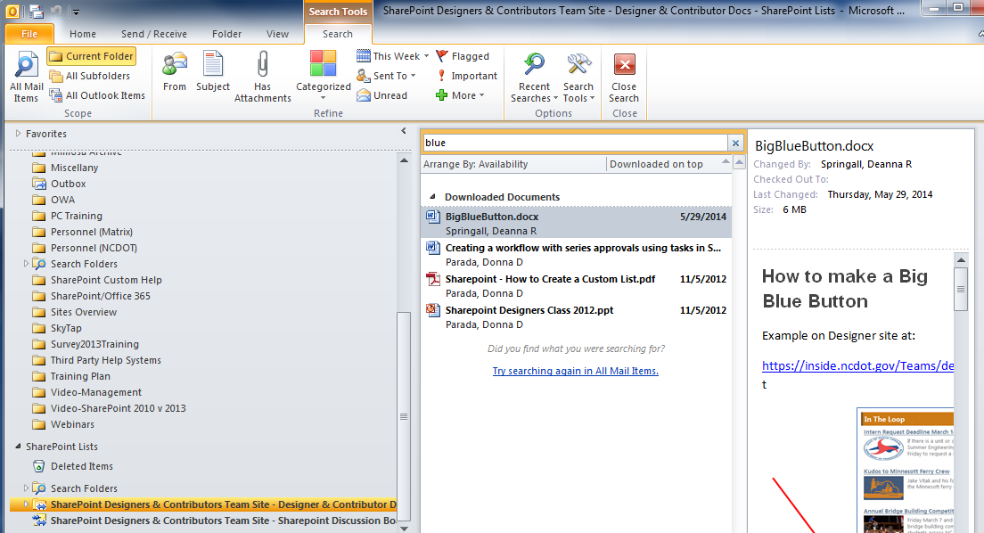
Click the library name if you need to refresh the list.

Edit a File
Note: Only Contributors and Designers can edit files in the library; files cannot be added or removed.
- Open Outlook.
- Expand SharePoint Lists in the navigation pane. Click the name of the library to display a list of its files. Double-click the file to open it in its Office application.
- Click Edit Offline.
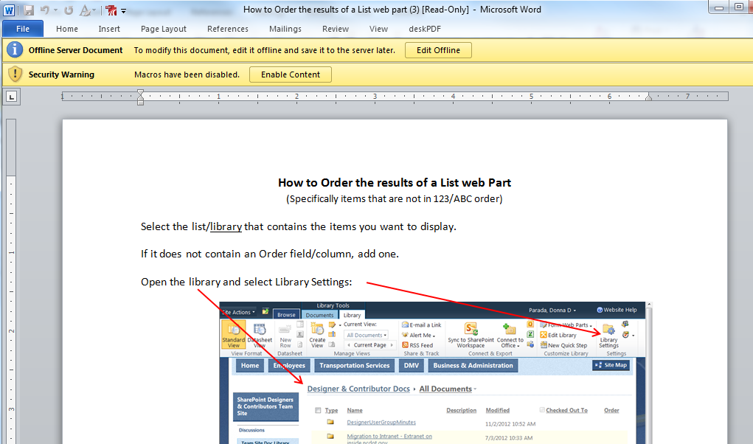
- Click OK to confirm the editing.
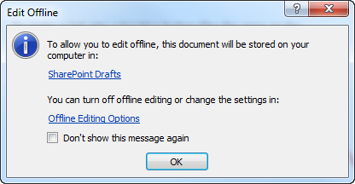
- Make any necessary changes, and click Save.
- When prompted, click Update.
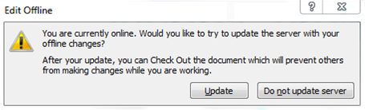

Print a File
- Open Outlook.
- Expand SharePoint Lists in the navigation pane, and click the name of the library that contains the file to print.
- Right-click the file name, and click Quick Print from the menu.
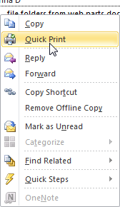
- Click Open to trust and print the file.
