Connect (Overlay) a SharePoint Calendar to Outlook
You can connect SharePoint calendars to your Outlook calendar to see multiple schedules at once. You can overlay the calendars or view them side by side.
Depending upon your SharePoint permissions, changes may be automatically synchronized with Outlook as you work with the SharePoint calendar. For example, if you are in Outlook and add an appointment to the SharePoint calendar, it automatically appears in the SharePoint calendar on the team site. Similarly, if you are in the team site and add an appointment to the SharePoint calendar, it automatically appears in the Outlook calendar.

Contents
Create the Overlay
Hide the Overlay
Remove the Overlay

Create the Overlay
- Navigate to the SharePoint calendar.
- On the ribbon, click the CALENDAR tab. In the Connect & Export group, click Connect to Outlook.
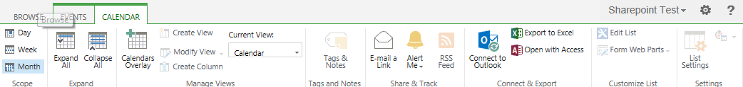
- When prompted to allow the website to open a program, click Allow.
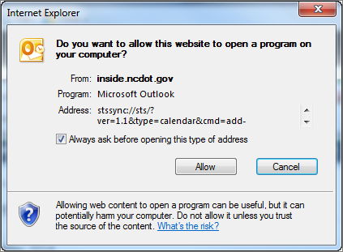
- When prompted to connect the SharePoint calendar to Outlook, click Yes.
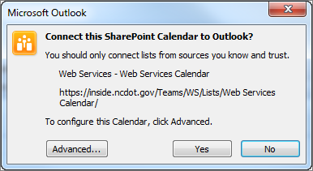
The calendars appear side-by-side in Outlook, and the SharePoint calendar appears under Other Calendars in the calendar folders.
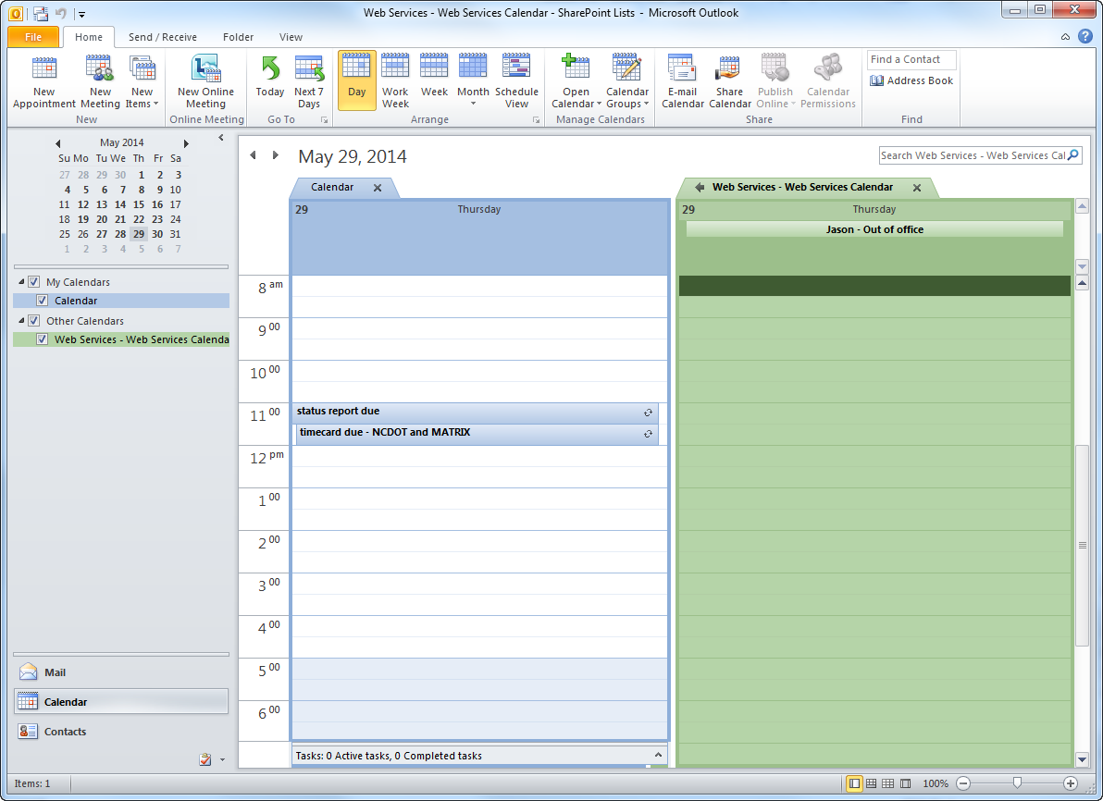
- Click the left arrow on the right calendar to overlay the two calendars.
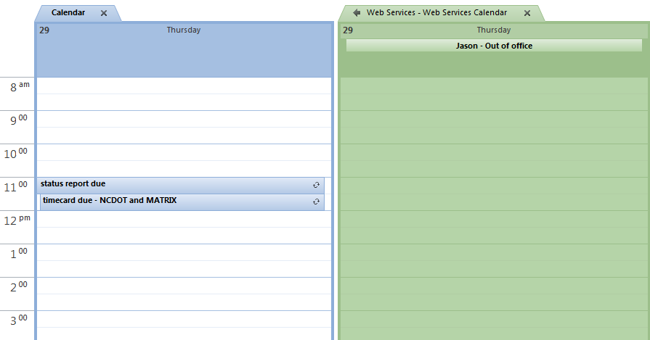This is how the overlay appears.
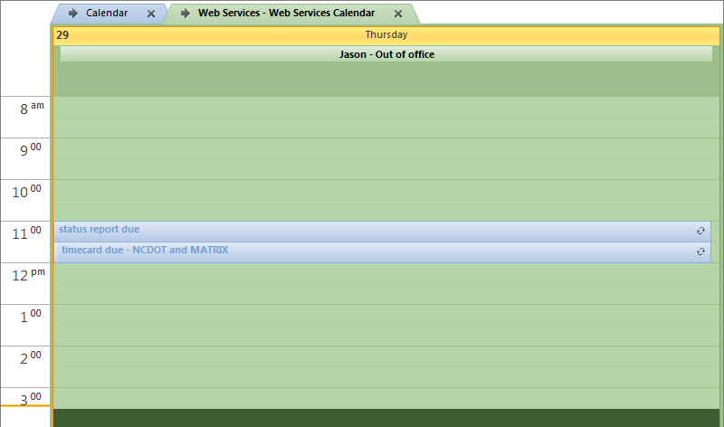

Hide the Overlay
Turn the overlay on and off by clicking the checkbox next to the name of the calendar in the left column.

Remove the Overlay
To remove the calendar from Outlook, right-click the calendar name (either in the top tab or in the left column), and click Delete Calendar. The calendar is removed from Outlook but not from the SharePoint site.

