Configure Content Approval for a List or Library
When Content Approval is enabled, new and modified files are treated as drafts and are given a Pending status. By default, drafts are only visible to their authors and to approvers until an approver changes the status from Draft to Approved.
When Content Approval is enabled, a new column and new views are added to the library.
Note: Content Approval, Versioning and Check Out/In are interrelated. Refer to the help files on Versioning and Check Out, Check In or Discard a Check Out. Also, refer to the Designer class materials on Versioning for a detailed explanation of the interrelationship.
- Navigate to the list or library.
- On the ribbon, click the LIST or LIBRARY tab. In the Settings group, click List Settings or Library Settings. This example uses a library.
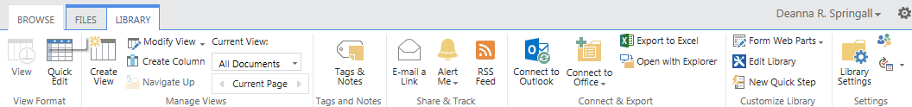
- On the Settings page under General Settings, click Versioning settings.
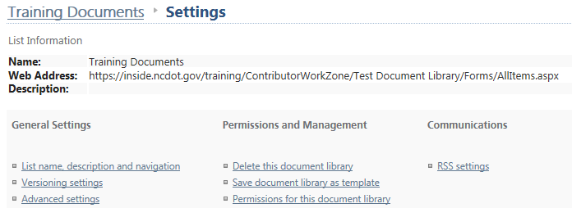
- In the Content Approval section, click Yes to Require content approval for submitted items.
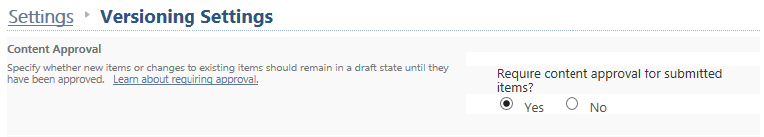

- The Draft Item Security settings are only available after Content Approval is enabled. The default is Only users who can approve items (and the author of the item); if you choose Only users who can edit items, drafts can be seen by Contributors and Designers. Change Draft Item Security as needed and click OK to confirm the change.
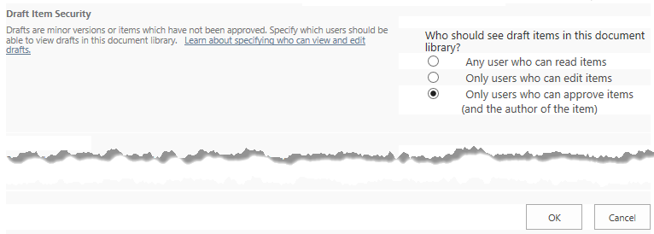
- Return to the library. The Approval Status column and Approve/reject Items and My submissions views have been added.
