Content Editor Web Part
Rather than place the same content repeatedly on different web pages, it is far more efficient to maintain that content in one file and reuse the same file wherever it’s needed. The Content Editor web part lets you do this.
For example, if you have a disclaimer that you want on several different pages, place the statement in a text file and store that file in a library. Then, add a Content Editor web part on any page that needs the disclaimer. The Content Editor links to the text file, extracts the disclaimer from the file, and displays it on the page.
In addition to text, this approach can also be used for JavaScript, CSS, HTML, or other reusable content.
The Content Editor web part can also be used to add and format text (such as an introductory paragraph or an explanation) that does not reside in a list or library. NCDOT discourages using the Content Editor for this because you must have Designer permissions to access pages and web parts in order to edit the text. If you want Contributors to maintain content, use the NCDOT Announcement List Content web part because you only need Contributor permissions to edit lists.
Note: The Edit Source option appears under the FORMAT TEXT tab when you edit a page. While you can use Edit Source to change a page’s HTML, NCDOT recommends using the Script Editor web part because it offers more options.

Contents
Link to Content in Another File
Enter and Format Text

Link to Content in Another File
- Navigate to the page where you want to add a Content Editor web part and link to a file. In this example, the text file contains a copyright statement to be placed at the bottom of the Center zone.
- Click the Settings gear, and click Edit page.
- Click Add a Web Part in the Center web part zone. The web part gallery opens below the ribbon. In the Categories section, click the Media and Content category. In the Parts section, click Content Editor, and click Add.
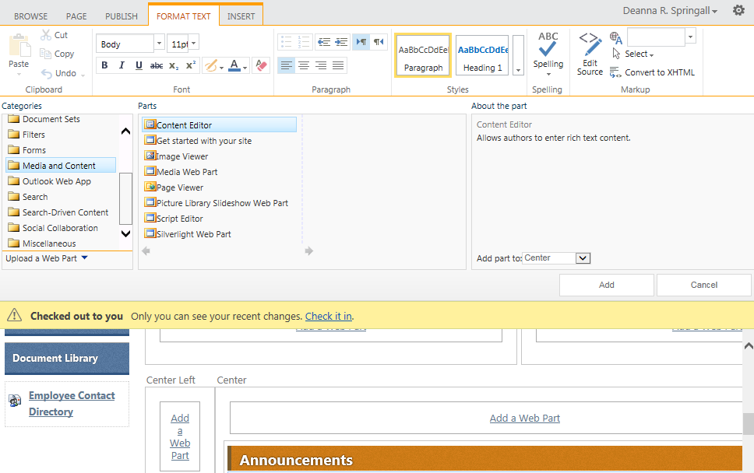
- Hover over the title of the web part, click the down arrow, and click Edit Web Part.
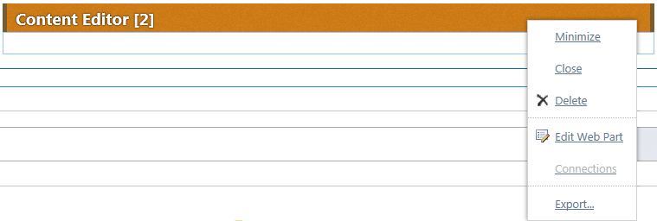
- In the tool pane, enter the location of the text file in the To link to a text file, type a URL text box. Click Test Link to ensure the link is correct.
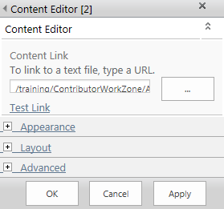
- Expand the Appearance section and change the Chrome Type to None.
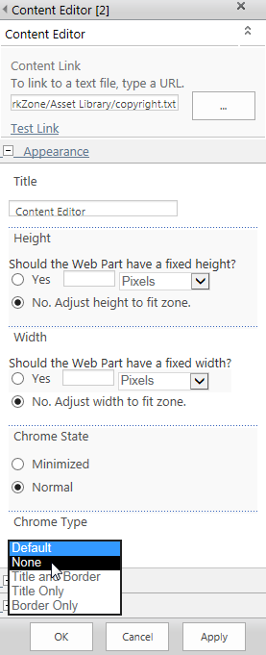

- The copyright statement needs to appear toward the bottom of the page. Expand the Layout section and enter a Zone Index that is larger than the Zone Index of the last web part in the Center zone. Click OK.
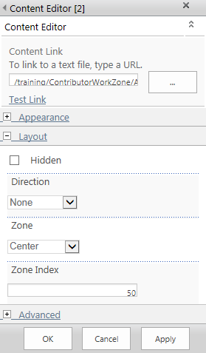
(If you do not want content such as HTML or CSS to appear on the page, expand the Layout section, check Hidden and click OK.)
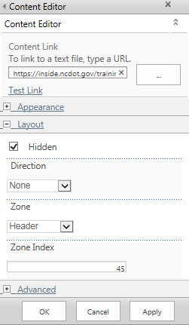
- Remember to save, check in, and publish the page. The copyright statement appears at the bottom of the Center web part zone.
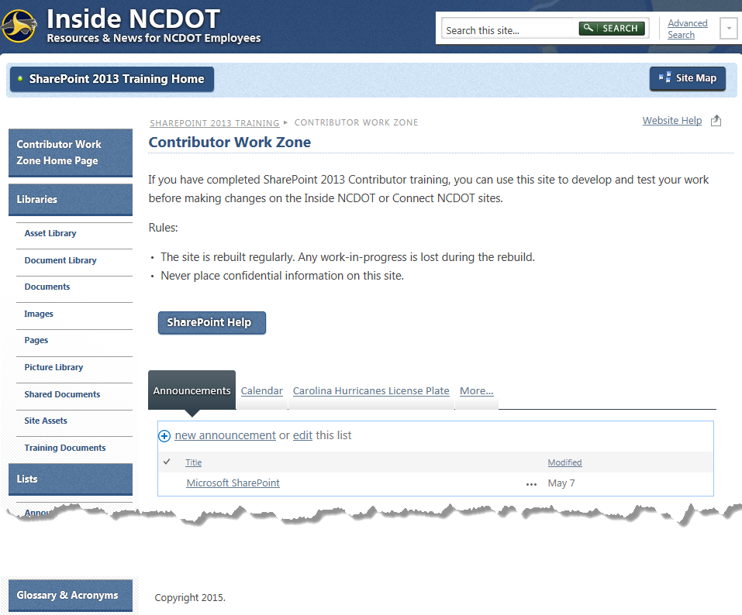

Enter and Format Text
Note: If you use the Content Editor web part for simple text placement, only those with Designer permissions will be able to open the page and web part for editing.
- Navigate to the page where you want to add a Content Editor web part.
- Click the Settings gear, and click Edit page.

- Click Add a Web Part in the web part zone where you want to add content. The web part gallery opens below the ribbon. In the Categories section, click the Media and Content category. In the Parts section, click Content Editor and click Add.
- In the Content Editor web part, click Click here to add new content.
On the ribbon, additional tabs appear for formatting and inserting.
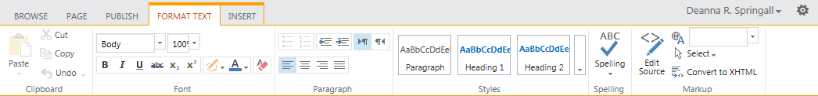You can now enter text directly into the Content Editor.
- Enter and format text as needed. Here, text has been pasted from Notepad, so the default font and font size are used.
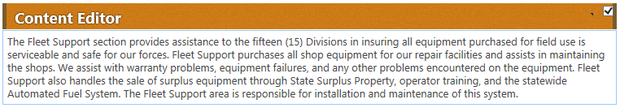

- Here, options under the FORMAT TEXT tab have been used to change the font and font size and to add bolding.
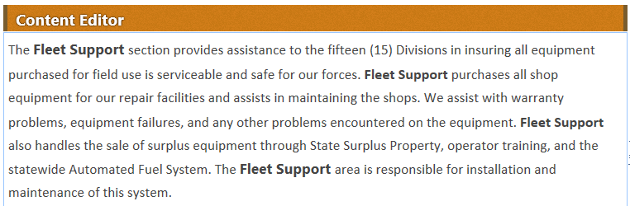
- Here, options under the INSERT tab have been used to insert a table and a picture.
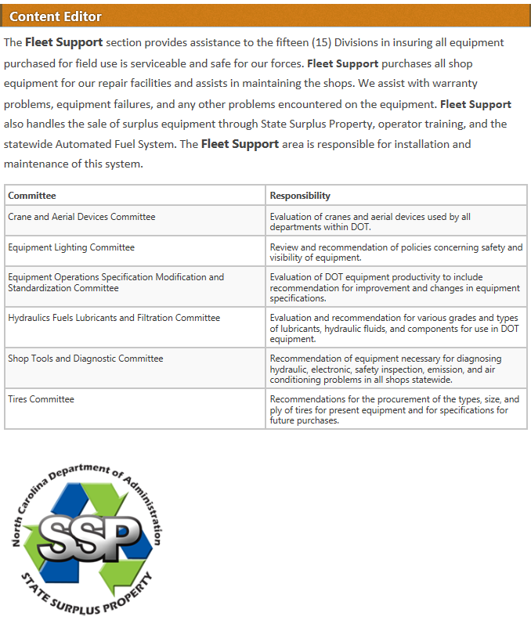
- Remember to save, check in, and publish the page.

