Content Query Web Part
The Content Query web part (CQWP) lets you query an individual list or library, a site and its subsites, or an entire site collection. The query can be limited to a specific type of list (such as Announcements) or library (such as a Document library) and the results can be filtered, grouped and sorted. Much of the CQWP’s power lies in this ability to work across sites.
NCDOT also uses the CQWP to display content in a manner that is more visually appealing and easy to use than the displays available through the use of standard SharePoint views and filters or the List View web part.

Content
CQWP on Inside NCDOT
CQWP on Connect NCDOT
Display Library Content
Display Library Content from One Site on Another Site
Combine Content from Several Announcement Lists

CQWP on Inside NCDOT
On Inside NCDOT, a view of 2015 Planning Documents in a Shared Documents library looks like this.
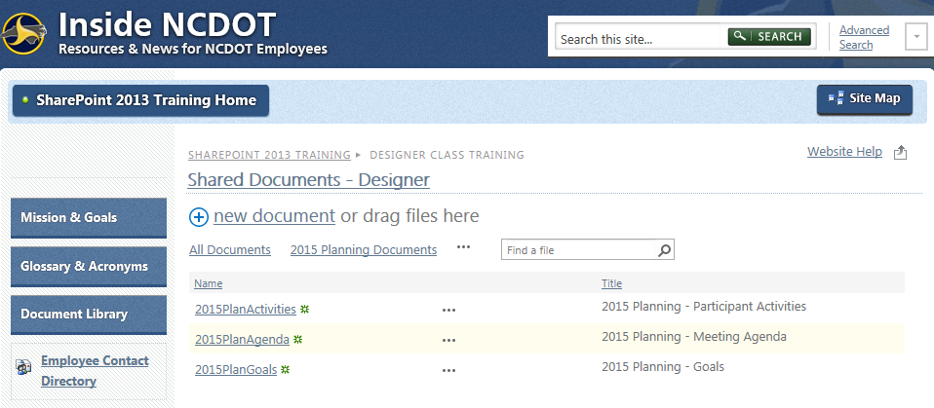

If you use the List View web part to display the 2015 Planning Documents view on another page, you can hide the toolbar and add a title to the web part make the look-and-feel more appealing.
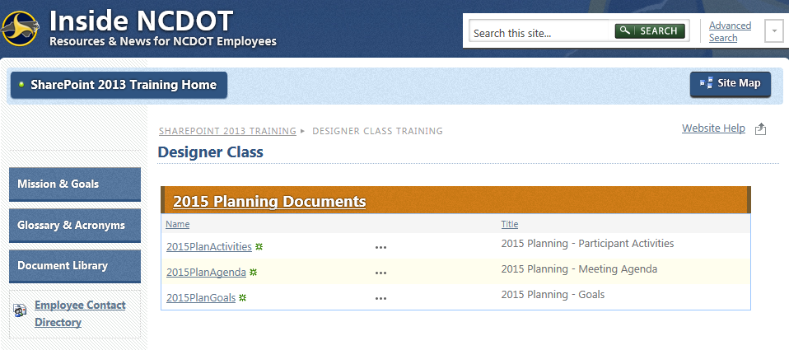
The CQWP displays the information in a much more pleasing manner, however, by using only the title with a link, removing the ellipsis, and using an image for the bullet.
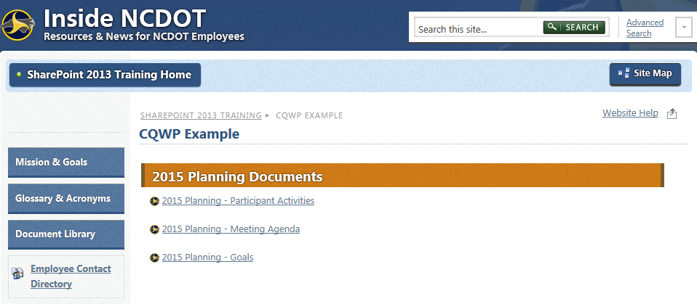

CQWP on Connect NCDOT
On Connect NCDOT, this is the Help, Search and Find view in a Documents library.
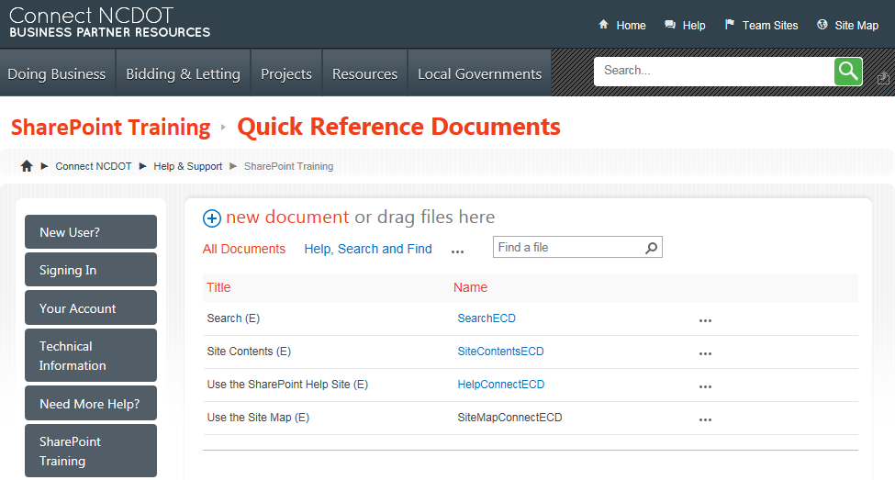
If you place the Help, Search and Find view on another page with the List View web part, you can hide the toolbar and add a title to the web part to improve the display.
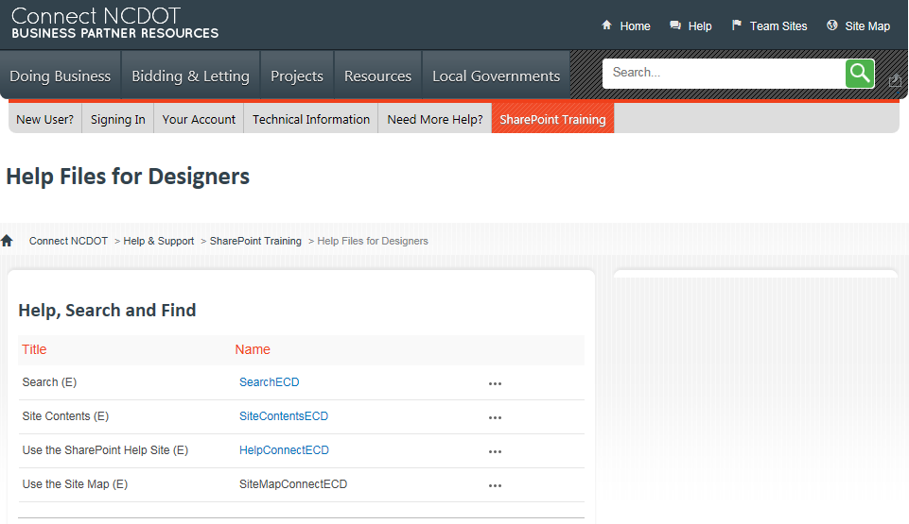

Again, the CQWP displays the information in a much more pleasing manner by using only the title with a link, removing the ellipsis, and using an image for the type of document.
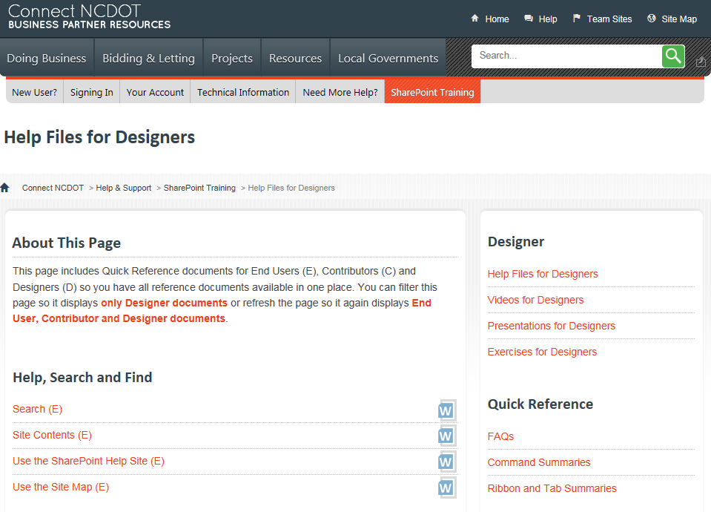

Display Library Content
This example queries a library and displays selected documents from the library on another page in the same site. This is an example of the library and its contents.
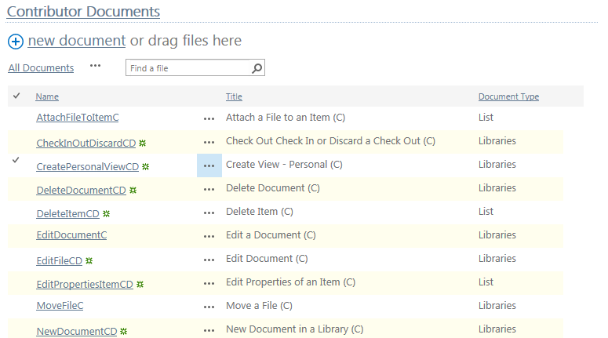
- Navigate to the page where you want to add a CQWP.
- Click the Settings gear, and click Edit page.

- In the zone where you want to place the CQWP, click Add a Web Part. The web part gallery opens below the ribbon. In the Categories section, click Content Rollup. In the Parts section, click Content Query, and click Add.
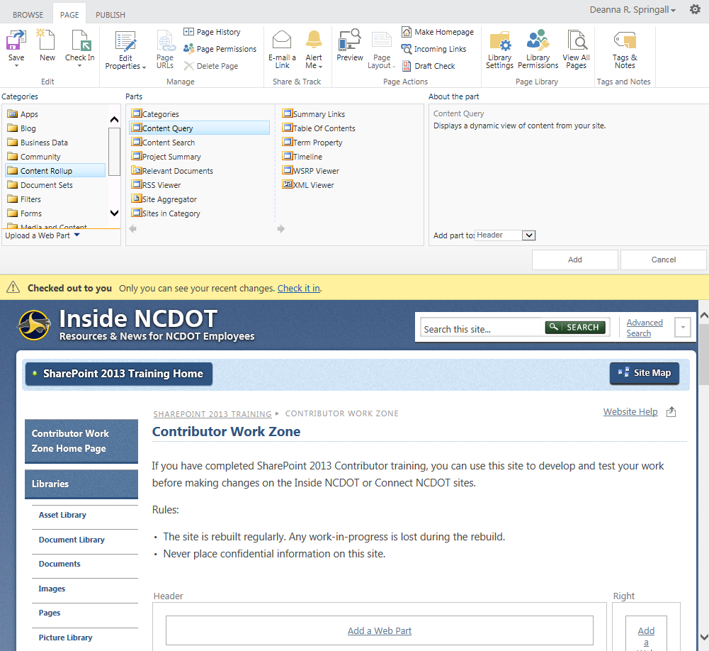
- In the Content Query web part, click open the tool pane.
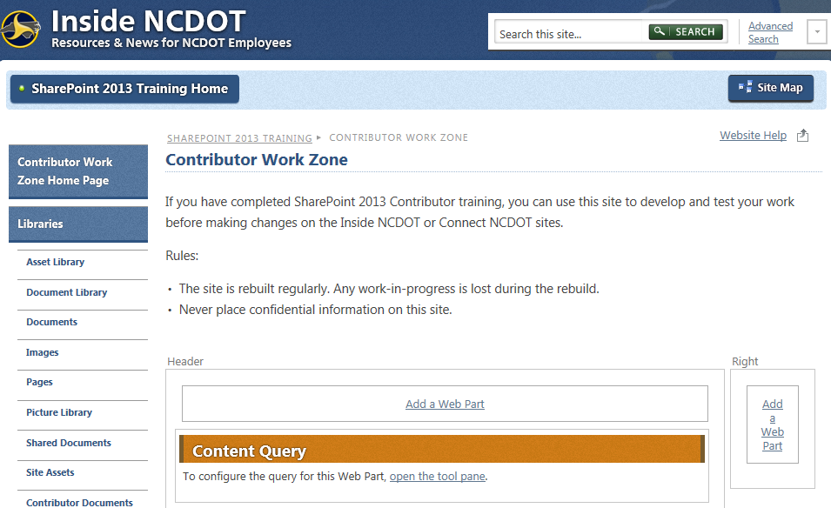
- In tool pane, expand the Query section.
- Choose Show items from the following list and click Browse. Click the library containing the documents and click OK.
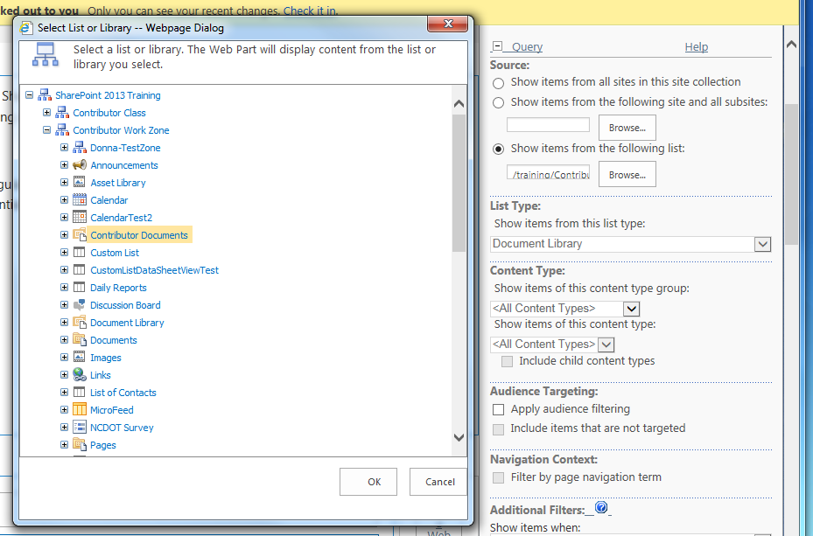The default List Type and Content Type are correct and do not need modification. There is no Audience Targeting or Navigation Context.
- Scroll down to Additional Filters and define a filter for Document Type is equal to Libraries.
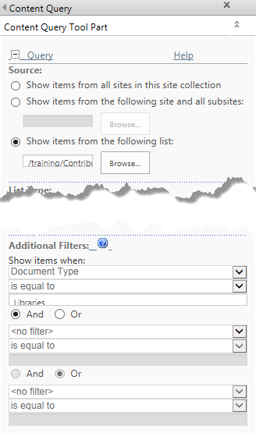
- Expand the Presentation section. Sort items by Title in ascending order. The Item Style of Image on Left creates a bulleted list with a hyperlinked Title.
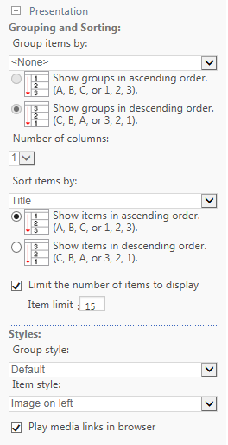
- Expand the Appearance section and enter Contributor Files as the Title.
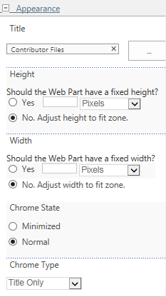
- Click OK to close the tool pane. Remember to save, check in and publish the page so users can see your changes. This is an example of the result.
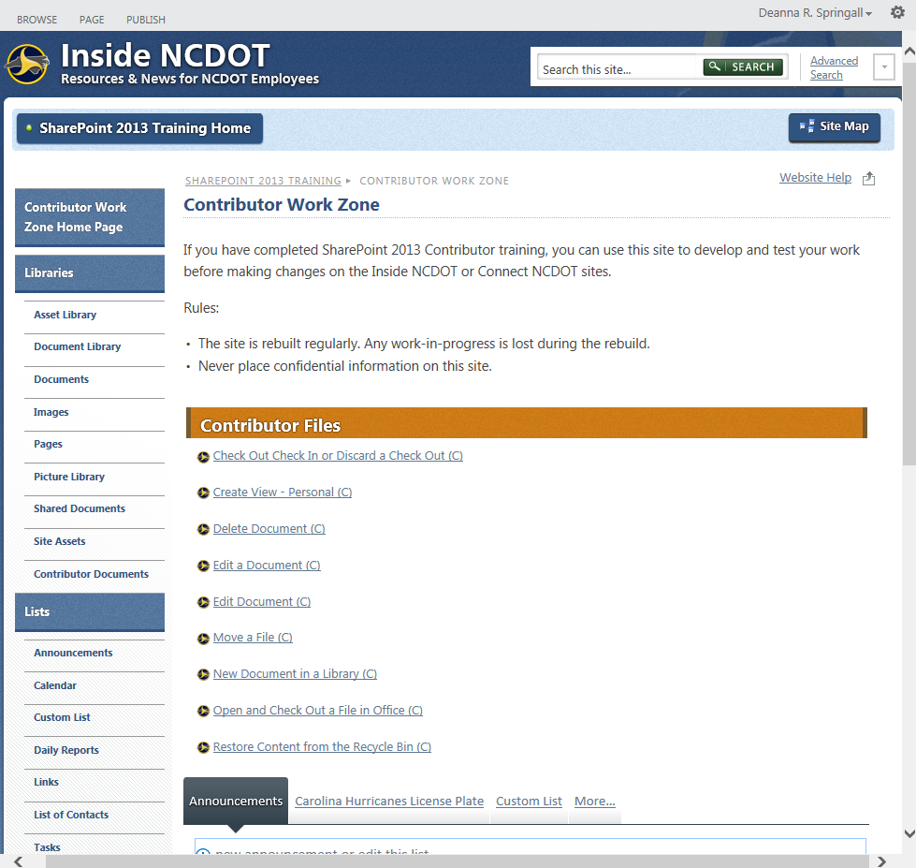

Display Library Content from One Site on Another Site
In the first example, you displayed a list from the same site. In this example, you are on one SharePoint site (Designer Training Zone) in the Training site collection but you are displaying a list from another SharePoint site (Contributor Training Zone) in the Training site collection.
- Navigate to the page where you want to add a CQWP.
- Click the Settings gear, and click Edit page.
- In the zone where you want to place the CQWP, click Add a Web Part. The web part gallery opens below the ribbon. In the Categories section, click Content Rollup. In the Parts section, click Content Query, and click Add.
- In the Content Query web part, click open the tool pane.
- In tool pane, expand the Query section.
- Choose Show items from the following list and click Browse. Browse to the library containing the documents. Note that it is in a different SharePoint site. Click OK.
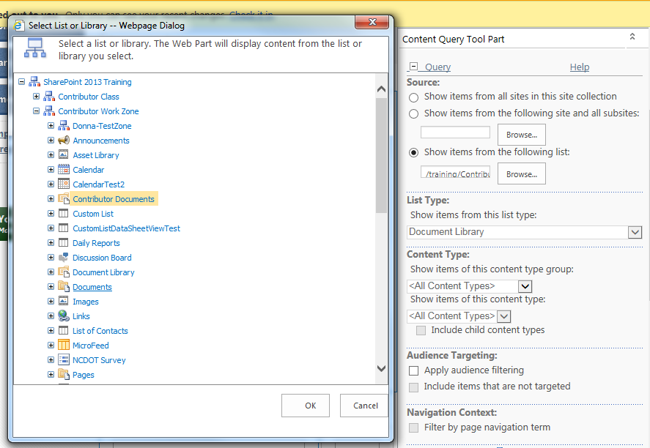
- The default List Type and Content Type are correct and do not need modification. There is no Audience Targeting or Navigation Context.
- Scroll down to Additional Filters, and define a filter for Document Type is equal to Libraries.
- Expand the Presentation section. Sort items by Title in ascending order. The Item Style of Image on Left creates a bulleted list with a hyperlinked Title.
- Expand the Appearance section and enter Contributor Files as the Title.

- Click OK to close the tool pane. Remember to save, check in and publish the page so users can see your changes. This is an example of the result.
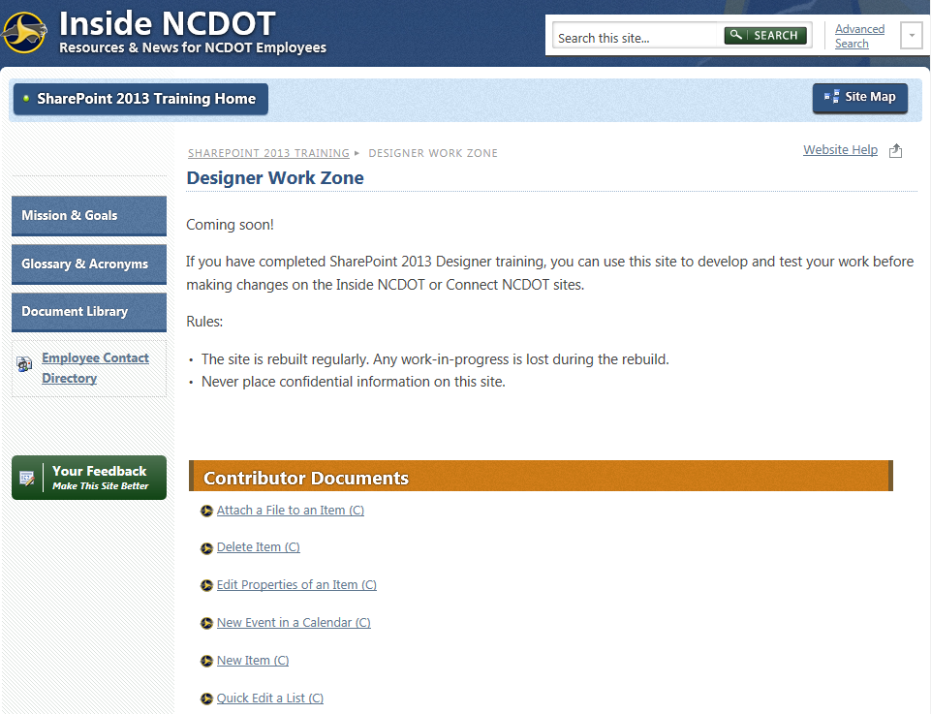

Combine Content from Several Announcement Lists
This example takes three announcement lists on different pages of a site and combines them into one list on the site’s home page. These are the three sets of announcements.
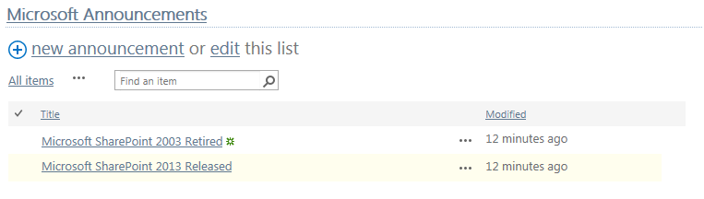
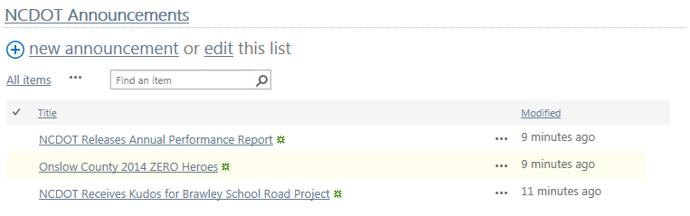
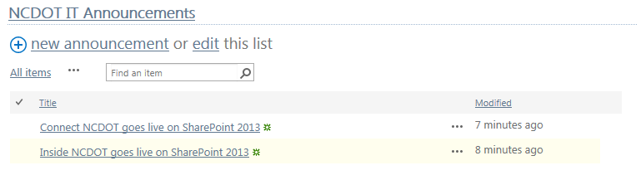
- Navigate to the page where you want to add a CQWP.
- Click the Settings gear, and click Edit page.
- In the zone where you want to place the CQWP, click Add a Web Part. The web part gallery opens below the ribbon. In the Categories section, click Content Rollup. In the Parts section, click Content Query, and click Add.
- In the Content Query web part, click open the tool pane.
- In the tool pane, expand the Query section.
- Choose Show items from the following site and all subsites and click Browse. Browse to the site containing the announcement lists. Click OK.
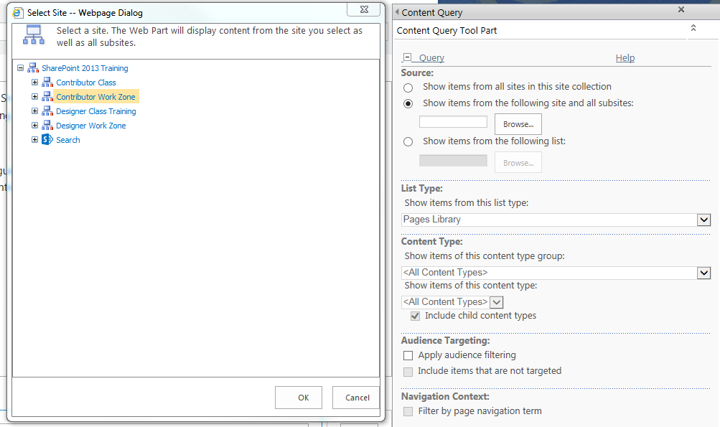
- Click Announcements as the default List Type.
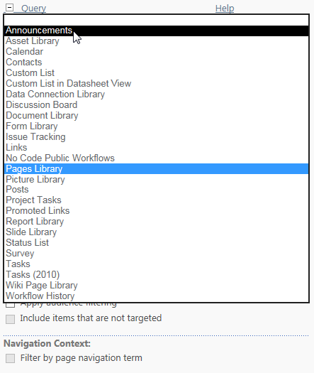
Content Type does not need modification. There is no Audience Targeting, Navigation Context or Additional Filters in this example.
- Expand the Presentation section. Sort items by Title in ascending order. The Item Style of Image on Left creates a bulleted list with a hyperlinked Title.
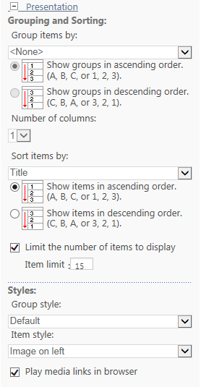
- Expand the Appearance section and enter All Announcements as the Title.
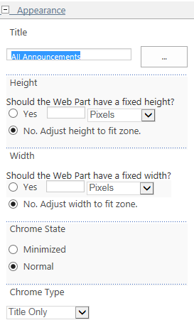
- Click OK to close the tool pane.
- You may get an error message such as this.
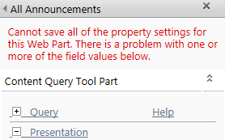
- Expand the sections of the tool pane until you see a further explanation. In this example, the problem area is in the Presentation section.
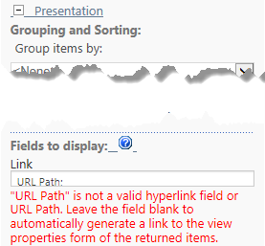
- Delete URL Path: from the Link text box and click OK.
- Remember to save, check in and publish the page so users can see your changes. This is an example of the result.
