Create a Column in a List or Library
Columns display the properties of an item or a file. You can create and customize columns and set up validation checks to ensure correct data entry. Here’s an example of a library with a column for each of these document properties: Name, Title, Doc Status, Document Type and Milestone.
When a column is created, you have the option to insert it into the default view of the list or library. Or, you can insert columns into views later. See the help file on Views for more information.

Contents
Create Column – Method 1
Create Column – Method 2
Create Column – Method 3
Additional Column Settings
Single Line of Text
Multiple Lines of Text
Choice
Number
Currency
Date and Time
Lookup
Yes/No
Person or Group
Hyperlink or Picture
Calculated
Task Outcome
External Data
Managed Metadata
Column Validation

Create Column – Method 1
- Navigate to the list or library.
- On the ribbon, click the LIST or LIBRARY tab. In the Manage Views group, click Create Column.
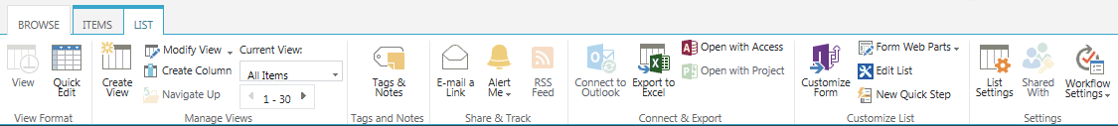
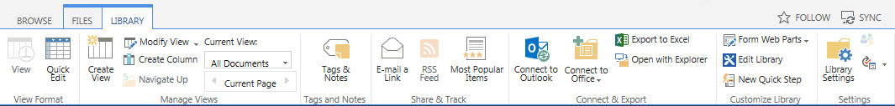
- Enter a name for the column and choose the type of information that the column will contain.
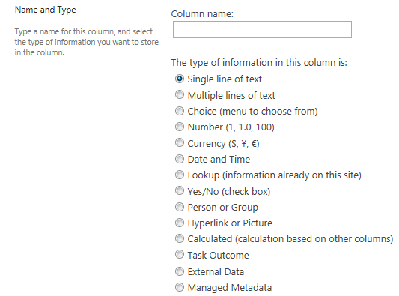
- Define the additional settings for the column. The settings vary by type of column and are detailed in the next sections. Validation is available for some column types; see the last section of this help file for details.
- Click OK to save the column in the list or library.

Create Column – Method 2
- Navigate to the list or library.
- On the ribbon, click the LIST or LIBRARY tab. In the Settings group, click List Settings or Library Settings.
- On the Settings page, scroll down to the Columns section and click Create column.
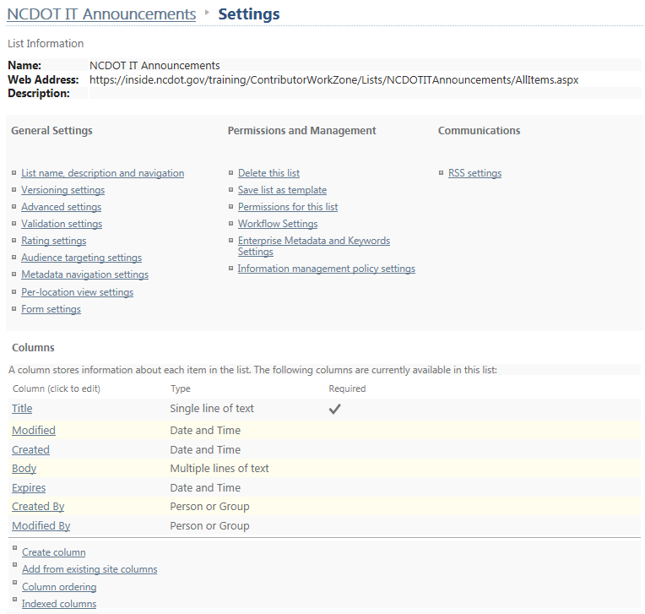
- Enter a name for the column and choose the type of information that the column will contain.
- Define the additional settings for the column. When you use this method to create a column, you have an option to add the column to the default view of the list or library.
- The settings vary by type of column and are detailed in the next sections. Validation is available for some column types; see the last section of this help file for details.
- Click OK to save the column in the list or library.

Create Column – Method 3
You can create a column when you are in Quick Edit mode for a list or library.
- Navigate to the list or library.
- On the ribbon, click the LIST or LIBRARY tab. In the View Format group, click Quick Edit. This example uses a list.
- Click the + (plus sign) in the rightmost column of the view to see the column options.
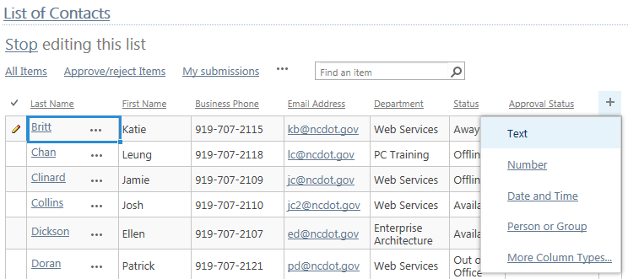
- Choose the type of information for the column to contain.
  - Click More Column Types to enter the regular interface for column creation. Enter a name for the column and choose the type of information that the column will contain.
Define the additional settings for the column. The settings vary by type of column and are detailed in the next sections. Validation is available for some column types; see the last section of this help file for details.
OR

  - Click one of the first four options to immediately add a column so you can begin to enter data in Quick Edit. Once the column appears, you can change the name if needed.
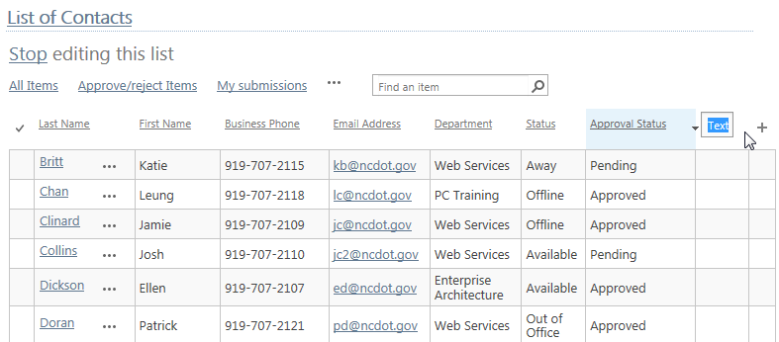The Text option creates a Single line of text column, while the other three create the standard Number, Date and Time, and Person or Group columns.
- Exit Quick Edit to save the column in the list or library.

Additional Column Settings

Single Line of Text
The user can enter a simple line of unformatted text. A common example is a last name. Validation is available. Additional settings are:
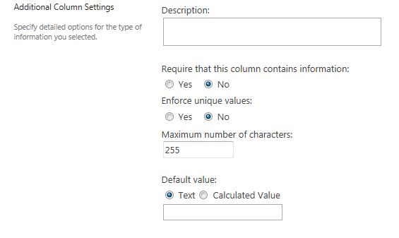
- Description – This explanation appears when users define item or file properties.
- Require that this column contains information – If a value is not entered in this column, an error message appears. An asterisk (*) indicates that data is required.
- Enforce unique values – A unique value appears only once in the column; that is, no two items or files can have the same value.
- Maximum number of characters – This is the most number of characters allowed in the field.
- Default value – This value is automatically used if the user does not enter another value. Many users accept the default value without thinking, so it may be a good idea to leave the text box blank and make it required. Alternatively, you can calculate a value (such as [Me]) and use it as the default.

Multiple Lines of Text
The user can enter many lines of text that can be formatted. This is often used for descriptions, notes or comments. Additional settings for this column when used in a list are:
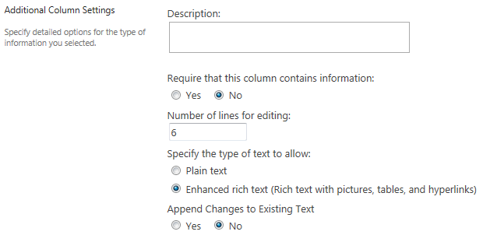
- Description – This explanation appears when users define item or file properties.
- Require that this column contains information – If a value is not entered in this column, an error message appears. An asterisk (*) indicates that data is required.
- Number of lines for editing – This is the number of lines in the text box. It affects the size of the text box, but not the amount of text you can enter.
- Specify the type of text to allow – You can enter unformatted (plain) or formatted (font, size, color, etc.) text, or you can use advanced formatting such as hyperlinks, images, and tables.
- Append Changes to Existing Text – If versioning is on, Yes lets the user see the version history.
When this column is used in a library, there is an additional option:
- Allow unlimited length in document libraries – By default, this column type allows up to 255 characters. While this setting removes that restriction, use it carefully. Office applications only support columns with up to 255 characters and you may lose data.

Choice
The user chooses from standardized options listed in a drop-down menu, radio buttons, or checkboxes. This approach helps ensure data consistency. Validation is available. Additional settings are:
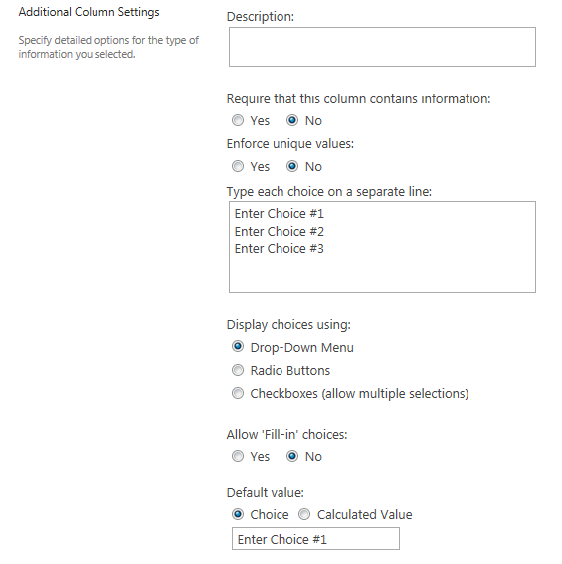
- Description – This explanation appears when users define item or file properties.
- Require that this column contains information – If a value is not entered in this column, an error message appears. An asterisk (*) indicates that data is required.
- Enforce unique values – A unique value appears only once in the column; that is, no two items or files can have the same value.
- Type each choice on a separate line – This is the list of values (such as a list of districts or divisions) that you want the user to choose from.
- Display choices using – A drop-down menu or set of radio buttons allow the user to make only one choice; radio buttons are generally recommended for three or fewer choices, and drop-down menus for four or more choices. Checkboxes allow the user to make more than one choice.
- Allow ‘Fill-in’ choices – The user can enter a value that does not appear in the list of choices. This value is not added to the list of choices.
- Default value – This value is automatically used if the user does not enter another value. Many users accept the default value without thinking, so it may be a good idea to leave the text box blank and make it required. Alternatively, you can calculate a value and use it as the default.

Number
The user can enter non-monetary, numeric values. Validation is available. Additional settings are:
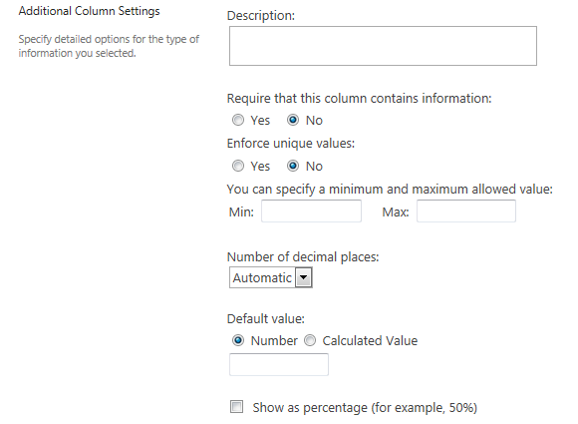
- Description – This explanation appears when users define item or file properties.
- Require that this column contains information – If a value is not entered in this column, an error message appears. An asterisk (*) indicates that data is required.
- Enforce unique values – A unique value appears only once in the column; that is, no two items or files can have the same value.
- You can specify a minimum and maximum allowed value – These are the smallest and largest values that can be entered.
- Number of decimal places – This is how many decimal places the entry can have. The value of automatic uses the number of decimal places that the user entered.
- Default value – This value is automatically used if the user does not enter another value. Many users accept the default value without thinking, so it may be a good idea to leave the text box blank and make it required. Alternatively, you can calculate a value and use it as the default.
- Show as percentage – The value is shown as a percentage.

Currency
The user can enter monetary values. Validation is available. Additional settings are:
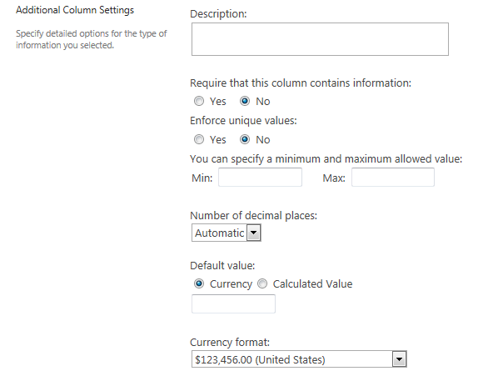
- Description – This explanation appears when users define item or file properties.
- Require that this column contains information – If a value is not entered in this column, an error message appears. An asterisk (*) indicates that data is required.
- Enforce unique values – A unique value appears only once in the column; that is, no two items or files can have the same value.
- You can specify a minimum and maximum allowed value – These are the smallest and largest values that can be entered.
- Number of decimal places – This is how many decimal places the entry can have. The value of automatic uses the number of decimal places that the user entered.
- Default value – This value is automatically used if the user does not enter another value. Many users accept the default value without thinking, so it may be a good idea to leave the text box blank and make it required. Alternatively, you can calculate a value and use it as the default.
- Currency format – This defines the currency symbol.

Date and Time
The user can enter a calendar date or date/time combination. Some SharePoint features, such as a calendar, require this format. Validation is available. Additional settings are:
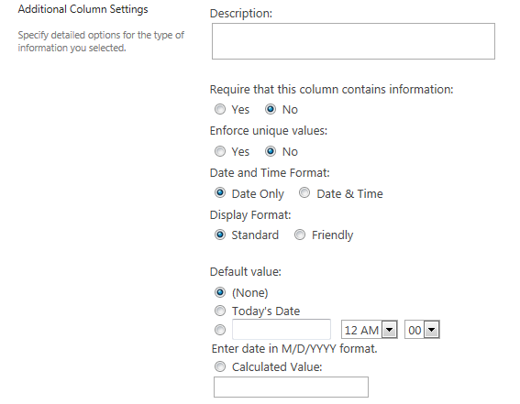
- Description – This explanation appears when users define item or file properties.
- Require that this column contains information – If a value is not entered in this column, an error message appears. An asterisk (*) indicates that data is required.
- Enforce unique values – A unique value appears only once in the column; that is, no two items or files can have the same value.
- Date and Time Format – This determines whether the user can enter a date only or a date and time
- Display Format – The column value is shown in standard format or friendly format. Friendly format, for example, is “April 15” instead of 4/15/2015 or “3 hours ago” instead of 12:13 PM.
- Default value – This value is automatically used if the user does not enter another value. Many users accept the default value without thinking, so it may be a good idea to leave the text box blank and make it required. Alternatively, you can calculate a value (such as [Today] + 42 for six weeks from today) and use it as the default.

Lookup
The user can choose values for a column as if they were using a Choice column. However, those values actually reside in a column in a second list and the current column looks them up in the second list.
For example, assume there are two lists: a Reports list filed by field inspectors and a Contacts list with names and addresses. The Reports list can connect to the Contacts list and “look up” the field inspector names in the Contacts list. This way, the Reports list does not duplicate the names column, and the names are maintained in one place even if they are used in many places. Additionally, changes in the Contacts list are automatically propagated to the lookup columns that use the Contacts list.
You can easily show additional columns such as addresses in the Reports list because that information is associated with the names in the Contacts list.
Additional settings for this column when used in a list are:
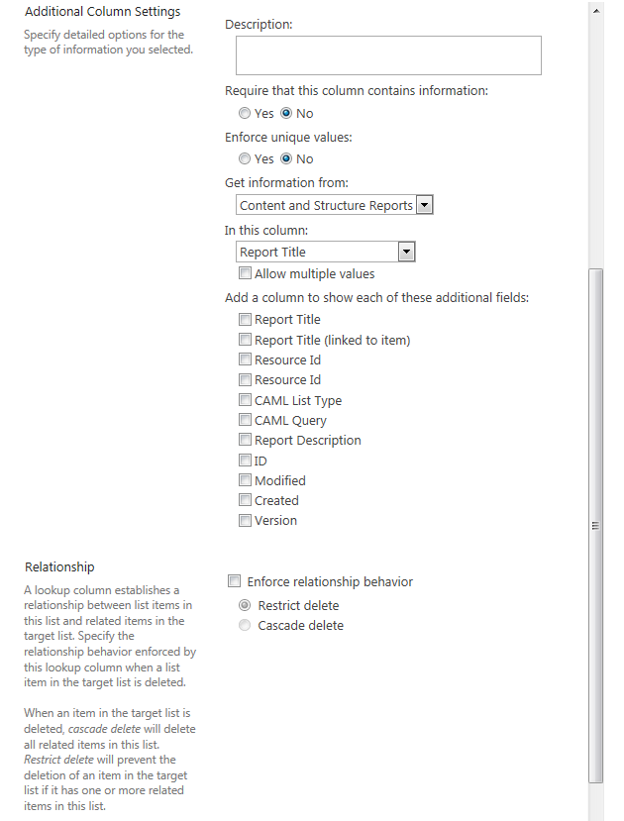
- Description – This explanation appears when users define item or file properties.
- Require that this column contains information – If a value is not entered in this column, an error message appears. An asterisk (*) indicates that data is required.
- Enforce unique values – A unique value appears only once in the column; that is, no two items or files can have the same value.
- Get information from – This is the “remote” list that contains the column with the values you want to use. The list must reside on the same site.
- In this column – This is the column in the “remote” list that contains the values you want to use. Select Allow multiple values if you want the user to choose more than one value; if you do this, the Enforce unique values and Enforce relationship behavior settings are disabled.
- Add a column to show each of these additional fields – You can display additional columns from the “remote” list. These columns can be viewed but cannot be edited because they come from a different list. There are some restrictions on what type of columns from the “remote” list can be displayed.
- Enforce relationship behavior – If an item in the “remote” list is deleted, choose Cascade delete to delete related items in this list; use Cascade delete carefully because it deletes the items in all lists. Otherwise, choose Restrict delete to prevent deleting an item in the “remote” list if this list has a related item; it issues a warning that says the item is in use.
When this column is used in a library, you will a different setting:
- Allow unlimited length in document libraries – By default, this column type allows up to 255 characters. While this setting removes that restriction, use it carefully. Office applications only support columns with up to 255 characters and you may lose data.

Yes/No
The user selects a checkbox for Yes or deselects the checkbox for No. The value can also be treated as true/false or 1/0. Additional settings are:
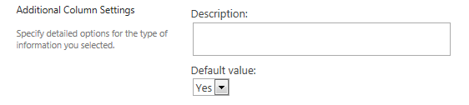
- Description – This explanation appears when users define item or file properties.
- Default value – The default value is either Yes (checked) or No (unchecked).

Person or Group
Note: If you wish to use SharePoint Groups, call or email the Help Desk to request assistance from Web Services. This section only addresses people.
The user chooses one or more people from a list of all users. An example is choosing a person to whom you are assigning a task. Because SharePoint recognizes this column as containing names (not just text strings), it can summon additional information associated with that name in Active Directory. Additional settings are:
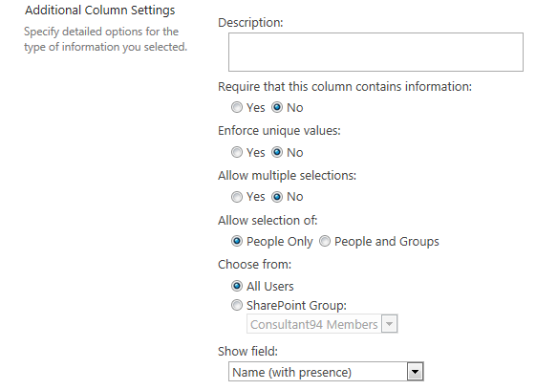
- Description – This explanation appears when users define item or file properties.
- Require that this column contains information – If a value is not entered in this column, an error message appears. An asterisk (*) indicates that data is required.
- Enforce unique values – A unique value appears only once in the column; that is, no two items or files can have the same value.
- Allow multiple selections – This allows selection of more than one person.
- Allow selection of – Select People Only, not People and Groups.
- Choose from – Select All Users, not SharePoint Group.
- Show field – This selects the information you wish to show about the person or people.

Hyperlink or Picture
The user enters the URL for an image, then chooses whether the URL is displayed as text or as that image. Additional settings are:
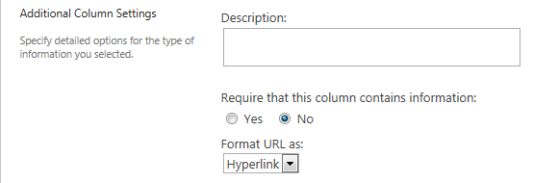
- Description – This explanation appears when users define item or file properties.
- Require that this column contains information – If a value is not entered in this column, an error message appears. An asterisk (*) indicates that data is required.
- Format URL as – This is the selection between a hyperlink or a picture.

Calculated
This column contains a formula and displays the results of that calculation. An example is a formula that calculates a deadline that is 45 days after the Start Date
=[Start Date] + 45
or a formula that calculates the average of the day’s high and low temperatures
=AVERAGE([High Temp], [Low Temp])
Data entry is not permitted, since the value is calculated automatically. Additional settings are:
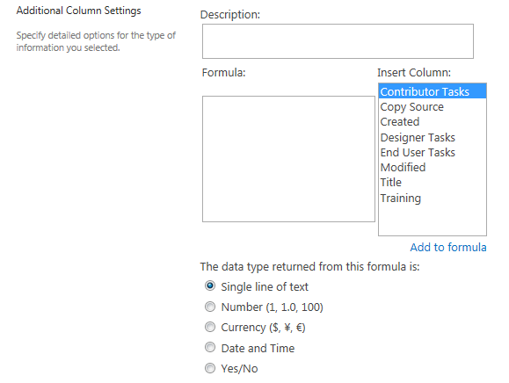
- Description – This explanation appears when users define item or file properties.
- Formula – This is the calculation to be performed. Select a column from the Insert Column list and click Add to formula to move it into the Formula box. Enter appropriate operators and add additional columns to construct the formula. The formulas are similar to those used in Excel.
- The data type returned from this formula is – This is the type of data that you are creating. You can use columns of different types, such as multiplying a value in a Number column by a number in a Currency column to get a total sale price - but the result can only be one of the two.

Task Outcome
The user chooses a value for the outcome of a task. Additional settings are:
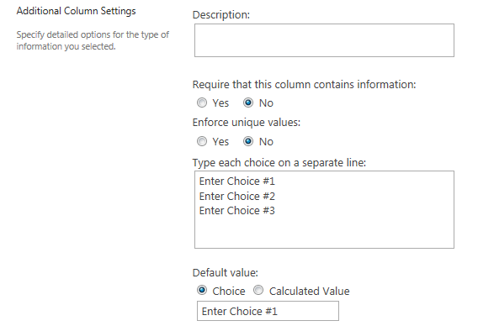
- Description – This explanation appears when users define item or file properties.
- Require that this column contains information – If a value is not entered in this column, an error message appears. An asterisk (*) indicates that data is required.
- Enforce unique values – A unique value appears only once in the column; that is, no two items or files can have the same value.
- Type each choice on a separate line – This is the list of values (such as Assigned or Pending) that you want the user to choose from.
- Default value – This value is automatically used if the user does not enter another value. Many users accept the default value without thinking, so it may be a good idea to leave the text box blank and make it required. Alternatively, you can calculate a value and use it as the default.

External Data
This column displays data that comes from a data source outside of SharePoint through Business Connectivity Services (BCS). For example, you might wish to pull in a list of licenses from the SAP system.
Note: This requires advanced configuration. Call or email the Help Desk to request assistance from Web Services.

Managed Metadata
This column uses data stored in the Term Store.
Note: This requires advanced configuration. Call or email the Help Desk to request assistance from Web Services.

Column Validation
When you create a column, you can set validation rules in addition to the column settings described above. The formulas are similar to those used in Excel.
An example is a formula that compares the date for a task to be completed to the known date for the end of a project:
=[TaskCompletionDate]<DATE(2014,10,15)
If the task completion date occurs after the end of the project, you can define a user (error) message such as Task must be completed before the project ends.
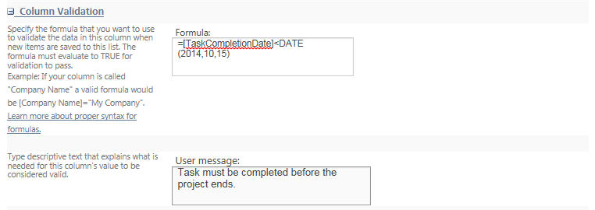
Validation is available for these column types: Single line of text, Choice, Number, Currency, and Date and Time.
Because you are working at the individual column level, you can only compare the value in that column with a static value. You cannot compare two columns.
Note: Validation can also be set at the list and library level. In that scenario, you can compare columns within the list or library, such as checking whether an expiration date is older than the created date. See the documentation for Validation Settings.

