Create a Personal View
If you frequently want to view information in a list or library in a certain way, you can create a personal view. Limitations of a personal view include:
- Only you can see your personal view.
- A personal view cannot be the default view for a library.
- You can only modify the properties that are already in the list or library. For example, you can rearrange the columns and turn their display on or off, but you cannot add new columns.
- Navigate to the list or library.
- On the ribbon, click the LIST or LIBRARY tab. In the View Format group, click Create View.
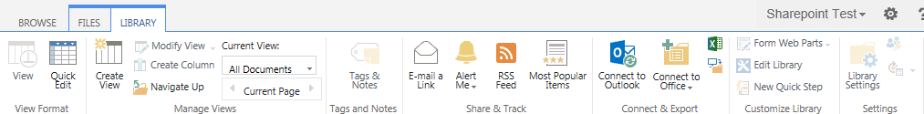
- Click the type of view you want.
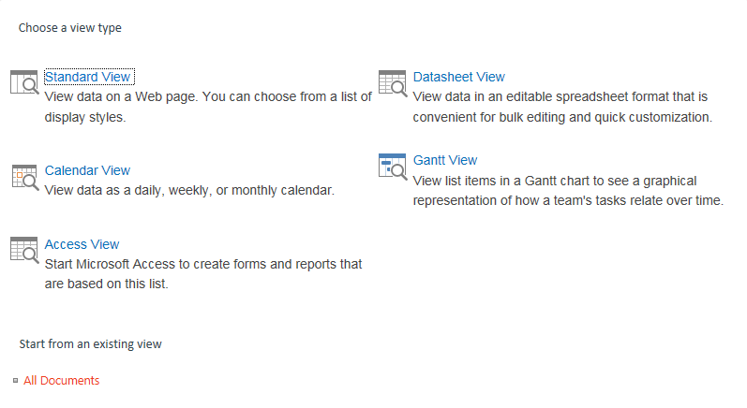There are several types of views available, depending upon the list or library.
  - Standard View – the most common view
  - Datasheet View – a spreadsheet view similar to Excel; this is the same as Quick Edit
  - Calendar View – a date-based view like a calendar
  - Gantt View – a task- and time-based view used by project managers
  - Access View – an Access database view
You can also use an existing view (such as All Documents) as a starting point for your personal view.
- Define the properties of your view.
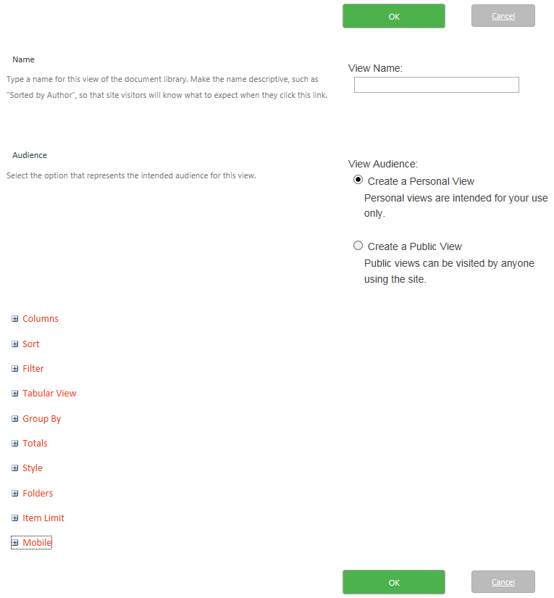Note: See the help files for Create a View and Modify or Delete a View for additional details on these properties.
  - Name: Enter a name for your view in the text box.
  - Audience: Click Create a Personal View. Only Designers can create a public view, so this option is preselected if you are not a Designer.
  - Columns: Check the columns to show and uncheck the columns to hide. Use the drop-downs to define each column’s Position from Left; this sets the order of the columns. If you uncheck columns, you do not need to redefine the Position from Left for columns that follow because the renumbering is automatic.
  - Sort: Choose up to two columns for sorting in ascending or descending order.
  - Filter: Narrow down the number of items to display by defining the criteria that the items must meet.
  - Tabular View: Enable individual checkboxes for each row.
  - Group By: Create collapsible/expandable groups for more efficient display of data.
  - Totals: Display calculation results (such as count, sum, average) at the top of appropriate columns.
  - Style: Control the appearance of the list or library.
  - Folders: Turn folders on or off; this should only be used for libraries.
  - Item Limit: Limit the number of items or files displayed per page and in total.
  - Mobile: Modify the view for mobile access.
- Click OK to complete your personal view.

