Create a View for a List or Library
Views are a powerful feature that let you keep information in one location, yet “slice and dice” to tailor the information to display. You can create a new view so that it displays items or files of particular interest.
For example, in a list of tasks you might want to see only those that are incomplete for auditing purposes. In a team calendar, you might want to display events occurring over the next five days on the home page of the team site. Or, in a library, perhaps you want to display only documents authored by a particular person.
When a list or library is created, it contains a default view that, in most cases, is the All Items or All Documents view. Some lists or libraries contain more than one view when they are created.
- Task list –All Tasks, My Tasks
- Calendar –Calendar, All Events, Current Events
- Discussion Board – Recent, My Discussions, Features, Unanswered questions, Answered questions
- If Content Approval is on – All Documents, Approve/reject Items, My submissions
- Asset library – Thumbnails, All Assets
- Images library – Thumbnails, All Assets
- Picture library – Thumbnails, All Assets, Slides

Contents
Example of a List View
How Other Settings Affect the Example View
View Types
Filter
Tabular View
Group By
Totals
Style
Folders
Item Limit
Mobile
Create a View
Create a New View from a Modified View

Example of a List View
Let’s review the properties of the All Items view of a Daily Reports list to learn options and terminology.
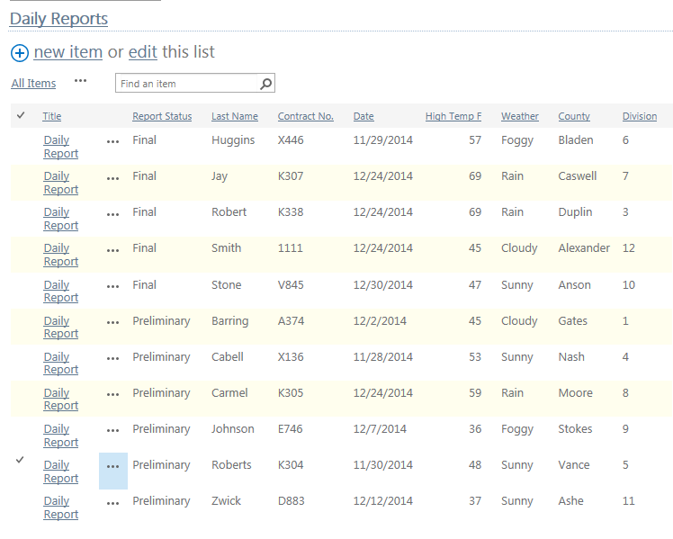
When created, the View Type for the All Items view was defined as a Standard View. Except for using the Quick Edit feature, the View Type cannot be changed once a view is created.
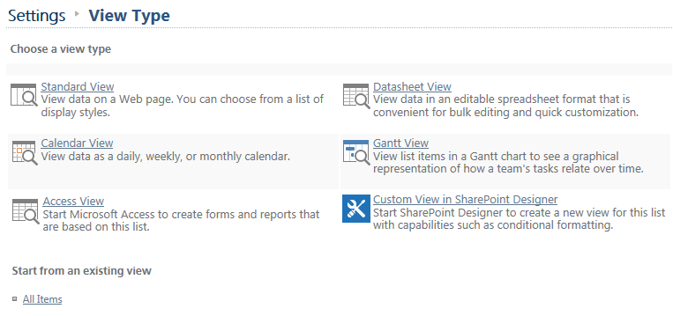
The name of the view is All Items, but can be changed after a view is created.
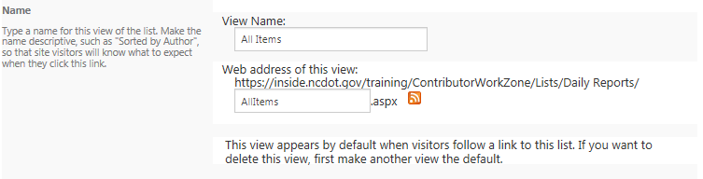
When created, the All Items view was defined as public. The audience cannot be changed once a view is created.
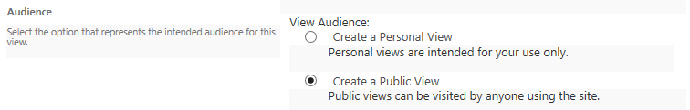

Nine of the 27 available columns are displayed in the All Items view. After a view is created, you can display or hide the column by checking (on) or unchecking (off) Display. You can also change the left-to-right order of the columns by selecting another position from the drop-down for Position from Left. If you add a column and do not specify its position, it is added as the rightmost column. If you hide a column, other columns are automatically repositioned.
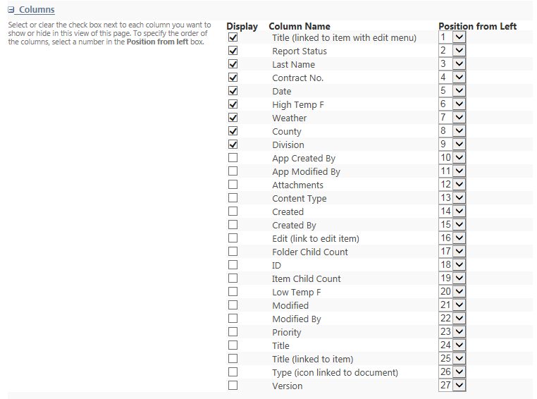
Sorting is arranging all items in a specific order, such as ascending by name or descending by date. The All Items view is sorted by Report Status in ascending order, then Last Name in ascending order. Sorting can be changed after a view is created.
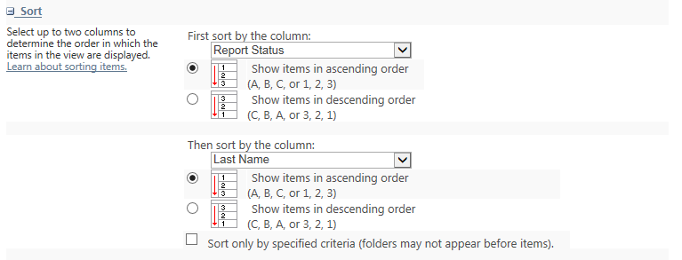

How Other Settings Affect the Example View
These are the additional options when you create a view.

View Types
Several view types are available.
- Standard – This view displays items and files in rows. A standard view is usually the default view.
- Calendar – This view is automatically created for calendars, but is available for any list or library that has a date/time column.
- Access – This view lets you use Access to view and change library (but not list) information.
- Datasheet – This view uses a spreadsheet format and automatically opens in edit mode. It is the same as Quick Edit and is an efficient way to change multiple edits at a time. The datasheet view cannot support grouped views.
- Gantt – The Gantt view tracks progress and tasks.
- Existing view – You can use an existing view as a starting point for a new view. This is useful if you need multiple views that are similar, such as the same information for different countries.

Filter
A filter reduces the number of items to display by defining criteria that the items or files must meet. For example, the Daily Reports list could have a view that shows only items where the high temperature is greater than or equal to 50 degree. Filtering can be changed after a view is created.
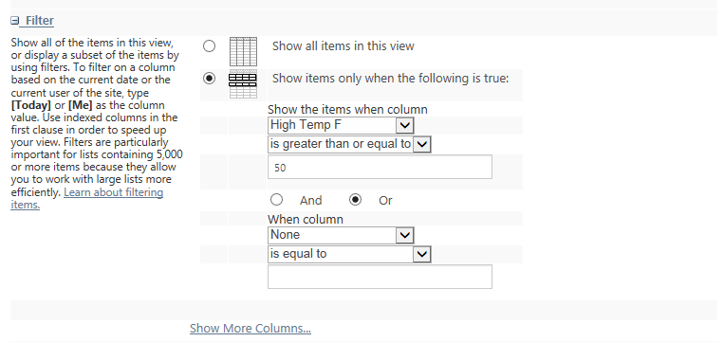
This is the result.
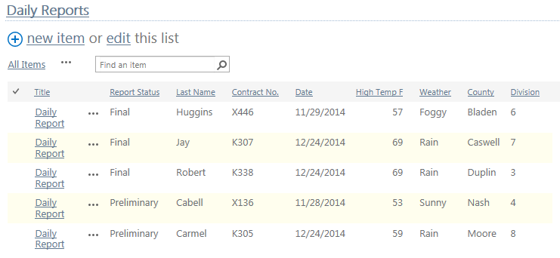

Tabular View
The tabular view toggles individual checkboxes for each row on and off. The checkboxes are useful when you are working on multiple items or files. Here’s an example of how it affects the Daily Reports list. Tabular View can be changed after a view is created.
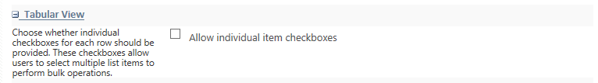
This is the result.
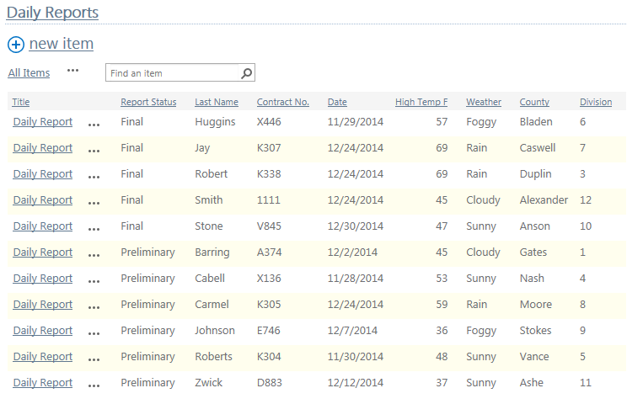

Group By
Grouping lets you collapse and expand data for a more efficient display. For example, the Daily Reports list could be grouped by Report Status. Grouping can be changed after a view is created.
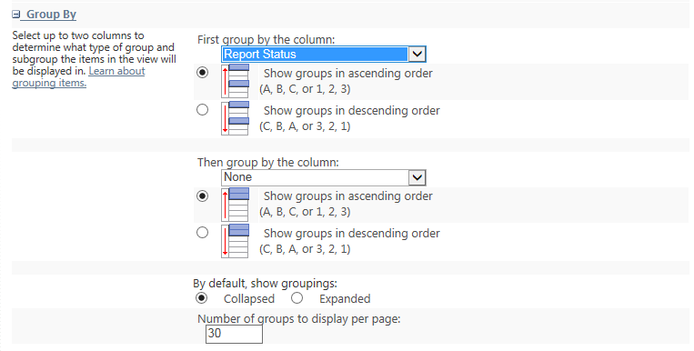
This is the result.
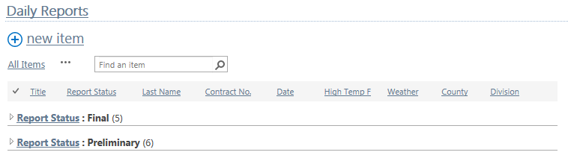

Totals
You can display the results of calculations at the top of the columns. Text columns can have a count. Number columns can have a count, average, maximum, and minimum; depending upon the type of data, the column can also have a sum, standard deviation, and variance. For example, the various columns in the Daily Reports list could have different metrics at the top. Totals can be changed after a view is created.
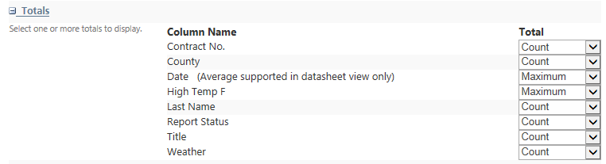
This is the result.
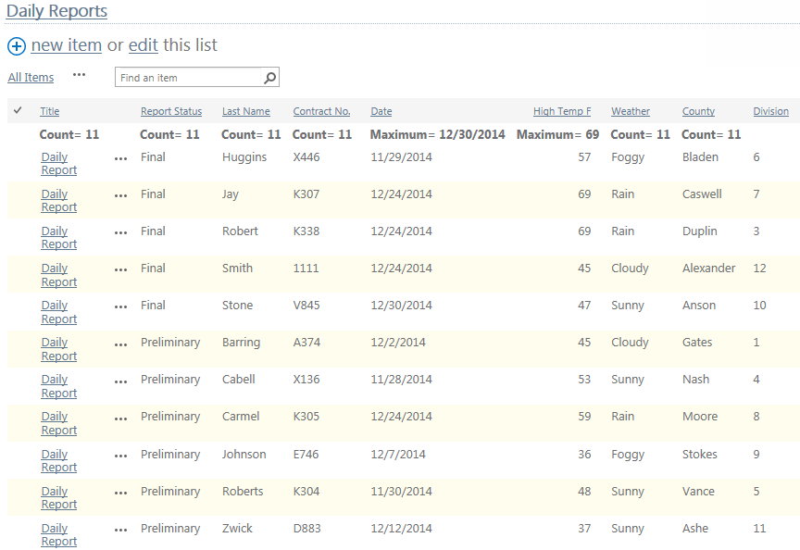

Style
Style controls the appearance of the list or library and can be changed after a view is created.
Basic Table
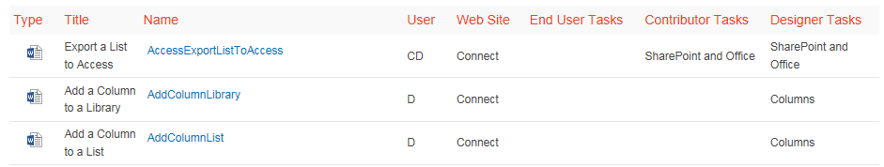
Boxed – only available for lists
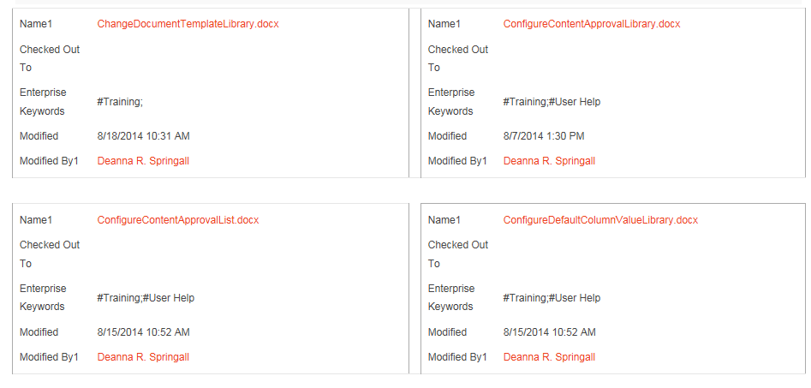
Boxed, no labels – only available for lists
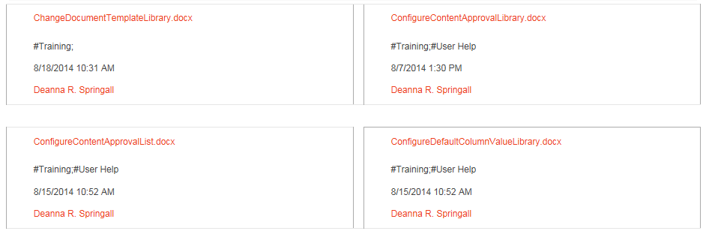

Document details – available for most libraries, but not lists
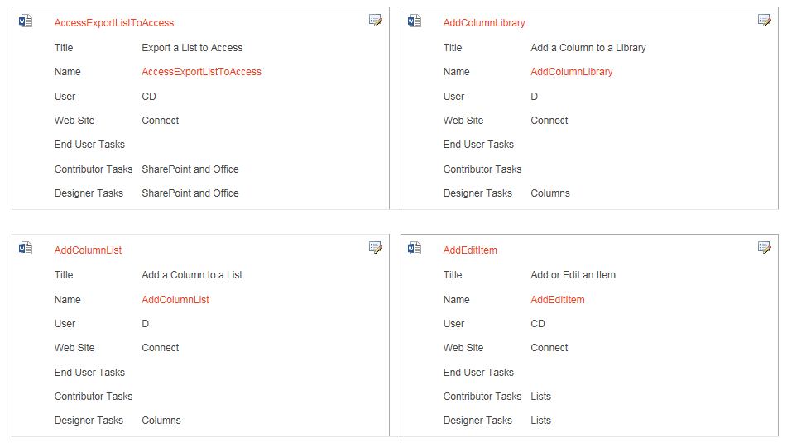
Newsletter – rows with lines in between
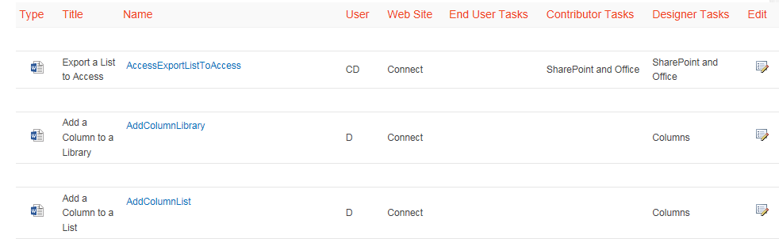
Newsletter, no lines– rows with alternate shading
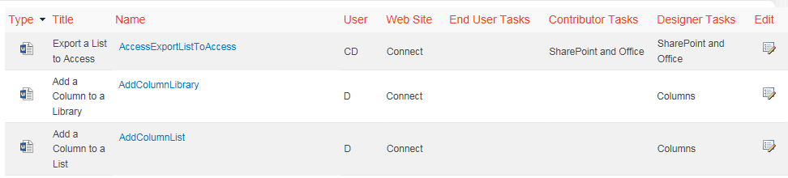

Shaded – rows with alternate shading
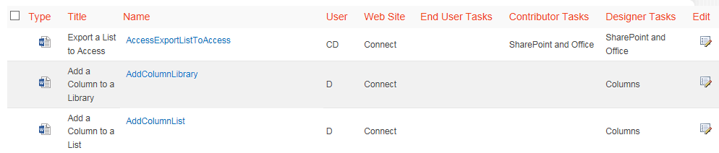
Preview Pane –displays properties on right when user hovers over item title
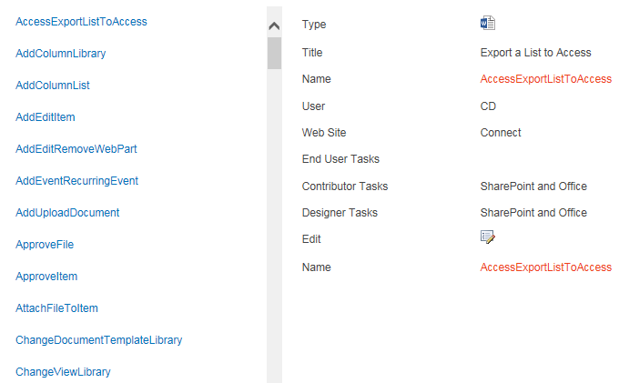
Default – varies depending upon type and configuration of list or library.
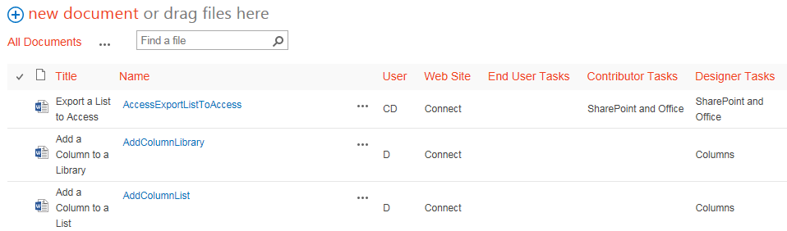

Folders
The display of folders can be turned on or off. If on, click the folder to see the items or files within it. If off, the flat view shows all items or files in all folders. This display can be changed after a view is created.

Item Limit
You can regulate the number of items or files displayed per page as well as the total number of items or files displayed. The item limit can be changed after a view is created. For example, the Daily Reports list could be limited to a display of five per page.
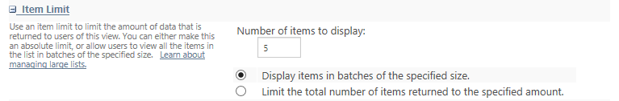
Or, it could be limited to a total display of five.
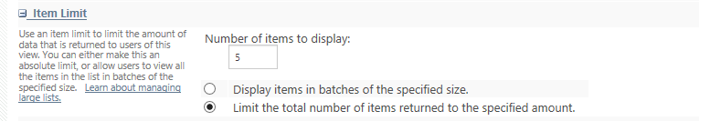
This is an example of limiting a view to five results per page; simply page to see the next set of results.
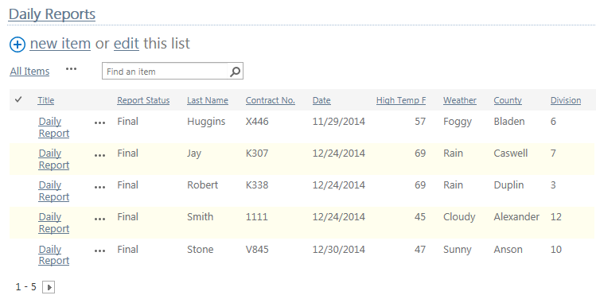
This is an example of limiting a view to five total results. This approach is useful if you want to limit the content in a “most recent” web part.
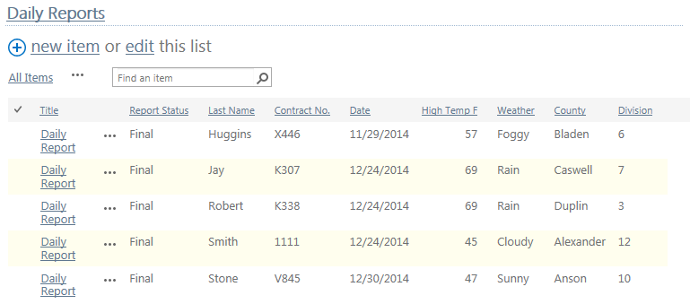

Mobile
For mobile use, you can enable a view, make it the default mobile view, limit the number of items or files to display, and define which columns to display. This can be changed after a view is created.
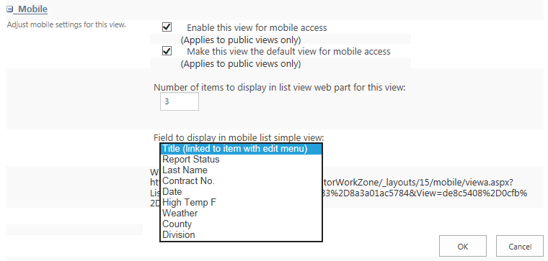

Create a View
To create a new view, you modify the settings of a list. This may be a default SharePoint list, such as Contacts, or a view that you are creating for a custom list. This example creates another view of the Daily Reports list, which displays only the daily reports from the Triad Economic Development Region (EDR), sorted by Last Name.
- Navigate to the list or library.
- On the ribbon, click the LIST or LIBRARY tab. In the Manage Views group, click Create View. You can also click the ellipsis by the list of views and click Create View. This example uses a list.
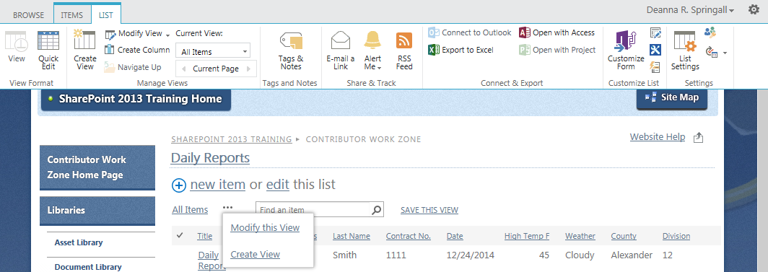
- Click the type of view you want to create. This example uses the Standard View.
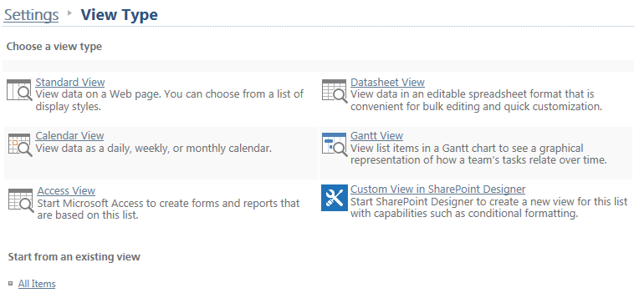
- In the Create View page, enter a name for your view. If you want this view to appear by default, click Make this the default view. Remember, by definition, a personal view cannot be a default view because it can only be seen by you. This example uses a name of Triad Economic Development Region and does not make the new view the default view.
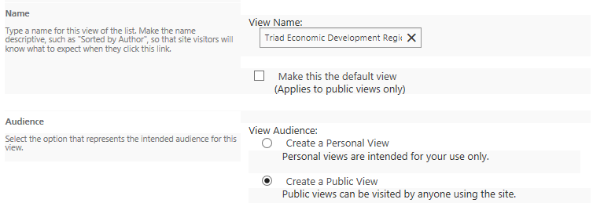
- In the Audience section, click Create a Public View. This example defines the view as public.
- In the Columns section, check the columns to show and uncheck the columns to hide. Use the drop-downs to define the order of the columns. This example uses the columns Title, Report Status, Last Name and Division.
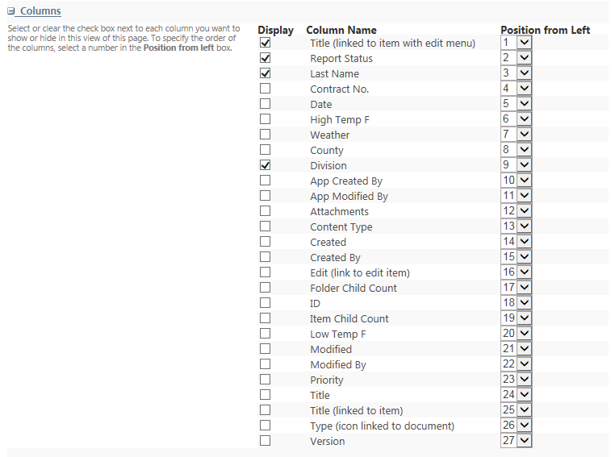
- In the Sort section, define the sort criteria. This example sorts by Last Name in ascending order.
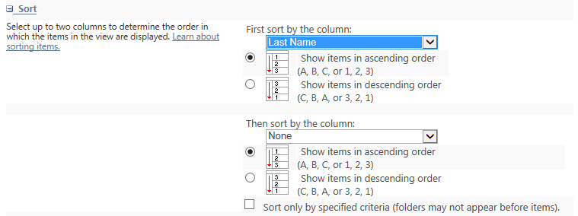

- In the Filter section, define the filter by clicking Show items only when the following is true, and setting up the criteria. For example, the Triad region contains 12 counties (Alamance, Caswell, Davidson, Davie, Forsyth, Guilford, Montgomery, Randolph, Rockingham, Stokes, Surry, Yadkin). Set up the logic of county = Alamance OR county = Caswell OR county = Davidson. Click Show More Columns to add the logic for the remaining counties.
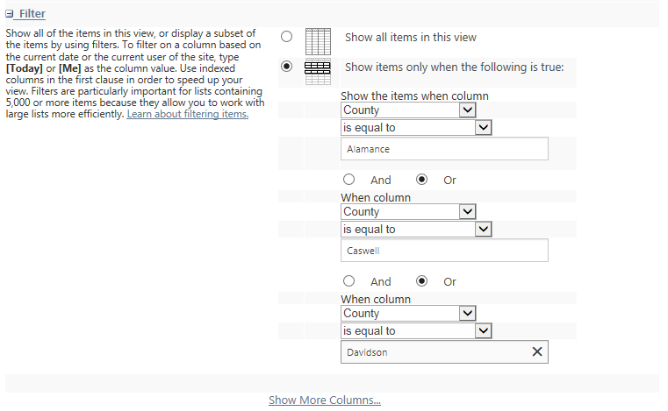
- In the Group by section, click the column to use for grouping, and click the order. For example, group by Report Status.
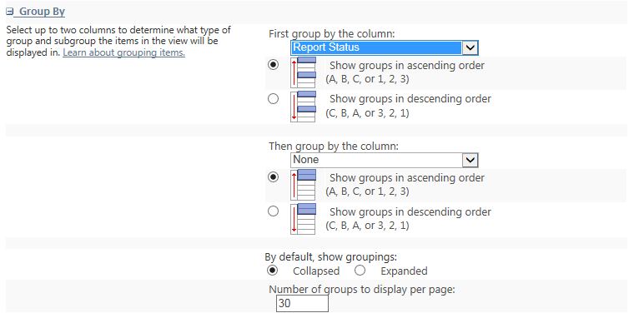
- Click OK to see the new view. These are the unexpanded groups.
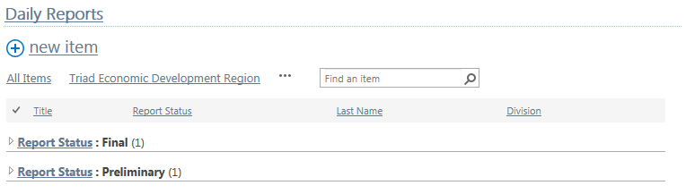These are the expanded groups.
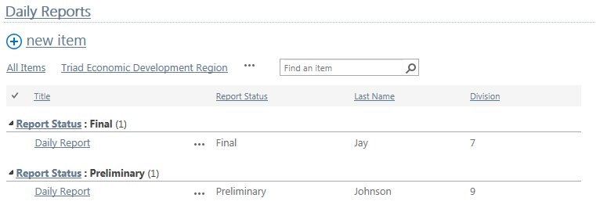

Create a New View from a Modified View
Suppose you are looking at an existing list or library and make some modifications using the column sort and filter options. You can create a new view by saving the changes you have made. This example continues to use the Daily Reports list and shows how to develop a view for the high temperature on sunny days.
- Navigate to the list or library where you want to change a view.
- Ensure you are in the view you want to modify.
- Hover over the Weather column, click the down arrow, and click Sunny to select only the sunny days. Click Close.
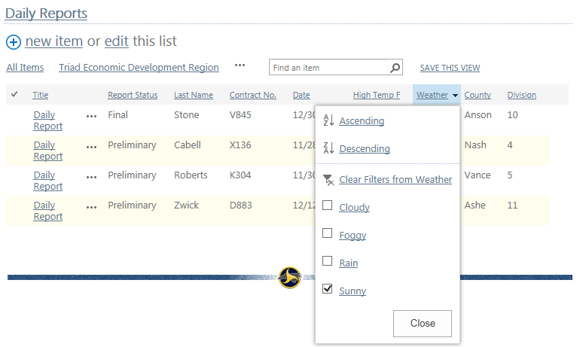
- Hover over the High Temp F column, click the down arrow, and click the box next to Smallest on Top to arrange the list in ascending order of temperature. Click Close.
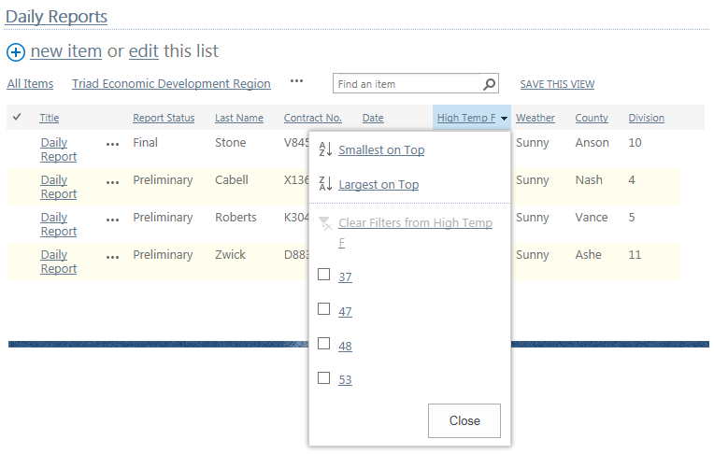
- This is the modified list. Click SAVE THIS VIEW.
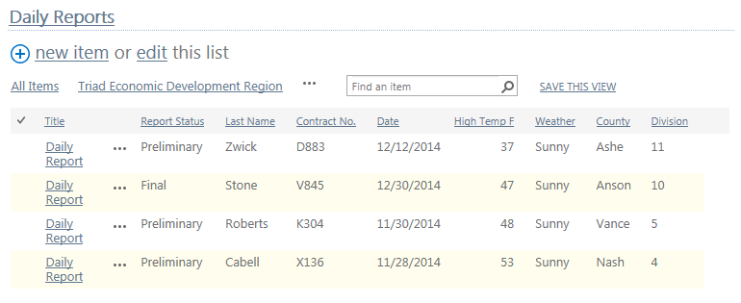
- Enter the name for the new view, click to Make it public so everyone can see it, and click Save.
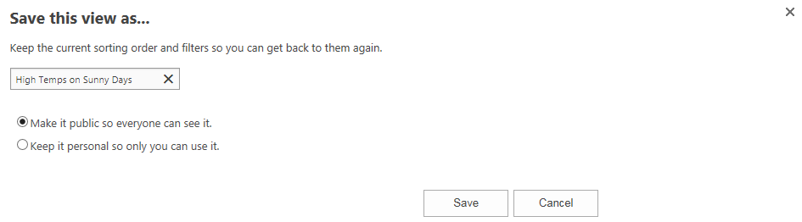This is the new view.
