Change the View
A view controls the way the content of a list or library is displayed. For most libraries, the default view is All Documents and, for most lists, the default view is All Items. The first three views are listed at the top of the list or library and additional views, if any, are available by clicking the ellipsis next to the three views.
- Navigate to the list or library.
- Click the name of the view you wish to see. By default, the All Documents or All Items view appears. In this example library, click the additional view called My Submissions.
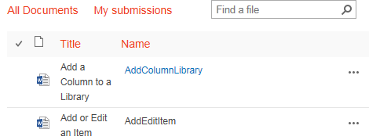
The My Submissions view is grouped by approval status.
