Delete or Close a Web Part
This help file focuses on how to delete and close web parts. See the help files for commonly used web parts to learn how to use and customize specific web parts.

Contents
Delete a Web Part
Close a Web Part

Delete a Web Part
If you delete a web part, the web part is completely removed from the current page but not from the web part gallery. Don’t let the terminology mislead you – the web part remains available for use elsewhere. However, you will lose any customization that you performed on that web part.
- Navigate the page with the web part to delete.
- Click the Settings gear, and click Edit page.
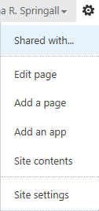
- Hover over the web part, click the down arrow and click X Delete.
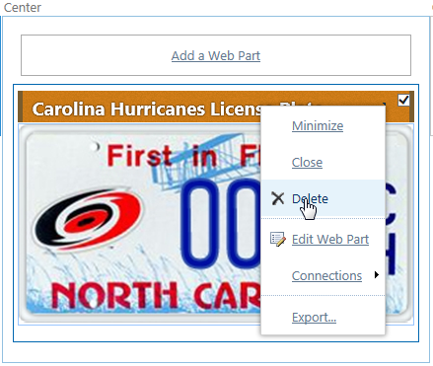
- Click OK to confirm the deletion.
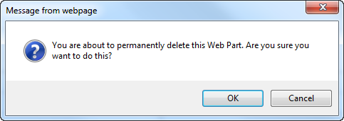
- In the ribbon, click the PAGE tab. In the Edit group, click Save to save the page.
- Remember to check the page in and publish it so users can see your changes.

Close a Web Part
Closing a web part hides the web part so that it is not visible on a page. However, the web part is still associated with the page, remains available and retains any customization.
- Navigate to the page with the web part to close.
- Click the Settings gear, and click Edit page.
- Hover over the web part, click the down arrow, and click Close.
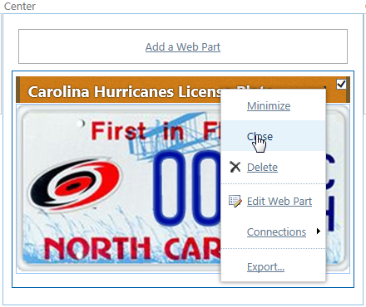
- In the ribbon, click the PAGE tab. In the Edit group, click Save to save the page.
- Remember to check the page in and publish it so users can see your changes.
You can add a closed web part back to the page.
- Navigate to the page with the web part to re-open.
- Click the Settings gear, and click Edit page.
- In the web part zone where you want to add the closed web part, click Add a Web Part.
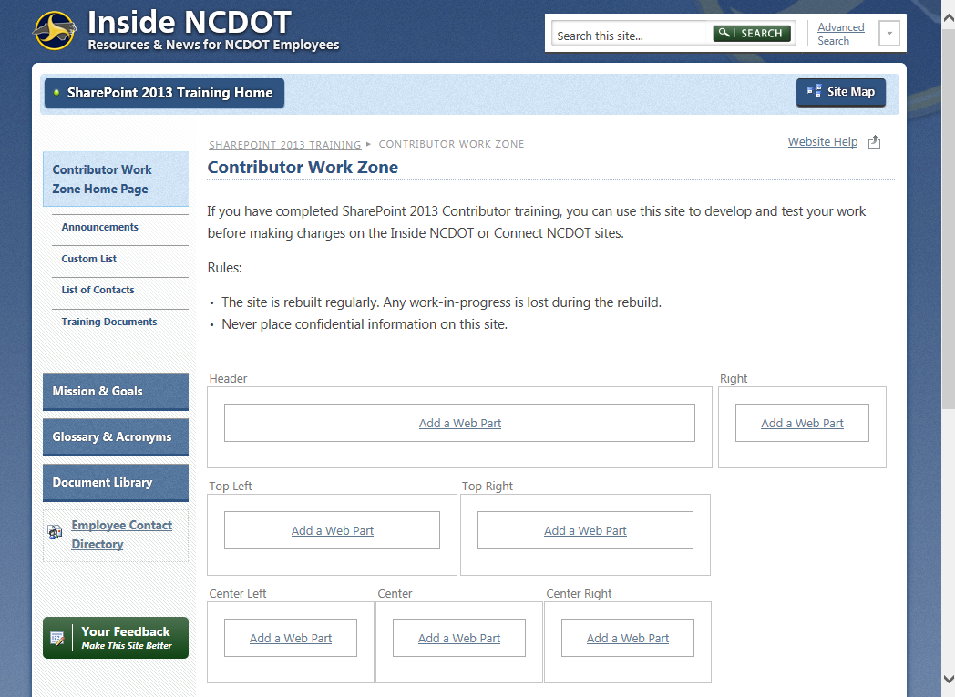
- The web part gallery opens below the ribbon. In the Categories section, scroll to the bottom of the list, and click the Closed Parts group to see all the web parts on the page that have been closed. Click the web part to open and click Add to restore it to that web part zone.
- In the ribbon, click the PAGE tab. In the Edit group, click Save to save the page.
- Remember to check the page in and publish it so users can see your changes.

