Delete a Document
A deleted file may be restored from the Recycle Bin if necessary. See the help file for Restore Selection from Recycle Bin.
Note: Governance policies, records management policies, and retention and disposition rules may prohibit the deletion of files.

Contents
Delete a File
Delete One or More Files – Method 1
Delete One or More Files – Method 2

Delete a File
- Navigate to the library.
- Click the ellipsis next to the name of the file, and click the ellipsis in the callout. In the context menu, click Delete.
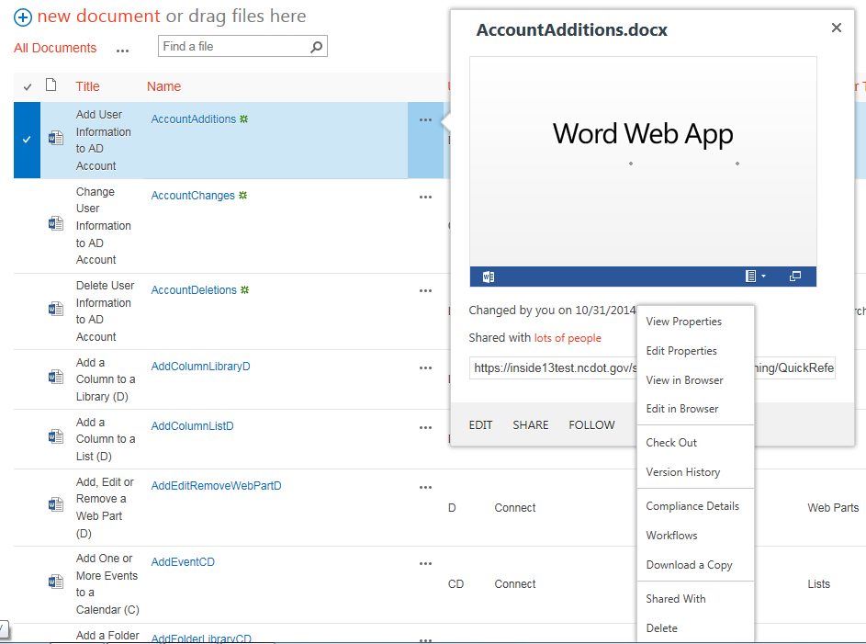
- Click OK to confirm the deletion.
The content is moved to the Recycle Bin.

Delete One or More Files – Method 1
- Navigate to the library.
- Select one or more files by clicking the checkbox next to the name of the file.
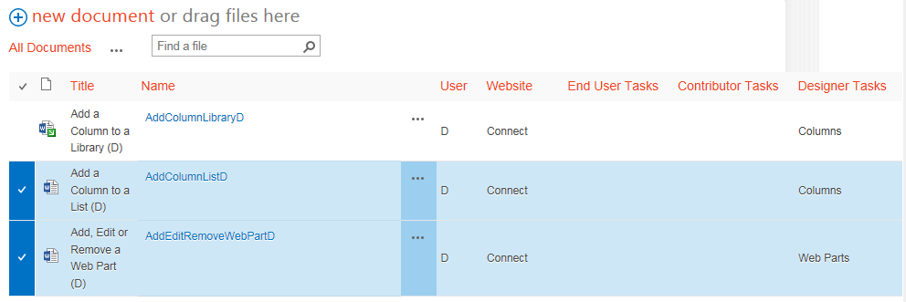
- On the ribbon, click the FILES tab. In the Manage group, click X Delete Document.
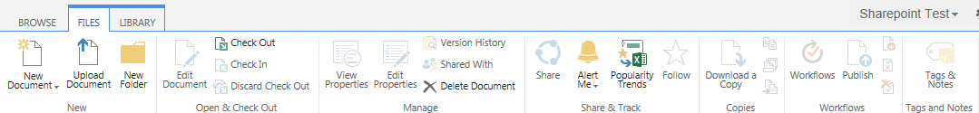
- Click OK to confirm the deletion.
The content is moved to the Recycle Bin.

Delete One or More Files – Method 2
- Navigate to the library.
- Select one or more files by clicking the checkbox next to the name of the file. Press the Delete key. Click OK to confirm the deletion.
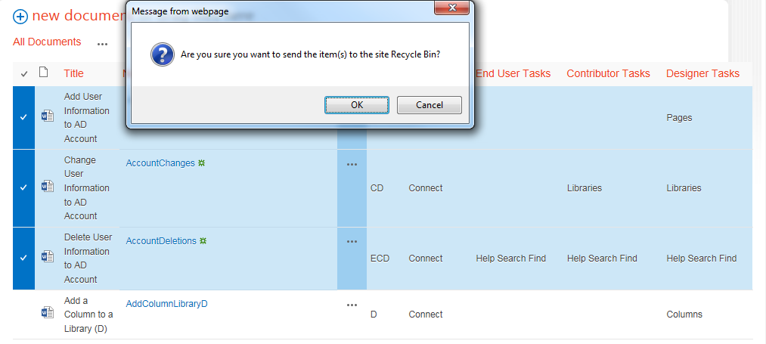The content is moved to the Recycle Bin.

