Delete an Item
A deleted item may be restored from the Recycle Bin if necessary. See the help file for Restore Selection from Recycle Bin.
Note: Governance policies, records management policies, and retention and disposition rules may prohibit the deletion of items.

Contents
Delete an Item
Delete One or More Items – Method 1
Delete One or More Items – Method 2

Delete an Item
- Navigate to the list.
- Click the ellipsis next to the title of the item. In the context menu, click Delete Item.
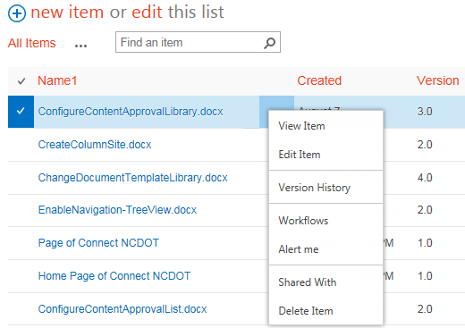
- Click OK to confirm the deletion.
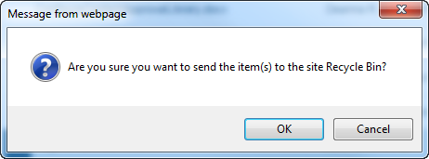
The content is moved to the Recycle Bin.

Delete One or More Items – Method 1
- Navigate to the list.
- Select one or more items by clicking the checkbox next to the title of the item.
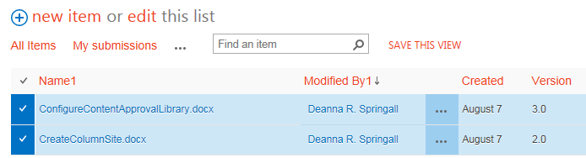
- On the ribbon, click the ITEMS tab. In the Manage group, click X Delete Item.
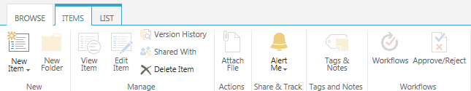
- Click OK to confirm the deletion.
The content is moved to the Recycle Bin.

Delete One or More Items – Method 2
- Navigate to the list.
- Select one or more items by clicking the checkbox next to the title of the item. Press the Delete key. Click OK to confirm the deletion.
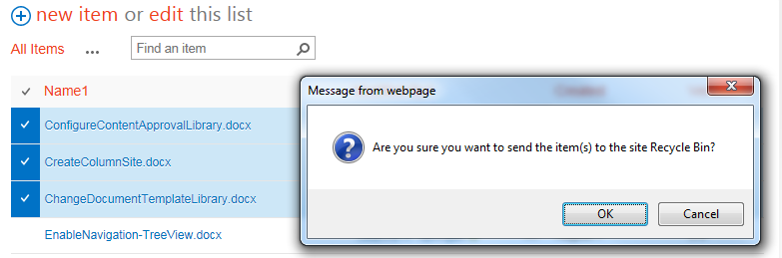The content is moved to the Recycle Bin.

