Delete a Library
When you delete a library, all of the library content (folders, documents, metadata, etc.) is also deleted. A deleted library may be restored from the Recycle Bin if necessary. See the help file for Restore Selection from Recycle Bin.
Note: You cannot remove “system” libraries that are automatically created by SharePoint. Additionally, governance policies, records management policies, and retention and disposition rules may prohibit the deletion of libraries.

Contents
Delete a Library – Method 1
Delete a Library – Method 2

Delete a Library – Method 1
- Navigate to the library.
- On the ribbon, click the LIBRARY tab. In the Settings group, click Library Settings.
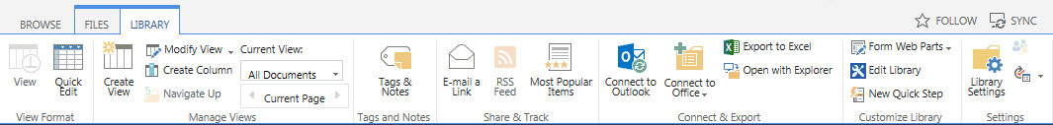
- On the Settings page under Permissions and Management, click Delete this document library or Delete this picture library.
- Click OK to confirm the deletion. The content is moved to the Recycle Bin.

Delete a Library – Method 2
- Click the Settings gear, and click Site contents.
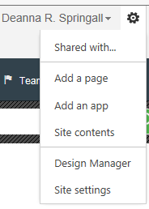
- Hover over the name of the library, click the ellipsis that appears, and click REMOVE. The content is moved to the Recycle Bin.

