Delete a List
When you delete a list, all of the list content (folders, items, metadata, etc.) is also deleted. A deleted list may be restored from the Recycle Bin if necessary. See the help file for Restore Selection from Recycle Bin.
Note: You cannot remove “system” lists that are automatically created by SharePoint. Additionally, governance policies, records management policies, and retention and disposition rules may prohibit the deletion of lists.

Contents
Delete a List – Method 1
Delete a List – Method 2

Delete a List – Method 1
- Navigate to the list.
- On the ribbon, click the LIST tab. In the Settings group, click List Settings.
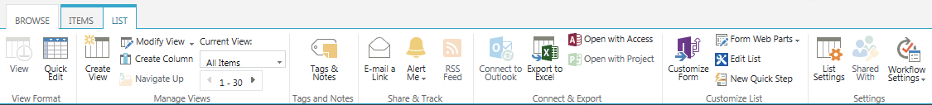
- On the Settings page under Permissions and Management, click Delete this list.
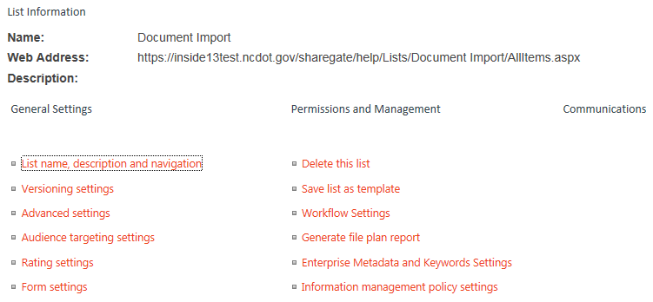
- Click OK to confirm the deletion. The content is moved to the Recycle Bin.

Delete a List – Method 2
- Click the Settings gear, and click Site contents.
- Hover over the name of the list, click the ellipsis that appears, and click REMOVE. The content is moved to the Recycle Bin.
