Delete a Page
A deleted page may be restored from the Recycle Bin if necessary. See the help file for Restore Selection from Recycle Bin.
Note: Governance policies, records management policies, and retention and disposition rules may prohibit the deletion of pages.

Contents
Delete a Page – Method 1
Delete a Page – Method 2

Delete a Page – Method 1
- Click the Settings gear, and click Site contents.
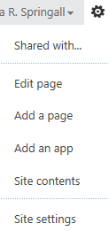
- Click the icon for the Pages library.
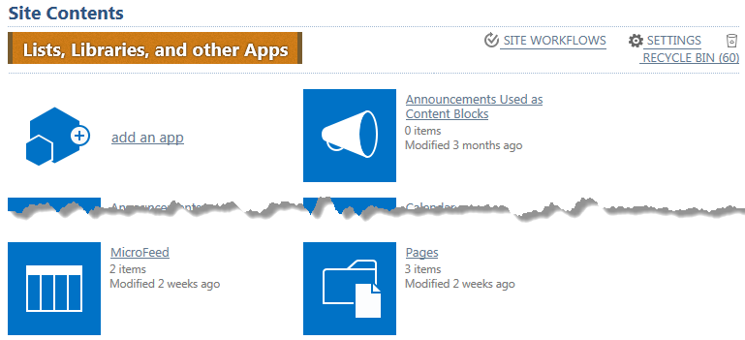
- Click the ellipsis next to the name of the page, and click the ellipsis in the callout. In the context menu, click Delete.
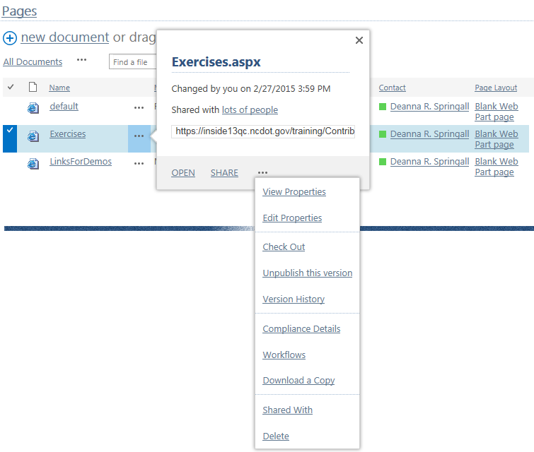
- Click OK to confirm the deletion. The content is moved to the Recycle Bin.

Delete a Page – Method 2
- Navigate to the page.
- Click the Settings gear, and click Edit page.
- On the ribbon, click the PAGE tab, and click X Delete Page.
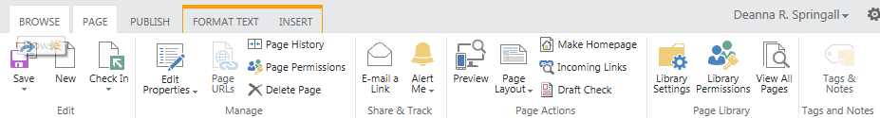
- Click OK to confirm the deletion. The content is moved to the Recycle Bin.

