Download a Copy of a File
If you download a file, you are placing a copy of the file on your computer.
Note: Use the download option carefully. The source file remains in SharePoint and your local copy is not synchronized.
- Navigate to the library.
- Select the file to copy by clicking the checkbox next to the name of the file.
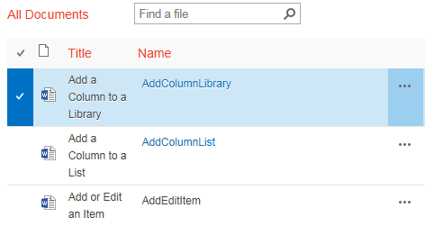
- On the ribbon, click the FILES tab. In the Copies group, click Download a Copy.
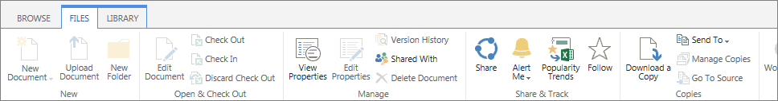
- Depending upon your browser, you may see additional prompts to save the document to a default downloads folder on your computer or to another folder of your choice.
Note: You can only download one document at a time with this command. See the help file for Open with Explorer to copy multiple documents to your computer.

