Edit a File
With SharePoint, you can edit files in a library without downloading them to your computer.
- Navigate to the library.
- Click the ellipsis next to the name of the file, and click EDIT in the callout.
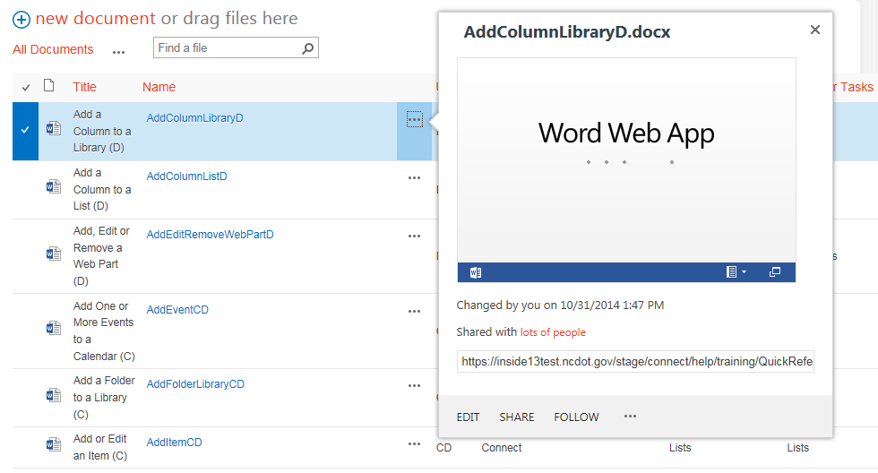or
Click the name of the file.
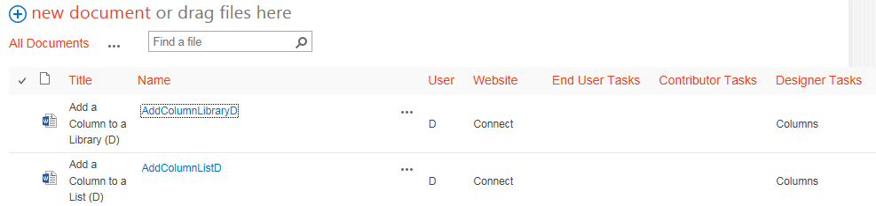
- If you receive a warning about trusting the file, click OK.
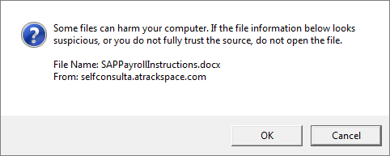
- Depending upon various settings, you may be prompted to open the file, check out the file, enable editing, and/or log in.
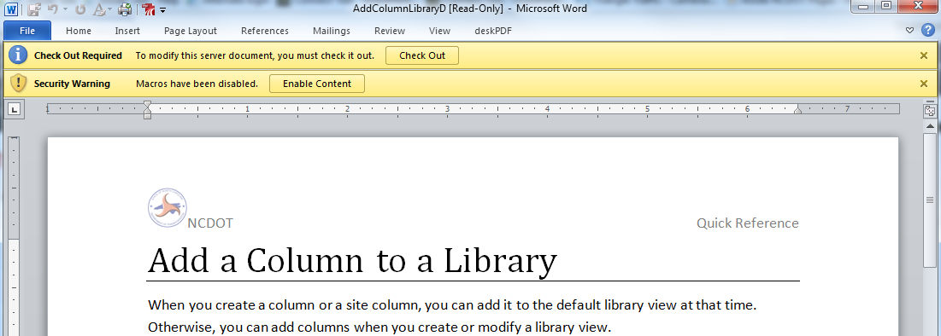Office documents open on your computer using your local Office applications (Word, Excel, PowerPoint).
- When your work is complete, click the File tab in the Office application, and click Save to save the file in the same library.
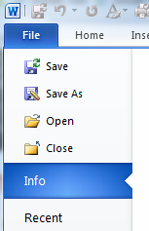
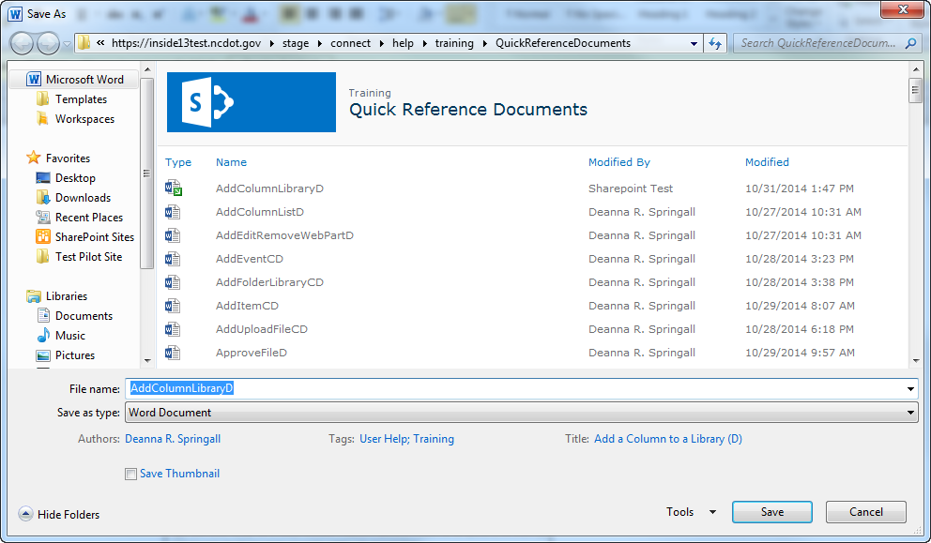
You can use Save As instead of Save to save the file in another library.

