Edit a Page
All pages on Inside NCDOT and Connect NCDOT contain and display web parts and apps (lists and libraries). The process to edit a page is:
- Open a page for editing. The page is automatically checked out to you.
- Make any necessary edits. This help file briefly summarizes the many editing actions you can take, and refers you to other help files for further details.
- Save and check in the page when editing is complete.
- Publish the page so the changes are visible to others.
Once published, page changes are generally visible within a few minutes, with the exception of the unauthenticated (public) pages on Connect. Those pages go live (that is, they are copied from the staging server to the production server) at :42 past each hour.

Contents
Open Page for Editing
Change Page Layout
Add Content to a Page
Check a Page for Unpublished Items
Save, Check In and Publish a Page

Open Page for Editing
- Navigate to the page.
- Click the Settings gear, and click Edit Page.
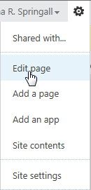
OR
Click the PAGE tab and click Edit.
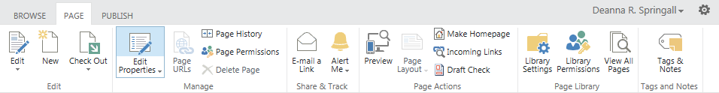The page is checked out to you and is ready for editing. If the page is checked out to you and you make no changes, use the Discard Check Out option to cancel your work and to avoid unnecessary versioning.

Change Page Layout
While Inside NCDOT uses only one page layout, Connect NCDOT uses several. You can change the layout on Connect NCDOT pages if needed.
- Navigate to the page.
- Click the Settings gear, and click Edit page.
The page is checked out to you and is ready for editing.
- On the ribbon, click the PAGE tab. In the Page Actions group, click Page Layout.
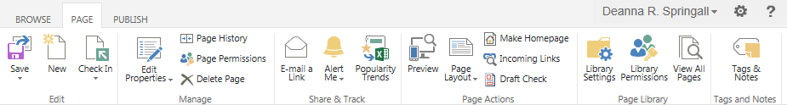A drop-down of available layouts appears, and the current layout is denoted with a yellow frame. See the help file for Add a Page for details on the Connect NCDOT page layouts.
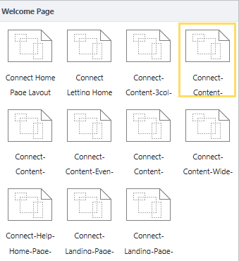
- Click the new layout for your page. Depending upon the change in layout, SharePoint may rearrange web parts on the page. For example, if you change from a three-column to two-column layout, web parts must be moved.
- Click Save.
- Remember to check the page back in and publish it to make your changes visible to others.

Add Content to a Page
- Navigate to the page.
- Click the Settings gear, and click Edit page.
The page is checked out to you and is ready for editing.
The content of pages is contained within web parts and apps (lists and libraries), so you must be familiar with web parts, lists, libraries and views to add content to a page. Because there are so many options, see these help files for details.
- Add, Edit, Remove, Delete or Close a Web Part
- Create, Modify or Delete a View
- Add an App – List
- Add an App – Library
- Use the Content Editor Web Part
- Use the Content Query Web Part
- Use the Image Viewer Web Part
- Use the List View Web Part
- Use the Media Web Part
- Use the NCDOT Custom Web Parts

Check a Page for Unpublished Items
Use the Draft Check feature to identify unpublished content or links to unpublished content on a page. If you do not ensure that all content has been published, you may publish the page and have missing content.
- Navigate to the page.
- Click the Settings gear, and click Edit page.
The page is checked out to you and ready for editing.
- On the ribbon, click the PAGE tab. In the Page Actions group, click Draft Check.
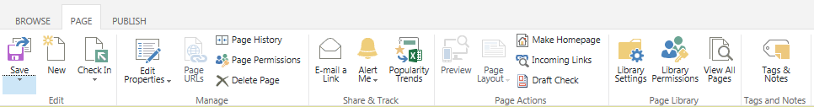The message Please wait while checking for unpublished items appears.
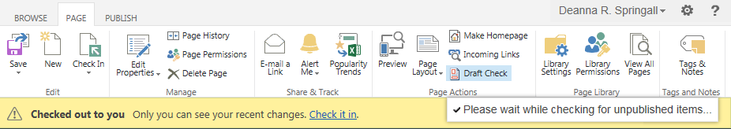
- If issues are detected during the Draft Check, a message appears. Problems on the page are outlined with yellow and red dashes. Click full report.
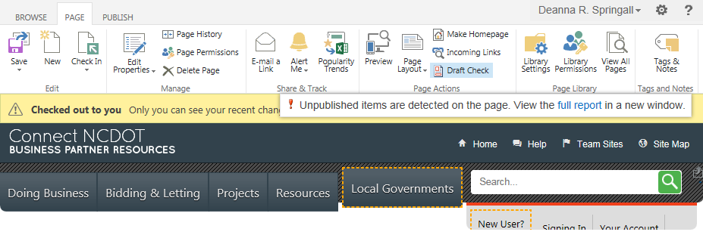The report appears in a separate window. The yellow outlines on the page correspond to yellow Old Version warnings in the report. Click Old Version for an explanation of the issue.
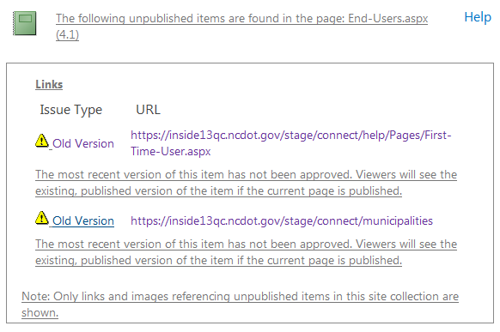
- Click the URL to see the content. In this example, the first three links are to pages that have been modified but not published. The last link is to an image that has also been modified but not published.
Red outlines on the page correspond to red Not Approved warnings in the report. The Not Approved warning means that the item has not been published and has no approved version. If the current page is published, the link will be broken. Click the URL to see what has not been published.

Save, Check In and Publish a Page
Once editing is complete, save the page, check it in, and publish it so your changes are visible to users.
- On the ribbon, click the PAGE tab. In the Edit group, click Save.
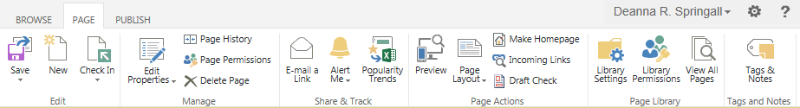
- In the Edit group, click Check In, or click Check it in in the yellow bar. If you check in the page without saving it first, the page is automatically saved.
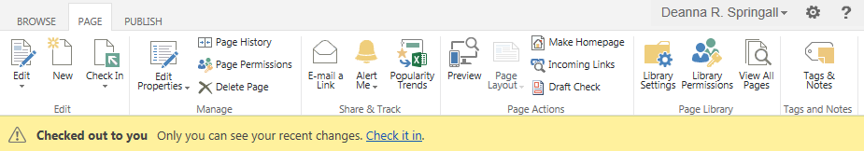
- In the CHECK IN dialog, document the changes you made, and click Continue.
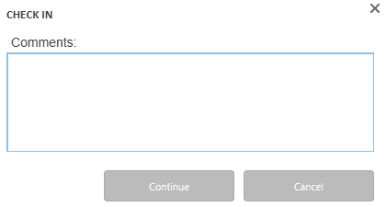
- Note that the message in yellow at the top of the page changes to indicate the page has not been published. Click Publish this draft to complete the publishing process.
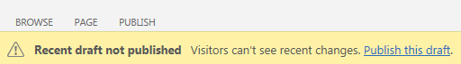
These are the other useful Edit options.
- Use Save and Keep Editing to periodically save your changes so that others can see them. The page remains checked out to you and you can continue to edit.
- Use Stop Editing to discontinue editing and discard your changes. It is generally better to use Discard Check Out.
- Use Discard Check Out if you have made no changes or have made changes you do not wish to keep. This option avoids unnecessary versioning.

