Edit the Properties of a File
Each file has standard properties, such as name and title, and may have custom properties, such as district or department. These properties can be changed if needed. Editing the properties of a file is a real and significant change; so, if check out/check in is enabled, you must check out the file before editing its properties.
Methods in this help file describe how to edit the properties of individual files one at a time. The Quick Edit feature is a much more efficient way to edit the properties of multiple files at the same time; see the help file for Quick Edit.
Note: Properties are also called metadata. Some properties, such as security level or content type, may be required. It is important that you assign properties correctly.

Contents
Edit Properties – Method 1
Edit Properties – Method 2

Edit Properties – Method 1
- Navigate to the library.
- Click the ellipsis next to the name of the file, and click the ellipsis in the callout. In the context menu, click Edit Properties.
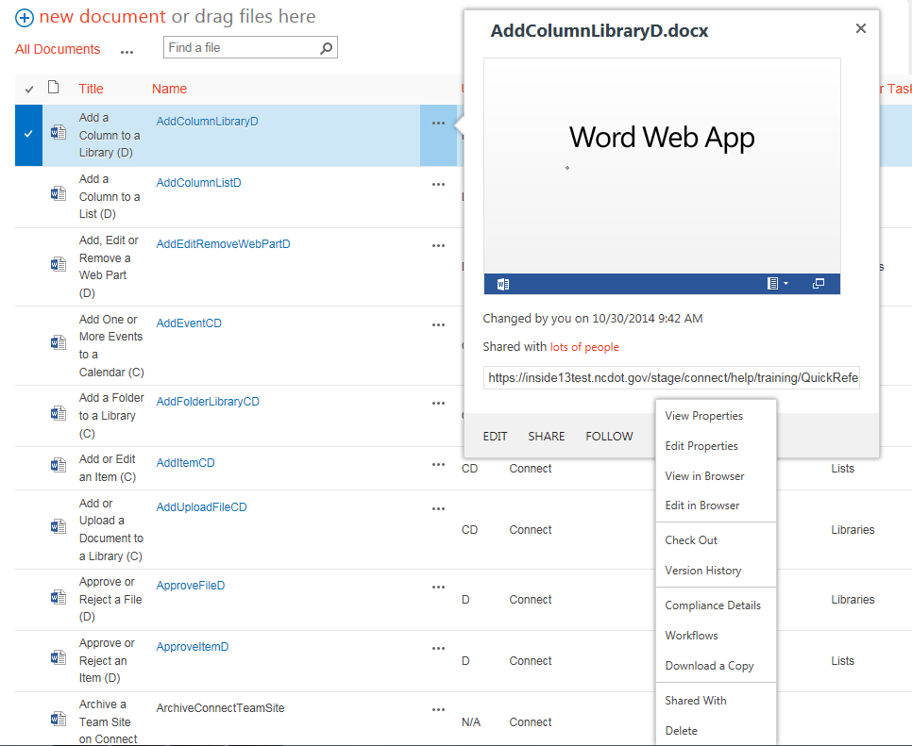
- If prompted, click OK to check out the file.
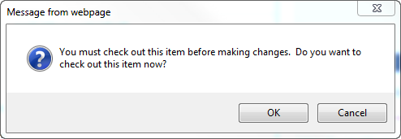
- Edit the properties as needed. When you complete your work, click Save.
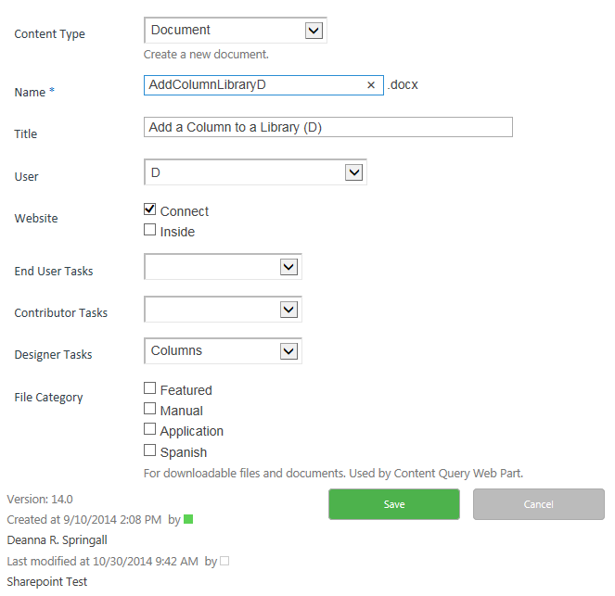

Edit Properties – Method 2
- Navigate to the library.
- Select the file by clicking the checkbox next to the name of the file.
- On the ribbon, click the FILES tab. In the Manage group, click Edit Properties.
- If prompted, click OK to check out the file.
- Edit the properties as needed. When you complete your work, click Save.

