Edit Properties of an Item
Each item has standard properties, such as name and title, and may have custom properties, such as district or department. These properties can be changed if needed. Some properties may be required.
In this example list, division and region are automatically assigned based upon the county and midpoint is a calculated column, based upon the start date and an end date (that is not displayed); thus, those properties cannot be edited.
Methods in this help file describe how to edit individual items one at a time. The Quick Edit feature is a much more efficient way to edit multiple items at the same time; see the help file for Quick Edit.
Note: Properties are also called metadata. Some properties, such as security level or content type, may be required. It is important that you assign properties correctly.

Contents
Edit an Item – Method 1
Edit an Item – Method 2
Edit an Item – Method 3

Edit an Item – Method 1
- Navigate to the list.
- Click the ellipsis next to the title of the item, and click Edit Item.
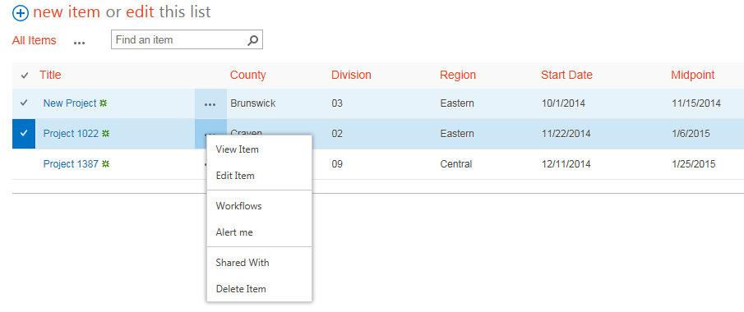
- If prompted, click OK to check out the item.
- Edit the properties as needed. When you complete your work, click Save.
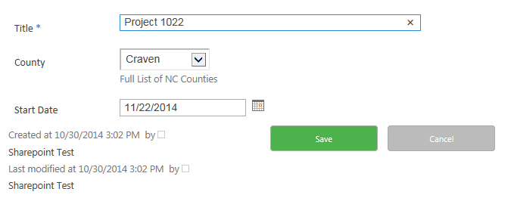

Edit an Item – Method 2
- Navigate to the list.
- Select the item by clicking the checkbox next to the title of the item.
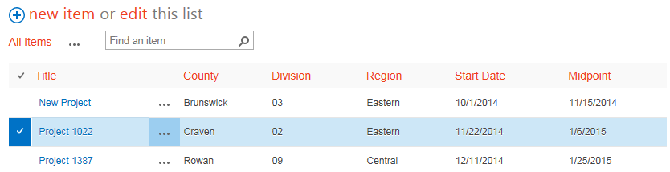
- On the ribbon, click the ITEMS tab. In the Manage group, click Edit Item.
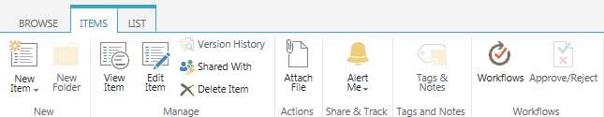
- If prompted, click OK to check out the item.
- Edit the properties as needed. When you complete your work, click Save.

Edit an Item – Method 3
- Navigate to the list.
- Click the item to edit.
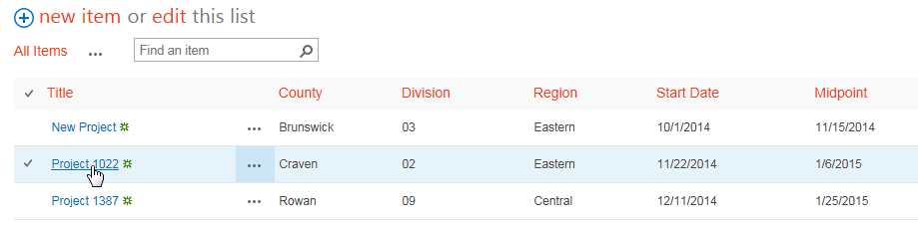 The item properties are displayed.
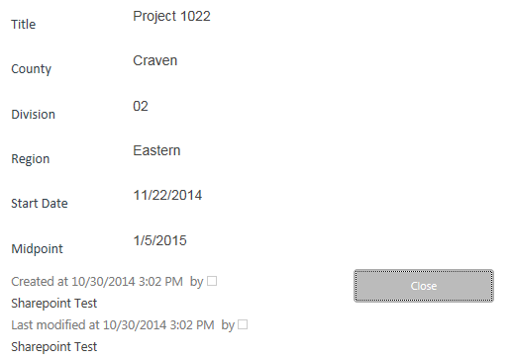
- On the ribbon, click the VIEW tab. In the Manage group, click Edit Item.
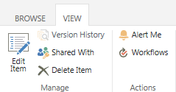
- Edit the properties as needed. When you complete your work, click Save.

