Edit the Properties of a Page
Each page has standard properties (such as name, title, comments and contact) and may have custom properties (such as the website on which it should appear or the user for whom it is intended). These properties can be changed if needed.
Page properties may vary, depending upon whether the page is on Inside NCDOT or Connect NCDOT or is part of a team or project site.
Note: Properties are also called metadata. Some properties, such as security level or content type, may be required. It is important that you assign properties correctly.

Contents
Page Properties – Ribbon
Example of Page Properties – Inside
Example of Page Properties – Connect
Edit Properties – Method 1
Edit Properties – Method 2
Edit Properties – Method 3
Edit Properties – Method 4

Page Properties – Ribbon
The Edit ribbon at the top of the page properties contains options to work with the page.
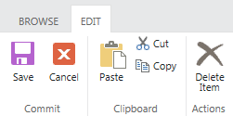

Example of Page Properties – Inside
The properties you likely need to edit are at the top of the list (Name, Title, etc.) or the bottom of the list (custom properties).
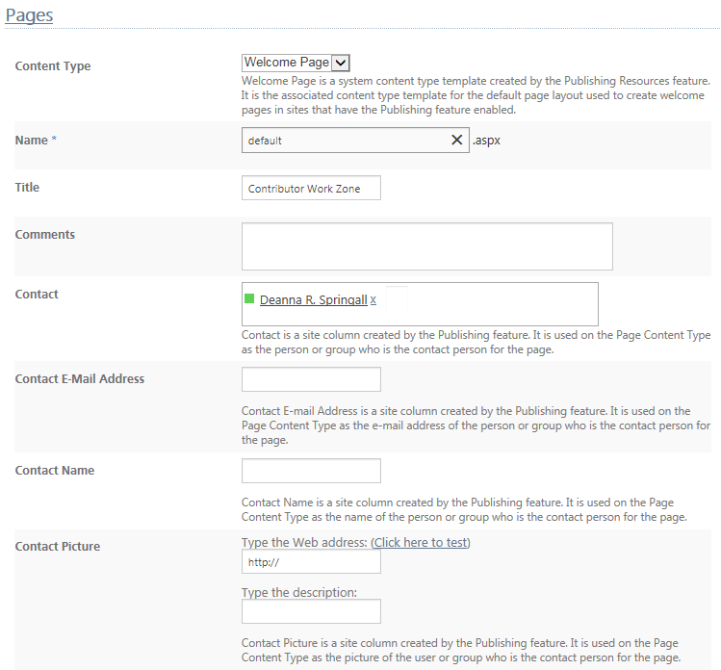

Example of Page Properties – Inside (continued)
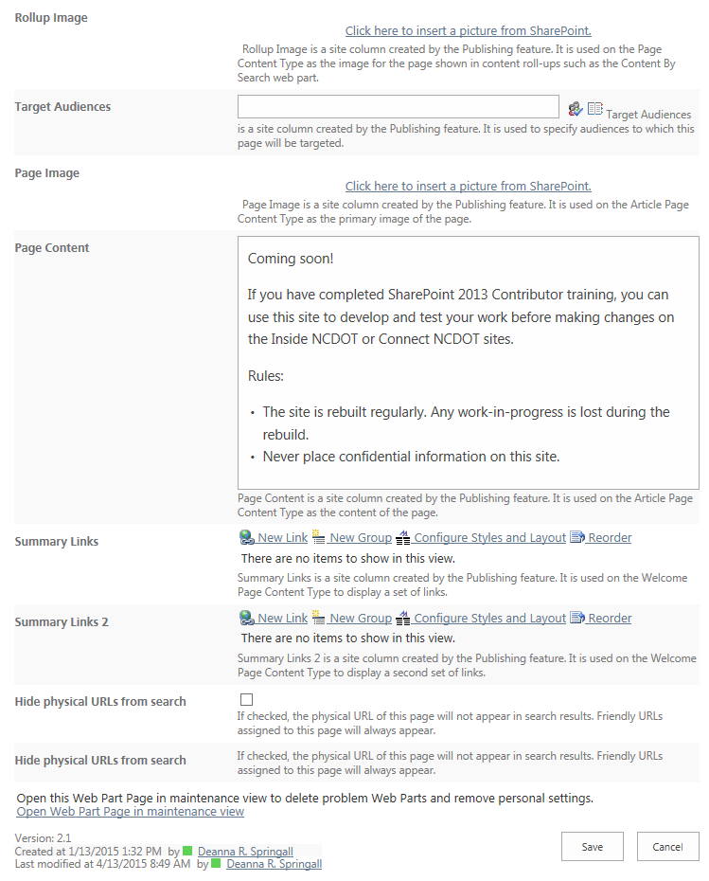

Example of Page Properties – Connect
The properties you likely need to edit are at the top of the list (Name, Title, etc.) or the bottom of the list (custom properties).
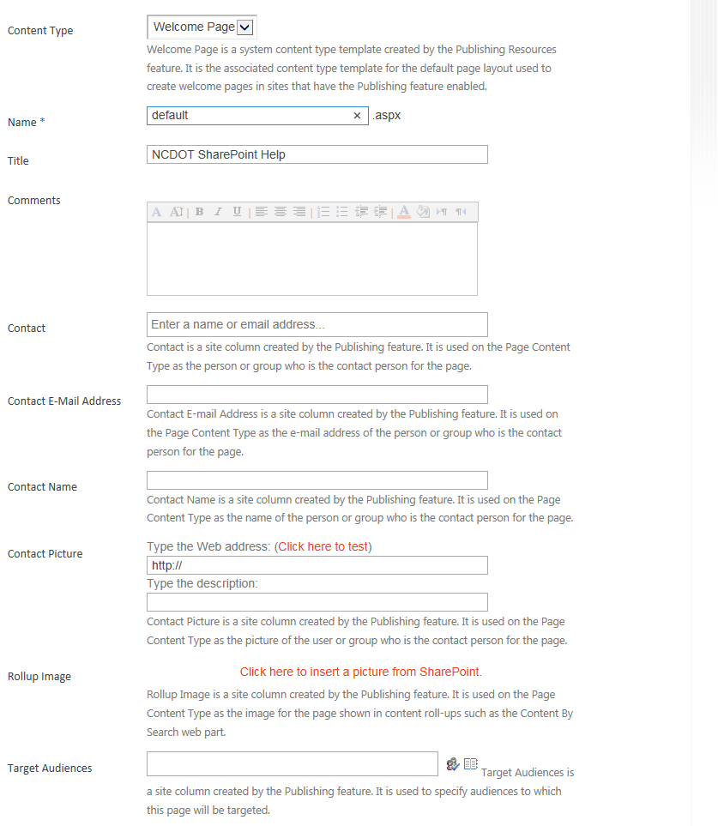

Example of Page Properties – Connect (continued)
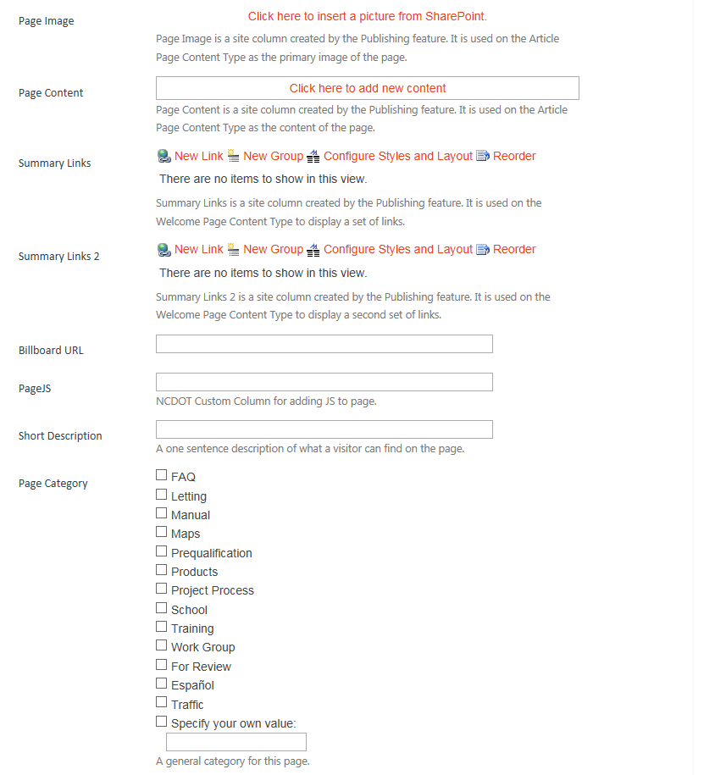

Example of Page Properties – Connect (continued)
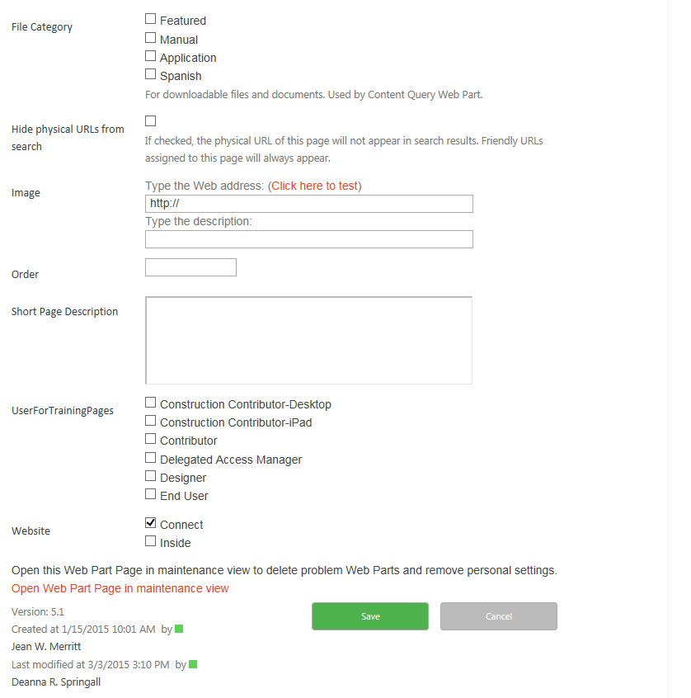

Edit Properties – Method 1
- Navigate to the page.
- On the ribbon, click the PAGE tab. In the Manage group, click Edit Properties. If prompted, check out the page.
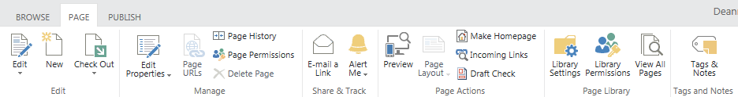
- Update the properties as needed.
- Click Save.

Edit Properties – Method 2
- Navigate to the page.
- Click the Settings gear and click Edit page. If prompted, check out the page.
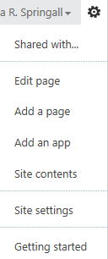
- On the ribbon, click the PAGE tab. In the Manage group, click Edit Properties.
- Update the properties as needed.
- Click Save.

Edit Properties – Method 3
- Click the Settings gear and click Site contents.
- Click the Pages library.

- Click the ellipsis next to the page name, click the ellipsis in the callout, and click Edit Properties. If prompted, check out the page.
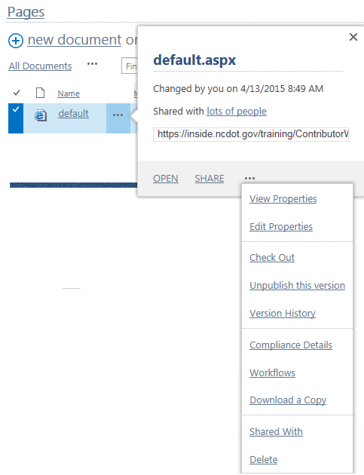
- Update the properties as needed.
- Click Save.

Edit Properties – Method 4
- Click the Settings gear and click Site contents.
- Click the Pages library.
- Select a page by clicking the checkbox next to the name of the page.
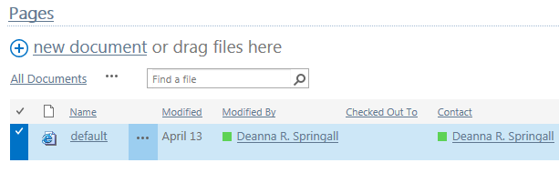
- On the ribbon, click the FILES tab. In the Manage group, click Edit Properties.
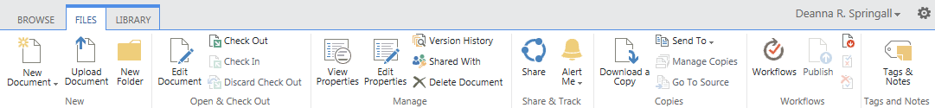
- Update the properties as needed.
- Click Save.

