Edit or Remove a Column in a List or Library
You can modify or delete columns in a list or library. However, column changes and deletions cannot be restored from the Recycle Bin.
To define a default value for a column, see the help file for Configure a Default Value for a Column in a Library.
Note: Do not remove the columns for Data Security Classification or Business Content Type. These are required.

Contents
Edit a Column
Delete a Column

Edit a Column
- Navigate to the list or library.
- On the ribbon, click the LIST or LIBRARY tab. In the Settings group, click List Settings or Library Settings. This example uses a list.
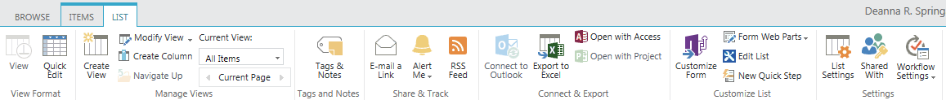
- On the Settings page, scroll to the Columns area, and click the name of the column to edit.
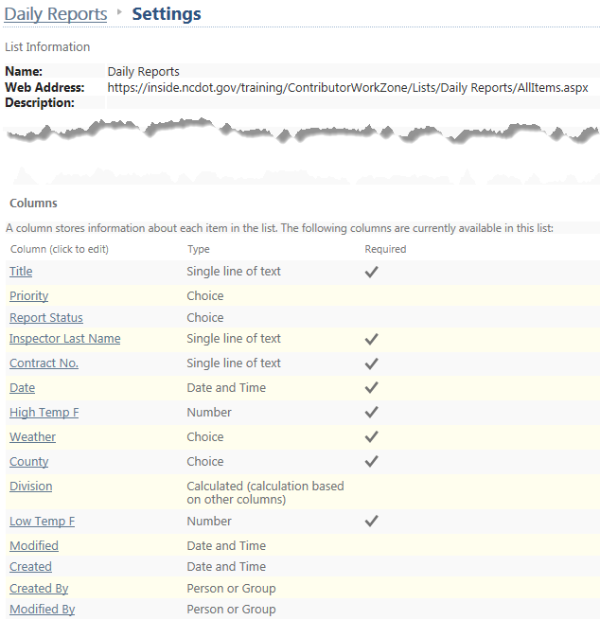

- On the Edit Column page, make any necessary changes. In this example, change the maximum number of characters for a contract to 6 and click OK to save the changes.
Change the type of information in a column carefully because it may result in the loss of data!
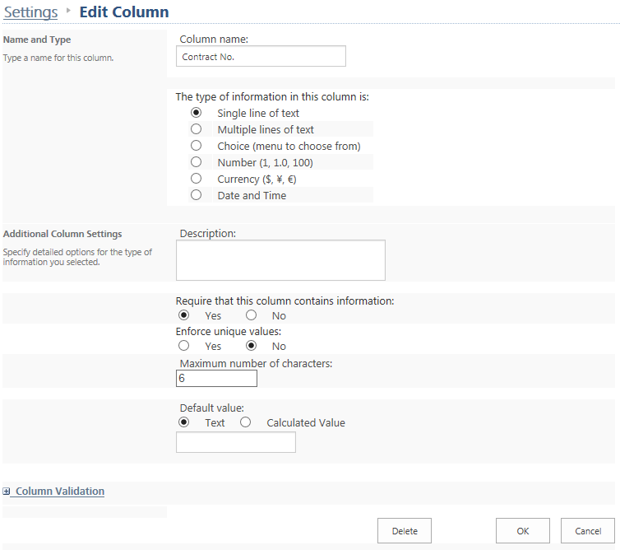

Delete a Column
Note: Do not remove the columns for Data Security Classification or Business Content Type. These are required.
- Navigate to the list or library.
- On the ribbon, click the LIST or LIBRARY tab. In the Settings group, click List Settings or Library Settings. This example uses a list.
- On the Settings page, scroll to the Columns area, and click the name of the column to delete.
- On the Edit Column page, click Delete.
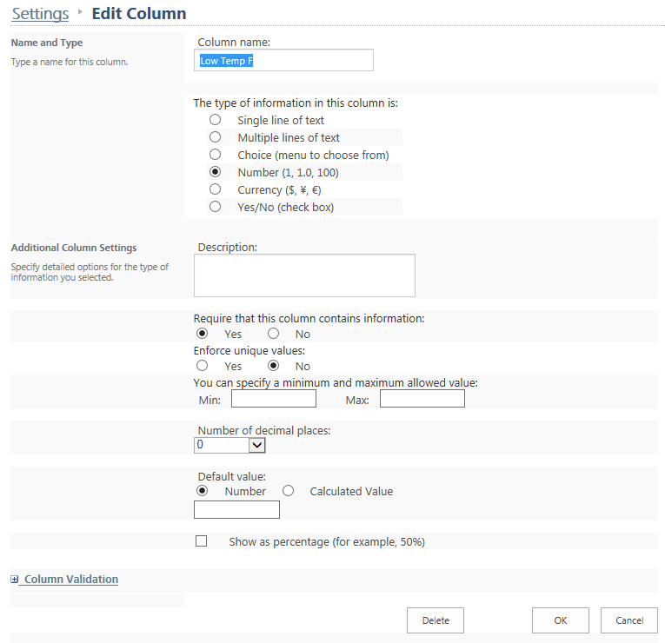
- Click OK to confirm the deletion.
- In List Settings, confirm that the column has been deleted.

