Edit and Sort Quick Launch – Connect NCDOT
Because Connect NCDOT is a public-facing site, options to customize Quick Launch are more restricted than on Inside NCDOT.
In the unauthenticated (public) area of Inside NCDOT, Quick Launch appears below the top navigation and cannot be customized.
In the authenticated area of Connect NCDOT, where a log in is required for team and project sites, Quick Launch can be customized. Here is an example.
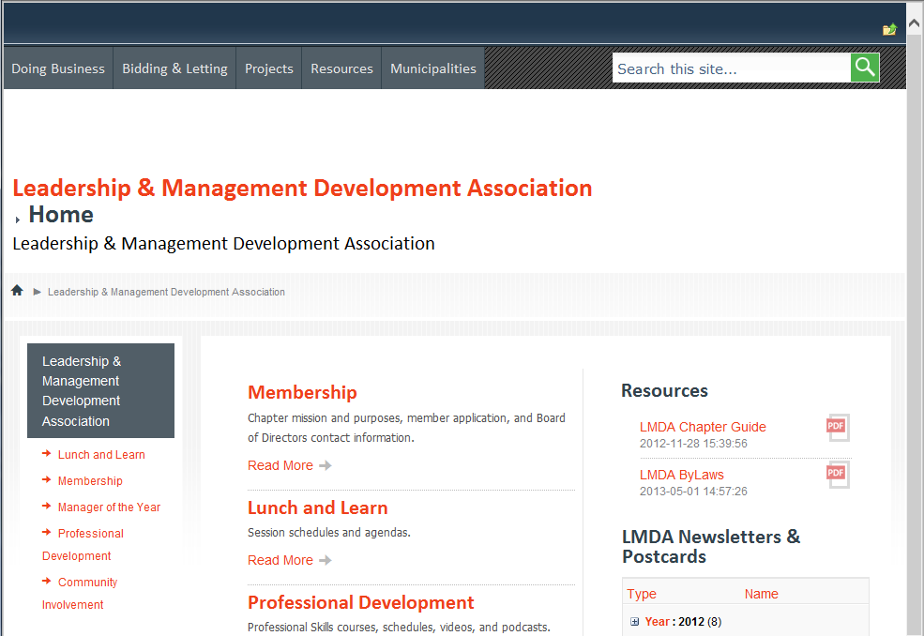
However, some types of team and project sites in Connect NCDOT are more controlled.
- Quick Launch for PMO sites contains a standard Quick Launch. This is an example.
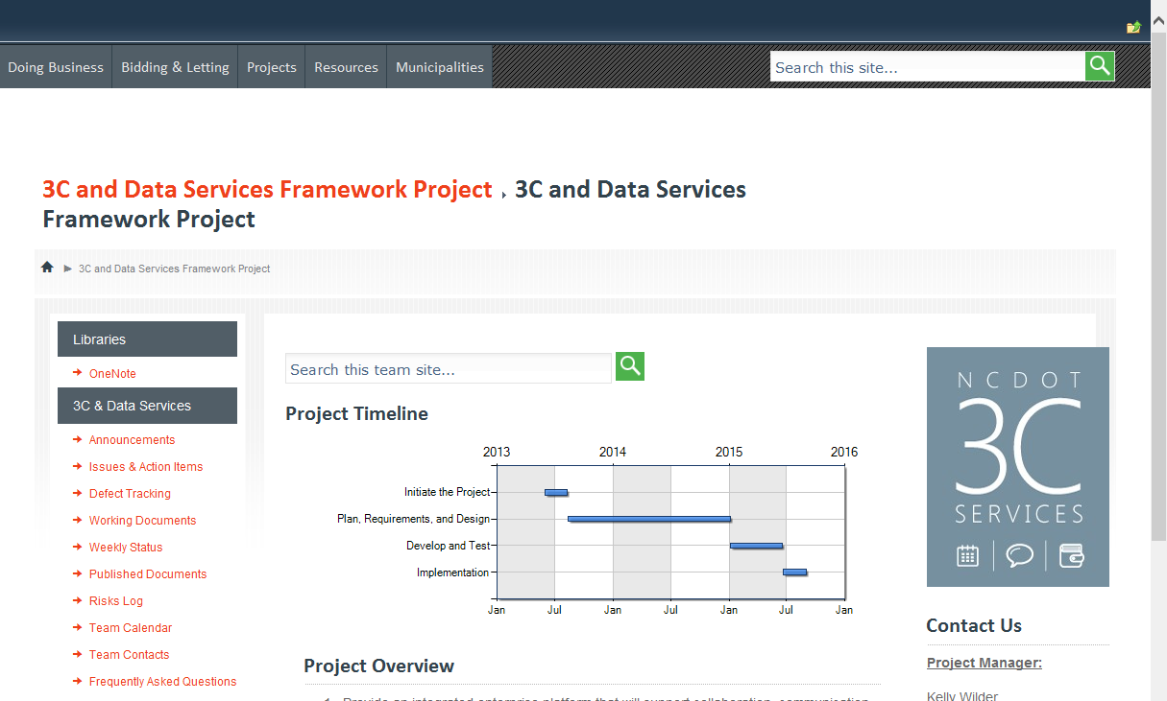
- Quick Launch for Construction sites uses a few different standards. Here are two examples.
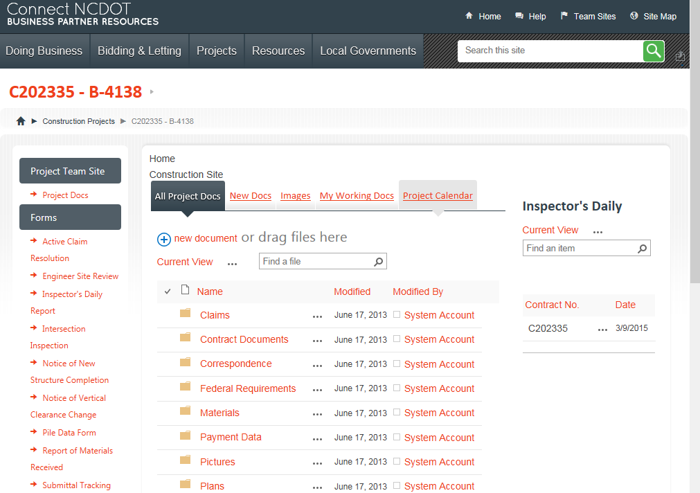
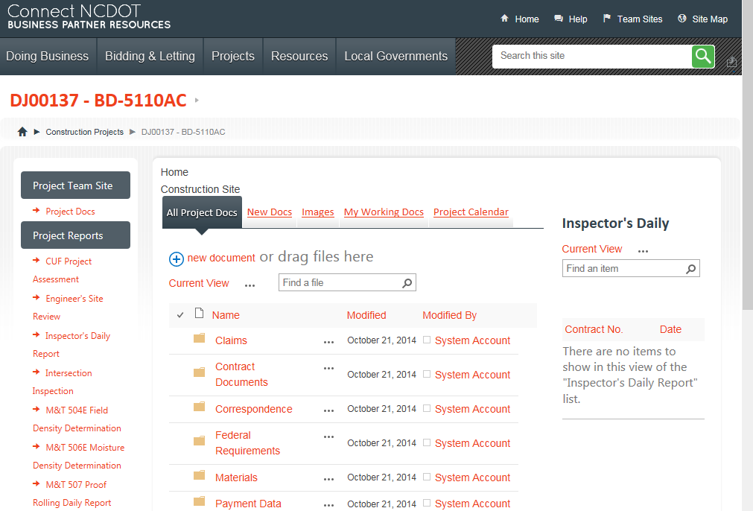

Contents
Open Quick Launch Navigation
Rearrange Quick Launch
Edit Heading
Delete Heading
Add Heading

Open Quick Launch Navigation
Note: Quick Launch on Inside NCDOT lets you configure both headings and links. Quick Launch on Connect NCDOT only lets you configure headings but displays them as links.
- Click the Settings gear, and click Site settings.
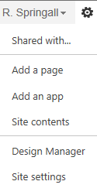
- In the Look and Feel group, click Navigation.
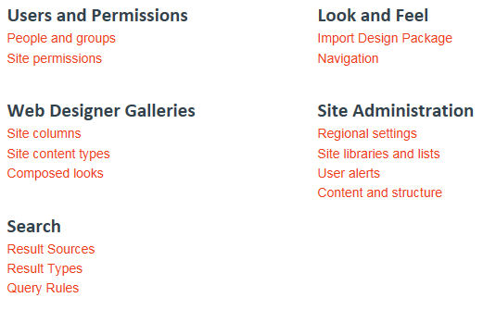
- In the Navigation Settings page, the Current Navigation hierarchy is equivalent to Quick Launch and is located in the left column. Leave the Structural Navigation configured as shown here.
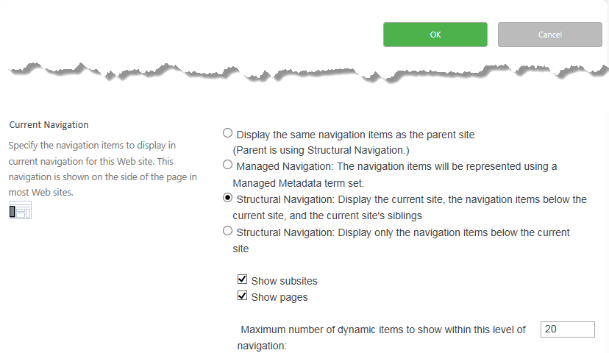
- Scroll down to Structural Navigation: Sorting and click Sort manually.
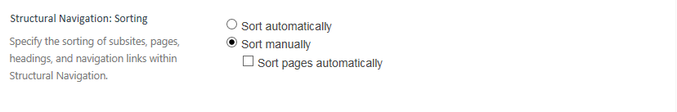The next sections describe how to modify Quick Launch using Structural Navigation.

Rearrange Quick Launch
- Scroll down to Structural Navigation: Editing and Sorting. To rearrange Quick Launch, click the heading (denoted by a folder), then click Move Up or Move Down.
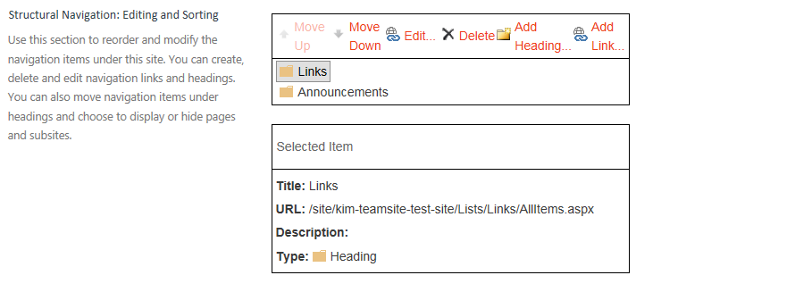
- This example moves the Announcements heading above the Links heading.
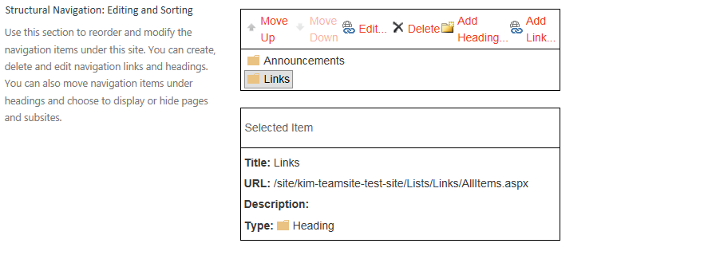
- Click OK to save your changes.

Edit Heading
- Scroll down to Structural Navigation: Editing and Sorting. To edit a heading (denoted by a folder), click the heading, and click Edit to change its properties.
- These are the properties that you can modify. Click OK to save your changes.
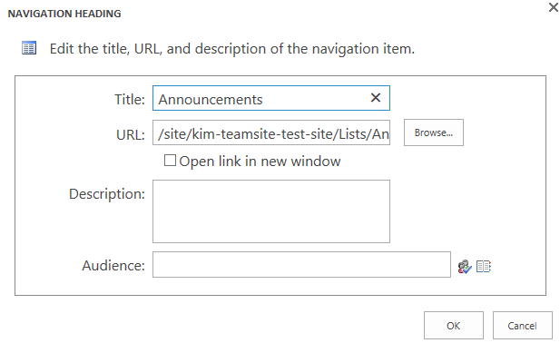

Delete Heading
Deletions are immediate, with no warning! You cannot cancel out of Navigation Settings to restore the deletion.
- Scroll down to Structural Navigation: Editing and Sorting. To delete a heading (denoted by a folder), click the heading, and click Delete.

Add Heading
- Scroll down to Structural Navigation: Editing and Sorting. To add a heading (denoted by a folder), click an existing heading and click Add Heading to create a new heading on the same level.
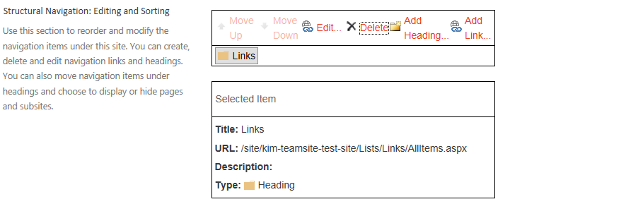
- Enter the text you want to appear in Quick Launch, then enter the URL for that heading. You can enter the address directly or browse to the URL.
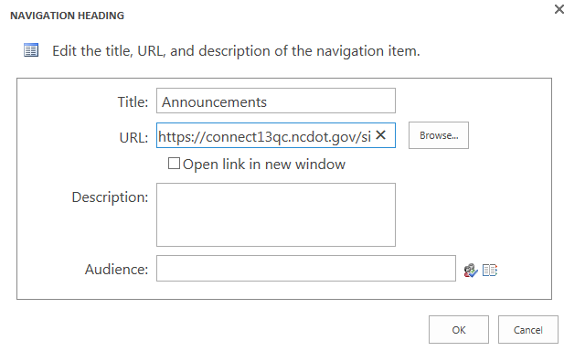
- If you choose to browse, click the list or library from the left column and click Insert.
Here’s an example of the Navigation Settings once the new heading is added. 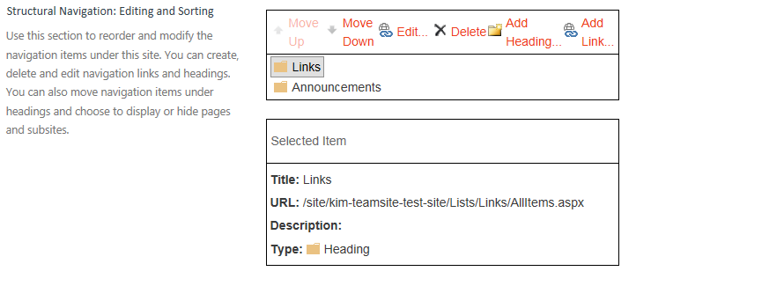
- Click OK to save your changes.

