Edit and Sort Quick Launch – Inside NCDOT
On Inside NCDOT, Quick Launch always contains these five elements in the left column.
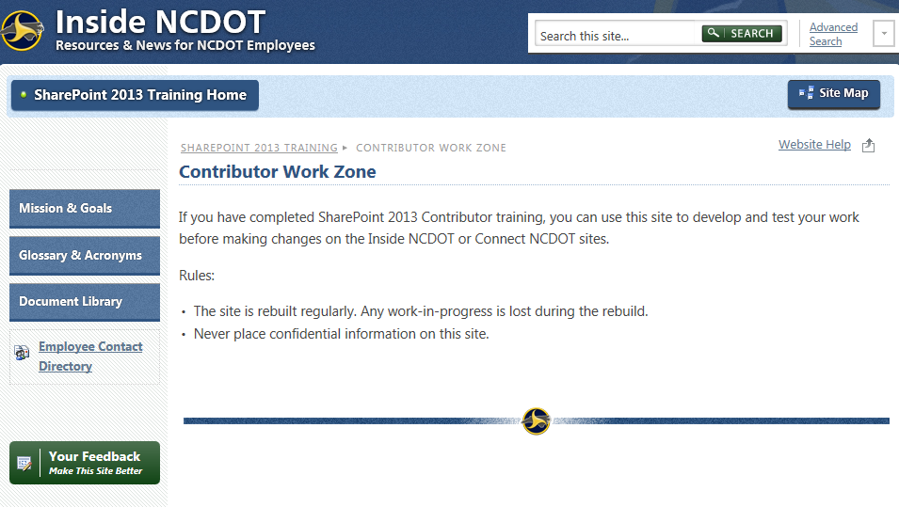
You can add headings and links in Quick Launch above these five standard elements. This is an example of a heading with four links.
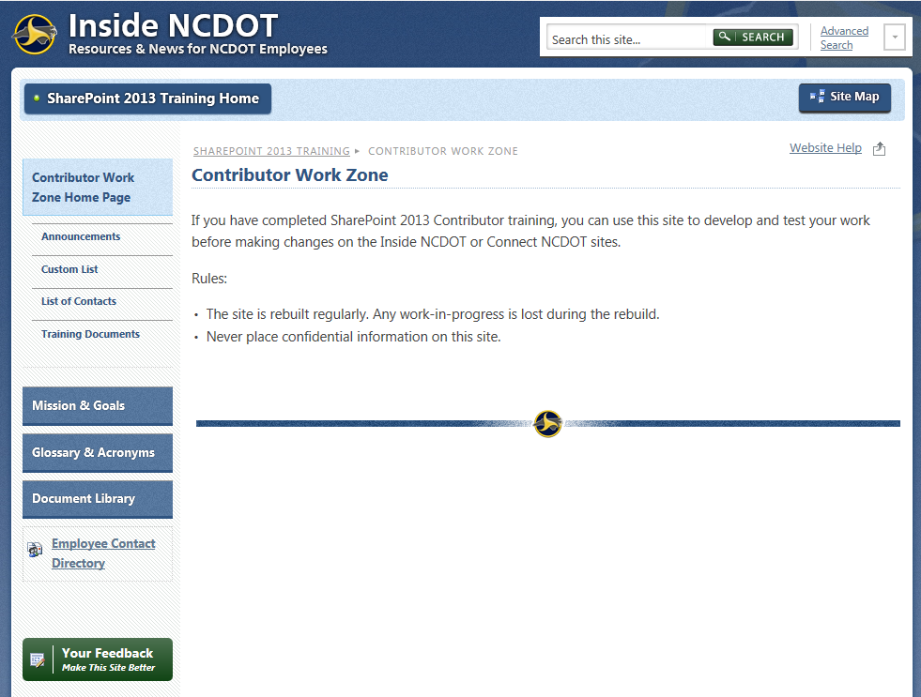

Contents
Open Quick Launch Navigation
Rearrange Quick Launch
Edit Heading or Link
Delete Heading or Link
Add Heading
Add Link
Example

Open Quick Launch Navigation
- Click the Settings gear, and click Site settings.
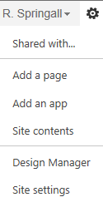
- In the Look and Feel group, click Navigation.
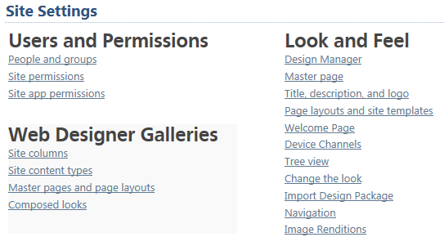
- In the Navigation Settings page, the Current Navigation hierarchy is equivalent to Quick Launch and is located in the left column. Leave the Structural Navigation configured as shown here.
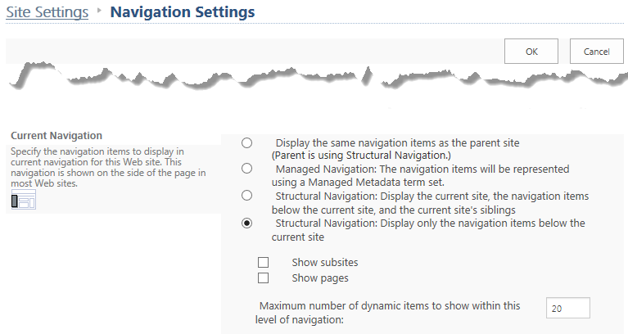
- Scroll down to Structural Navigation: Sorting and click Sort manually.
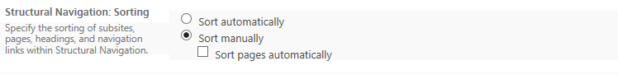The next sections describe how to modify Quick Launch using Structural Navigation.

Rearrange Quick Launch
- Scroll down to Structural Navigation: Editing and Sorting. To rearrange Quick Launch, click a heading (denoted by a folder) or a link (denoted by a globe), then click Move Up or Move Down.
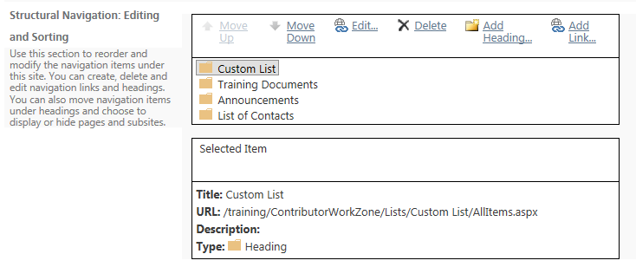
This example rearranges the headings in Quick Launch alphabetically.
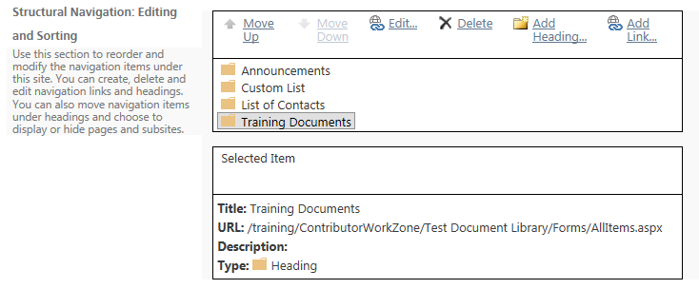
- Click OK to save your changes.

Edit Heading or Link
- Scroll down to Structural Navigation: Editing and Sorting. To edit a heading (denoted by a folder) or a link (denoted by a globe), click the heading or link, and click Edit to change its properties.
- These are the properties that you can modify. Click OK to save your changes.
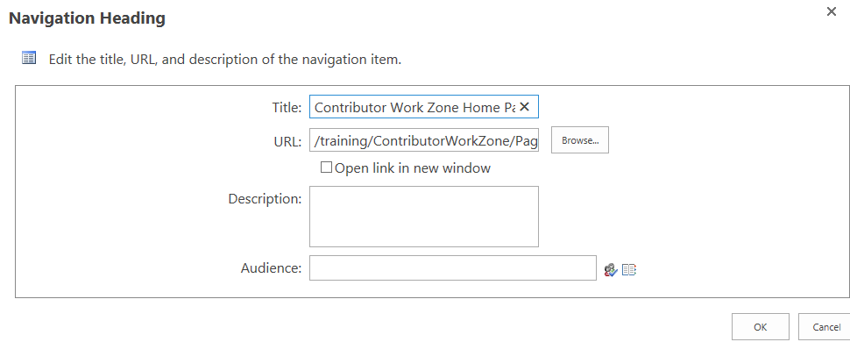

Delete Heading or Link
Deletions are immediate, with no warning! You cannot cancel out of Navigation Settings to restore the deletion.
- Scroll down to Structural Navigation: Editing and Sorting. To delete a heading (denoted by a folder) or a link (denoted by a globe), click the heading or link, and click Delete.
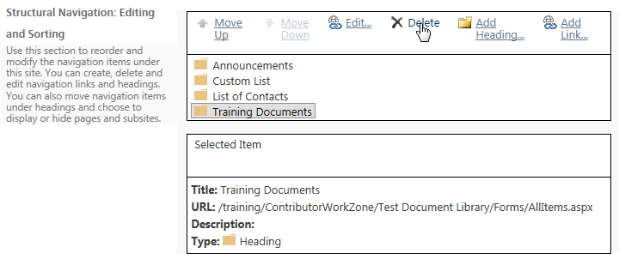

Add Heading
- Scroll down to Structural Navigation: Editing and Sorting. To add a heading (denoted by a folder), click an existing heading and click Add Heading to create a new heading on the same level.
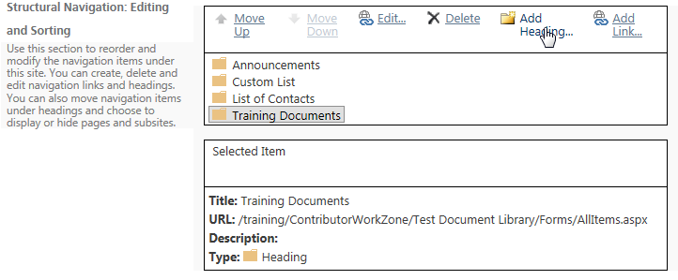
- Enter the text you want to appear in Quick Launch, then enter the URL for that heading. You can enter the address directly or browse to the URL.
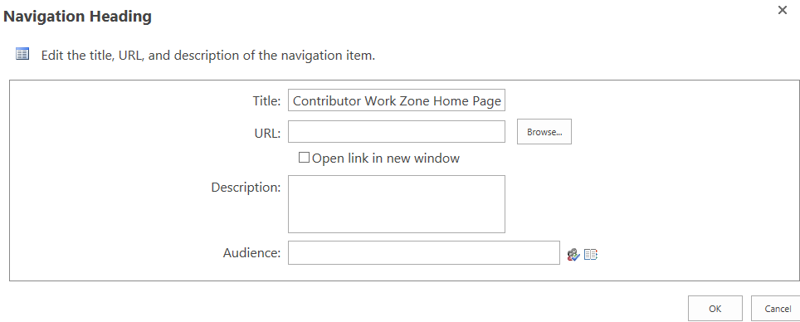
- If you choose to browse, click the list or library from the left column and click Insert.

Here’s an example of the Navigation Settings once the new heading is added.
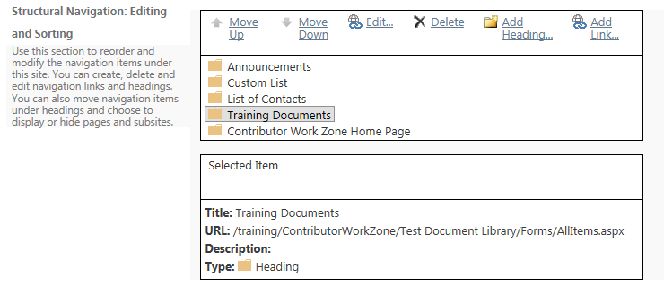
- Click OK to save your changes.

Add Link
- Scroll down to Structural Navigation: Editing and Sorting. To add a link (denoted by a globe with a link), click an existing heading and click Add Link to create a new link under that heading.
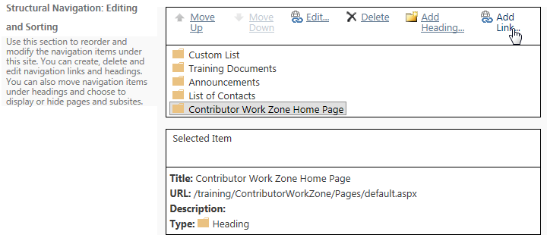

- Enter the text you want to appear in Quick Launch, then enter the URL for that heading. You can enter the address directly or browse to the URL.
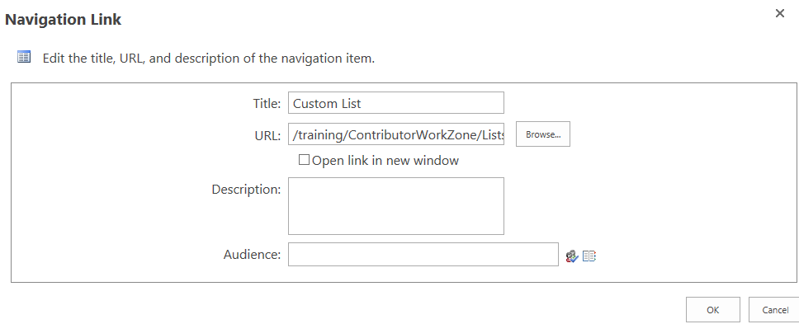
- If you choose to browse, click the list or library from the left column and click Insert.
- Here’s an example of the Navigation Settings once the new link is added.
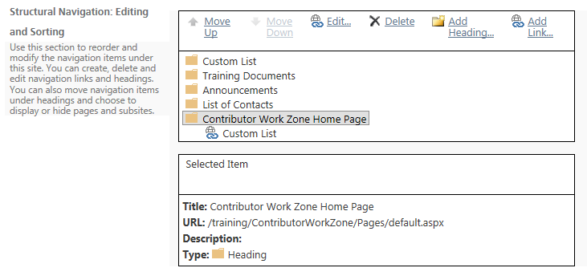
- Click OK to save your changes.

Example
This navigational structure:
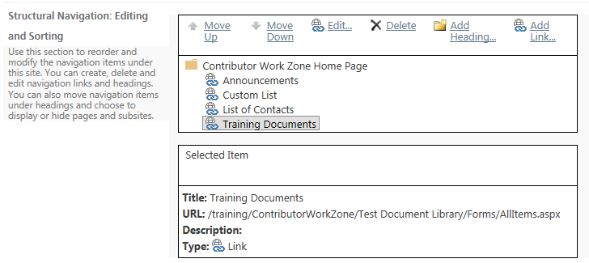
creates this Quick Launch:

