Edit the Library Template
Each library has a default template that is used whenever a new file is created within the library.
For example, in a document library, a blank Microsoft Word document is used as a template when a file is created with the New Document command. However, you can edit that template to, for example, include a standardized header and footer, contain boilerplate text for introductory paragraphs, or contain a suggested outline for all proposals.
- Navigate to the library.
- On the ribbon, click the LIBRARY tab. In the Settings group, click Library Settings.
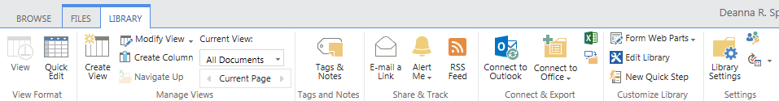
- On the Settings page under General Settings, click Advanced Settings.
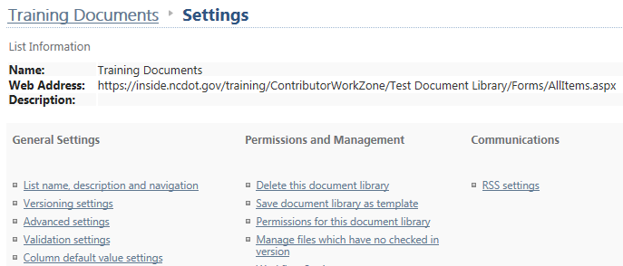

- In Advanced Settings:
  - Ensure that Allow management of content types is No.
  - Ensure that the default behavior is Open in the client application.
  - Click Edit Template.
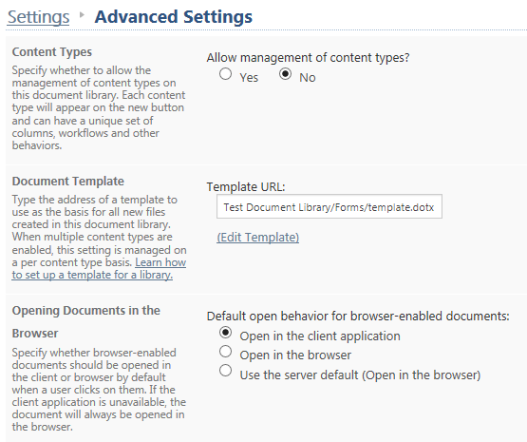
- As the template opens, you may be prompted to trust the file and/or log in.
- Edit the template as needed.
- Save and close the template.
- Click OK to close the Advanced Settings page.
- Navigate back to the library. Use the New Document command to create a new document and confirm that the modified template is used.

