Email a Link
You can use Outlook to distribute a link to a list, library or page; the email recipients simply click the link to go directly to the content you wish them to see.
Note: Only Designers can view the PAGE tab to email links to pages.
- Navigate to the list, library or page.
- On the ribbon, click the LIST, LIBRARY or PAGE tab. In the Share & Track group, click E-mail a Link.
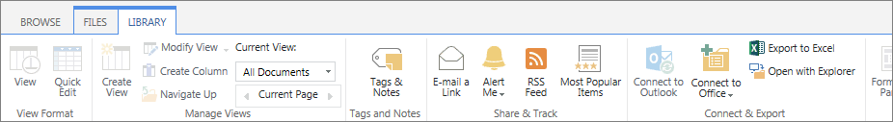
- If prompted, sign into your Outlook account to continue.
- The link is automatically pasted into a new Outlook email message. Enter the recipient(s) and a subject, and edit the message as you need. Click Send to email the link.
LIST: If you prefer to copy and paste a URL directly into an email message, here are several methods to find the URL of either a list or its individual items:
- Navigate to the list, and copy the URL from the browser address bar.
- Hover over the link for a list or item. Right-click, and click Copy shortcut to copy the URL.
- Navigate to the list, click the title of the item, and copy the URL from the browser address bar.
- Navigate to the list, click the ellipsis next to the title of the item, click View Item, and copy the URL from the browser address bar.
LIBRARY: If you prefer to copy and paste a URL directly into an email message, here are several methods to find the URL:
- Navigate to the library, and copy the URL from the browser address bar.
- If a document (such as a PDF) displays within the browser, copy the URL from the browser address bar.
- Hover over the link for a file or library. Right-click, and click Copy shortcut to copy the URL.
- Navigate to the library, click the ellipsis by the name of the file, and copy the URL from the callout.
PAGE: If you prefer to copy and paste a URL directly into an email message, here are several methods to find the URL:
- Navigate to the web page, and copy the URL from the browser address bar.
- Hover over the link for a page. Right-click, and click Copy shortcut to copy the URL.
- Navigate to the library, click the ellipsis by the name of the page, and copy the URL from the dialog.

