Export a Table from Excel to SharePoint
You can easily create a SharePoint list by exporting an Excel table.
- Open the spreadsheet in Excel and ensure it is defined as a table. Click inside the table. On the ribbon, click the Table Tools/Design tab. In the External Table Data group, click Export.
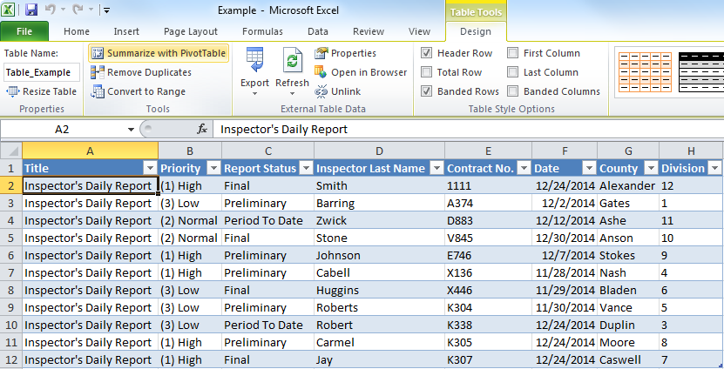
- Click Export Table to SharePoint List.
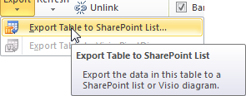
- If prompted, click OK to trust the file.
- Enter the address of the top level of the SharePoint site; be sure the address is not a page or list or library. Enter a name and description for the new list and click Next.
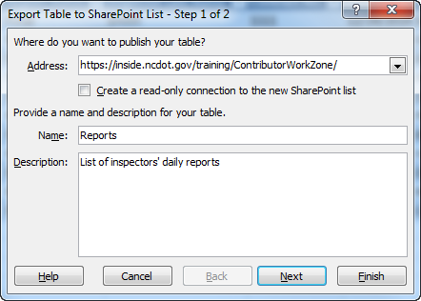
- If prompted, log in to the SharePoint site.
- Review the columns and their data types, and click Finish.
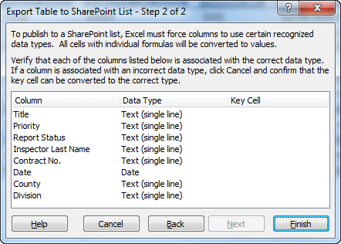
If the Data Type is not correct, click Cancel and make changes within Excel to correct any issues.
- A dialog appears with the address of the new SharePoint list. Click the link to see the list.
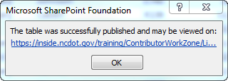
- In SharePoint, the imported data appears in Quick Edit mode. Click Stop editing this list to save the list.
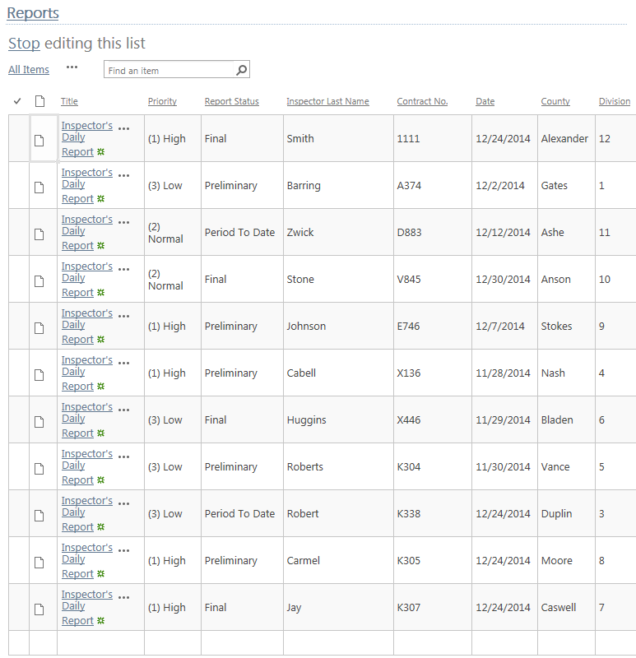
- Return to Excel, click OK and close the spreadsheet.

