Export a List or Library to Excel
This feature lets you export items from a list or library to an Excel spreadsheet.
- Navigate to the list or library.
- On the ribbon, click the LIST or LIBRARY tab. In the Connect & Export group, click Export to Excel.
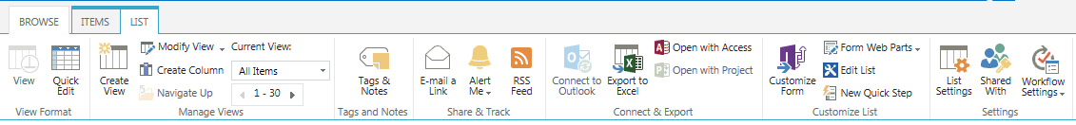
- When you see this message, click Open to view the list’s or library’s content in Excel, or click one of the Save options to store the spreadsheet on your computer.
- If you see a security warning, click Enable if you trust the source.
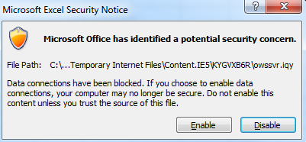
This is an example of a SharePoint list that has been exported to Excel. Note that filters are automatically created.
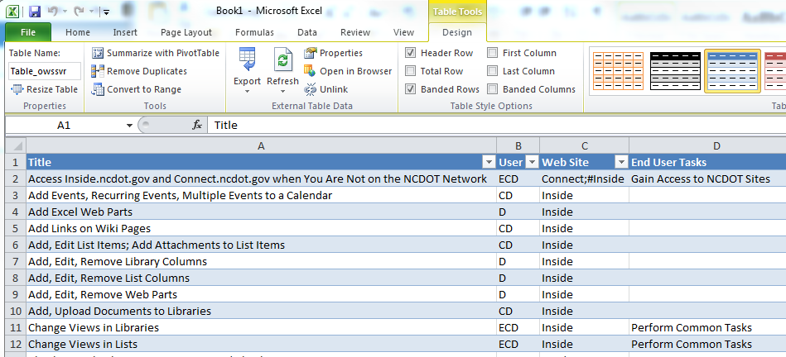

The exported list or library is saved as a Microsoft Excel Web Query File (owssvr.iqy). The query file is linked to the SharePoint list or library, and changes are automatically synchronized between the two when you open the query file.
If you save the query file as an Excel spreadsheet (.xlsx), you must refresh the connection to synchronize the spreadsheet and the SharePoint list. Use the Refresh All command in the Data tab.
To break the connection, click the Table Tools tab in Excel. In the External Table Data group, click Unlink.
Note: When a list or library is exported, permissions are lost and columns that are used within Office (such as Created, Created by, Modified, Modified by) are automatically updated.

