Why Do I Get a “File Name Does Not Exist. Check Your Spelling or Try Another Path” Error?
When you try to open a file in SharePoint, you receive the error message http://myportal/library/filename.docx does not exist. Check your spelling or try another path. However, you have checked the library, the path, and the spelling – and you know the file is there.
- Go to the taskbar on your desktop.
- Click the up arrow for Show hidden icons, click the icon for the Microsoft Office Upload Center, and click Open Upload Center.
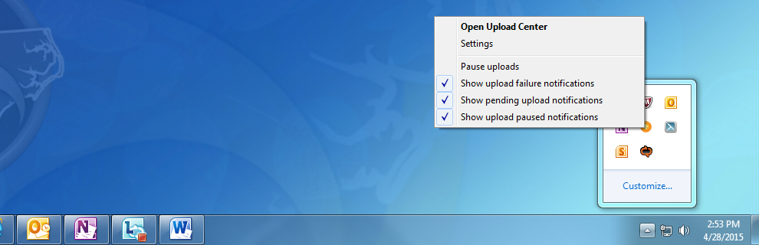
- In the Upload Center, click Settings.
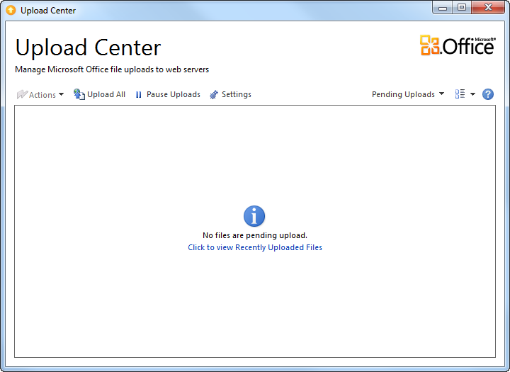
- Click Delete cached files and check the Delete files from the document cache when they are closed option. Click OK and close the Upload Center.
