Why Do I Get a “File Name Not Valid” Error?
If you use invalid characters in the name of a file, you receive an error message.
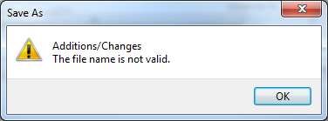
File names cannot contain these special characters:
Tilde ~  Number sign #  Percent %  Ampersand &  Asterisk * | Braces {}  Backslash \  Colon :  Angle brackets < > | Question mark ?  Slash /  Pipe |  Quotation mark "

